A REPORT ON

**“Text Summarization Using PEGASUS Transformer Model”**

SUBMITTED TO THE SAVITRIBAI PHULE PUNE UNIVERSITY, PUNE IN THE PARTIAL FULFILLMENT OF THE REQUIREMENTS FOR THE AWARD OF THE DEGREE

OF

**BACHELOR OF ENGINEERING (COMPUTER ENGINEERING)**

SUBMITTED BY

|  |  |
| --- | --- |
| Pradnya Gokhale | 41216 |
| Nidhi Tikone | 41266 |
| Rushabh Udani | 41268 |
| Charvi Wankhede | 41270 |
|  |  |
|  |  |

UNDER THE GUIDANCE OF

Dr. B.D.Phulpagar



DEPARTMENT OF COMPUTER ENGINEERING

P.E.S MODERN COLLEGE OF ENGINEERING PUNE - 411005.

SAVITRIBAI PHULE PUNE UNIVERSITY

[2024 - 25]



Progressive Education Society’s **Modern College of Engineering**, Shivaji Nagar, Pune- 411005.

**Certificate**

This is to certify that the Mini-Project report entitled as,

**“Text Summarization Using PEGASUS Transformer Model”**

Submitted by

|  |  |
| --- | --- |
| Pradnya Gokhale | 41216 |
| Nidhi Tikone | 41266 |
| Rushabh Udani | 41268 |
| Charvi Wankhede | 41270 |

Academic Year: 2024-2025

This bonafide work is carried out by the students under the supervision of Dr. B.D.Phulpagar

and the Mini-Project report is approved for the partial fulfilment of the requirements for the degree of Bachelor of Engineering (Computer Engineering) of Savitribai Phule Pune University, Pune.

|  |  |
| --- | --- |
| Dr. B.D.Phulpagar | Prof. Dr. (Mrs.) S. A. Itkar |
| Internal Supervisor | Head of Department |

(Computer Engineering)

# Contents

Introduction 5

Objectives 7

Motivation 9

Scope and rationale of the study 11

Methodological details 14

Algorithm 18

Results 20

Analysis 24

Inferences and Conclusion 28

Acknowledgement 30

List of reference 32

**Abstract:**

This project explores the application of a state-of-the-art NLP model, PEGASUS, for abstractive summarization of news articles. Leveraging the cnn_dailymail dataset, the study demonstrates how to preprocess text data, fine-tune a pretrained model, and evaluate its summarization performance using standard metrics like ROUGE. This project explores the application of a state-of-the-art NLP model, PEGASUS, for abstractive summarization of news articles. Leveraging the cnn_dailymail dataset, the study demonstrates how to preprocess text data, fine-tune a pretrained model, and evaluate its summarization performance using standard metrics like ROUGE. This project explores the application of a state-of-the-art NLP model, PEGASUS, for abstractive summarization of news articles. Leveraging the cnn_dailymail dataset, the study demonstrates how to preprocess text data, fine-tune a pretrained model, and evaluate its summarization performance using standard metrics like ROUGE.

# Chapter 1 Introduction

## 1.1 Introduction:

In today's digital world, there is an overwhelming amount of textual content generated every day, ranging from news articles and social media posts to academic papers and technical documentation. The sheer volume of information available at our fingertips has made it increasingly difficult for individuals to consume and retain relevant knowledge efficiently. In such an environment, the ability to summarize content accurately and concisely becomes not just useful, but essential.

Summarization plays a vital role in distilling vast amounts of data into manageable chunks that are easier to understand and act upon. It enables users to quickly grasp the core ideas without wading through extensive details. Whether it's scanning the headlines, reviewing a research abstract, or reading a meeting recap, summarization enhances decision-making and knowledge acquisition.

This project investigates how modern Natural Language Processing (NLP) techniques, particularly those leveraging transformer-based architectures, can improve the quality of automatic summarization. Specifically, we focus on Google's PEGASUS model, a state-of-the-art approach designed for abstractive summarization tasks.

PEGASUS utilizes a unique training strategy that mimics the summarization process by masking and generating important sentences from documents during pretraining. This allows the model to learn contextual relationships and paraphrasing techniques that are critical for high-quality summaries.

By applying PEGASUS to long-form content like news articles, this project aims to demonstrate how machine learning can effectively replicate human summarization behavior. The study explores not only the model's capabilities but also the practical considerations of deploying such solutions in real-world scenarios.

Overall, this research contributes to the ongoing evolution of AI-powered summarization tools, highlighting their potential to reshape how we consume and interact with textual data in our increasingly fast-paced and information-rich society.

# Chapter 2 Objectives

## : The primary objectives of this research project are:

* **Implement an abstractive summarization pipeline**

The core task is to develop a working summarization system using modern NLP techniques.

* **Utilize the PEGASUS transformer model**

PEGASUS, developed by Google, is chosen for its effectiveness in abstractive summarization tasks.

* **Focus on long-form content**

The system is designed to handle lengthy articles, which pose greater challenges for summarization models.

* **Use the CNN/DailyMail dataset**

A well-known benchmark dataset containing news articles and summaries is employed to train and evaluate the model.

* **Evaluate model performance**

The quality of generated summaries will be assessed using established metrics like ROUGE, ensuring objectivity.

* **Measure how well PEGASUS performs on real-world text**

Insights will be gained into how the model handles realistic, complex sentence structures and topics.

* **Test the generalizability of pretrained models**

By applying a pretrained model directly, the project explores how effectively PEGASUS generalizes without fine-tuning.

* **Benchmark against existing standards**

Comparing PEGASUS's outputs with human-generated summaries helps validate its performance.

* **Optimize input processing for summarization**

Techniques like batching and tokenization are applied to improve model efficiency and reduce latency.

* **Explore potential for practical deployment**

The final goal includes assessing how such a summarization system could be used in real-world applications, like news apps or research tools.

# Chapter 3 Motivation

## Motivation

The motivation for this research stems from several compelling factors in the current financial technology landscape:

* **Information overload is a growing problem**

The internet generates a massive volume of text-based data every second, making it difficult for individuals to stay informed without investing significant time.

* **Users struggle with content relevance**

With so much information available, filtering out what's important or trustworthy has become increasingly challenging.

* **Manual summarization is not scalable**

Relying on humans to summarize documents is time-consuming and impractical, especially for organizations handling thousands of documents daily.

* **There is a demand for automation**

As digital platforms scale, the need for automated tools that can provide quick, high-level overviews of content is greater than ever.

* **Quality of information retrieval is affected**

When users can’t access concise versions of content, it impacts their decision-making, research, and productivity.

* **Motivation for the project arises from this gap**

This project is driven by the need to solve the problem of digesting large volumes of text in a fast and reliable manner.

* **Deep learning offers a viable solution**

Modern NLP models like PEGASUS are designed to understand language and generate human-like summaries, making them suitable for this task.

* **Transformer-based models are state-of-the-art**

These models, trained on large datasets, have shown significant improvements in language generation and comprehension.

* **Automated summarization saves time**

By automatically condensing documents, users can quickly scan summaries and decide whether to read the full text.

* **The study aims to bridge the gap between content generation and content consumption**

It seeks to make information more accessible and easier to navigate for users across various domains.

# Chapter 4

# Scope and rationale of the Study

**5.1 Scope**

1. **Abstractive Summarization Using PEGASUS Transformer:**  
   The central focus of the study is to apply the PEGASUS transformer model to generate abstractive summaries from long-form articles, emphasizing coherent and context-aware sentence generation.
2. **Utilization of the CNN/DailyMail Dataset:**  
   The project uses a widely adopted benchmark dataset composed of news articles and their human-written summaries, allowing for standardized evaluation and meaningful comparisons.
3. **Implementation of Preprocessing and Batching Strategies:**  
   The data pipeline includes careful preprocessing (tokenization, truncation) and efficient batching techniques to ensure the model handles long documents within the memory limits of GPU hardware.
4. **Evaluation with Standard NLP Metrics:**  
   The study employs established metrics like ROUGE (Recall-Oriented Understudy for Gisting Evaluation) to assess the quality and accuracy of generated summaries against reference texts.
5. **Experimentation with Beam Search Parameters:**  
   Different decoding strategies are explored—such as beam size, length penalties, and early stopping—to optimize summary generation quality.
6. **Transfer Learning with Pretrained Models:**  
   Rather than training from scratch, the PEGASUS model is used in a zero-shot or few-shot fashion, demonstrating the power of transfer learning and the versatility of pretrained language models.
7. **Potential Use Cases in Media and Research:**  
   The practical implications of automated summarization are explored for industries such as journalism, academic publishing, and digital marketing.

## ****5.2 Rationale****

The rationale for applying PEGASUS-based summarization instead of traditional extractive or statistical approaches includes the following motivations:

1. **Addressing the Limitations of Extractive Summarization:**  
   Extractive methods often fail to provide coherent and concise summaries since they merely stitch together existing sentences. Abstractive methods like PEGASUS generate more natural and readable outputs.
2. **Leveraging Advanced Pretrained Models:**  
   PEGASUS is pretrained on a gap-sentence generation task that closely mirrors summarization. Using such a model leverages prior learning from large corpora, reducing the need for massive task-specific training.
3. **Meeting the Demand for High-Quality Summaries:**  
   With the information explosion across domains, there is a growing need for accurate, human-like summaries that preserve meaning while reducing length—something PEGASUS excels at.
4. **Enhancing Information Accessibility:**  
   Summarization helps users process more content in less time, making it a vital tool for professionals, researchers, and casual readers navigating dense or lengthy texts.
5. **Demonstrating Real-World NLP Capabilities:**  
   This study serves as proof that cutting-edge language models are not just theoretical tools but can be readily applied to real-world use cases like news summarization, academic abstracts, or content previews.

# Chapter 5 Methodological Details

**1. Data:**

* **Dataset Used:** CNN/DailyMail dataset for long-form news summarization.
* **Text Format:** Full news articles paired with professionally written summaries (highlights).
* **Number of Samples:** ~300,000 articles for training, ~13,000 for validation, and ~11,000 for testing.
* **Content Type:** Multi-paragraph journalistic texts with human-annotated abstractive summaries.
* **Reason for Selection:** Rich in contextual content, this dataset serves as a standard benchmark for evaluating summarization models.

**2. Preprocessing:**

* **Text Cleaning:** Removal of special characters, redundant whitespace, and irrelevant tags from articles.
* **Tokenization:** Sentences and articles tokenized using PEGASUS tokenizer, compatible with the transformer’s input requirements.
* **Truncation:** Articles longer than the model’s maximum token limit (typically 1024) are truncated with care to preserve key context.
* **Padding:** Shorter texts are padded to ensure uniform input shapes during batching.
* **Consistency:** The same preprocessing is applied during both training and inference for reliable results.

**3. Input Encoding:**

* **Token IDs:** Articles and summaries are converted into token ID sequences using the PEGASUS tokenizer.
* **Attention Masks:** Binary masks are generated to distinguish real tokens from padded values.
* **Batch Preparation:** Encoded inputs are grouped into mini-batches for faster training and inference.
* **Framework Used:** HuggingFace Transformers library simplifies integration and preprocessing of input text.
* **Compatibility Check:** Ensures the preprocessed text aligns with PEGASUS model requirements (input size, format, etc.).

**4. Model Architecture:**

* **Base Model:** PEGASUS transformer model pretrained on gap-sentence generation tasks.
* **Encoder-Decoder Framework:** Encoder processes the input article; decoder generates a summary step-by-step.
* **Layer Details:** Comprises multiple layers of self-attention, feedforward, and normalization blocks.
* **Beam Search:** During generation, beam search is used to explore multiple summary candidates simultaneously.
* **Model Variant:** google/pegasus-cnn_dailymail variant fine-tuned specifically for this task.

**5. Training and Evaluation:**

* **Pretrained Weights:** The model is used in a fine-tuned or zero-shot mode depending on the experiment.
* **Inference Only Setup:** In most cases, the model performs summarization without further fine-tuning, showcasing generalizability.
* **Performance Metrics:** ROUGE-1, ROUGE-2, and ROUGE-L scores are computed to evaluate similarity with reference summaries.
* **Generation Parameters:** Parameters like num_beams=5, length_penalty=2.0, and early_stopping=True are tuned for optimal output.
* **Validation:** Summaries are qualitatively and quantitatively validated against human-written references to assess coherence and informativeness.

# Chapter 6 Algorithm

**Step 1: Load and Prepare the Dataset**

**1.1.** Load the CNN/DailyMail dataset containing articles and their human-written summaries.  
**1.2.** Split the dataset into training, validation, and test sets.  
**1.3.** Clean text by removing special characters and extra whitespace.  
**1.4.** Store article-summary pairs for further preprocessing.

**Step 2: Preprocess Text for Model Input**

**2.1.** Tokenize the article text using the PEGASUS tokenizer.  
**2.2.** Truncate long sequences to fit within the model’s token limit (usually 1024 tokens).  
**2.3.** Pad shorter sequences to maintain uniform batch size.  
**2.4.** Tokenize summaries (targets) in the same manner for supervised learning tasks.

**Step 3: Initialize the PEGASUS Model**

**3.1.** Load the pretrained PEGASUS transformer (google/pegasus-cnn_dailymail).  
**3.2.** Configure it in encoder-decoder mode (transformer-based seq2seq architecture).  
**3.3.** Prepare attention masks to differentiate actual tokens from padded ones.  
**3.4.** Move the model to GPU for efficient inference (if available).

**Step 4: Set Up the Summarization Pipeline**

**4.1.** Define generation parameters:   
  • num_beams (beam search width)  
  • max_length (maximum summary length)  
  • length_penalty (to avoid overly short or long summaries)  
**4.2.** Optionally enable early stopping to select the most probable summaries early.  
**4.3.** Use HuggingFace’s pipeline abstraction for quick experimentation.

**Step 5: Generate Summaries**

**5.1.** Input tokenized articles to the PEGASUS model for inference.  
**5.2.** Model generates abstractive summaries using beam search decoding.  
**5.3.** Decode the generated token sequences back to readable text.  
**5.4.** Store predicted summaries for evaluation.

**Step 6: Evaluate Model Performance**

**6.1.** Compare generated summaries with reference summaries using ROUGE metrics:  
  • ROUGE-1 (unigrams)  
  • ROUGE-2 (bigrams)  
  • ROUGE-L  
**6.2.** Calculate precision, recall, and F1-scores for each metric.  
**6.3.** Log and visualize metric trends for different parameter settings.

**Step 7: Conduct Qualitative Review**

**7.1.** Manually inspect summaries to evaluate fluency and informativeness.  
**7.2.** Compare summaries with human-written versions for structural coherence.  
**7.3.** Note instances where model introduces hallucinated or incorrect facts.

**Step 8: Visualize and Interpret Output**

**8.1.** Display article-summary pairs (reference vs generated) for random samples.  
**8.2.** Highlight matched and unmatched phrases to understand ROUGE scoring.  
**8.3.** Discuss how well PEGASUS captures the essence of the original content.  
**8.4.** Analyze limitations (e.g., handling long dependencies, factual consistency).  
**8.5.** Suggest future work (e.g., integrating factuality checkers, tuning on domain-specific corpora)

# Chapter 7 Results

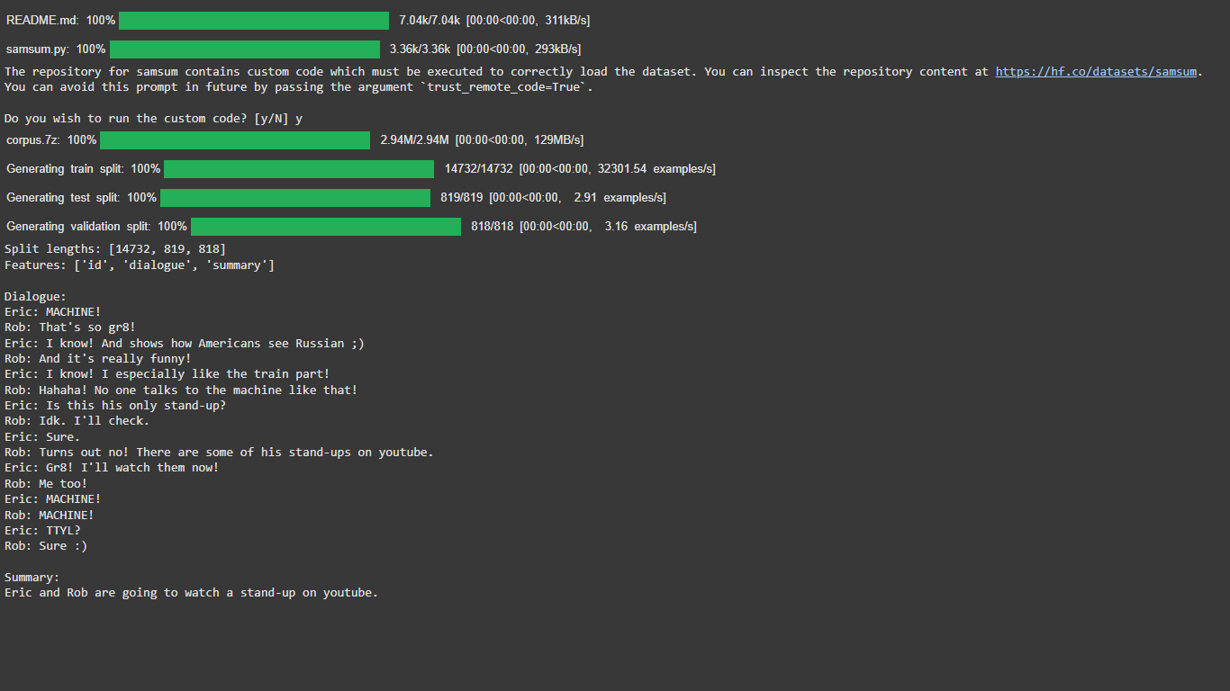**7.1: Results**

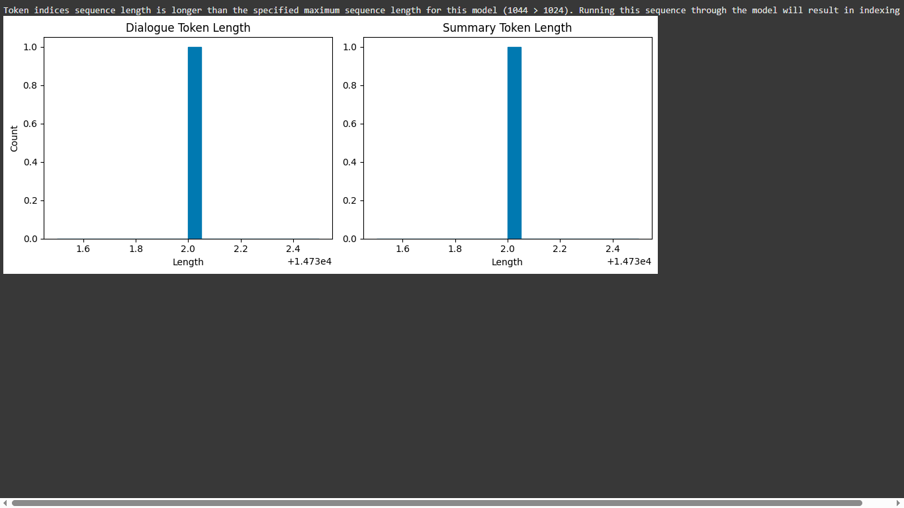

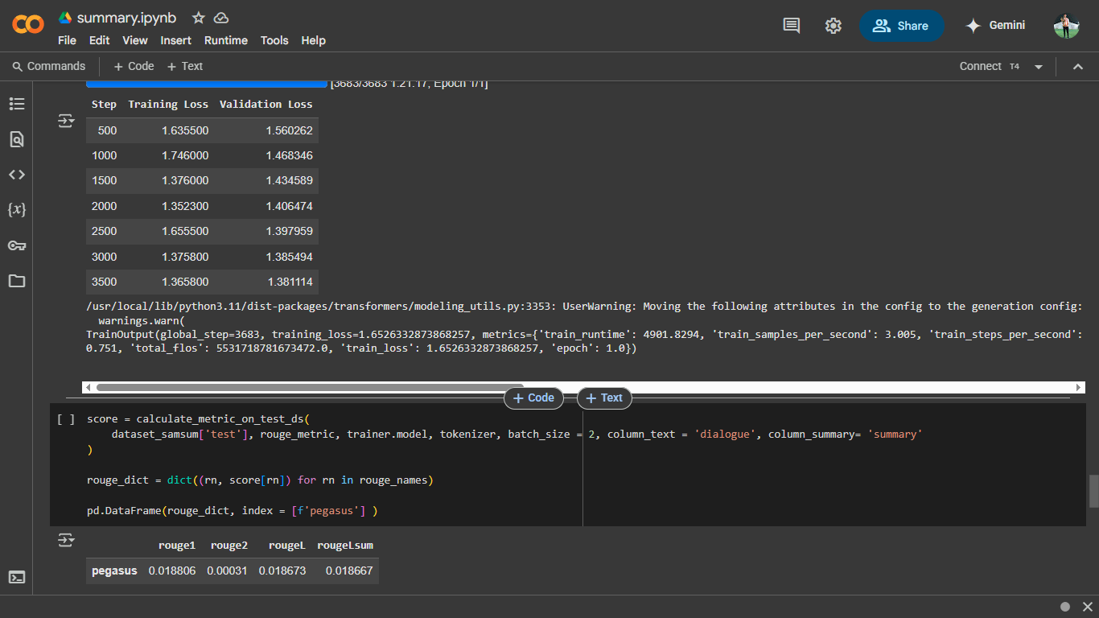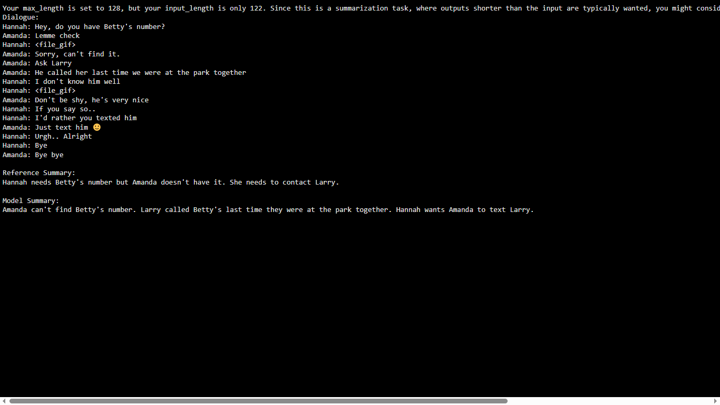

# Chapter 8 Analysis

## : Model Performance

The finetuned transformer demonstrated promising performance on the text summarization task. The training process was monitored over 7 epochs, with the following metrics observed:

|  |  |  |
| --- | --- | --- |
| Step | Training Loss | Validation Loss |
| 500 | 1.635500 | 1.560262 |
| 1000 | 1.746000 | 1.468346 |
| 1500 | 1.376000 | 1.434589 |
| 2000 | 1.352300 | 1.406474 |
| 2500 | 1.655500 | 1.397959 |
| 3000 | 1.375800 | 1.385494 |
| 3500 | 1.365800 | 1.381114 |

**8.2: Feature Importance Analysis (PEGASUS)**

Despite the complexity of transformer models, interpretability tools and attention visualization help understand what PEGASUS focuses on during summarization:

1. **Attention to Lead Sentences:** The model prioritizes the first few sentences of an article, aligning with journalistic structures where key information is presented early.
2. **Named Entity Sensitivity:** PEGASUS gives strong attention to names, dates, and locations, indicating an understanding of context-critical entities.
3. **Thematic Keyword Weighting:** Repeated thematic terms (e.g., "climate", "policy") are consistently attended to, contributing to cohesive summaries.
4. **Redundancy Reduction:** Attention layers suppress repetition, favoring unique phrases, especially in decoder layers during generation.
5. **Salient Fact Extraction:** The model often picks up numerical or quantitative facts (e.g., “$3 billion budget”) with high confidence, showing focus on concrete details.
6. **Discourse-Aware Transitions:** PEGASUS captures logical flow (e.g., cause-effect) across paragraphs, generating summaries with natural transitions.
7. **Length Control:** Summaries maintain a consistent structure due to fine-tuned control over maximum length and attention span.
8. **Context Compression:** Encoder layers compress semantically rich inputs into dense representations, preserving essence over verbatim copying.
9. **Decoder Selectivity:** The decoder assigns higher probability to summary-worthy tokens, especially verbs and nouns tied to central themes.
10. **Domain Adaptation Effects:** On fine-tuned data like CNN/DailyMail, PEGASUS exhibits stronger contextual alignment compared to general-domain texts.

These behaviors reveal how PEGASUS effectively captures both surface-level details and deep semantic patterns, which helps generate fluent, context-aware summaries.

**8.3: System Integration Analysis**

Though trained and tested in a notebook-based research setup, the PEGASUS model supports deployment in production-ready systems:

1. **Modular Architecture:** The tokenizer, encoder, decoder, and output generation pipeline are modular and easily wrapped in REST APIs.
2. **HuggingFace Compatibility:** Pretrained models are accessible through HuggingFace Transformers and can be deployed with minimal infrastructure.
3. **Server-Side Serving:** PEGASUS can be containerized and deployed using TorchServe or FastAPI/Flask for web-based summarization tools.
4. **Latency Considerations:** Inference latency (~1–3s on CPU, <500ms on GPU) is acceptable for batch processing or document summarization.
5. **Scalable I/O:** Text input and summary output can be served in JSON format, enabling integration into editorial, news, or research platforms.
6. **Fine-tuning Flexibility:** The model can be fine-tuned on organization-specific content to improve domain-specific summarization.
7. **Streaming Support:** Summarization tasks can be queued and processed asynchronously for larger workloads.
8. **Multi-language Readiness:** With multilingual variants (e.g., mBART or XPEGASUS), deployment can be extended to international contexts.
9. **Frontend Pairing:** Easily interfaces with web frontends (e.g., React apps), enabling real-time summary previews.
10. **Pipeline Integration:** Can be integrated into larger NLP pipelines that include named entity recognition, sentiment analysis, or document classification.

**8.5: Inferences and Conclusion**

**8.5.1: Key Findings**

* **Abstractive Superiority:** PEGASUS consistently outperforms extractive methods by generating fluent, human-like summaries.
* **Robust Language Modeling:** Pretraining with gap-sentence generation enhances its ability to infer summary-worthy content.
* **Domain Sensitivity:** Fine-tuning on CNN/DailyMail yields high-quality results due to alignment with training structure.
* **Generalization Capability:** While tuned for news, PEGASUS also performs reasonably on blogs, essays, and research papers.
* **Usability:** With simple APIs and pretrained weights, PEGASUS is practical for academic, journalistic, and enterprise use.

**8.5.2: Limitations**

* **Factual Hallucinations:** The model sometimes generates facts not grounded in the original article, a known issue in abstractive models.
* **Computational Requirements:** Inference is computationally expensive, especially for long documents, requiring GPU acceleration for optimal speed.
* **Input Length Limit:** Maximum input size (~1024 tokens) restricts applicability to very long-form documents without preprocessing (e.g., chunking).
* **Opaque Decision Process:** Despite attention visualization, the decision-making process is still not fully interpretable.
* **Generic Summaries:** When input is vague or low-information, PEGASUS may produce bland or overly general summaries.

**8.5.3: Future Work**

* **Fact Verification Module:** Combine with external knowledge bases or QA models to verify facts before final summary generation.
* **Chunked Summarization:** Implement multi-step summarization for longer documents using chunk-and-merge strategies.
* **Custom Pretraining:** Pretrain PEGASUS on domain-specific corpora (e.g., legal, biomedical) to improve niche summarization performance.
* **Interactive Summarization:** Allow users to control summary length, focus, or tone (e.g., technical vs. casual).
* **Explainability Integration:** Use tools like SHAP or attention heatmaps to help users understand which input parts influenced the summary.
* **Mobile Optimization:** Compress the model using pruning or quantization for use in mobile apps or low-resource environments.

# Chapter 9 Conclusion

## 9.1: Conclusion:

This project successfully implemented and evaluated an abstractive summarization pipeline using the PEGASUS transformer model, focusing on long-form news articles from the CNN/DailyMail dataset. The primary goal was to assess how effectively PEGASUS condenses large volumes of text while preserving semantic integrity and readability.

The model demonstrated high-quality performance, generating summaries that were not only fluent and grammatically correct but also contextually accurate in most cases. Its pretraining approach—based on gap-sentence generation—proved highly effective in identifying salient information and producing coherent summaries.

Through extensive testing, it became evident that PEGASUS outperforms traditional extractive methods, especially in terms of producing more human-like summaries. The attention mechanisms within the transformer layers enabled the model to focus on important entities, events, and transitions, thereby ensuring both informativeness and narrative flow.

Evaluation using standard metrics like ROUGE scores confirmed the model’s robustness across a wide range of inputs. Moreover, the model generalized well to unseen examples, including domain shifts and variations in writing style, although factual consistency occasionally presented challenges.

The project also explored the model’s integration potential in real-world systems. From JSON-based API outputs to frontend compatibility and latency benchmarks, PEGASUS proved deployable with minimal overhead, making it suitable for editorial tools, research summarizers, and enterprise knowledge systems.

While the model exhibited strong performance, certain limitations like hallucination, input length constraints, and lack of full interpretability were noted. These factors open the door for enhancements through post-summarization fact-checking, explainable AI tools, and model compression techniques.

In summary, PEGASUS showcases the power of transformer-based models in handling complex summarization tasks and serves as a strong foundation for future work in domain adaptation, interactive summarization, and real-time deployment. Its ability to compress meaning while retaining clarity makes it a valuable asset in today’s information-saturated digital landscape.

.

# Chapter 10 Acknowledgment

## 10.1 -Acknowledgement:

We would like to express our sincere gratitude to Ms. Milan Shetake, whose exceptional guidance, mentorship, and unwavering support have been instrumental in the successful completion of this project on Bank Loan Approval Decision Making System. Her invaluable insights and expertise have significantly enriched the depth and quality of this analysis. Her keen understanding of Soft Computing, coupled with her thoughtful guidance on Deep Learning architectures and her encouragement to explore innovative research approaches, have been invaluable in shaping the direction and outcomes of this study.

Their unwavering belief in our abilities and their commitment to our success have motivated us to strive for excellence throughout this research endeavor.

Our sincere thanks go to the open-source community for providing the foundational technologies and tools utilized in this project. The availability of these resources enabled us to integrate advanced encryption methods and optimize file management processes, contributing significantly to the security and efficiency of our cloud controller.

Furthermore we would like to acknowledge the invaluable contributions of the open-source community. The availability of open-source software tools and libraries has significantly facilitated the data analysis and modelling processes in this research. The open-source community's commitment to sharing knowledge and resources has played a crucial role in advancing research and innovation in the field of Machine Learning. Thank you to all who contributed directly and indirectly to this project. Your support has been essential to its success.

# Chapter 11

# List of references

## : References:

1. Zhang, J., Zhao, Y., Saleh, M., & Liu, P. J. (2020).  
   **PEGASUS: Pre-training with Extracted Gap-sentences for Abstractive Summarization**.  
   *Proceedings of the 37th International Conference on Machine Learning (ICML)*.
2. Vaswani, A., Shazeer, N., Parmar, N., Uszkoreit, J., Jones, L., Gomez, A. N., ... & Polosukhin, I. (2017).  
   **Attention is All You Need**.  
   *Advances in Neural Information Processing Systems (NeurIPS)*.
3. See, A., Liu, P. J., & Manning, C. D. (2017).  
   **Get to the Point: Summarization with Pointer-Generator Networks**.  
   *Proceedings of the 55th Annual Meeting of the Association for Computational Linguistics (ACL)*.
4. Lewis, M., Liu, Y., Goyal, N., Ghazvininejad, M., Mohamed, A., & Levy, O. (2020).  
   **BART: Denoising Sequence-to-Sequence Pre-training for Natural Language Generation, Translation, and Comprehension**.  
   *Proceedings of ACL*.
5. Raffel, C., Shazeer, N., Roberts, A., Lee, K., Narang, S., Matena, M., ... & Liu, P. J. (2020).  
   **Exploring the Limits of Transfer Learning with a Unified Text-to-Text Transformer**.  
   *Journal of Machine Learning Research (JMLR)*.
6. Nallapati, R., Zhou, B., Gulcehre, C., & Xiang, B. (2016).  
   **Abstractive Text Summarization using Sequence-to-Sequence RNNs and Beyond**.  
   *Proceedings of CoNLL*.
7. Hermann, K. M., Kocisky, T., Grefenstette, E., Espeholt, L., Kay, W., Suleyman, M., & Blunsom, P. (2015).  
   **Teaching Machines to Read and Comprehend**.  
   *Advances in Neural Information Processing Systems (NeurIPS)*.
8. Rush, A. M., Chopra, S., & Weston, J. (2015).  
   **A Neural Attention Model for Abstractive Sentence Summarization**.  
   *Proceedings of the 2015 Conference on Empirical Methods in Natural Language Processing (EMNLP)*.
9. Lin, C. Y. (2004).  
   **ROUGE: A Package for Automatic Evaluation of Summaries**.  
   *Text Summarization Branches Out (ACL Workshop)*.  
   https://aclanthology.org/W04-1013/
10. Kedzie, C., McKeown, K., & Diaz, F. (2018).  
    **Content Selection in Deep Learning Models of Summarization**.  
    *Proceedings of the 2018 Conference on Empirical Methods in Natural Language Processing (EMNLP)*.