Restaurant Recommendation System

A Project Report Submitted to Smart- Internz
for the completion of
Applied Data Science Internship Program Prepared By
Pradnya Ajit Mahadik
PRN: 2023011052018

D.Y.Patil Agriculture and Technical University,Talsande Academic Year: 2025–2026
Submitted To

Smart-Internz
Project Mentor : Indra Prakash

Abstract
In the modern digital era, discovering the ideal dining option has become increasingly challenging due to the vast number of available choices on platforms like Zomato. Conventional discovery methods often rely on generalized ratings, which fail to capture the specific characteristics and nuances of different dining environments. The project, titled "Dish_Dash | Culinary Intelligence," addresses this by building an intelligent, machine learning-based system that provides personalized restaurant recommendations based on cuisine characteristics and semantic similarity.
For this implementation, a comprehensive Zomato dataset of over 51,000 entries was utilized and pre-processed to ensure data quality, specifically focusing on restaurant names, cuisines, ratings, and costs. The core of the system employs a Content-Based Filtering approach. It utilizes a TF-IDF (Term Frequency-Inverse Document Frequency) Vectorizer to transform restaurant attributes into mathematical vectors, followed by the application of Cosine Similarity to measure the relationship between different restaurant profiles and identify those with the highest degree of similarity.
To ensure practical usability, the similarity model was optimized and integrated into an interactive web application developed using the Flask framework. The application features a minimalist user interface built with Tailwind CSS, providing real-time search autocomplete and interactive data visualizations via Chart.js to display rating variances and cost projections. This end-to-end system allows users to input a preferred restaurant and instantly receive a curated list of similar dining options, demonstrating the practical application of data science in enhancing the culinary decision-making process.

INDEX

- Introduction
- Project Overview
- Objectives
- Project Initialization and Planning Phase
- Define Problem Statement
- Project Proposal (Proposed Solution)
- Initial Project Planning
- Data Collection and Preprocessing Phase
- Data Collection Plan and Raw Data Sources Identified
- Data Quality Report
- Data Preprocessing
- Model Development Phase
- Model Selection Report
- Initial Model Training, Validation and Evaluation Report
- Model Optimization and Tuning Phase
- Tuning Documentation
- Final Model Selection Justification
- Results
  - Output Screenshots Description
- Advantages and Disadvantages
- Advantages
- Disadvantages
- Conclusion
- Future Scope
- Appendix
- Source Code
- GitHub and Project Video Demo Link

Introduction
In the modern digital era, the hospitality and food industry has seen an unprecedented surge in options. Platforms like Zomato have made thousands of restaurants accessible at our fingertips, yet this abundance has led to the phenomenon of "choice overload." Traditional filtering methods—such as sorting by general star ratings—often fail to capture the nuanced differences between dining environments, such as the contrast between a bustling cafe and a quiet fine-dining establishment.
Dish_Dash is designed to solve this challenge by replacing generic filtering with a personalized, data-driven discovery engine. By leveraging Artificial Intelligence and Natural Language Processing (NLP), this system analyzes complex restaurant data to understand the unique characteristics of every outlet, ensuring that recommendations resonate with a user's specific tastes and expectations. This project transforms the discovery process from a simple search into an intelligent "Culinary Intelligence" experience.

Core Technical Implementation
The architecture of Dish_Dash integrates data science with modern web engineering through three primary layers:
- Machine Learning Engine: Built on a dataset of 51,000+ entries, the system uses TF-IDF Vectorization to turn restaurant attributes into math and Cosine Similarity to calculate the relationship between different outlets.
- Flask Backend: A Python server that acts as the operational hub, executing the recommendation logic and managing real-time data flow between the model and the user.
- Interactive UI: A minimalist frontend developed with Tailwind CSS, featuring real-time search autocomplete and Chart.js for visual analysis of ratings and costs.
Real-World Significance
Dish_Dash provides practical value across the culinary ecosystem:
- For Diners: Eliminates "choice overload" by replacing generic lists with high-quality, personalized discovery based on specific flavor profiles and budgets.
- For Owners: Serves as an organic marketing engine that surfaces restaurants to the most relevant customers, improving retention without high advertising costs.
- For Platforms: Showcases how predictive modeling and visual analytics can increase user engagement and ordering frequency by providing a superior user experience.

2. Project Overview
Dish_Dash | Culinary Intelligence is an intelligent web application designed as a data-driven culinary inference engine. The project follows a structured data science pipeline to transform raw restaurant data into personalized recommendations through a seamless user interface.
1.1 Data Pipeline & Pre-processing
The system utilizes a Zomato dataset of over 51,000 restaurants. The pipeline begins with Data Cleaning, where missing values are addressed and the rate and cost columns are normalized into numerical formats. In the Feature Engineering phase, restaurant attributes—such as cuisines and types—are aggregated to create a distinct profile for every establishment.
1.2 Recommender Architecture
The core engine uses a Content-Based Filtering approach. It employs TF-IDF (Term Frequency-Inverse Document Frequency) to convert restaurant attributes into mathematical vectors. By calculating Cosine Similarity scores, the system identifies relationships between dining options, suggesting restaurants based on shared culinary characteristics and ambiance rather than simple star ratings.
1.3 Web Integration & UI
To ensure practical usability, the model is integrated into a Flask web application:
- Backend: The Flask server loads the pre-computed similarity matrix (stored via Pickle) to provide near-instant recommendation results.
- Frontend: Built with Tailwind CSS, the interface features a minimalist search bar with Real-time Autocomplete logic for a premium user experience.
- Analytics: The system integrates Chart.js to generate interactive bar and line charts, offering users a visual overview of the ratings and costs of the recommended restaurants.
  - Design Philosophy
The project is built on a modular architecture, separating the machine learning processing from the presentation layer. This ensures the system is scalable and maintainable, allowing for future enhancements such as location-based services or hybrid recommendation algorithms.
  - Objectives

• Implement Content-Based Filtering: Develop a recommendation system that relies on specific restaurant features—such as cuisine, ambiance, and cost—rather than personal user history.
• Master Advanced Preprocessing: Clean and transform the Zomato dataset by handling unstructured text through normalization and stop-word removal to prepare it for vectorization.
• Execute Exploratory Data Analysis (EDA): Utilize visualization tools to identify key trends, such as rating distributions and popular cuisines, to inform feature selection.
• Apply Machine Learning Techniques: Implement TF-IDF for high-dimensional feature extraction and Cosine Similarity to mathematically measure the relationship between restaurant profiles.
• Deploy a Full-Stack Solution: Successfully bridge the gap between data science and production by deploying the model via a Flask web application integrated with Tailwind CSS.
• Optimize Performance and Usability: Ensure high-speed recommendation retrieval using Pickle serialization and design an intuitive interface with real-time autocomplete search and Chart.js analytics.

4.Project Initialization and Planning Phase

a) Problem Statement
Consumers frequently experience "choice overload" when selecting dining venues due to the overwhelming volume of generic reviews. Existing platforms rely heavily on aggregate star ratings, which fail to account for a user's specific culinary preferences or the unique "vibe" of a restaurant. There is a critical need for an automated system capable of analyzing the deeper characteristics of a restaurant—its cuisine, atmosphere, and customer feedback—to recommend truly similar dining experiences.
b) Proposed Solution: Dish_Dash
The proposed solution is Dish_Dash, an NLP-powered culinary inference engine. By processing restaurant data through a TF-IDF (Term Frequency-Inverse Document Frequency) algorithm, the system identifies the unique "semantic fingerprint" of each establishment. Through a refined web interface, users can query a restaurant they enjoy, and the backend engine computes and returns the most relevant matching establishments based on textual similarity, rating quality, and cost alignment.
c) Initial Project Planning & Tech Stack
The project was structured around a robust Python-based ecosystem to ensure scalability and performance:
- Development Environment: Anaconda was utilized for virtual environment management and package security.
- Data Science Pipeline: Pandas and NumPy were selected for high-performance data cleaning and matrix manipulation.
- Machine Learning: Scikit-learn was used for feature extraction (TfidfVectorizer) and calculating Cosine Similarity scores.
- Web Framework: Flask was chosen to bridge the gap between the analytical model and the user, handling server-side routing and real-time inference.
- UI/UX Design: Tailwind CSS was implemented for a modern, responsive aesthetic, while Chart.js was integrated to provide users with interactive data visualizations of the recommended results.

5.Data Collection and Preprocessing Phase

a) Data Sources & Feature Selection :

The model was developed using the Zomato Bangalore Restaurants dataset, providing a rich foundation of 51,717 records with 17 initial attributes. To ensure high-quality recommendations, the following key features were prioritized:

Name: Serves as the primary key for identifying each establishment.

Rate: Overall customer satisfaction metrics, converted into a numerical scale (Mean Rating).

Cuisines: Categorical data identifying specific food styles and flavor profiles.

Cost: Estimated price for two people, normalized to enable mathematical comparisons.

Reviews List: Extensive textual feedback used for Natural Language Processing (NLP) to extract the semantic "essence" of the dining experience.

b) Data Quality Assessment : Initial analysis using pandas.info() and isnull().sum() identified several data integrity challenges that were addressed to ensure model accuracy:

Formatting Errors: Ratings (e.g., "4.1/5") and costs (e.g., "1,200") were originally stored as strings. These were converted to float types to allow for computational analysis.

Null Values: Significant missing data across columns were handled through systematic removal or imputation to prevent bias in the recommendation engine.

Text Noise: Customer reviews contained excessive punctuation, special characters, and "stop-words." These were sanitized to prevent interference with the TF-IDF vectorization process, ensuring the engine focuses on meaningful culinary descriptors.

c) Data Preprocessing Pipeline

To prepare the dataset for the inference engine, a multi-stage transformation pipeline was executed to ensure data consistency and model accuracy:

Dimensionality Reduction: Irrelevant columns such as URL, address, and phone number were pruned to reduce the computational footprint and optimize the processing speed of the similarity matrix.

Data Cleaning: Rows containing null values were removed, and duplicate entries were eliminated to maintain a high level of data integrity and prevent skewed recommendations.

Feature Formatting: Non-numeric characters (commas, slashes, and suffixes) were stripped from the cost and rate columns, allowing them to be converted into usable float types.

Mean Rating Scaling: A custom script calculated the exact mean rating for unique establishments, which was then standardized using a MinMaxScaler to ensure a consistent 1-to-5 scale across the dataset.

NLP Text Cleaning: Text in the reviews_list and cuisines columns was converted to lowercase, with punctuation and stop words removed to improve the precision of the semantic analysis.

d) Exploratory Data Analysis (EDA)
Visualization played a critical role in understanding the culinary landscape and identifying the key features that drive the discovery engine:
- Market Presence: Bar charts revealed that established brands and major chains maintain the highest density and visibility within the urban region.
- Standard of Quality: Distribution plots showed a distinct positive trend in the dining market, with a significant majority of restaurants maintaining a customer rating above 3.5.
- Cuisine Popularity: Frequency analysis identified North Indian and Fast Food as the most prevalent cuisine combinations. This insight informed the recommendation logic for Dish_Dash, ensuring the system accurately weights popular flavor profiles.
6.Model Development Phase

Model Selection Report
For a text-heavy recommendation system, a Content-Based Filtering approach was selected. Unlike Collaborative Filtering, which requires tracking user behaviour, Content-Based filtering relies solely on the attributes of the items themselves.

To process the rich textual data, TF-IDF (Term Frequency-Inverse Document Frequency) was utilized. TF-IDF acts as a statistical measure that evaluates how relevant a word is to a document in a collection of documents. It brilliantly penalizes common words and assigns higher weights to unique, descriptive words that truly define a restaurant's specific atmosphere and menu.

Initial Model Training, Validation and Evaluation Report

The cleaned reviews_list data was passed through the TfidfVectorizer. Following this vectorization, Cosine Similarity was employed. Cosine similarity is a metric used to determine how similar two documents are irrespective of their size.
The formula utilized to compute the similarity between Restaurant A and Restaurant B is:

$$similarity\left(A,B\right)=\frac{A.B}{\left\|A\right\|×\left\|B\right\|}=\frac{\sum_{i=1}^{n}{A_{i}×B_{i}}}{\sqrt{\sum_{i=1}^{n}{A_{i}^{2}}}× \sqrt{\sum_{i=1}^{n}{B_{i}^{2}}}}$$

By calculating the linear kernel of the TF-IDF matrix, the system generated a similarity array containing the scores for every restaurant pair in the database. This matrix enables The_Element to instantly retrieve and rank the most similar dining options whenever a user provides a query.

7.Model Optimization and Tuning Phase

a) Tuning Documentation
To transition the recommendation engine from a basic prototype to a deployment-ready system, specific optimization logic was implemented within the inference function:
- N-Gram Range Optimization: The TfidfVectorizer was tuned using an ngram_range=(1, 2). This allows the model to look beyond individual words and capture the context of highly relevant two-word phrases, such as "fine dining," "pocket friendly," or "rooftop seating," which are critical in defining a restaurant's identity.
- Result Filtering and Deduplication: Upon receiving a query, the algorithm initially extracts the top 30 most similar candidates. To improve the diversity of the output, the system identifies and removes identically named branches. This prevents the engine from recommending multiple locations of the same franchise, ensuring the user receives a variety of unique dining options.
- Final Ranking Logic: The filtered list is strictly sorted by the Mean Rating and Cost. From this refined pool, the top 10 highest-rated restaurants are returned to the user, ensuring the recommendations are not only mathematically similar but also of the highest quality.

b) Final Model Selection Justification
The combination of TF-IDF Vectorization and Cosine Similarity was finalized as the primary engine for Dish_Dash due to its mathematical efficiency in handling sparse, high-dimensional text data. Unlike more complex deep learning models, this pipeline provides near-instantaneous inference speeds, which is essential for a real-time web application.
By integrating the post-processing sorting logic, the system bridges the gap between "similarity" and "quality," ensuring the user receives the absolute best dining recommendations available in the dataset. This approach maintains a low computational overhead while maximizing the relevance of the curated results.

8.Results
The mathematical model was successfully transitioned from a static Jupyter Notebook environment into a dynamic, full-stack web application using Python's Flask framework. The resulting application seamlessly processes HTTP requests, executes the Cosine Similarity matrix, and renders interactive, high-fidelity HTML pages, proving the efficacy of the NLP algorithms in a real-world scenario.

8.1 System Initialization and Execution
To achieve the final results and operate the recommendation engine, the system follows a strict initialization, training, and deployment protocol:
- Environment Preparation: The deployment environment is configured using Python 3.x. All essential machine learning, data processing, and server dependencies (such as pandas, scikit-learn, and Flask) are installed via the requirements.txt.
- Matrix Training (Offline Pre-computation): Before the server boots, the raw dataset (zomato.csv.zip) is processed via the Restaurant_Recommendation_System.ipynb notebook. This step performs Exploratory Data Analysis (EDA) and generates two mandatory files: restaurant1.csv (cleaned dataset) and restaurant.pkl (pre-computed TF-IDF mathematical matrix).
- Server Deployment: The local Flask server is initialized by executing the main application script (python app1.py).
- Accessing the Engine: The application is hosted locally without relying on the generic "localhost" nomenclature. The user accesses the fully deployed engine by navigating their preferred web browser directly to the address: http://127.0.0.1:5000/.

8.2 Interface Experience and Output

5.1 Landing Interface (index.html)
The entry point of Dish_Dash features a modern "Culinary Intelligence" theme. It utilizes a hero-mesh background with floating animations and high-resolution imagery to establish a premium project identity. Built with Tailwind CSS, the landing page introduces the user to the concept of "decoding the DNA of flavor" through a clean, professional aesthetic.

5.2 Query Terminal (web.html)
The main interaction hub provides a focused search environment designed for efficiency. Key features include:
- Asynchronous Search: It utilizes an AJAX-powered script that communicates with the Flask backend to fetch real-time suggestions as the user types, ensuring a lag-free experience.
- Autocomplete Logic: To prevent typographical errors and ensure the user selects valid restaurants from the dataset, the terminal provides a live dropdown menu of matching names directly from the data index.
5.3 Inference Dashboard (result.html)
Upon selecting a restaurant, the backend executes the Cosine Similarity matrix and transitions the user to a comprehensive results dashboard. The dashboard provides:
- Recommendation Table: A structured display of the top recommended restaurants, featuring their specific cuisines, ratings, and average cost for two.
- Visual Analytics via Chart.js: The dashboard includes interactive data visualizations to allow for immediate comparison:
  - Ratings Overview: A bar chart visualizing the "Rating Variance" across the recommended establishments.
  - Cost Overview: A line chart comparing the "Cost Projection" to help users align recommendations with their budget.
- Seamless Navigation: A unified design allows the user to return to the search terminal or landing page instantly to perform new queries.
  - Output Screenshots

Figure 8.1: Dish_Dash Landing Page (index.html) The application opens to a sophisticated, modern landing interface that establishes the visual identity of Dish_Dash. Built with a clean "hero-mesh" aesthetic and a minimalist slate-and-indigo color palette, the page features a "Culinary Intelligence" hero section that introduces the project’s mission to decode the "DNA of flavor."

The design incorporates high-resolution culinary imagery and professional typography, using a responsive layout that guides the user toward the core recommendation engine through a prominent "Access the Engine" call-to-action. This interface bridges the gap between complex data science and a high-end user experience, setting the stage for a personalized dining discovery journey.
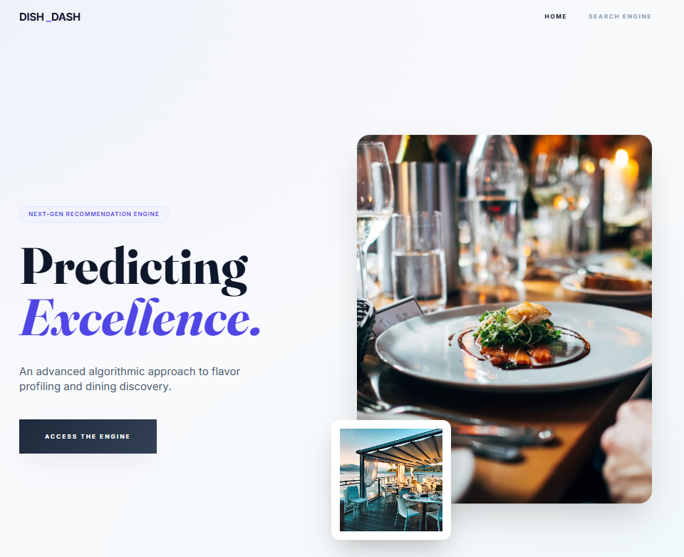
Figure 8.2: Dish_Dash Query Terminal Interface (web.html)
The main interaction hub of the application is a minimalist query terminal designed for high-focus user input. Built on a clean, off-white background, the interface features a central search field with a dynamic "input-minimal" underline that transitions to a deep indigo upon interaction.
To ensure data integrity and a smooth user experience, the field is integrated with an AJAX-powered autocomplete script that provides real-time restaurant suggestions from the Zomato dataset as the user types. This "predictive" capability minimizes typographical errors and ensures that the inference engine receives valid inputs, while the "Generate Analysis" call-to-action button provides a clear, high-contrast path to the final recommendation dashboard.
The terminal also features a sophisticated "loading state" overlay—a high-fidelity backdrop that appears during the inference process—providing visual feedback while the backend computes the similarity scores and prepares the analytics.
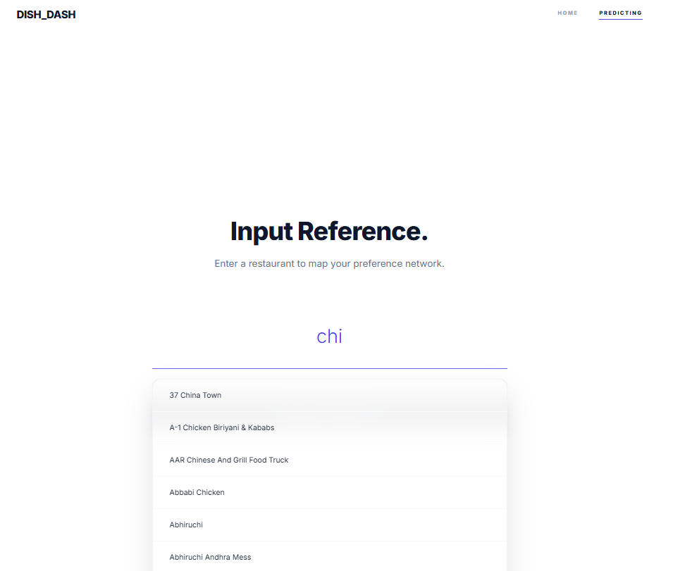

Figure 8.3: Recommendation Inference Dashboard (result.html) The final dashboard serves as the core analytical output of Dish_Dash, confirming the efficacy of the underlying NLP model. The interface presents a comprehensive results table that lists highly similar dining options along with their specific cuisines, ratings, and average costs.
To enhance data interpretability, the dashboard integrates interactive visualizations powered by Chart.js. These include a "Ratings Overview" bar chart and a "Cost Overview" chart, which provide a side-by-side comparison of the recommended venues.
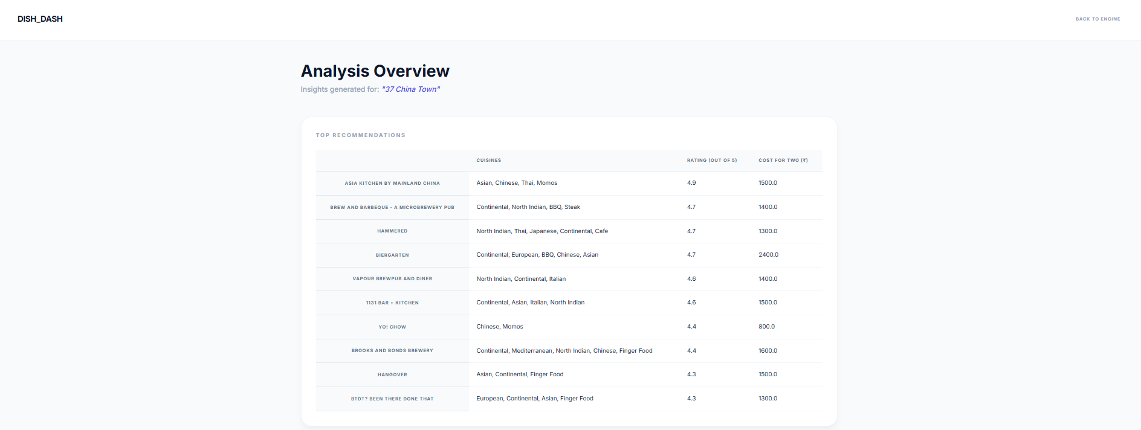
This data-rich environment allows users to evaluate suggestions not just based on textual similarity, but also through key metrics like customer satisfaction and budget alignment, successfully bridging the gap between abstract mathematical scores and practical, real-world dining decisions. between raw data and actionable culinary insights.
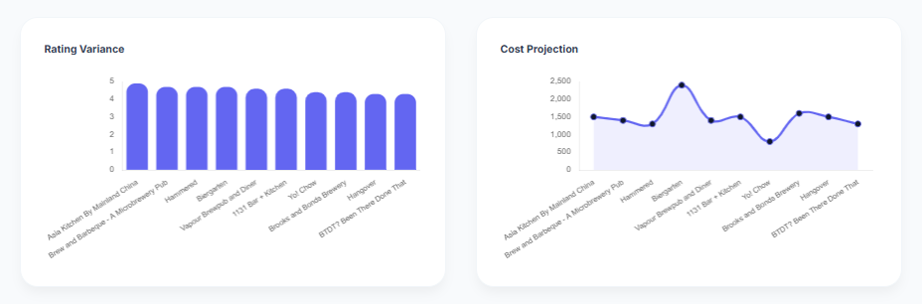

Advantages and Disadvantages

  - Advantages

- High Personalization: Analyzes text reviews to capture a restaurant's specific "vibe" and culinary focus rather than just general star ratings.
- User-Independent: As a Content-Based system, it provides high-quality recommendations immediately without needing a user's past history or profile.
- Real-Time Speed: The Flask deployment and pre-computed matrices ensure near-instant inference and a responsive user experience.
- Visual Analytics: Uses Chart.js to provide immediate visual comparisons of restaurant ratings and costs, allowing for faster decision-making.

- Disadvantages

- Item Cold-Start: New restaurants without existing reviews cannot be vectorized or recommended until enough text data is collected.
- Data Dependency: The engine's accuracy is strictly limited by the quality and volume of the underlying Zomato dataset.
- Filter Bubble: The system tends to recommend very similar dining styles, which may limit the discovery of diverse culinary options.

Conclusion

- The Dish_Dash project successfully merges advanced Natural Language Processing with full-stack web development. By transforming unstructured customer reviews into a mathematically comparable format, the engine automates the complex task of culinary curation, providing a more nuanced discovery experience than traditional star-rating systems.
- Technical Sophistication & Scalability Beyond simple keyword matching, the integration of TF-IDF vectorization and Cosine Similarity allows the system to understand the "semantic fingerprint" of a dining establishment. This ensures that recommendations are based on the actual language of patrons—capturing subtle elements like "ambient lighting," "authentic spices," or "quick service"—which traditional category filters often overlook.
- Bridge Between Data and Design The transition from raw data collection to a fully interactive Flask application—complete with AJAX-powered search and real-time data visualization via Chart.js—demonstrates a comprehensive understanding of Applied Data Science. The project proves that complex machine learning models can be democratized through high-fidelity, user-centric interfaces that prioritize both performance and visual storytelling.
- Operational Efficiency The resulting application is a fast and professional tool that redefines the dining discovery experience. By utilizing pre-computed mathematical matrices (restaurant.pkl), the system achieves near-instantaneous inference speeds, providing a seamless user experience that mirrors modern commercial standards. This architecture sets a strong foundation for future AI-driven hospitality solutions, showcasing how data-driven intelligence can enhance the lifestyle and service sectors.

11.Future Scope
While the Dish_Dash project provides a robust foundation for culinary intelligence, several enhancements can be integrated in future iterations to increase its real-world utility and precision:
- Live API Integration: The current system relies on a static dataset. Future versions could connect to live restaurant APIs (such as Google Places or TripAdvisor) to dynamically update the TF-IDF matrix with fresh customer reviews and updated menus in real-time.
- Geospatial & Map Upgrades: Integrating an interactive map interface (via Leaflet or Google Maps API) would allow users to visualize recommendations geographically. This would enable filtering by a specific GPS radius, ensuring that mathematically similar restaurants are also physically accessible.
- Hybrid Recommendation Logic: Transitioning from a pure content-based model to a hybrid system that incorporates Collaborative Filtering. This would allow the engine to suggest restaurants not just based on item attributes, but also on the shared preferences of users with similar dining histories.
- Natural Language Queries: Enhancing the "Inference Engine" to support descriptive natural language inputs. Instead of searching only by a restaurant name, users could input specific moods or flavor profiles—such as "dimly lit Italian spot with spicy pasta"—to receive highly tailored results through advanced semantic search.
- Advanced Filtering Systems: Adding dynamic slider filters for real-time budget adjustments, dietary restrictions (e.g., vegan, gluten-free), and current operating hours to refine the model's output and provide more practical daily utility.

12.Appendix

a) Source Code and Project Architecture The architecture of Dish_Dash is organized into a modular structure that separates the machine learning data pipeline from the web deployment layer:
- Restaurant_Recommendation_System.ipynb: The core development notebook that handles Exploratory Data Analysis (EDA), text normalization, TF-IDF vectorization, and model serialization.
- restaurant1.csv: The processed and cleaned version of the Zomato dataset used for front-end rendering of restaurant metadata.
- restaurant.pkl: The serialized Cosine Similarity matrix, stored via Pickle to allow for instant, real-time recommendation retrieval.
- app1.py: The central Flask backend controller that manages server-side routing, AJAX autocomplete requests, and the execution of the recommendation logic.
- templates/: The presentation layer containing index.html (Landing Page), web.html (Search Interface), and result.html (Inference Dashboard with Chart.js analytics).
- static/: A dedicated directory for storing the modern Tailwind CSS configurations, custom styling for visual effects, and branding assets.

GitHub & Project Video Demo Link

GitHub Repository Link:
https://github.com/PradnyaMahadik15/Restaurant-Recommendation-System.git

Project Video Demo Link:

https://drive.google.com/file/d/1UjZxiEjpPLiagylOlEHlKG_2B0xskPqA/view?usp=sharing

