**Test Case 3: Duplicate Phone Number**

* **Use an existing phone number:** Attempt to create a user with the same phoneNumber as a previously created user.
* **Expected Outcome:** The API should return a 400 Bad Request status code.

{

   "firstName": "Test",

   "lastName": "Test",

   "phoneNumber": 9999999999,

   "emailId": "test.test@test.com"

}

o/p

{

    "is_success": **false**,

    "message": "phoneNumber has already been used."

}

{

**Test Case 4: Duplicate Email ID**

* **Use an existing email ID:** Attempt to create a user with the same emailId as a previously created user.
* **Expected Outcome:** The API should return a 400 Bad Request status code.
* {
* "is_success": **false**,
* "message": "emailId has already been used."
* }

   "lastName": "Test",

   "phoneNumber": 67889000,

   "emailId": "test.test@test.com"

}

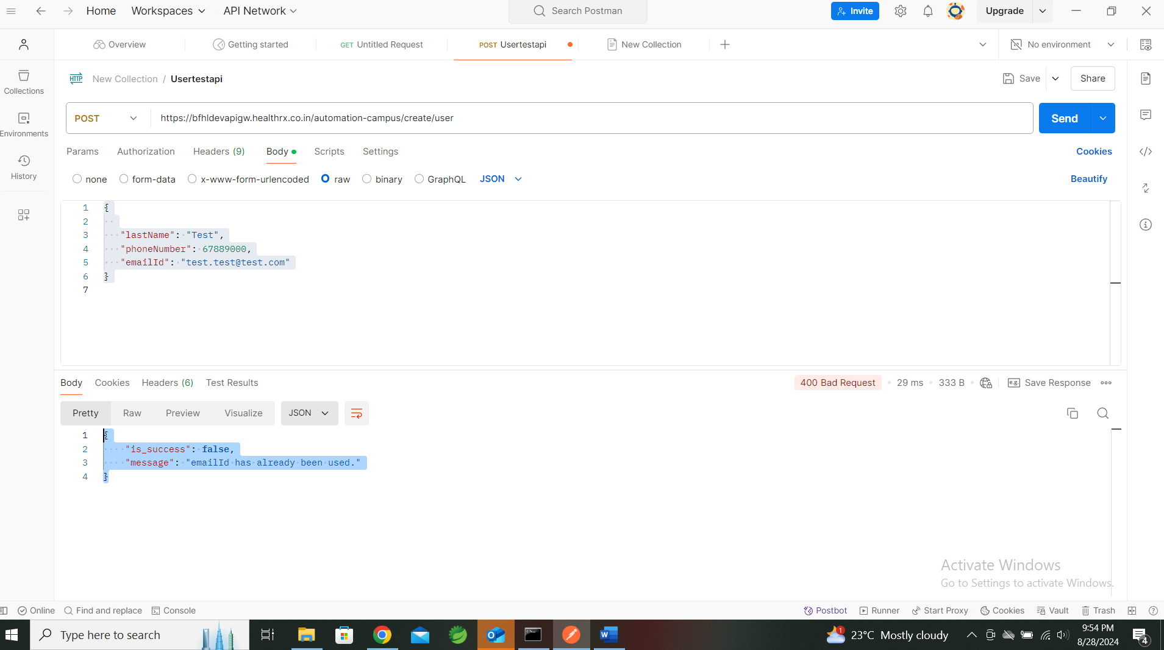

**Test Case 1: Valid User Creation**

* **Expected Outcome:** The API should return a 200 OK or 201 Created status code.

   "lastName": "Test",

   "phoneNumber": 67889000,

   "emailId": "cgyy.test@test.com"

}

{

    "is_success": **true**,

    "message": "Congratulations, you have successfully broken through the API. firstName was a required field."

}

