**Input-Output**

**Case 1: Both the points are inside**

**Before the clipping**

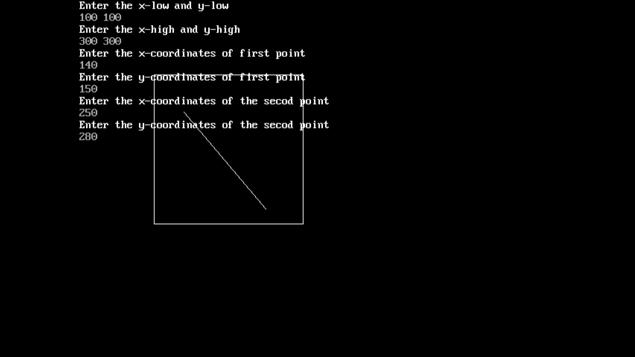

**After the clipping**

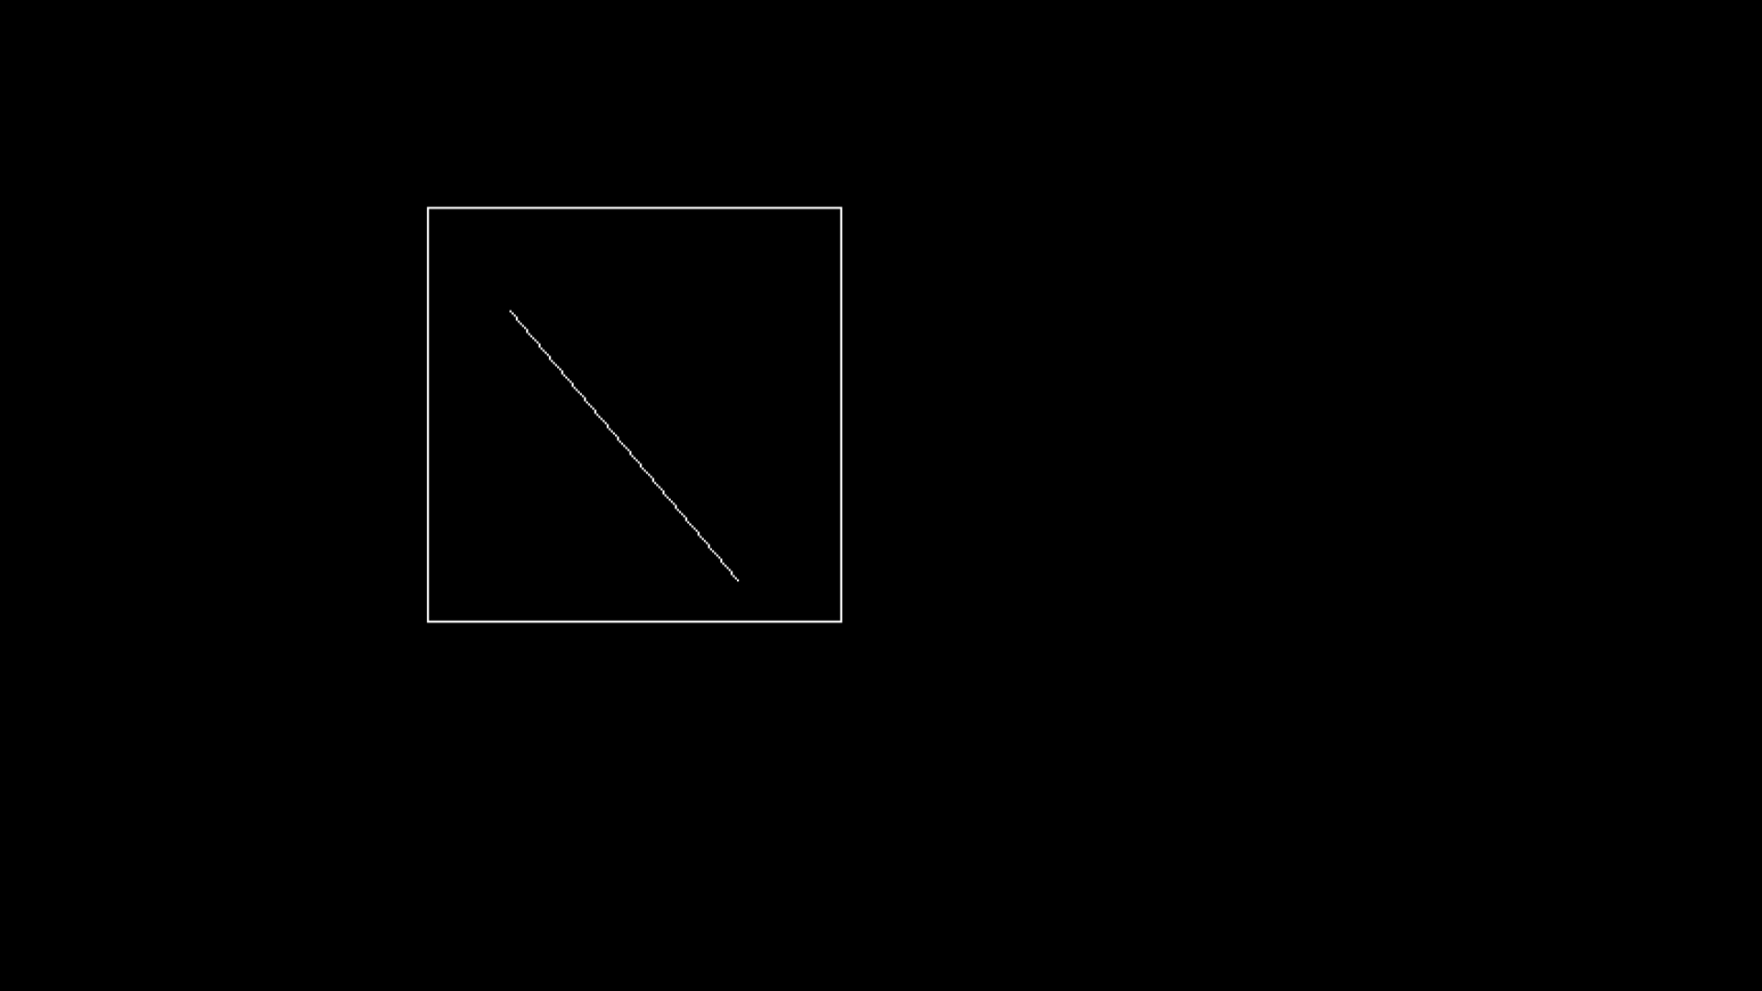

**Case 2: Line Completely outside**

**Before clipping**

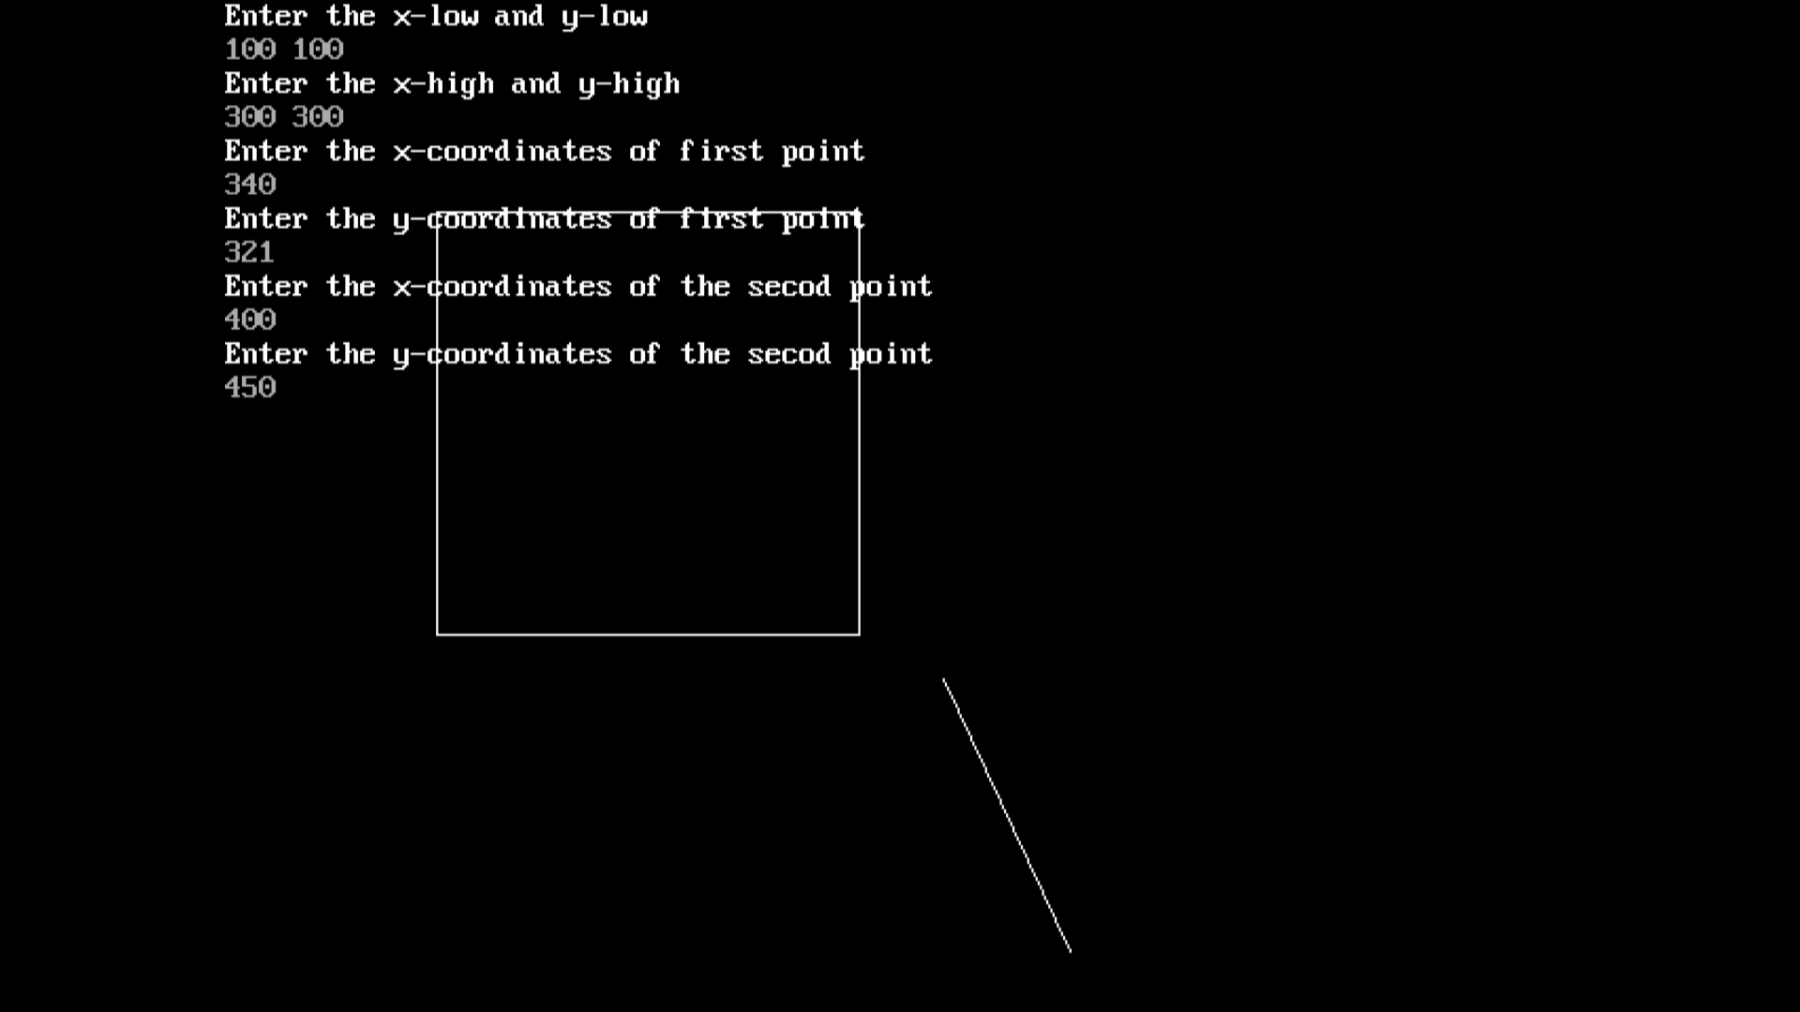

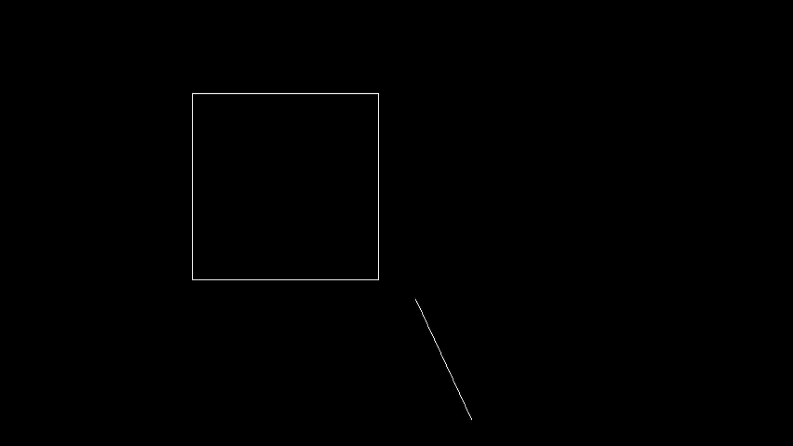

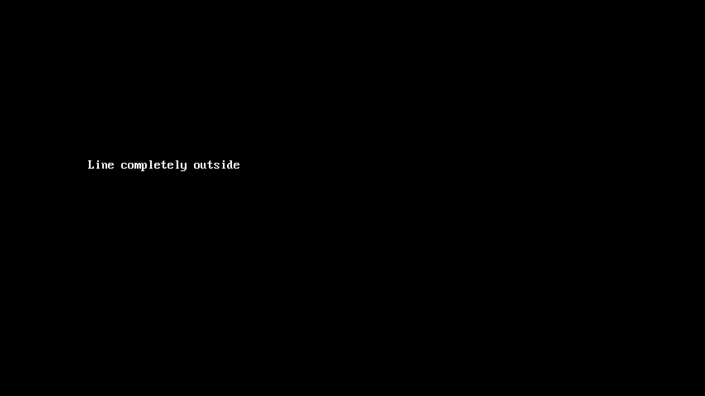

**Case 3:Line is partially inside**

**Before clipping**

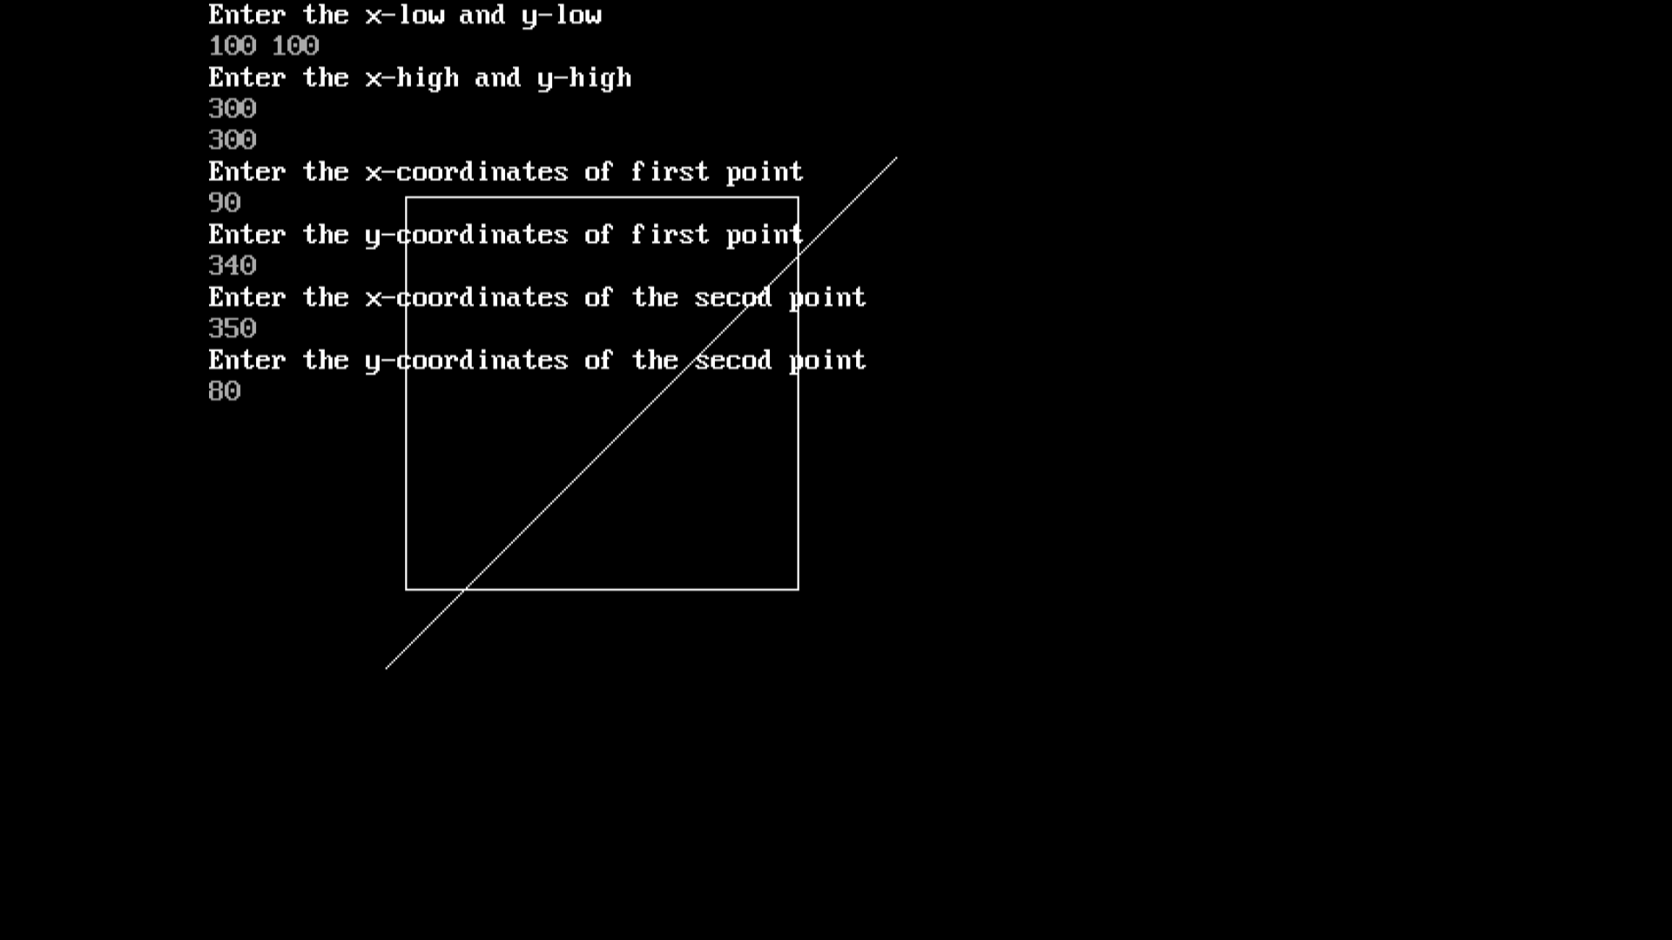

**After clipping**

