**Input of pass1:(Positional,keyword and default parameters are provided)**

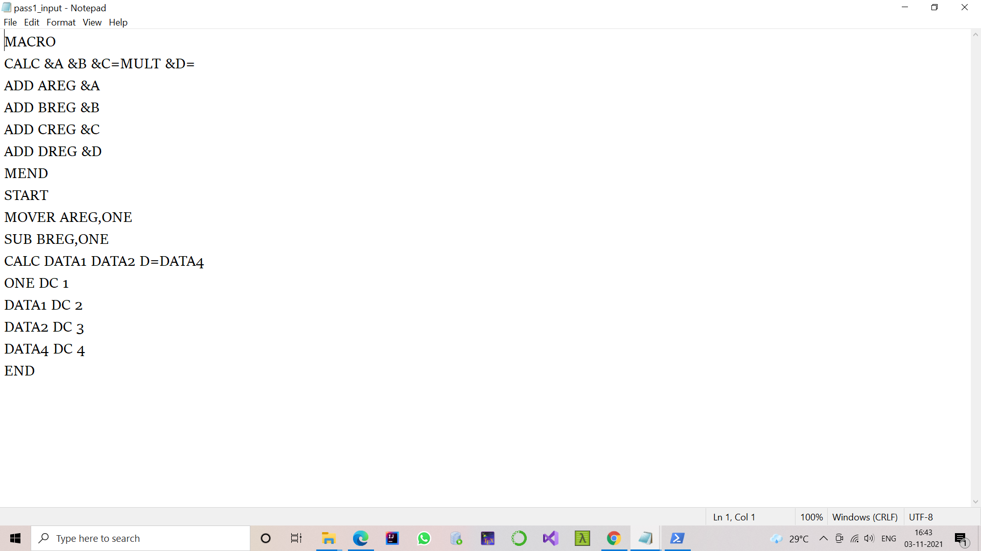

**Output of pass1:**

**/*Macro definition removed and tables like KPTAB,MNTAB completely filled and ALA partially filled*/**

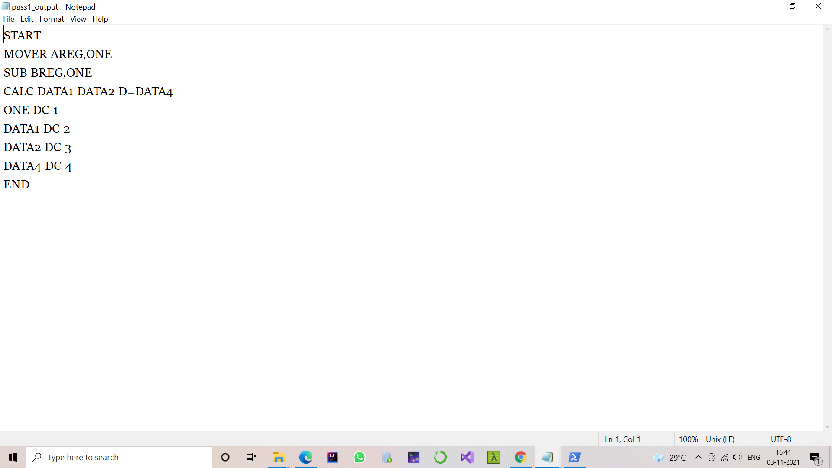

The above file is the input to the pass2

**Displayed Macro Name table,ALA,keyword parameter Table and Macro definition table after pass1 and pass2**

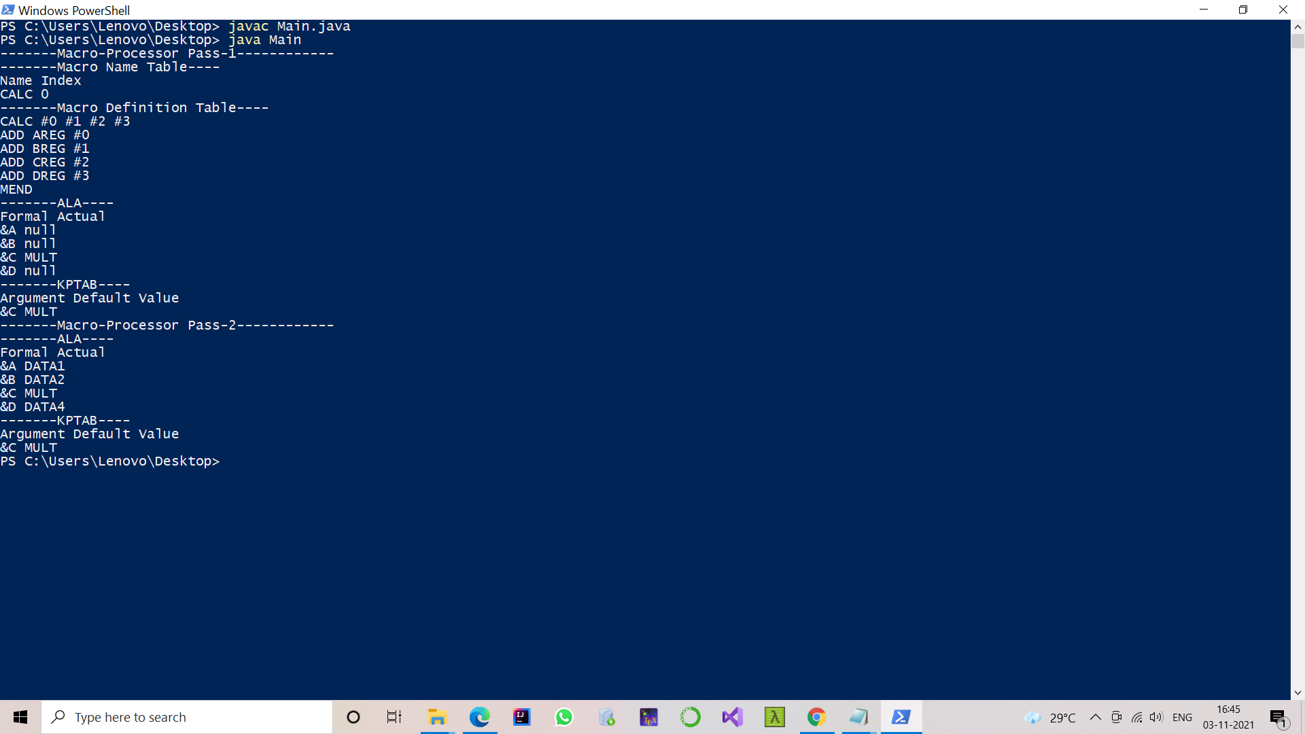

**Output of pass2:**

