Project Observations on Social Media Usage
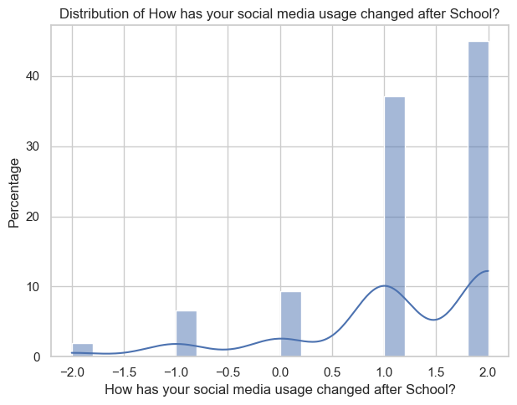

81% of participants reported a slight to significant increase in social media usage after school.

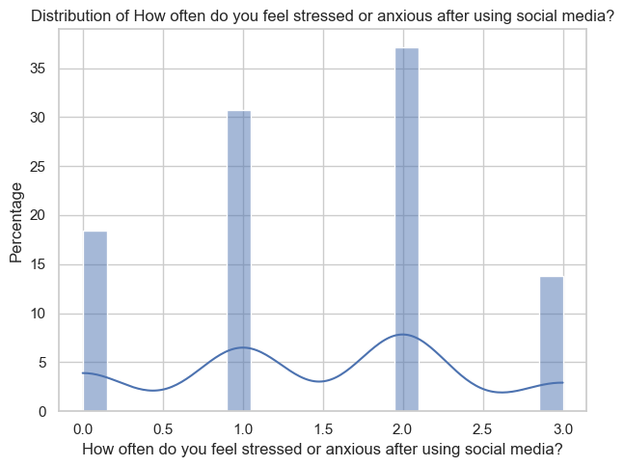
--14% people often feel stressed and anxious after using social media
-37% peopleocasionaly feel stressed and anxious after using social media
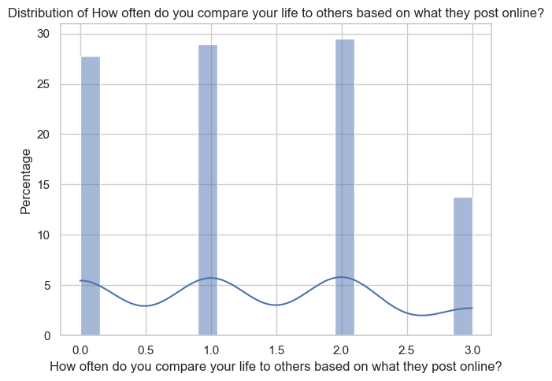
-- 30% people ocassionaly compare their life based on social media 'which affects my mood,
---14% people often compare their life based on social media and feel falling behind

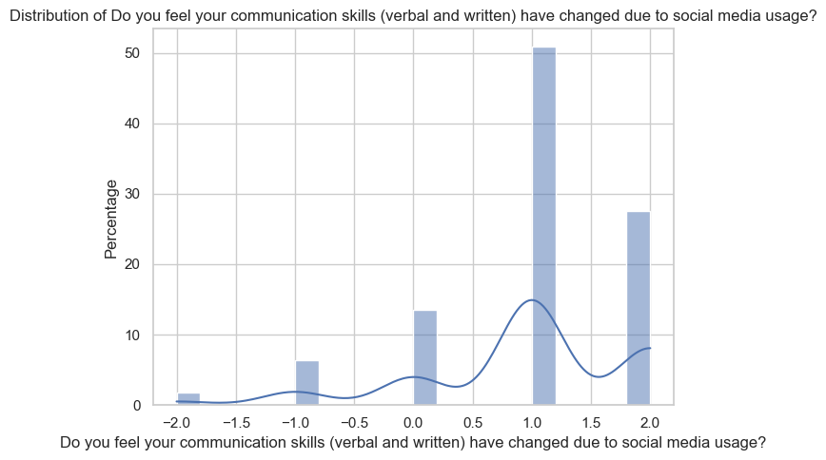
--80 % people saw improvement in communication skills with use of social media
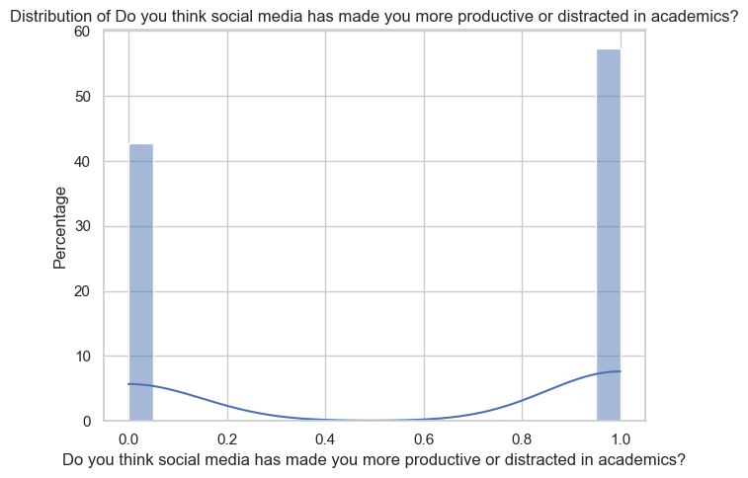
41% people feel more productive in acedamics due to social media while 59% feel more distracted
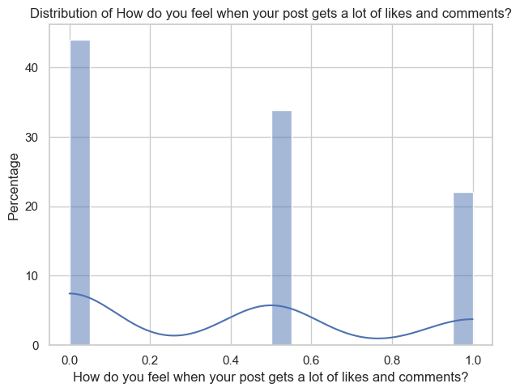
-21% people feel validated after getting likes on social media

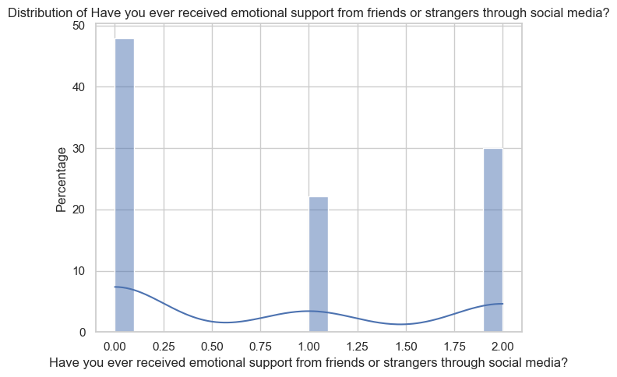
-30% people receive emotional support from strengers through social media

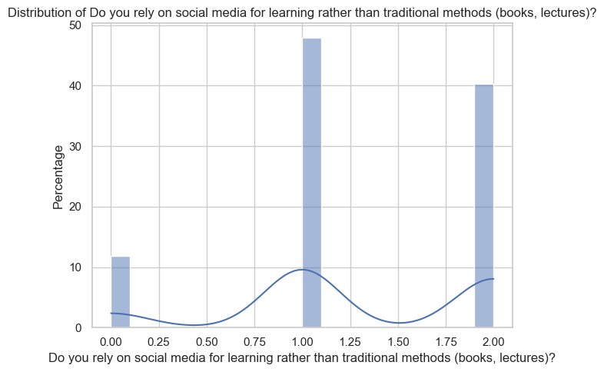
--40% people completely rely on social media for learning rather than traditional methods like books and lectures

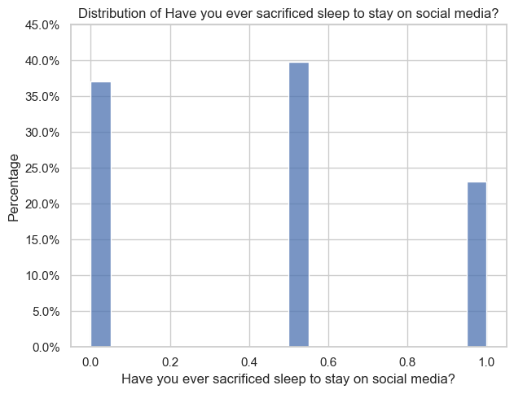
-24% people often sacrifice their sleep for social media while 40% people sacrifice sleep sometimes

Corelations:
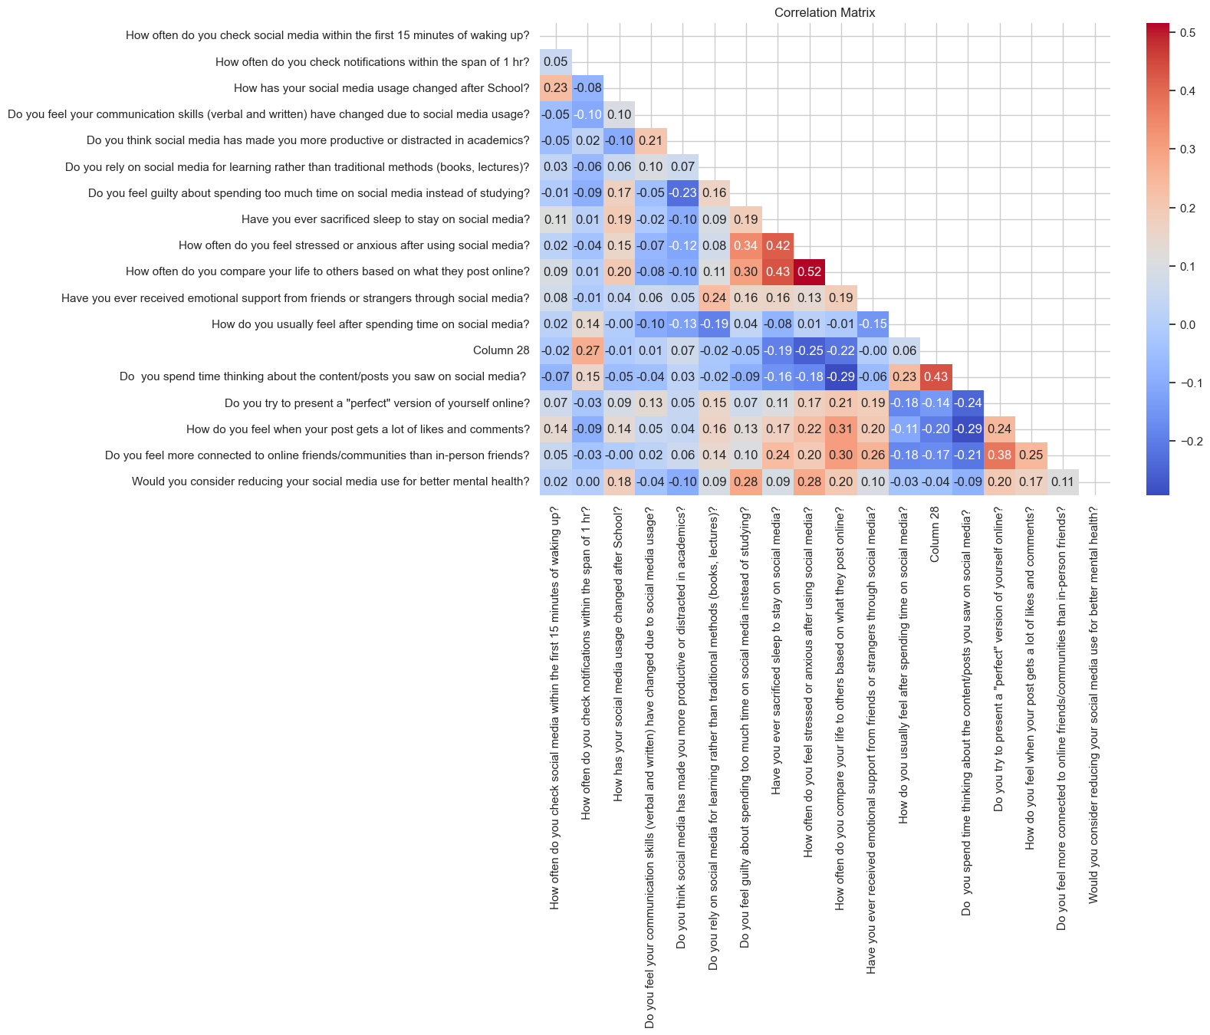
- How often do you feel stressed or anxious after using social media? - How often do you compare your life to others based on what they post online? ( 0.515951)
- Have you ever sacrificed sleep to stay on social media? --> How often do you compare your life to others based on what they post online? 0.432024
How often do you feel stressed or anxious after using social media? 0.420366

- Do you try to present a "perfect" version of yourself online? Do you feel more connected to online friends/communities than in-person friends? 0.379588

Top Negative Correlations:
- Do you think social media has made you more productive or distracted in academics? Do you feel guilty about spending too much time on social media instead of studying? -0.228929
- Do you spend time thinking about the content/posts you saw on social media? Do you try to present a "perfect" version of yourself online? -0.244287
- Do you spend time thinking about the content/posts you saw on social media? How do you feel when your post gets a lot of likes and comments? -0.286937
How often do you compare your life to others based on what they post online?

Final conclusion:
Here’s a more formal and presentable version of your document, structured for clarity and professionalism. You can copy this into your report or presentation as needed:

Project Observations on Social Media Usage
1. General Usage Trends
- 81% of participants reported a slight to significant increase in social media usage after school.
- 40% of individuals stated they completely rely on social media for learning, rather than traditional methods such as books and lectures.
2. Emotional and Psychological Impact
- 14% of respondents often feel stressed or anxious after using social media.
- 37% occasionally experience stress or anxiety post-usage.
- 30% of participants occasionally compare their lives with others on social media, which negatively affects their mood.
- 14% frequently compare their lives to others online and feel as though they are falling behind.
- 21% of users stated they feel validated when they receive likes on their posts.
3. Social and Communication Aspects
- 80% observed an improvement in communication skills due to social media.
- 30% received emotional support from strangers through social platforms.
- A significant portion of respondents feel more connected to online communities than to in-person relationships.
4. Impact on Academic Life
- 41% feel more productive in their academic pursuits because of social media.
- 59% report feeling more distracted academically due to social media usage.
- 24% of respondents often sacrifice sleep, and 40% do so sometimes, to remain active on social media.

Correlation Analysis
The following observations highlight relationships between different behavioral trends:
Positive Correlations
- 0.516 – Feeling stressed/anxious after using social media is positively correlated with comparing one’s life to others online.
- 0.432 – Sacrificing sleep for social media is positively correlated with comparing oneself to others online.
- 0.420 – Feeling stressed/anxious is also correlated with sleep sacrifice for social media.
- 0.380 – Presenting a “perfect” version of oneself online correlates with feeling more connected to online communities than to in-person friends.
Negative Correlations
- -0.229 – Perceiving social media as productive in academics is negatively correlated with feeling guilty about time wasted on it.
- -0.244 – Thinking deeply about social media content is negatively correlated with trying to present a perfect version of oneself.
- -0.287 – Thinking deeply about social media content is negatively correlated with feeling good after receiving many likes/comments.
- This trend is also observed with life comparison online.

