About US Page Content

Build Your Next Predictable B2B Revenue Engine
Subheading - We help sales-led B2B companies scale faster using AI-powered GTM systems, marketing automation, and data-driven growth strategies.

Primary CTA: Talk to Us
Secondary CTA: See How We Work (homepage video)

Section 2

Your Partner in B2B Sales Success.

At Insightstap, we help sales-led companies unlock product-led growth, automation, and analytics—without rebuilding their entire GTM stack. We blend PLG motion, marketing automation, performance campaigns, and data intelligence to help you scale revenue like e-commerce—predictably, measurably, and repeatably.

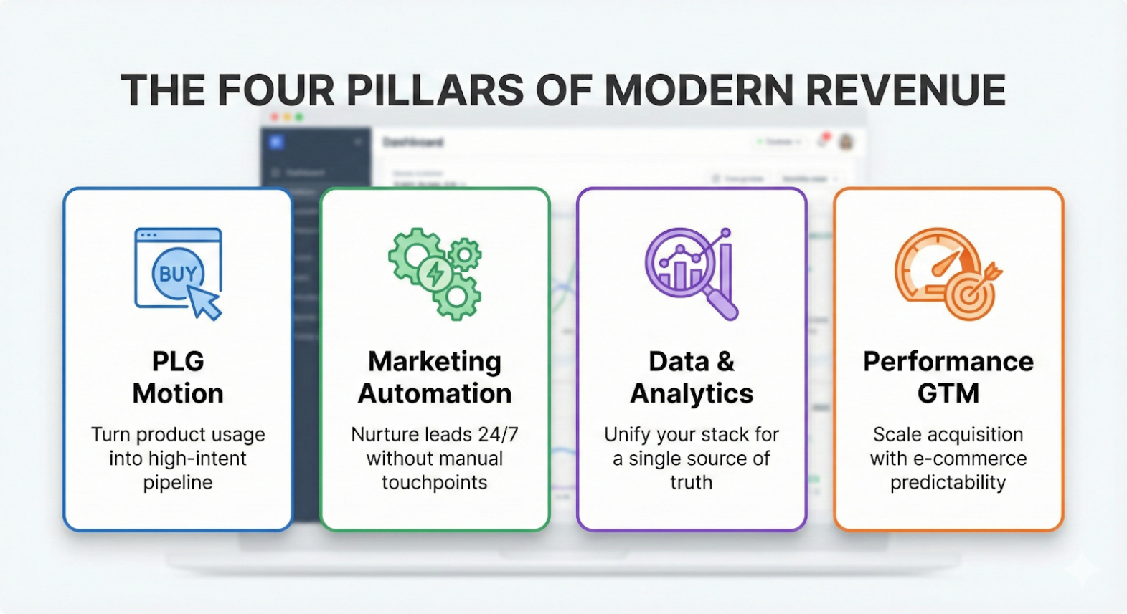

Section 3
Meet the Founder

Hi! I’m Ritesh Osta

Founder of Insightstap and a Top-Rated Fiverr Pro Consultant, with 10+ years of experience helping B2B enterprises and startups build scalable GTM and revenue systems. I’ve worked closely with growth, sales, and marketing teams to turn complex data, tools, and buyer signals into clear execution and real revenue impact.

Section 4
Our Mission

At Insightstap, we want to give B2B companies the agility of e-commerce when growing revenue.
We do this by building AI-powered GTM engines that transform hidden buyer intent into predictable, scalable pipelines.

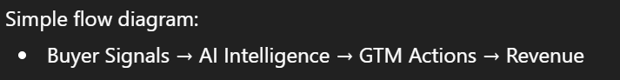

Section 5

How We Work: C.A.R.E. values
C — Customer-Centric
We solve real business problems, not surface-level tasks
A — Authentic
Clear, honest, no fluff—always
R — Results-Driven
Revenue, pipeline, efficiency. Nothing else matters
E — Expert-Led
Deep specialization, real execution

Section 6

Our Story
Foundation - InsightsTap was founded by a team of seasoned professionals in martech, sales, and data analytics with a vision to redefine B2B sales success.

Passion - Born from a passion for innovation, InsightsTap saw the disconnect between traditional B2B sales tactics and the data-driven strategies driving e-commerce success.

Vision - Determined to bridge this gap, we assembled a team of experts with diverse backgrounds in sales, marketing, and technology.

Future - We focus on developing innovative solutions that drive enterprises forward, aligning them with future trends and opportunities.

Section 7

Why Choose Us?
InsightsTap combines deep industry knowledge, a results-oriented approach, and a passion for innovation. We work as an extension of your team, providing the expertise and support needed to navigate complex challenges and seize new opportunities.

Section 8

Let’s Build Your Revenue Engine
Ready to take your B2B sales to the next level? We’d love to hear from you. Get in touch with our team today to schedule a consultation and see how InsightsTap can help you unlock your full potential.
CTA- Book a Session

Section 9
Leadership Team

