1. Sobel Edge Detection
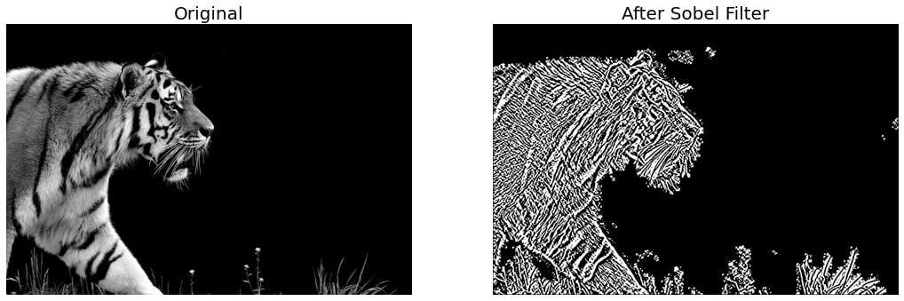
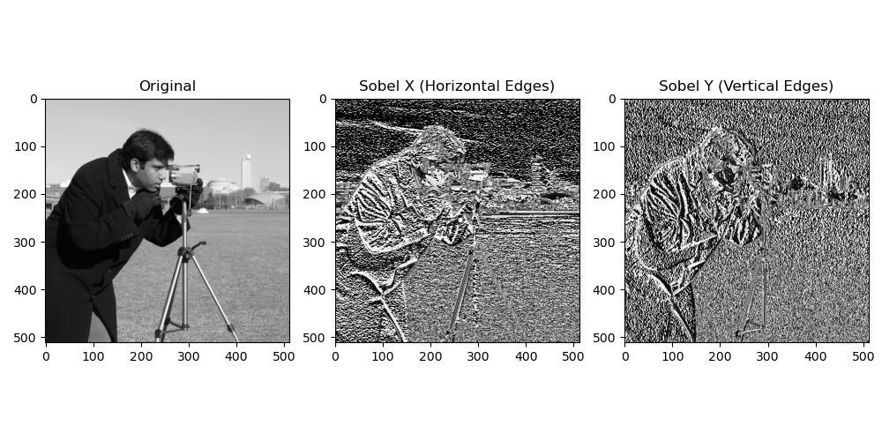
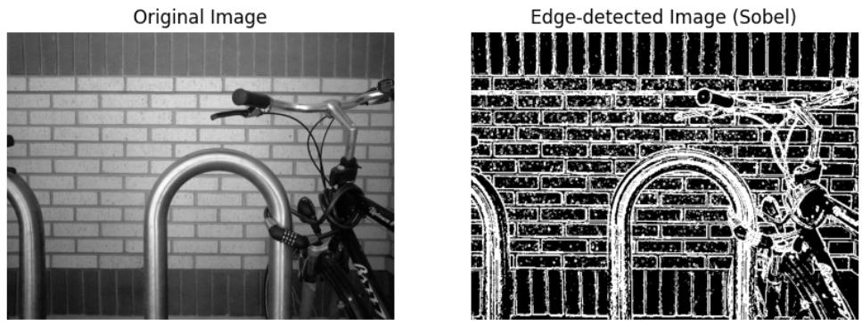
5

What is it?
Sobel Edge Detection finds the edges (boundaries) of objects in an image.
It looks for places where the brightness changes suddenly.
For example:
White Wall | Black Door
The change from white to black is an edge.

How does it work?
It checks the image in two directions:
- Horizontal (left → right)
- Vertical (top → bottom)
Then it combines both results to find all edges.

Example
Original
████████
████████
........
........
There is a clear change between white and black.
Sobel detects this line.
Output
--------

Real-life Example
Imagine taking a photo of a building.
Sobel highlights
- windows
- doors
- roof
- walls
because these are boundaries.

Advantages
✔ Fast
✔ Easy to use
✔ Finds horizontal and vertical edges

Disadvantages
✖ Sensitive to noise
✖ Doesn't always detect very thin edges

2. Canny Edge Detection
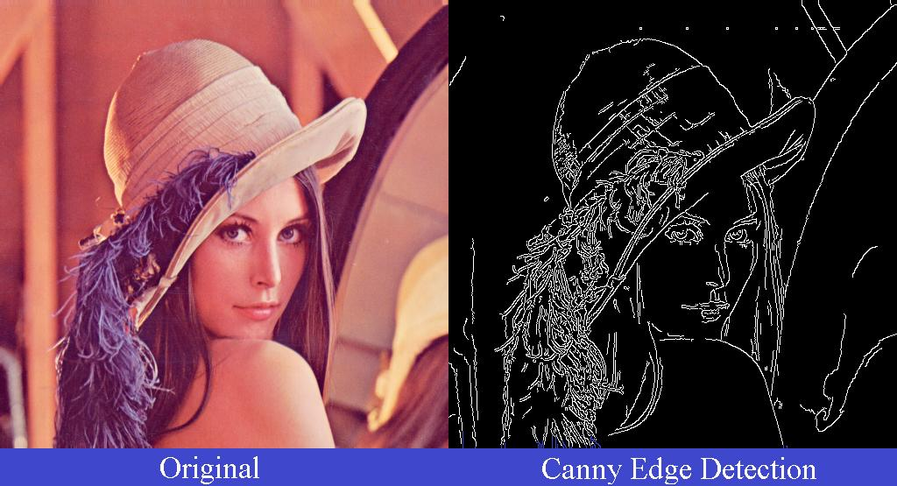
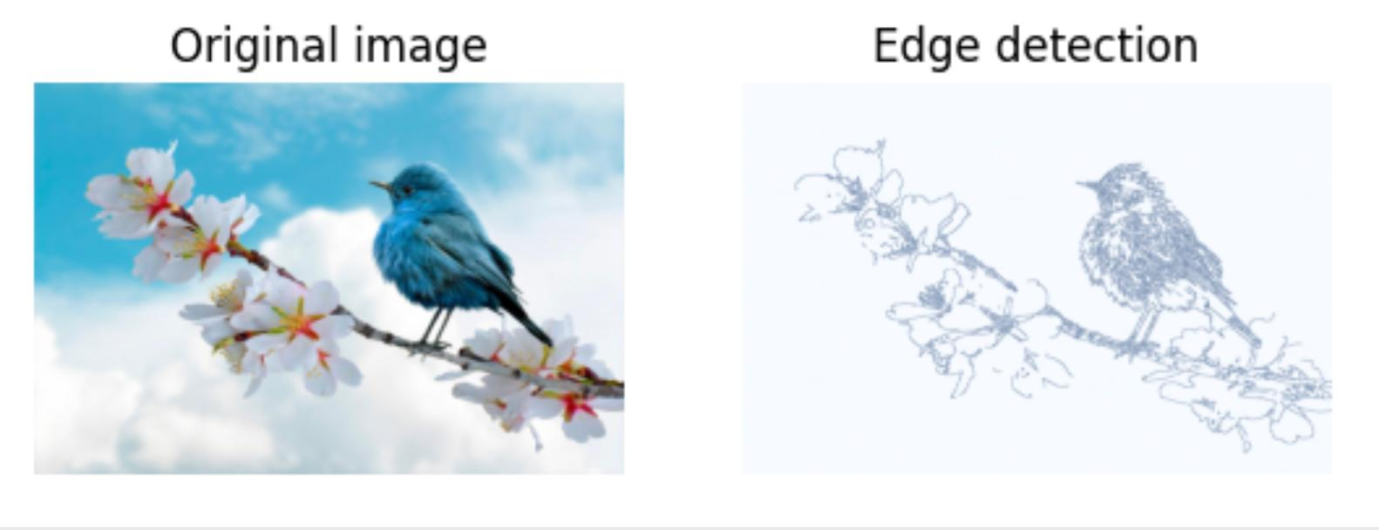
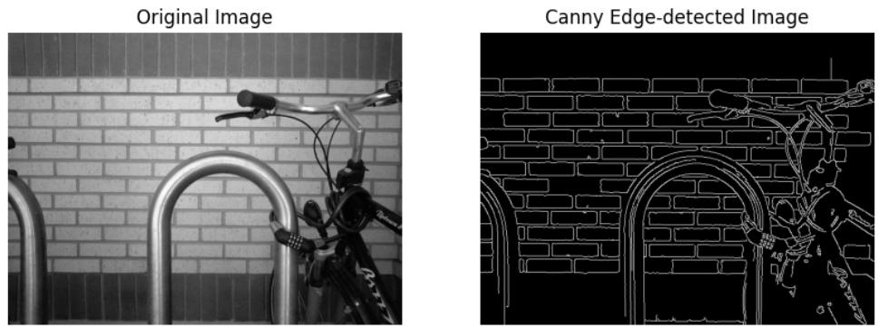
5

What is it?
Canny is one of the best edge detection algorithms.
It gives clean and thin edges.

Think of it like this
Suppose you draw a square.
Original
█████
█ █
█ █
█████
Canny returns only the boundary.
*****
* *
* *
*****

Steps
Canny works in several stages.
- Remove noise
- Find edges
- Remove unwanted edges
- Keep only strong edges

Example
Original
A picture of a cat.
Canny detects only
- ears
- eyes
- body outline
instead of every tiny color change.

Advantages
✔ Very accurate
✔ Less affected by noise
✔ Produces thin edges
✔ Most commonly used

Disadvantages
✖ Slower than Sobel
✖ More calculations

3. Laplacian Edge Detection
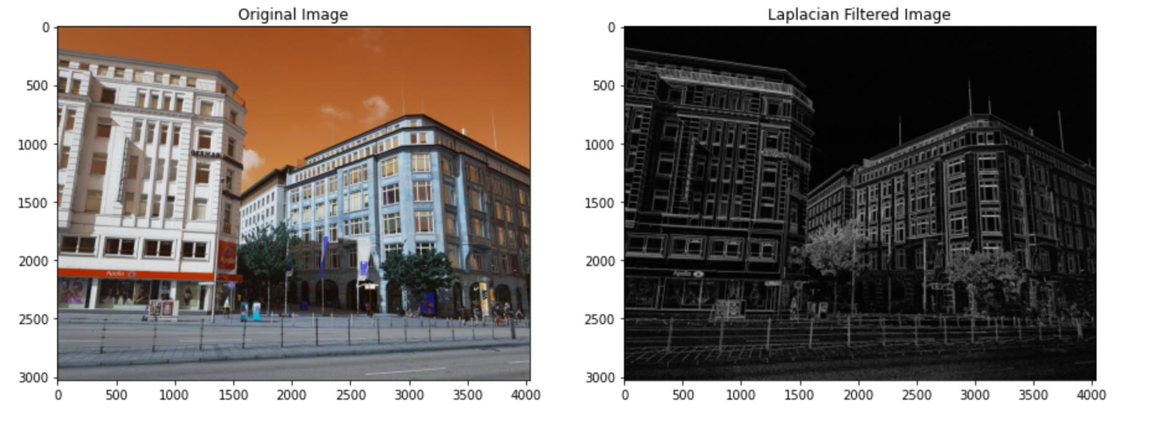
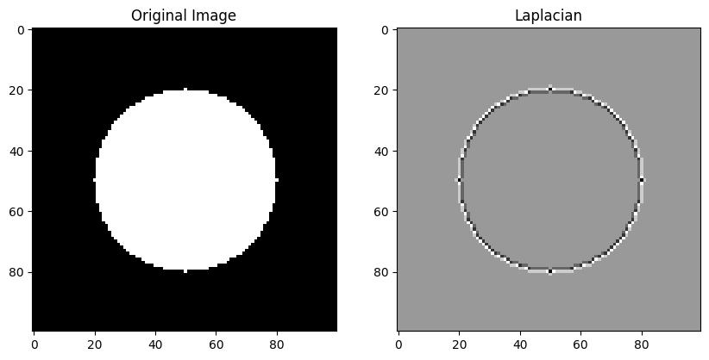
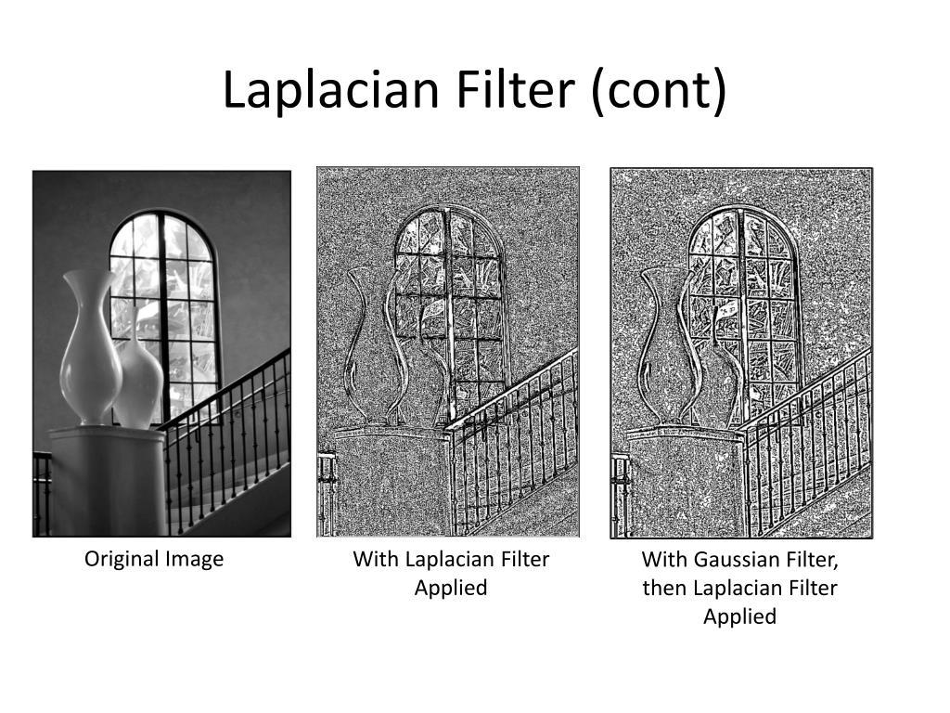
5

What is it?
Laplacian detects edges in all directions.
Unlike Sobel,
it does not separately check horizontal and vertical.

Example
Imagine a circle.
○
Laplacian detects the whole boundary.
*******

Real-life Example
Medical images
Satellite images
Object detection

Advantages
✔ Detects edges in every direction
✔ Simple to implement

Disadvantages
✖ Very sensitive to noise
✖ Usually used after smoothing

4. Gaussian Smoothing
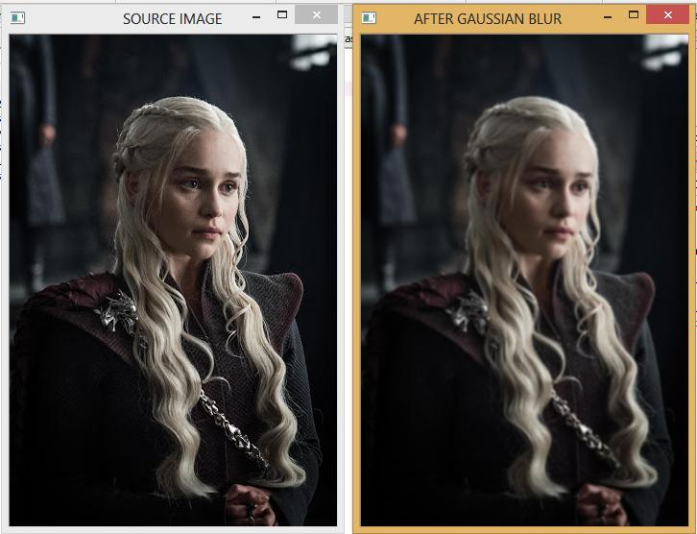
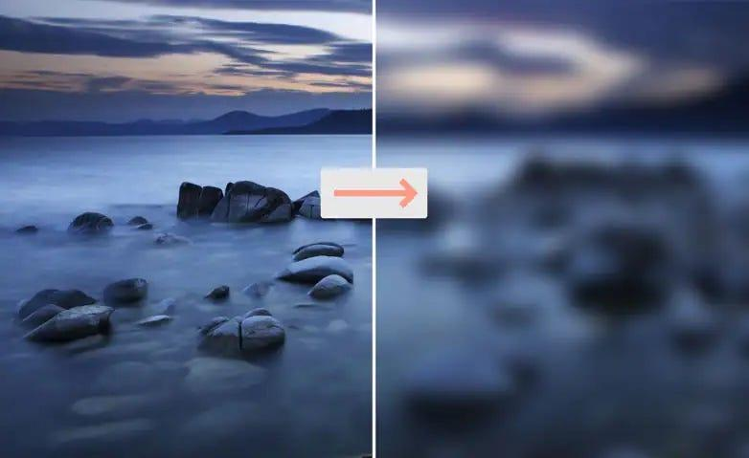
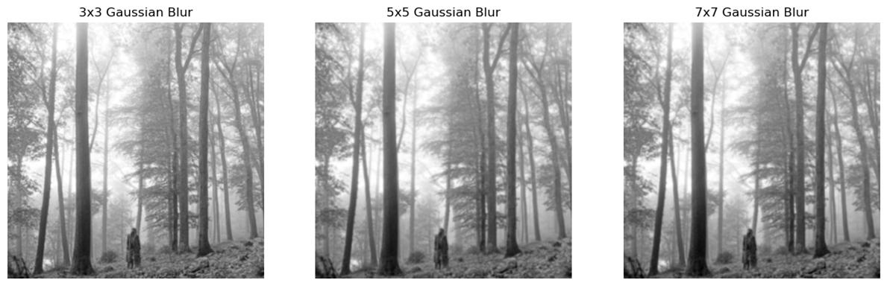
6

What is it?
Gaussian Smoothing blurs the image.
It removes small unwanted dots (noise).

Example
Original
😊
with random dots
😊 • • •
After Gaussian
😊
The dots become less visible.

Why is it used?
Suppose your camera captured a noisy image.
Before finding edges,
you first clean the image.
That is why Canny uses Gaussian Blur first.

Real-life Example
Phone camera
Security cameras
Medical scans

Advantages
✔ Removes noise
✔ Makes edge detection better
✔ Smooth image

Disadvantages
✖ Image becomes slightly blurry
✖ Fine details may disappear

5. Median Filtering
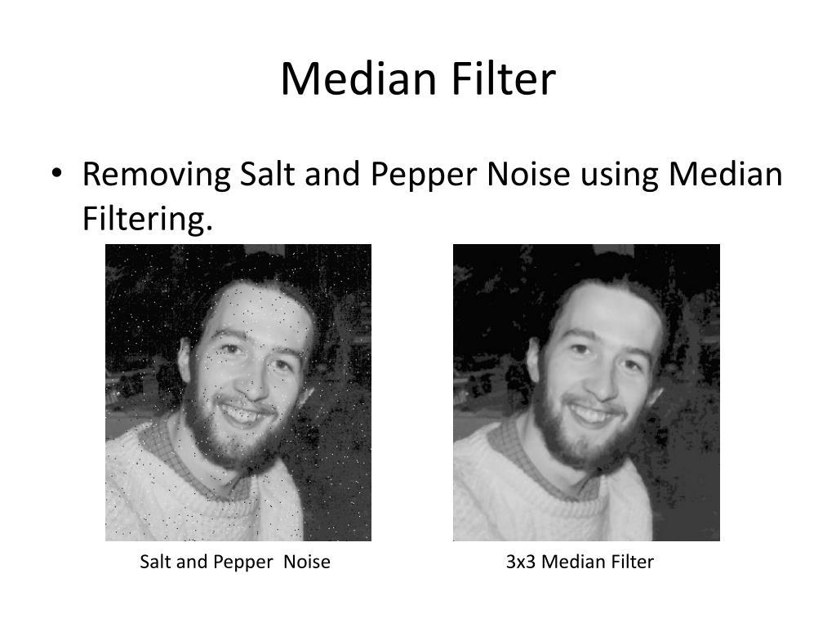
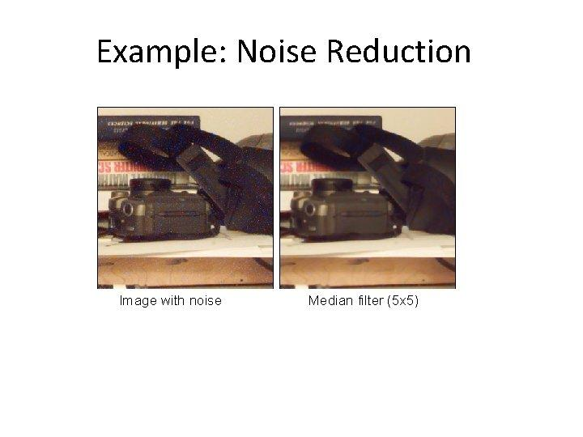
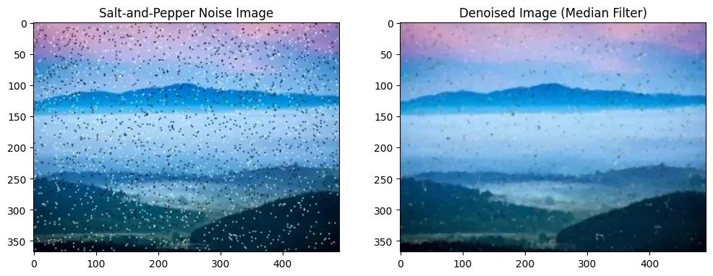
7

What is it?
Median Filter removes salt-and-pepper noise.
Salt-and-pepper noise looks like random black and white dots.
Example
⬛⬜⬛⬜
⬜⬛⬜⬛
These dots are unwanted.

How does it work?
Instead of averaging neighboring pixels, it:
- looks at nearby pixels
- sorts their values
- chooses the middle (median) value
This removes isolated noisy pixels while keeping edges sharper than simple averaging.

Example
Pixel values
10 12 11
15 255 14
13 12 11
Here 255 is noise.
Sorted values
10 11 11 12 12 13 14 15 255
Median = 12
The noisy pixel (255) becomes 12.

