SQL – Assignment – 11
1. Write a query that uses a subquery to obtain all orders for the customers named Cisneros. Assume you do not know his customer number (Cnum).
Ans.
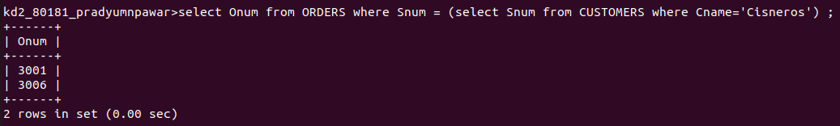
2. Write a query that produces the names and ratings of all customers who have above average orders.
Ans.
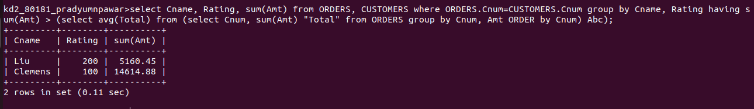

3. Write a query that selects the total amount in orders for each salesperson for whom this total is greater than the amount o the largest order in the table.
Ans.
