SQL Assignment – 8
1. Assume each salesperson has a 12% commision . Write a query on the order table that will produe the order number , the salesperson number , and the amount of the salesperson’s commision for that order.
Ans.
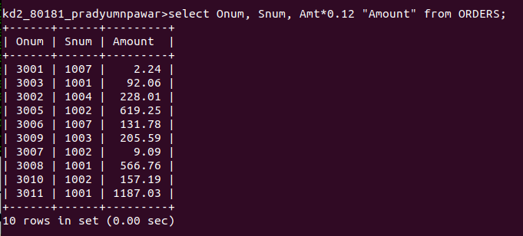

2. Write a query on Customers Table that will find the highest rating in each city.Put the outout in this form.
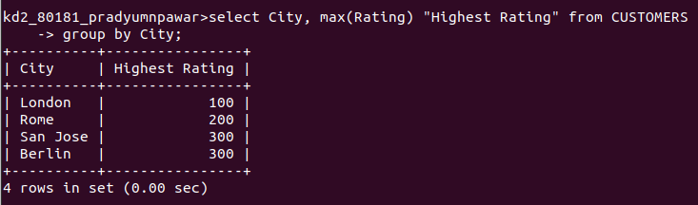

3. Write a query that lists customers in descending order of rating . Output the rating field first , followed by the customers’s name and number.
Ans.
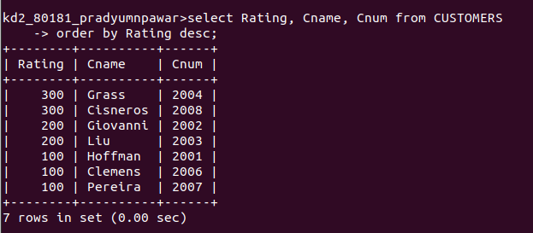

4. Write a query that totals the orders for each day and place the result in the descending order.
Ans.
