SQL – Assignment – 14

1. Write a command that puts the following values, in their given order, into the salespeople table: city – San Jose, name - Blanco, comm – NULL, cnum – 1100.
Ans.

2. Write a command that removes all orders from cutomer Clemens from the Order table.
Ans.

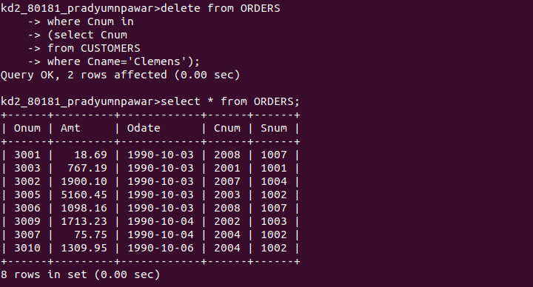

3. Write a command that increases the rating of all customers in Rome by 100.
Ans.
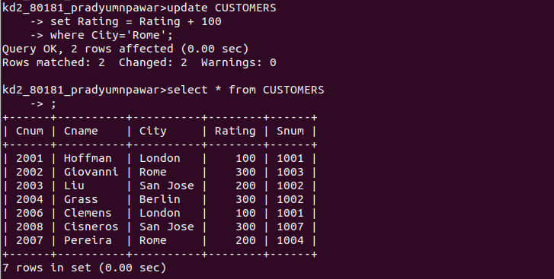

4. Salespeople Serres has left the company. Assign her customers to Motika.
Ans.
