SQL Assignment – 7
1. Write a query that counts all orders October 3.
Ans.
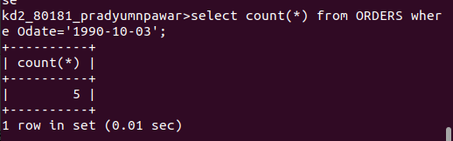

2. Write a query that counts the number of different non-null city values in the Customers table.
Ans.
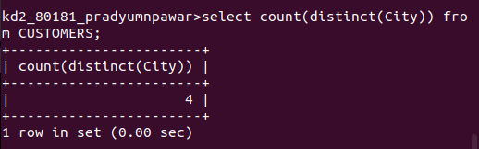

3. Write a query that selects each customer’s smallest order.
Ans.
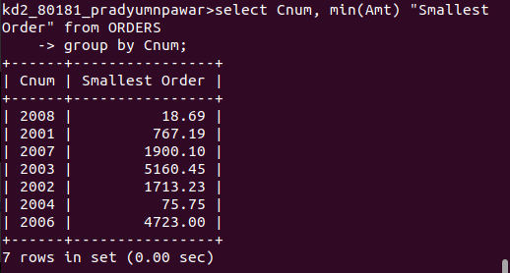

4. Write a query that selects the first customer, in alphabetical order, whose name begins with G.
Ans.
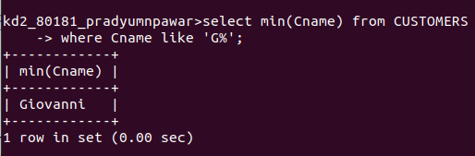

5. Write a query that selects the highest rating in each city.
Ans.
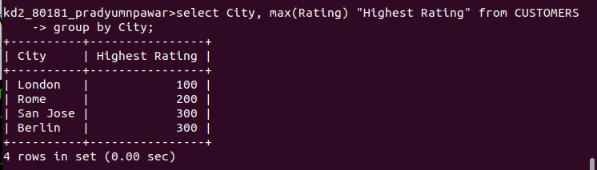

6. Write a query that counts the number of salespeople registering orders for each day.
Ans.
