SQL – Assignment – 15
1. Assume there isa atable called Multicust, with all of the sme column definations as Salespeople. Write a command that inserts all salespeople with more than one customer into this table.
Ans.
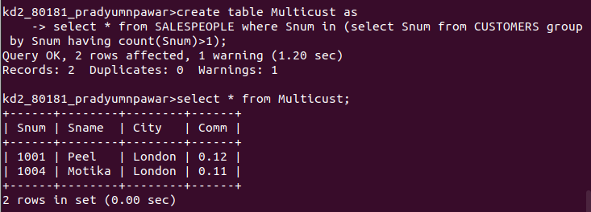

2. Write a command that deletes all customers with no current orders.
Ans.

3. Write a command that increases by twenty percent the commissions of all salespeople with total orders above Rs. 3,000.
Ans.
