SQL Assignment – 4
1. Write a select command that produces the other number, amount, and date for all rows in the Orders table.
Ans.
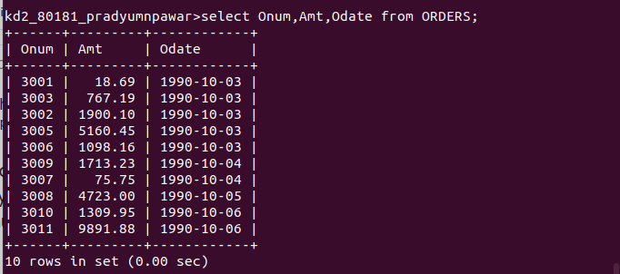

2. Write a query that produces all rows from the Customers table for which the salespeople’s number is 1001.
Ans.


3. Write a query that displays the Salespeople table with the columns in the following order: city, sname, snum, comm.
Ans.
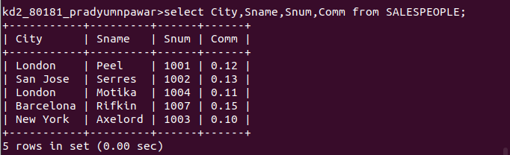

4. Write s select command that produces the rating followed by the name of each customer in San Jose.
Ans.
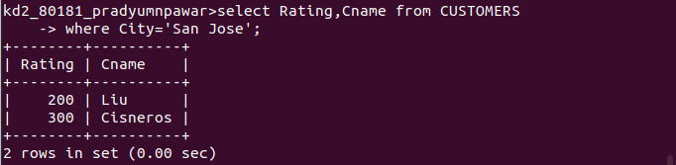
End of Assignment.

