SQL – Assignment – 12
1. Write a query that selects all customers whose ratings are equal to or greater than any of Serres’.
Ans.
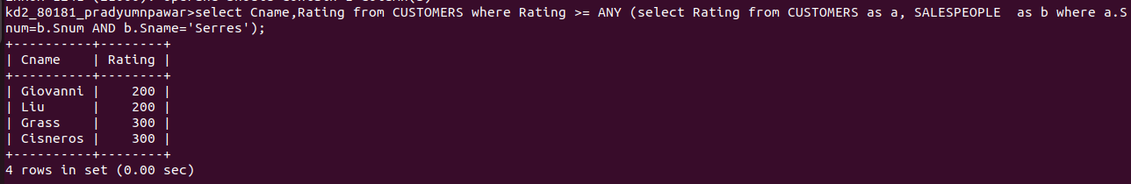

2. Write a query using any or all that will find all salespeople who have no customers located in their city.
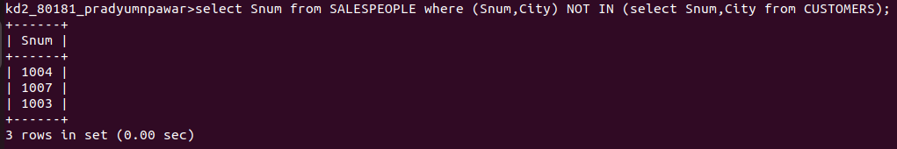
Ans.

3. Write a query that selects all orders for amounts greater than any for the customers in London.
Ans.
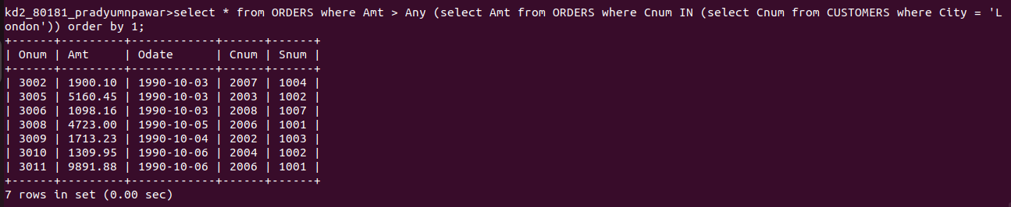

4. Write the above query using MIN and MAX.
Ans.
