Mongo DB Assignment

1. Install Mongo DB database Server.
Ans.
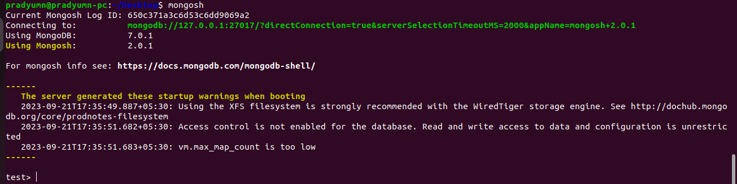
$ sudo apt-get install gnupg curl
$ curl -fsSL https://pgp.mongodb.com/server-7.0.asc | \
sudo gpg -o /usr/share/keyrings/mongodb-server-7.0.gpg \
--dearmor

2. Create a directory /folder to store MongoDB datafiles.
Ans.
datafiles

3. Set neccessary path environment variables.
Ans.
$ echo "deb [ arch=amd64,arm64 signed-by=/usr/share/keyrings/mongodb-server-7.0.gpg ] https://repo.mongodb.org/apt/ubuntu jammy/mongodb-org/7.0 multiverse" | sudo tee /etc/apt/sources.list.d/mongodb-org-7.0.list

4. Startup MongoDB database.
Ans.
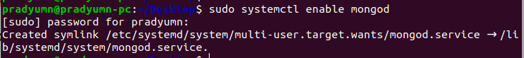

5. Connect to MongoDB database through the MongoDB shell command line interface.
Ans.
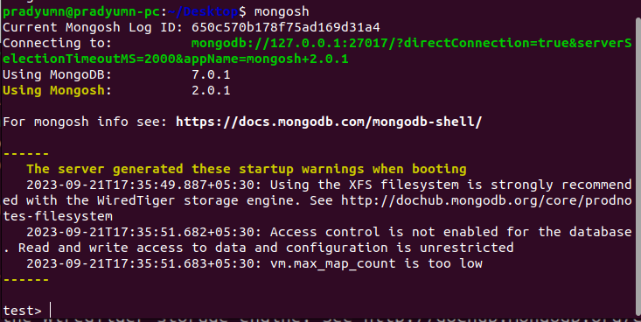

6. View list of available datbases.
Ans.
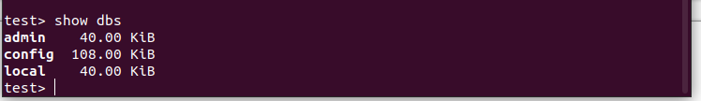
7. Create a new database named CDAC and connect to it.
Ans.

8. View List of available collection in CDAC database.
Ans.

9. Create a new collection by the name of LIBRARY.
Ans.
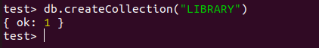

10. Insert the following document in the LIBRARY collection.
Ans.
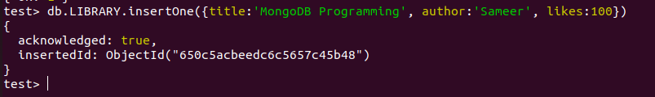

11. View the recently inserted document in the library collection as follows
Ans.
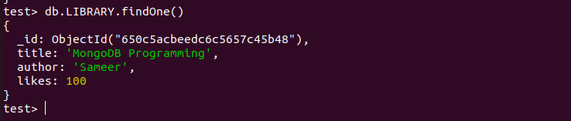

12. Insert another document in the library collection as follows.
Ans.
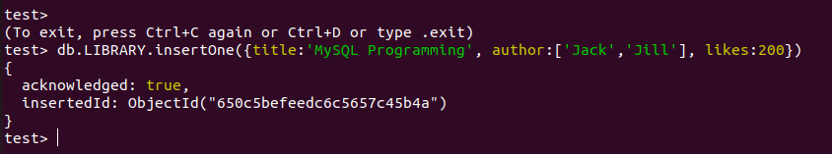

13. View the inserted documents.
Ans.
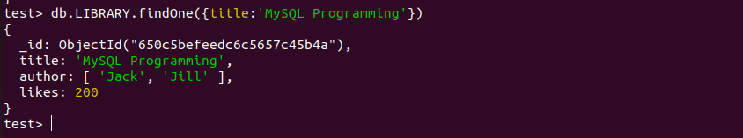

14. View only the first inserted document.
Ans.
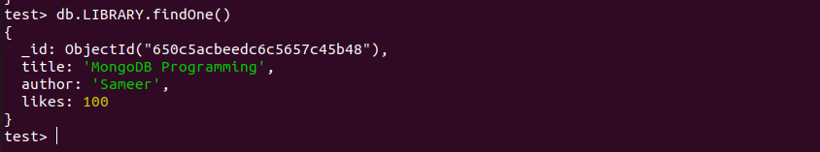

15. View the documents using the pretty() method.
Ans.
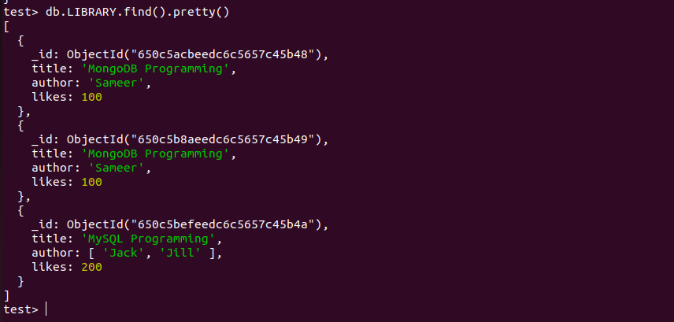

16. Update the document where the author names...
Ans.
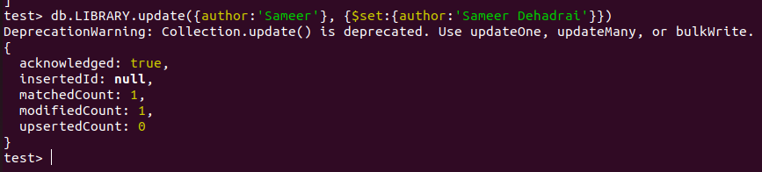

17. Delete all documents that have 100 likes
Ans.

18. Drop the library collection.
Ans.

19. Drop the CDAC database.
Ans.

20. Exit from MongoDB shell
Ans.

21. Stop MongoDB server.

