SQL Assignment – 5
1. Write a query that will give you all orders for more than Rs. 1000.
Ans.

2. Write a query that will give you the names and cities of all salespeople in London with a comission above .10.
Ans.
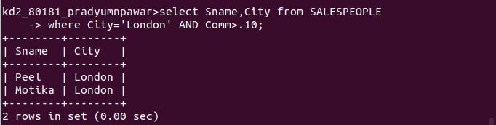
3. Write a query on the Customers table whose output will exclude all customers with a rating<=100, unless they are located in Rome.
Ans.

4. What will be the output from the following query?
Ans.
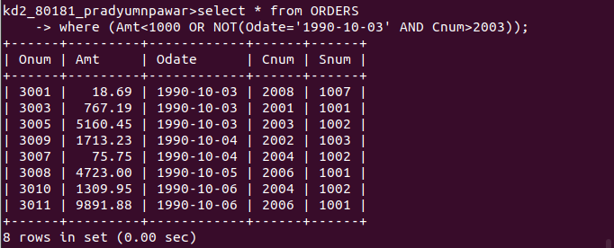
5. What will be the output of the follwoing query?
Ans.
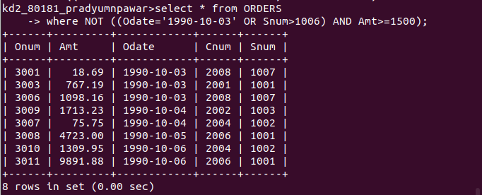
6. What is a simpler way to write this query?
Ans.
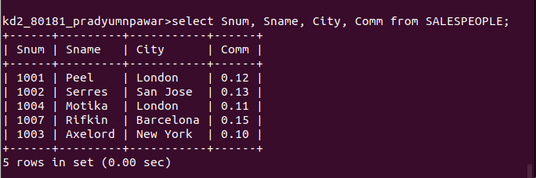
End of Assignment.

