SQL – Assignment – 10
1. Write a query that produces all pairs of salespeople who are living in the same city. Exclude combinations of salespeople with themselves as well as duplicate rows witht he order reversed.
Ans.
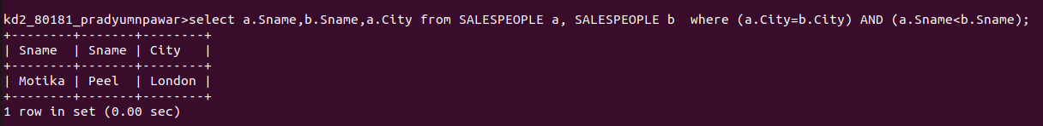

2. Write a query that produces the names and cities of all customers witht the same rating as Hoffman.
Ans.
