SQL Assignment – 9
1. Write a query that lists each order number followed by the name of the customer who made the order.
Ans.
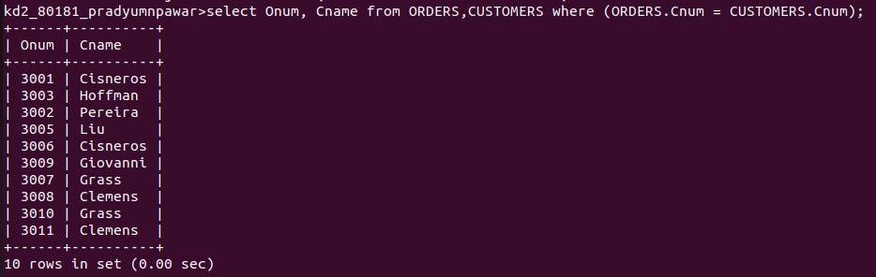
2. Write a query that gives the names of both the salespeople and the customers for each order along with the order number.
Ans.
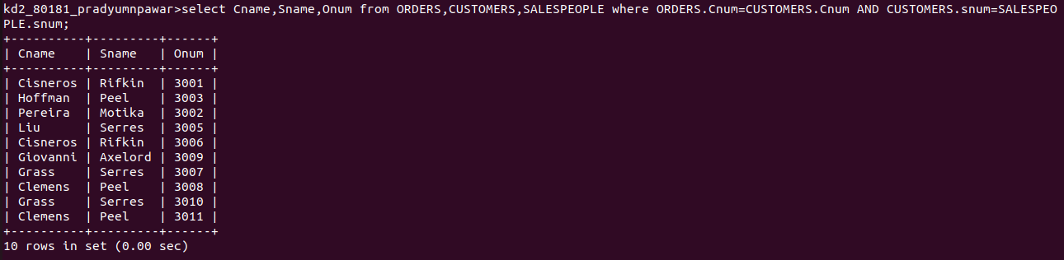

3. Write a query that produces all customers serviced by salespeople with a commission above 12%. Output the customers’s name, the salespeople’s name, and the salespeople’s rate of commission.
Ans.
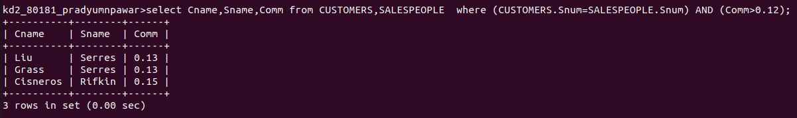

4. Write a query that calculates the amount of the salespeople’s commission on each order by a customer with a rating above 100.
Ans.
