SQL Assignment – 6
1. Write two different queries that would produce ll orders taken on October 3rd or 4th , 1990.
Ans.

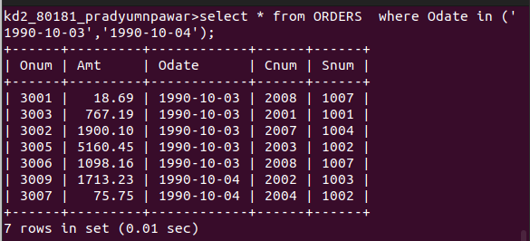
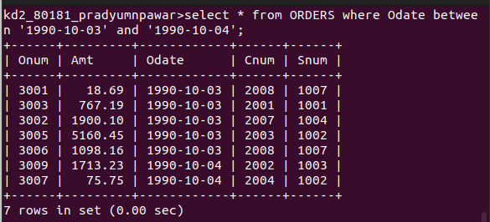

2. Write a query that selects all of the customers serviced by Peel or Motika.
Ans.
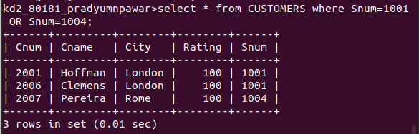

3. Write a query that will produce all the customers whose names begin with a letter from ‘A’ to ‘G’.
Ans.
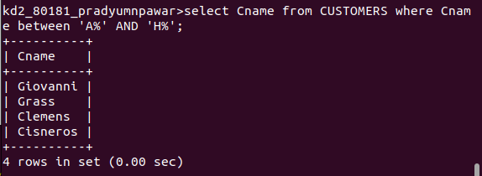

4. Write a query that selects all customers whose names begin with the letter ‘C’.
Ans.
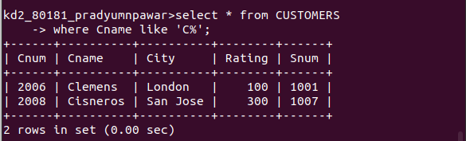

5. Write a query that selects all the orders except those with zeroes or nulls in the amt field.
Ans.
Next Page.
