🔍 What Can You Forecast?
With:
- Air Temp
- GHI (Global Horizontal Irradiance)
- Relative Humidity
- Wind Speed & Direction
- Timestamps
You can forecast:
- 🔆 Future GHI (for solar power prediction)
- ⚡ PV generation output (if you have system specs)
- 🌤️ Weather conditions (short-term: next few hours/days)

⚙️ 1. Define the Goal
Let’s say you want to forecast GHI for the next hour/day — this is called time series forecasting.
🧹 2. Preprocess Your Data
Clean your data to feed into ML or deep learning models:
- Handle missing/null values
- Convert timestamps to features:
hour, day, month, weekday, sin/cos(hour) for cyclic encoding
- Normalize or scale features if needed

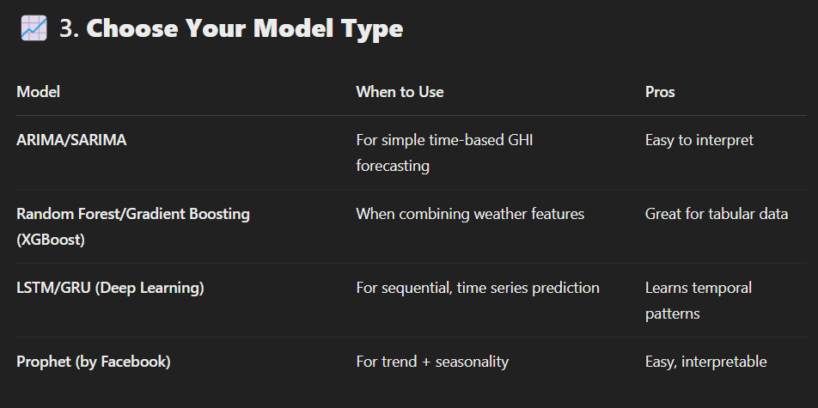

🤖 4. Model Inputs (Features)
For a model predicting GHI_next_hour, you could use:

Features = [
'air_temperature',
'relative_humidity',
'wind_speed',
'wind_direction',
'ghi',
'hour', 'day', 'month', 'weekday', 'sin_hour', 'cos_hour',
'ghi_lag_1h', 'ghi_lag_2h', 'ghi_rolling_mean_3h'
]

📊 5. Train & Evaluate
- Split data into train/test (e.g., 80/20 or based on time)
- Train the model
- Evaluate with metrics like MAE, RMSE, MAPE

📦 6. Forecast
You can forecast:
- 1 hour ahead (short-term)
- Multiple hours ahead (multi-step forecast)

📉 7. Visualize Results
Plot:
- Actual vs Predicted GHI over time
- Error metrics
- Feature importance (if using tree-based models)

Prediction: -
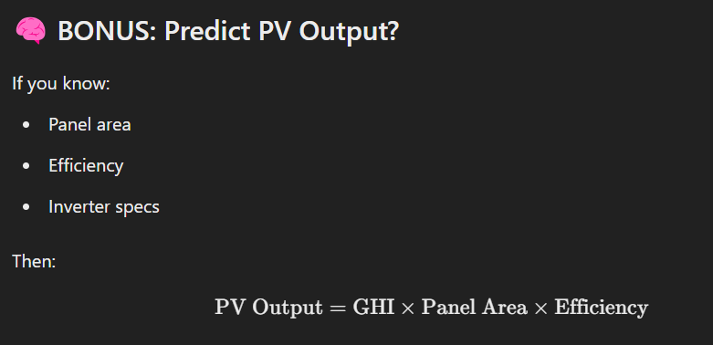

Formatting: -
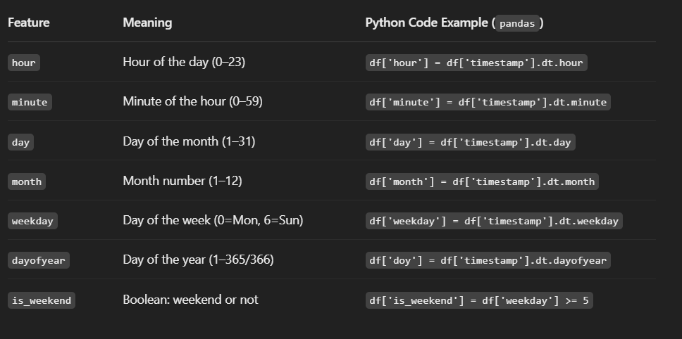

Forecasting Options: -

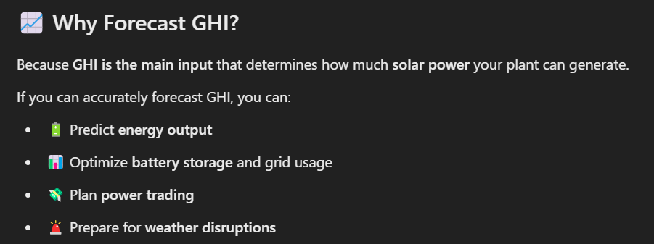
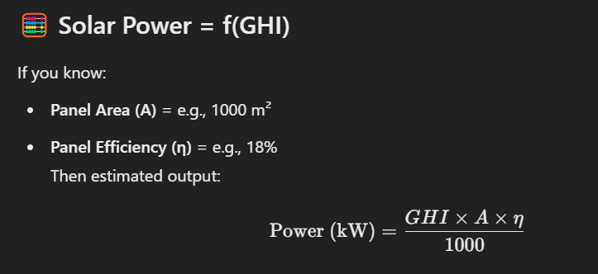
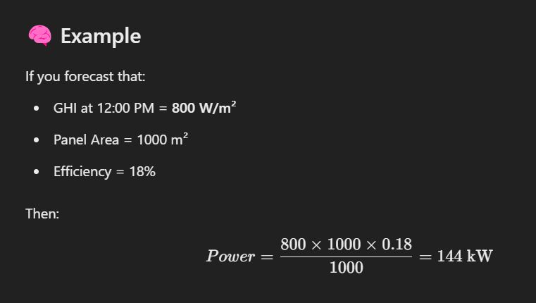
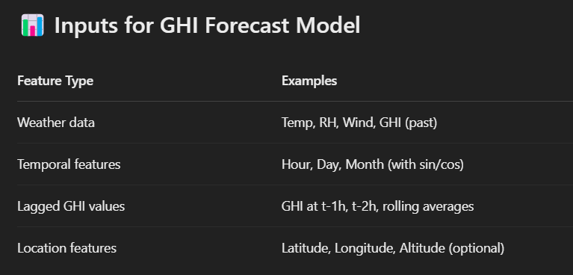
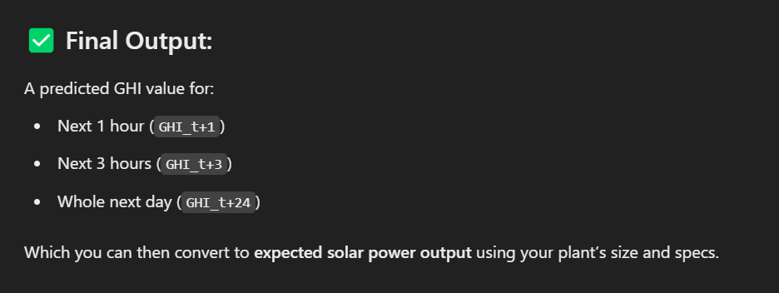

Testing: -
import requests
url = 'http://127.0.0.1:5000/predict'
data = {
'air_temp': 30,
'gti': 800,
'relative_humidity': 40,
'wind_direction_10m': 90,
'wind_speed_10m': 5,
'weekday': 2,
'sin_hour': 0.5,
'cos_hour': 0.866,
'sin_month': 0.866,
'cos_month': 0.5,
'sin_day': 0.9,
'cos_day': 0.1
}

response = requests.post(url, json=data)
print(response.json())

🌞 Project: Solar Plant GHI Forecasting and Monitoring System

📈 Problem Statement:
- Predict next 24 hours of Global Horizontal Irradiance (GHI) for a solar plant every morning at 6:00 AM.
- Store the forecasted data.
- Compare forecast vs actual at the end of the day automatically.
- Trigger a performance warning if prediction error is too high (say RMSE > 80).

🏗️ Project Breakdown:
Stage | What You'll Do | Skills Covered
Data Extraction (ETL) | Automatically pull hourly weather and site GHI data (CSV/API/Database) | Python (Pandas, Requests, SQLAlchemy)
Feature Engineering | Add lag features, cyclical features (sin(hour), cos(hour)) | Data Science
Time Series Model | Train SARIMAX / XGBoost / LSTM model for GHI prediction | Time Series Forecasting
Prediction & Storage | Forecast next 24 hours, store results in PostgreSQL | ETL Pipelines, SQL
Dashboard | Create a simple Power BI or Streamlit dashboard to view forecast vs actual | Data Visualization
Model Monitoring (MLOps) | Calculate RMSE daily and alert if RMSE > 80 | MLflow, basic Python scripts
API Deployment | Create a FastAPI endpoint that can return the 24-hour forecast | FastAPI, Docker Basics

🧠 Why this project?
- Covers full cycle: ETL ➔ Model ➔ Deployment ➔ Monitoring.
- Directly useful for solar operations and energy yield forecasting.
- Looks very strong on your resume or for internal growth inside Jakson Green.

🛠️ Tech Stack you can use:
Area | Technology
Data Extraction | Python (Pandas, Requests, SQLAlchemy)
Data Storage | PostgreSQL
Modeling | statsmodels (SARIMAX), XGBoost
Visualization | Power BI / Streamlit
Deployment (optional) | FastAPI + Docker
Monitoring | Python + MLflow (optional)

🎯 How to Begin (Step-by-Step):
- Week 1-2:
  - Collect historical hourly weather + GHI data.
  - Build basic SARIMAX and XGBoost models.
  - Forecast 24 hours and evaluate RMSE.
- Week 3-4:
  - Automate ETL: fetch daily data at 6 AM, retrain or forecast.
  - Create a basic Power BI dashboard to visualize today's forecast vs actual.
- Week 5-6:
  - Build a FastAPI server that can serve the forecasts via API.
  - Add simple model monitoring (daily RMSE checker + alerts).

🧩 Bonus Ideas (If you want to make it even more powerful):
- Build ensemble models (combine XGBoost + SARIMAX predictions).
- Add temperature forecasting (as another time series task).
- Use prophet model for fast and simple forecasts.
- Add basic alert emails if RMSE is too high using SMTP.

📢 Final Tip:
Document everything nicely:
- Code + ReadMe
- Data Pipeline Flow Diagram
- Model Metrics (RMSE, MAE)
- Dashboard screenshots
👉 It becomes your ready case study for promotions, team presentations, or future roles!

