File Reader is Web application created as coding exercise. It takes file name from the screen and manipulates files and shows the data with following rules.

**Rules**  
1. Each line of the file has a category, a space, and a sub-category (sub-category can have whitespace within it)  
2. Only process the pair (category, sub-category) once  
3. If a pair appears twice, ignore the second one  
4. Keep track of the order of the first occurrence of each pair  
5. Keep track of the count for each category  
6. Legal category values are: PERSON PLACE ANIMAL COMPUTER OTHER  
7. Illegal category values should be ignored

**Sample Input File Contents:**

PERSON Bob Jones  
PLACE Washington  
PERSON Mary  
COMPUTER Mac  
PERSON Bob Jones  
OTHER Tree  
ANIMAL Dog  
PLACE Texas  
FOOD Steak  
ANIMAL Cat  
   
**Output should be following:**

CATEGORY     COUNT  
PERSON       2  
PLACE        2  
ANIMAL       2  
COMPUTER     1  
OTHER        1

PERSON Bob Jones  
PLACE Washington  
PERSON Mary  
COMPUTER Mac  
OTHER Tree  
ANIMAL Dog  
PLACE Texas  
ANIMAL CatT

**Technologies Used:**

Spring 3.0, Spring MVC framework, Java 1.6, JSP, JSTL, Jquery, Javascript, CSS, Ajax, JSON,TOMCAT 1.7, Eclipse IDE, Maven, Log4j.

**Steps to run the application:**

1. Install application file into Eclipse by importing application folder into Eclipse.
2. Configure Tomcat 1.7 in Eclipse and deploy FileReader application into Tomcat 1.7.
3. After application is up and running in Tomcat, use URL to access application web page as shown on the screen 1.1. URL: *localhost:8080/FileReader/*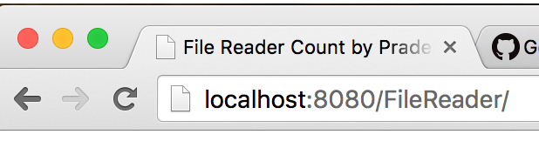

Screen 1.1

4. Application page is accessed and following page is displayed as shown on screen 1.2.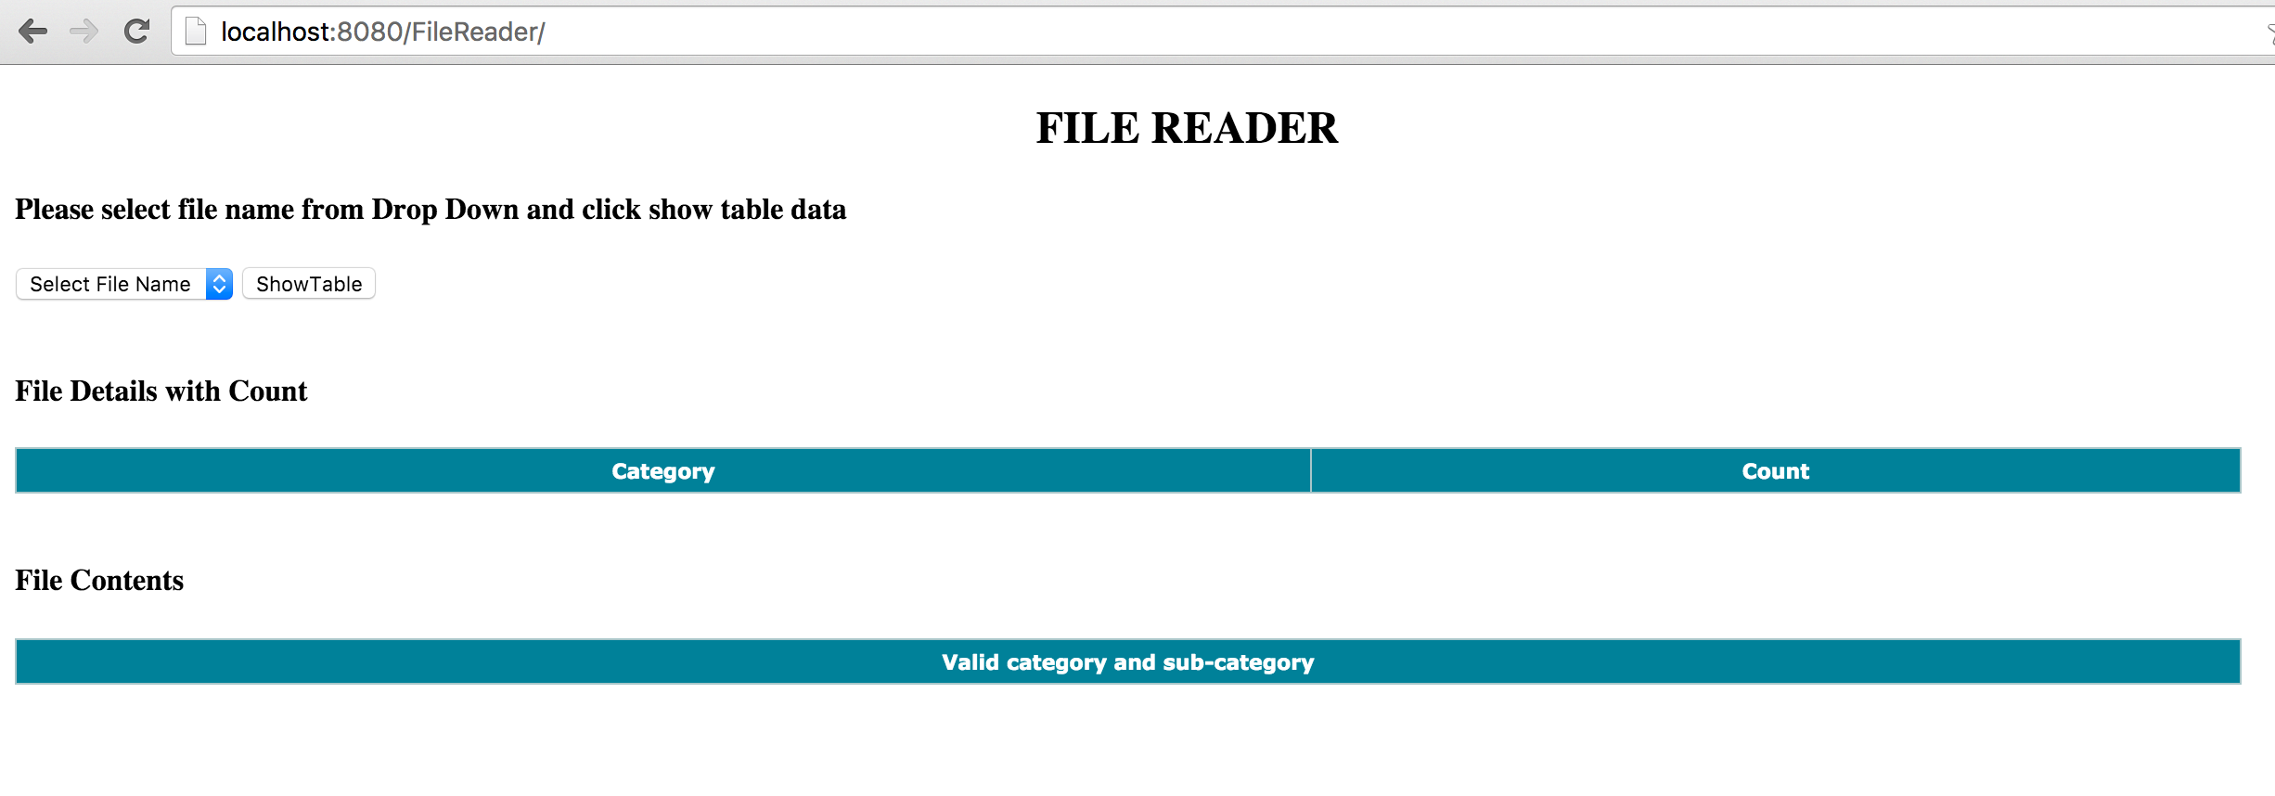

Screen 1.2

5. Click on “Select File Name” dropdown shown on screen 1.3. 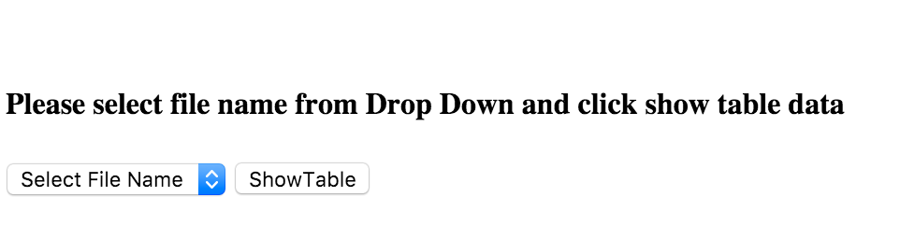

Screen 1.3

6. If clicked “ShowTable” without selecting File Name from drop down error message is displayed as shown on screen 1.4.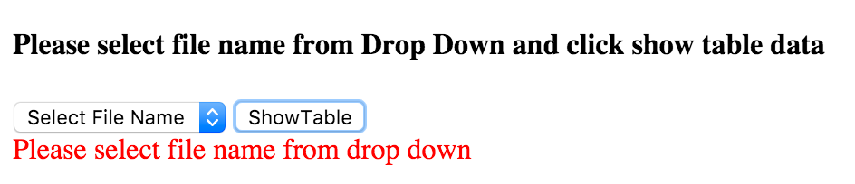

Screen 1.4

7. Click on “Select File Name” dropdown and it populates all file-names as shown on screen 1.5.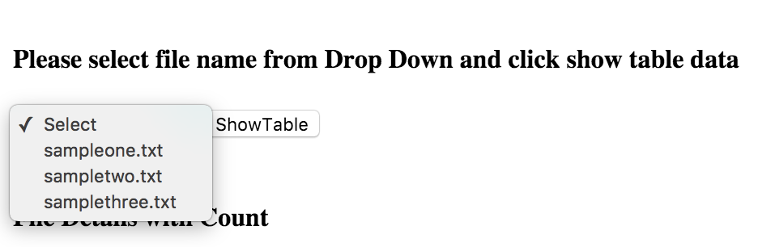

Screen 1.5

8. Select filename “sampletwo.txt” and click “ShowTable” button.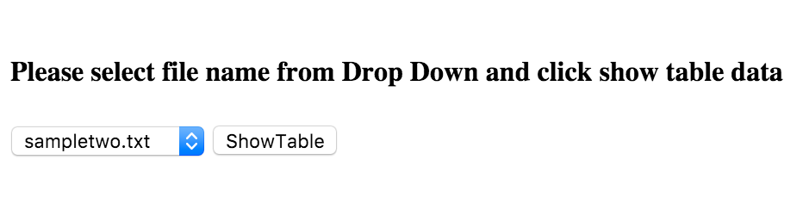

Screen 1.6

9. After clicking on ShowTable button table “File Details with count” and “File Contents” are displayed on page as shown on screen 1.7.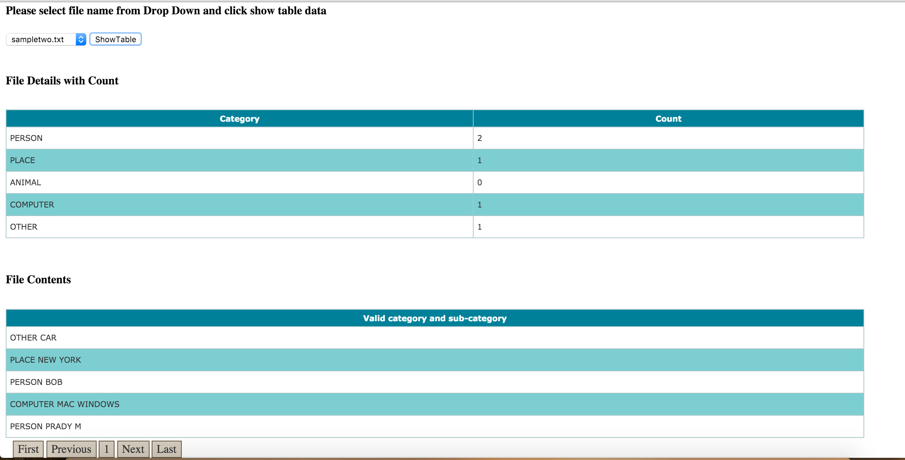

Screen 1.7

10. Select another file “samplethree.txt” from dropdown and click ShowTable button. as shown on screen 1.8.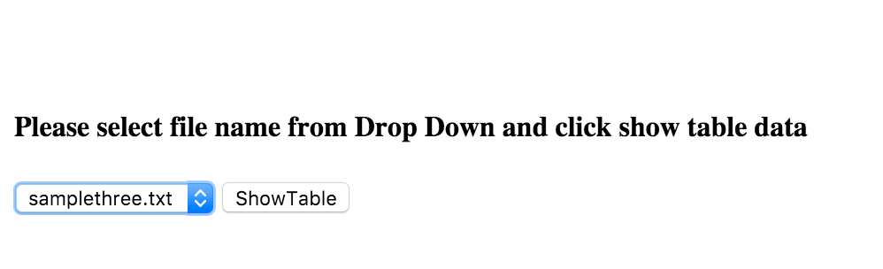

Screen 1.8

11. After clicking ShowTable button new Tables are loaded. as shown on screen 1.9.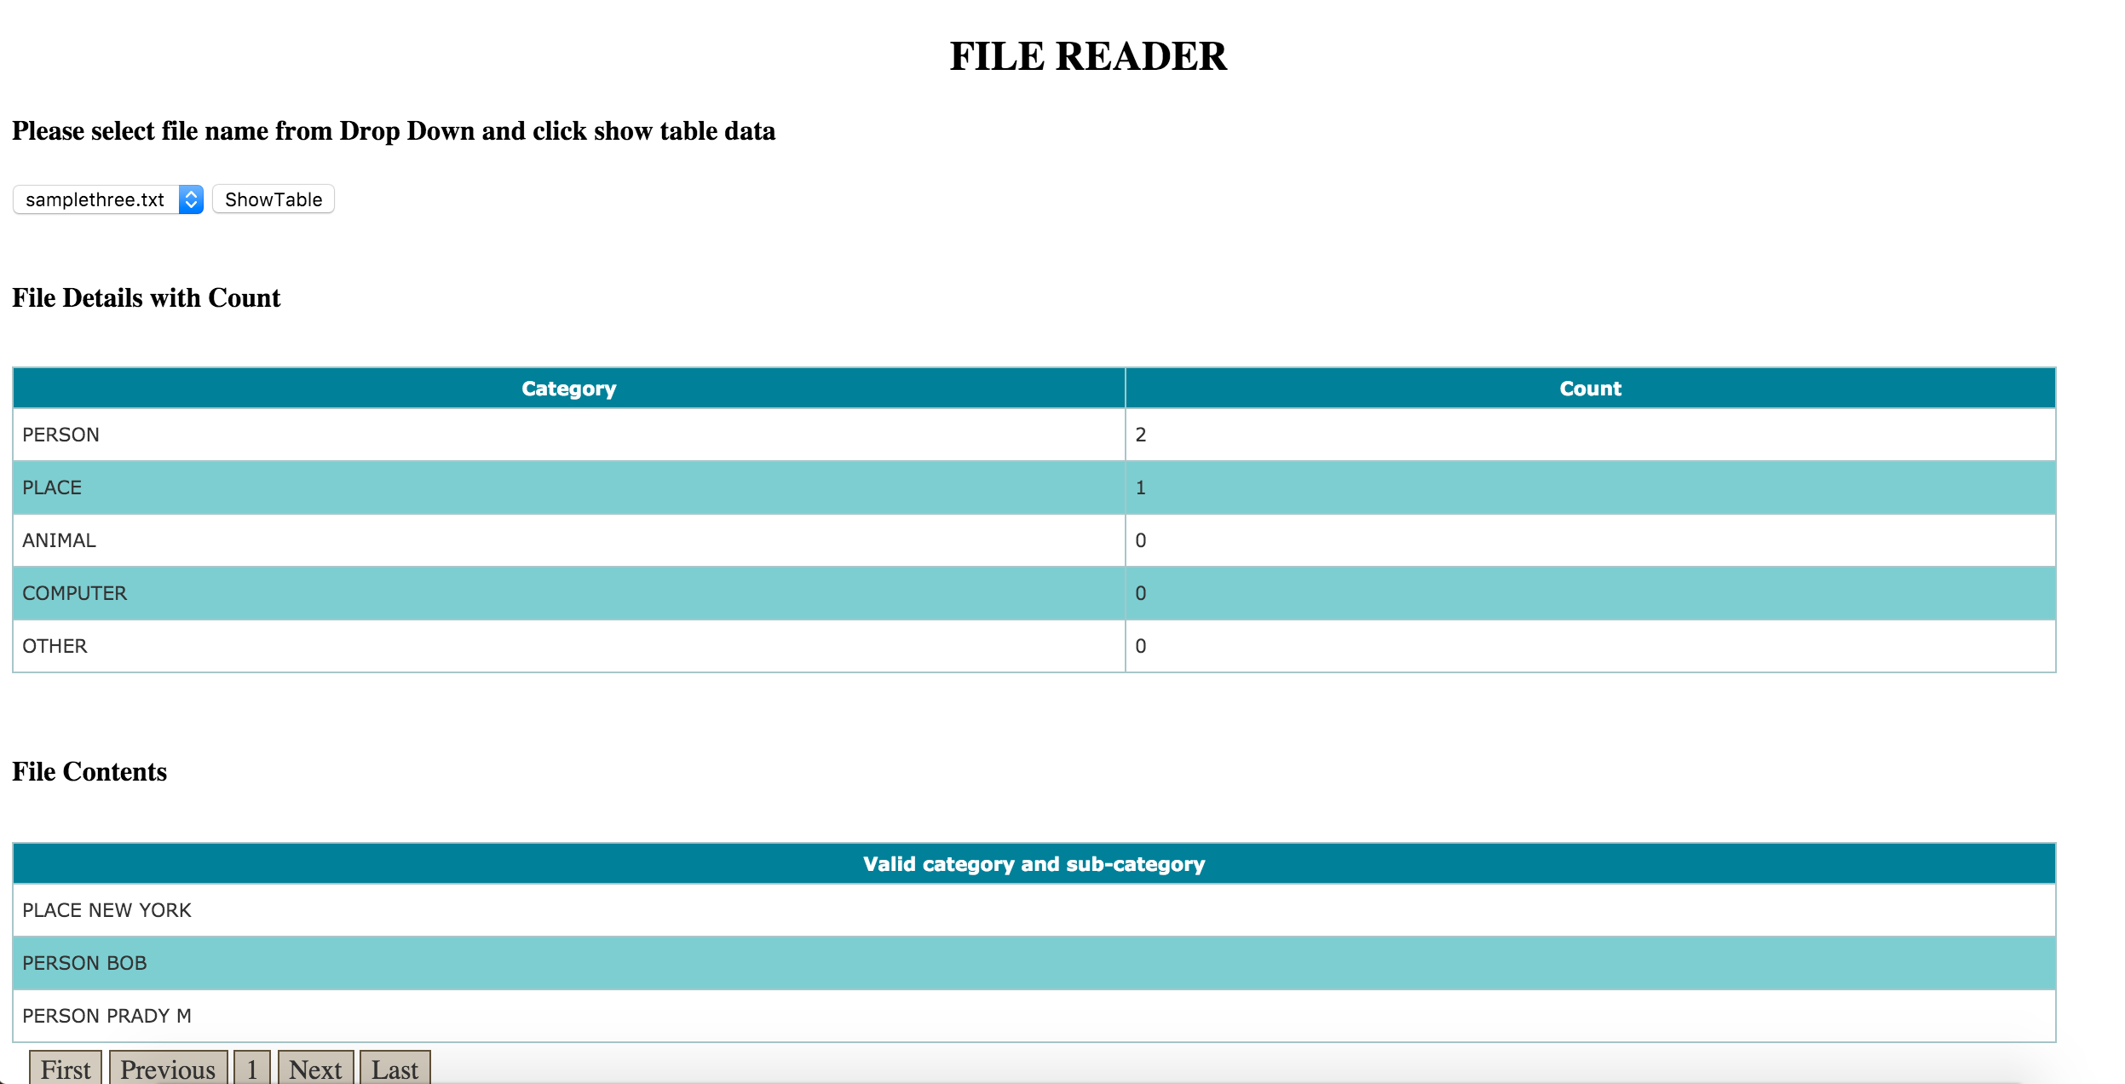

Screen 1.9

**NOTE:** In order to add new txt file to dropdown. go to src/main/resources add new file then go to

FileReaderController.java

public @ResponseBody String getFileNames() method

add new file name to ArrayList —- List<String> list = new ArrayList<String>();