**SUMMARY**

## USC ID/s: 2850400993

| M+N | Time in MS (Basic) | Time in MS (Efficient) | Memory in KB (Basic) | Memory in KB (Efficient) |
| --- | --- | --- | --- | --- |
| 16 | 3.032684326171875 | 9.300708770751953 | 11880 | 12044 |
| 64 | 3.4770965576171875 | 9.982585906982422 | 12140 | 12024 |
| 128 | 6.953001022338867 | 13.849973678588867 | 12232 | 12072 |
| 256 | 18.570899963378906 | 31.17966651916504 | 12624 | 12260 |
| 384 | 31.673908233642578 | 61.95878982543945 | 13480 | 12300 |
| 512 | 57.96074867248535 | 91.77446365356445 | 14664 | 12032 |
| 768 | 128.7863254547119 | 214.37621116638184 | 17872 | 12028 |
| 1024 | 220.0784683227539 | 371.7331886291504 | 22476 | 12060 |
| 1280 | 347.4297523498535 | 521.1272239685059 | 28652 | 12028 |
| 1536 | 478.0464172363281 | 728.8472652435303 | 35588 | 12092 |
| 2048 | 847.9204177856445 | 1292.328119277954 | 54552 | 12372 |
| 2560 | 1358.4742546081543 | 2063.9243125915527 | 78528 | 12324 |
| 3072 | 1964.1072750091553 | 2911.9534492492676 | 106724 | 12408 |
| 3584 | 2704.451322555542 | 3933.2165718078613 | 139836 | 12632 |
| 3968 | 3482.0382595062256 | 4945.048093795776 | 169292 | 12636 |

## Datapoints

## Insights

### Graph1 – Memory vs Problem Size (M+N)

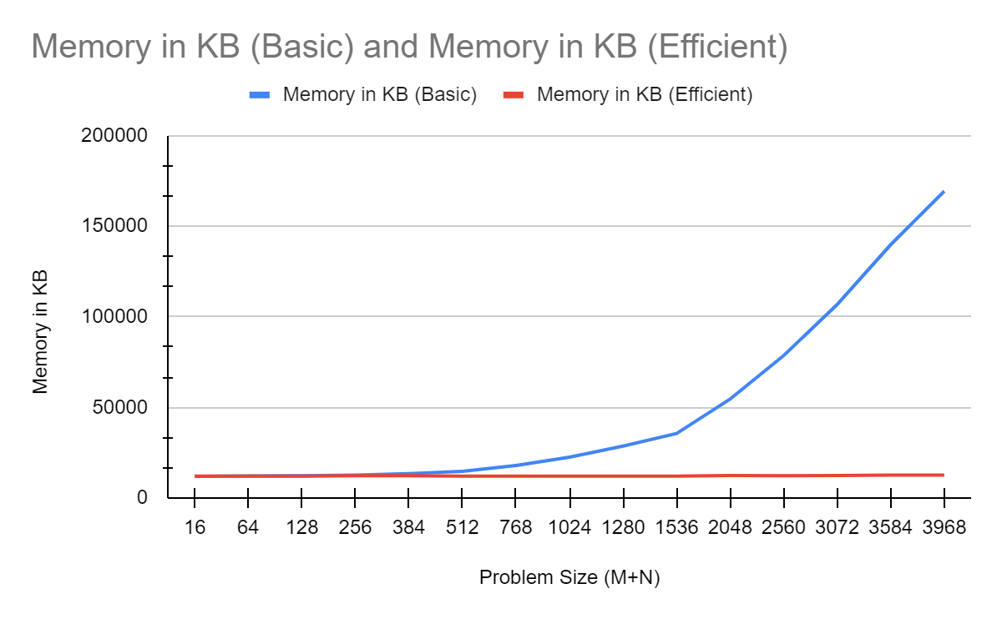

#### Nature of the Graph (Logarithmic/ Linear/ Exponential)

Basic: Exponential

Efficient: Linear

#### Explanation:

### Let m and n be string length of string 1 and string 2 respectively.

### In the basic version of sequence alignment, the memory requirement is O(M*N) as it creates a memoization table of size M*N therefore it has exponential space complexity.

### whereas the efficient version requires at most space of O(M) or O(N) since at each divide and conquer step it requires at most 2*M or 2*N memoization table which can be reused again so, its space complexity is linear.

### Graph2 – Time vs Problem Size (M+N)

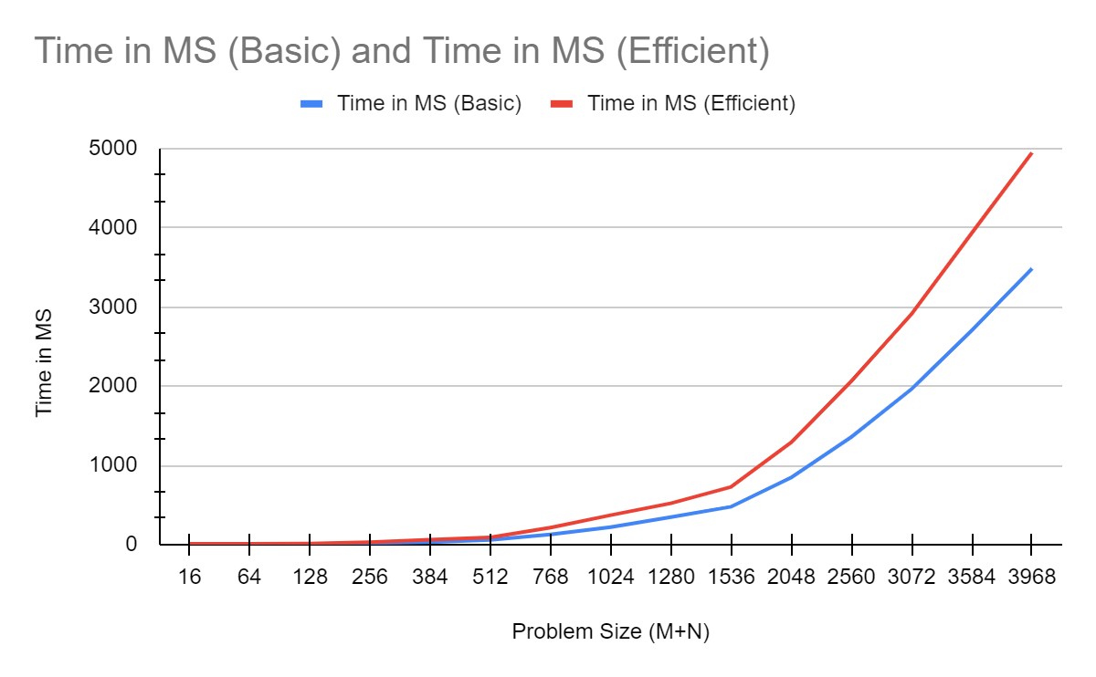

#### Nature of the Graph (Logarithmic/ Linear/ Exponential)

Basic: Exponential

Efficient: Exponential

#### Explanation:

### Let M and N be string length of string 1 and string 2 respectively. Let C be the constant time for computation.

### In the basic version of sequence alignment, the total time requirement is O(C*M*N) where C is the computations required to find the values of each element in the DP array.

So, the time complexity of basic version ≈ O(M*N)

### 

### For the efficient version work done at each step reduces to half of the previous step (as the subproblem is dividing the problem into halves). Here the work is done to find the values of the DP array.

### work done = C*M*N + C*M*N/2 + C*M*N/4 + ....... = O(2*C*M*N)

### Therefore, the time complexity of efficient version ≈ 2*O(M*N) ≈ 2 * time complexity of basic version.

Hence time complexity of both basic as well as efficient versions is exponential in nature but the time complexity of the efficient version increases at twice the rate of the basic version.

## Contribution

(Please mention what each member did if you think everyone in the group does not have an equal contribution, otherwise, write “Equal Contribution”)

<USC ID/s>: <Equal Contribution>