**Assignment** 1

Pradyoth Singenahalli Prabhu – 02071847

Woodi Raghavendra Varun – 02070206

Bharath Anand – 02044023

# 1. Data mining concepts

## a.

1. In this method of sampling, the number of elements selected is in direct proportion to m times n. The random selection of elements is done without considering the grouping of objects within the data set.

2. In this sampling method, the proportion of each group in the sample is determined solely by the number of elements selected from that group and not by the size of the group in the entire population.

## b.

1. Time in terms of AM or PM: **Categorical** – Nominal.
2. ISBN numbers for books: **Numeric** – Continuous.
3. Angles as measured in degrees between and 0 and 360: **Numeric** – Continuous.
4. Brightness as measured by a light meter: **Numeric** – Continuous.
5. Brightness as measured by people’s judgments: **Categorical** – Ordinal.
6. Bronze, Silver, and Gold medals as awarded at the Olympics: **Categorical** – Ordinal.
7. Height above sea level: **Numeric** – Continuous.
8. Number of patients in a hospital: **Numeric** – Discrete.

# 2. Matrices Concepts

## a.

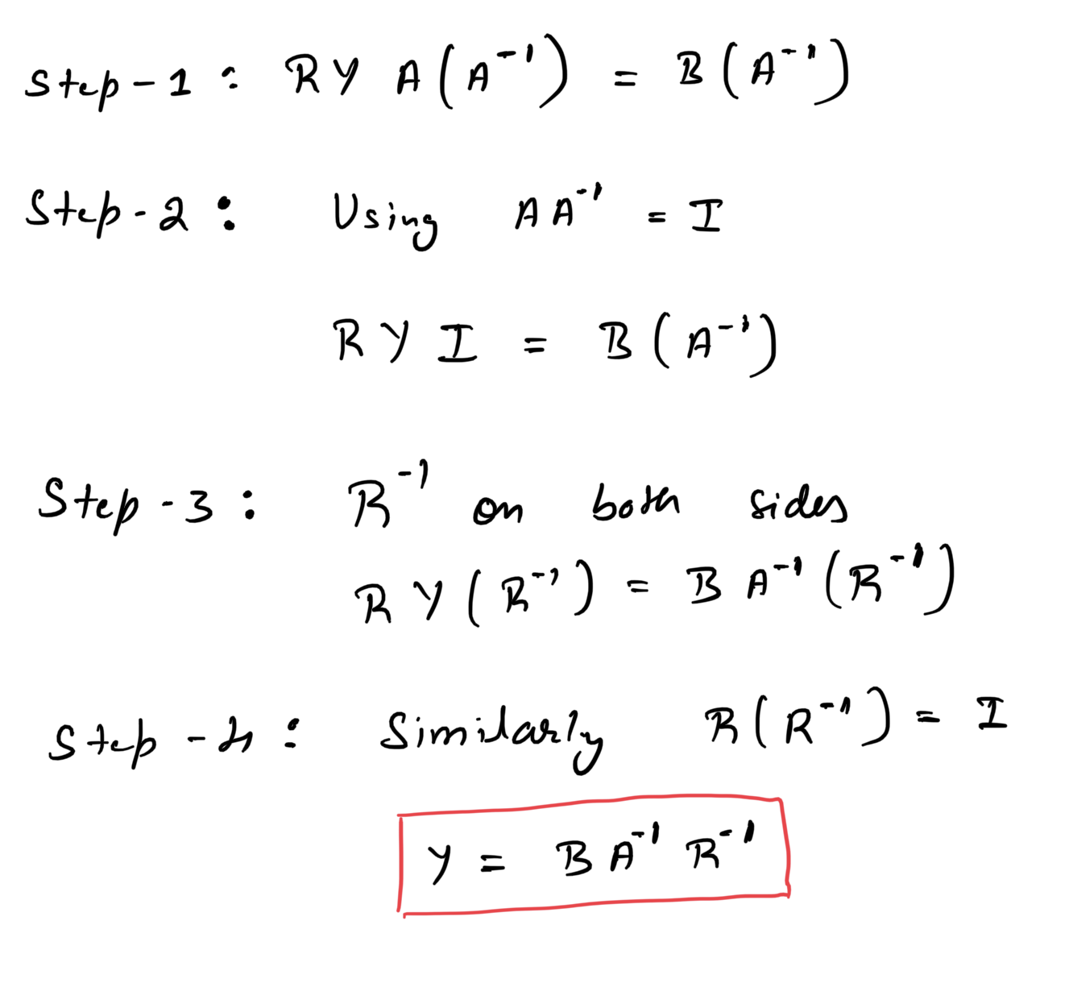

## b.

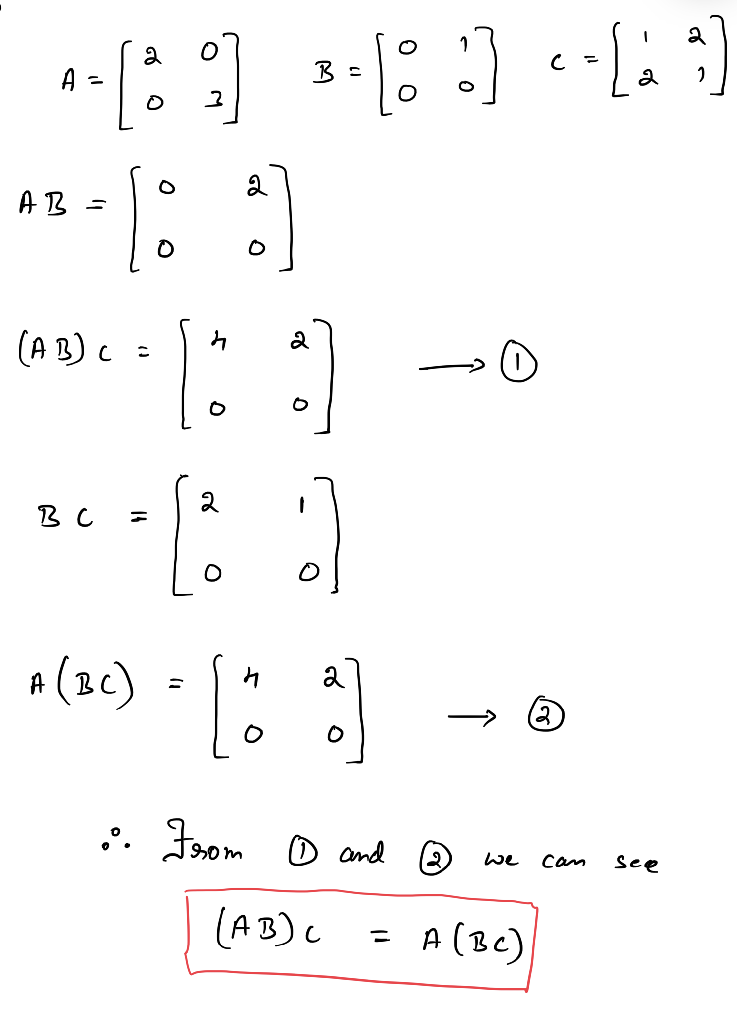

## c.

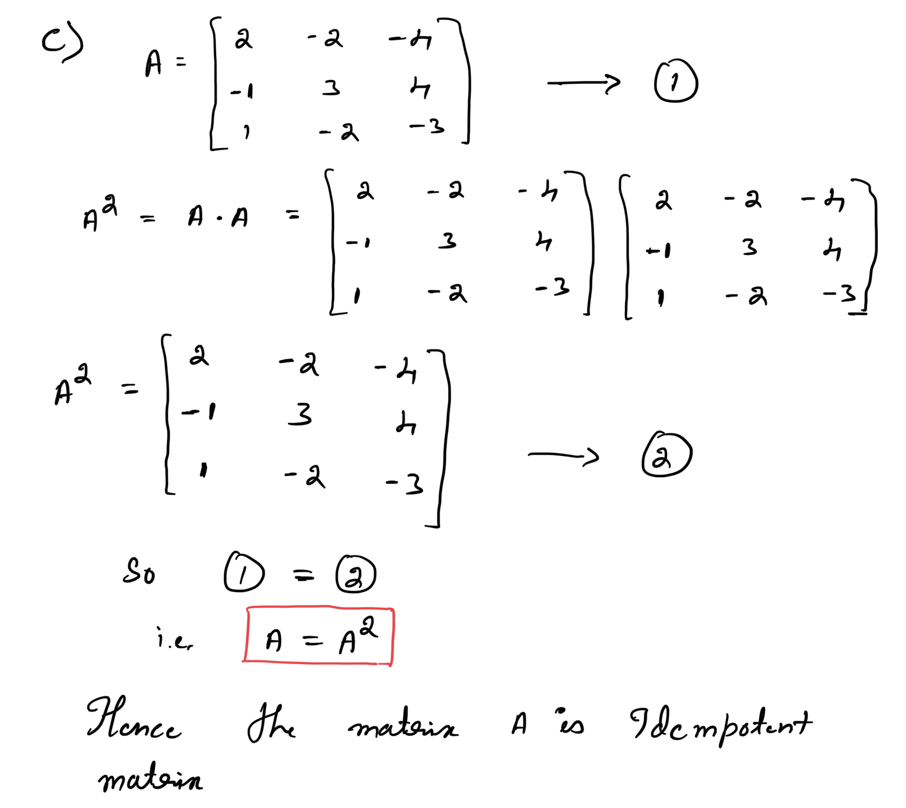

It is indeed feasible to locate an idempotent matrix whose determinant is non-zero. An identity matrix is a representative example of such a matrix. The identity matrix is a square matrix with 1s present along its main diagonal and 0s in the other elements. The property of being idempotent is derived from the fact that when multiplied by itself, an identity matrix results in itself. The determinant of an identity matrix is calculated as the product of the elements in its diagonal, which is 1. Therefore, an identity matrix is an idempotent matrix with a determinant value of 1, which is not equal to zero.

# 3.

## a.

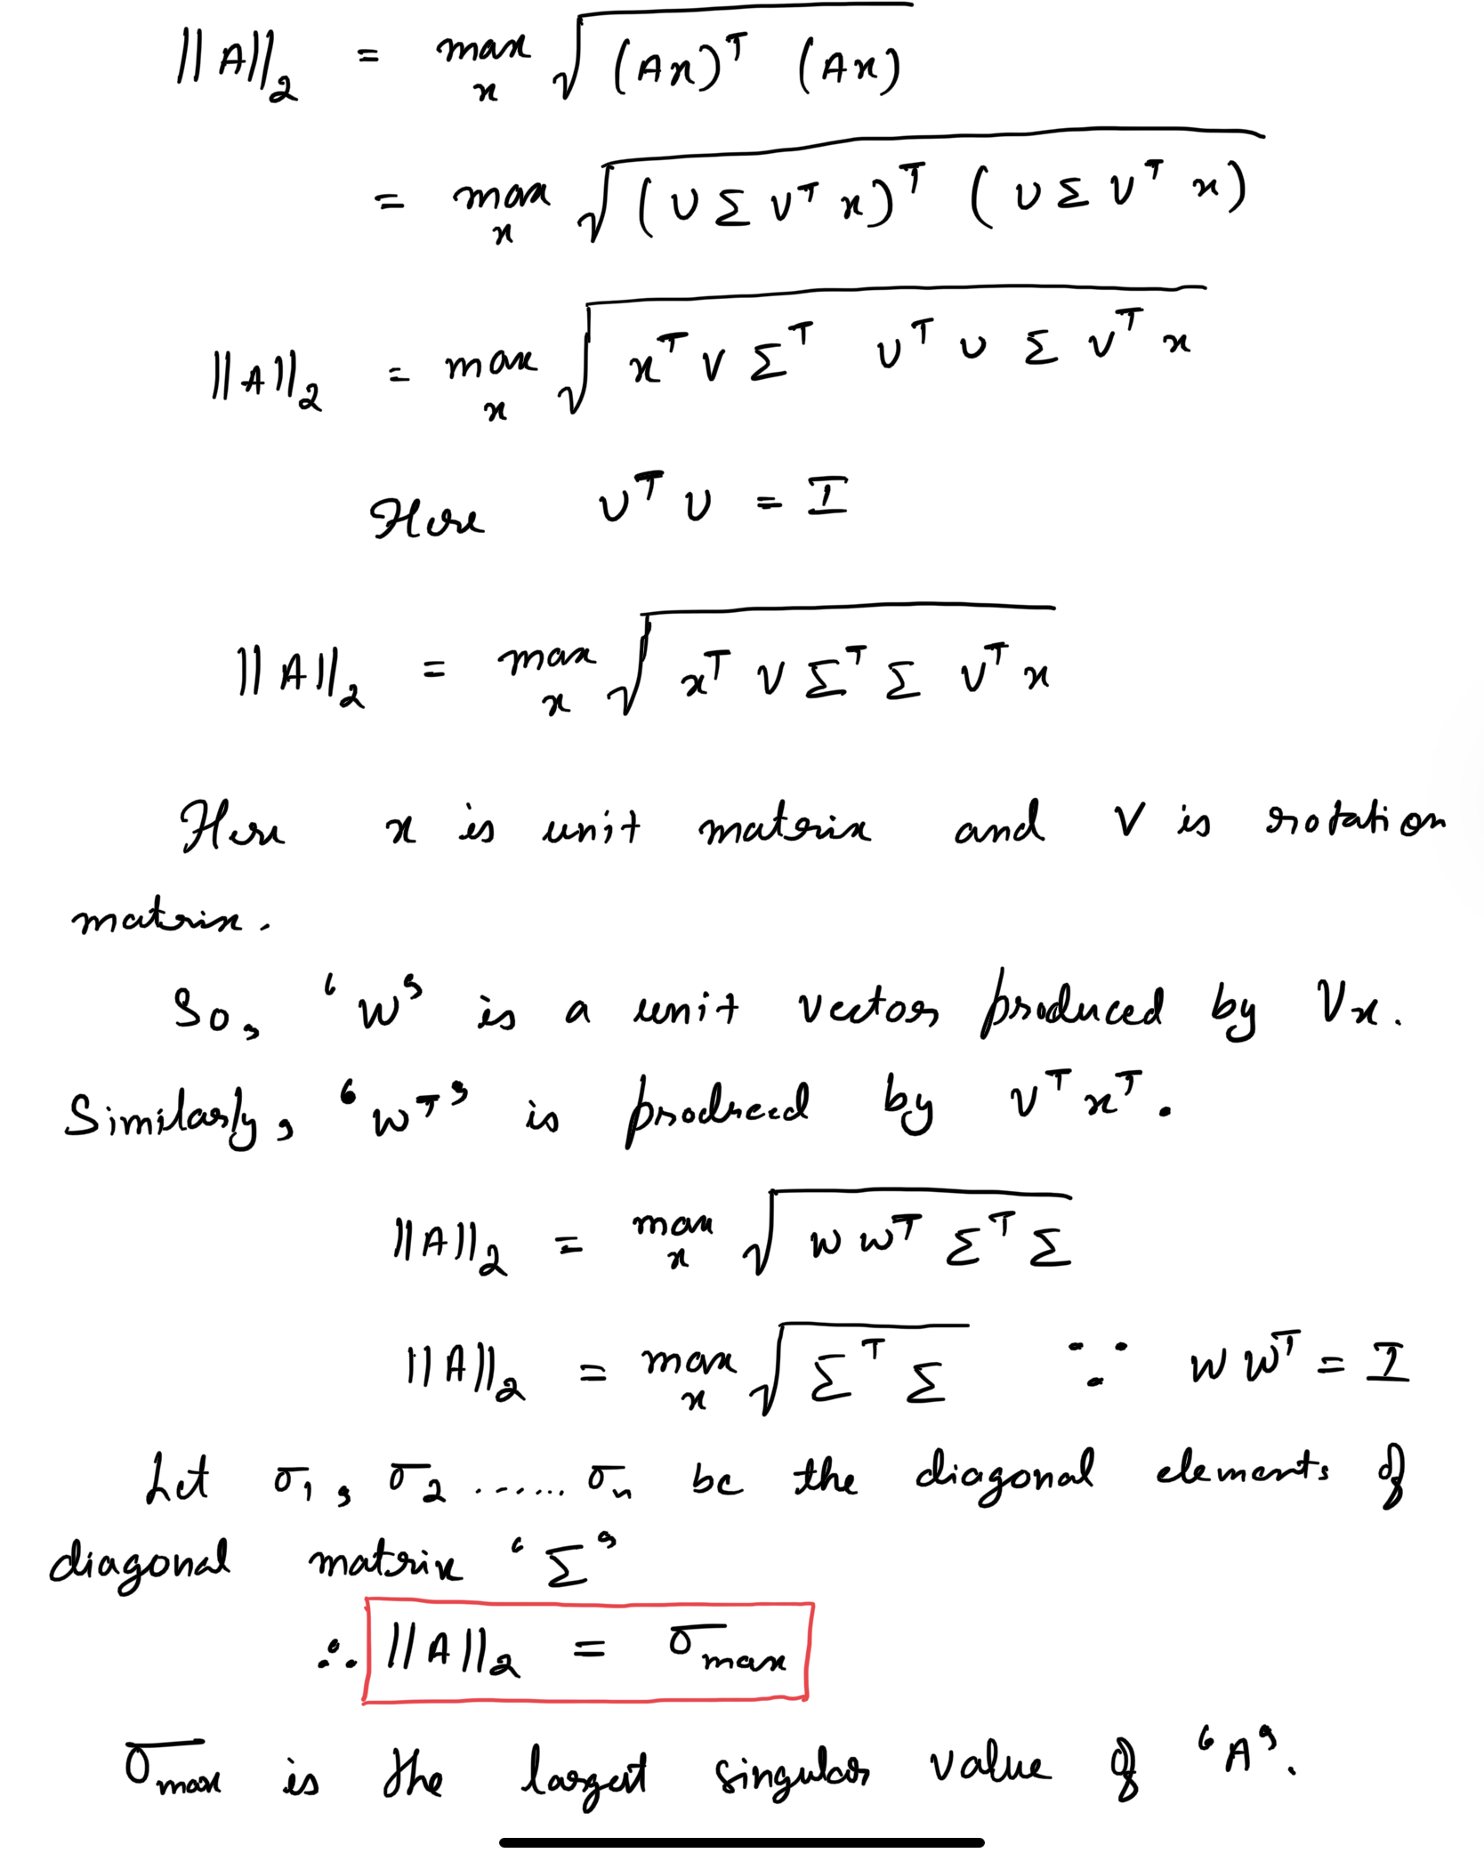

## b.

