PRADYOTH SINGENAHALLI PRABHU

02071847

[psingenahalliprabhu@umassd.edu](mailto:psingenahalliprabhu@umassd.edu)

CIS 552: Database Design – Homework 3

# Database “stored procedure” using SQL/PSM:

In this exercise we learnt the syntax and implementation of writing stored procedures. I have learned how to create a MySQL procedure called `incert_employee` that takes a several input parameters, including an employee's first name, middle initial, last name, social security number, birth date, address, sex, salary, supervisor's social security number, and department number. This procedure was written in MySQL and implemented in the IDE JetBrains DataGrip. I have also learned that procedures are like function, and stored procedure implementation can have input or output argument. The use of stored procedures can be advantageous in terms of time and effort savings by enabling the storage of lengthy SQL scripts that can be accessed by other queries through the CALL keyword at any given time.

## Creating a Stored Procedure:

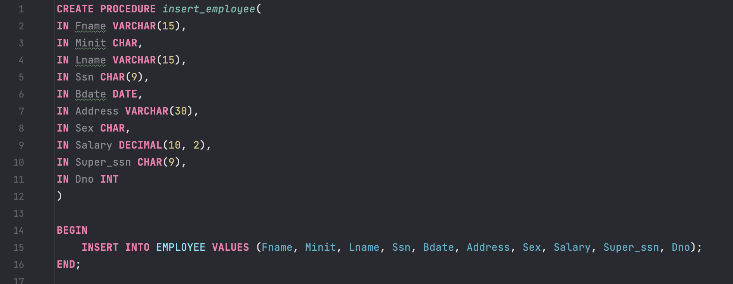

## Calling Stored Procedure:

Once the procedure was created, we proceeded to call the routine to generate an entry into the EMPLOYEE table. Specifically, we inserted an employee named 'Narendra' along with the relevant details using the input arguments required for the procedure call.

## Result:

We can see from the below table that new employee has been added along with all the details.

