PRADYOTH SINGENAHALLI PRABHU

02071847

[psingenahalliprabhu@umassd.edu](mailto:psingenahalliprabhu@umassd.edu)

CIS 552: Database Design – Homework 4

# Introduction:

In this assignment, I created an account in Microsoft Azure for Students and set up a MySQL database and SQL server in the Azure cloud. I also configured the network settings to allow public access and added my IPv4 to the allowed IP addresses. Lastly, I tested the connectivity of the database server using the Data Grip software.

# Database Setup:

To begin with, I created a MySQL database named ‘database-server-12’ and an SQL server named ‘database-server-12’ within a resource group named ‘database-1’ on the Azure cloud platform. I designated ‘database-server-12.mysql.database.azure.com’ as the database host name and ‘databaseserver12’ as the admin login name.

# Network Configuration:

Next, I modified the networking settings to allow public access and added my IPv4 address to the list of allowed IP addresses. This ensured that I would be able to access the database server from my computer.

# Migration Steps:

I am using MySQL Workbench for database migration.

## Source Selection:

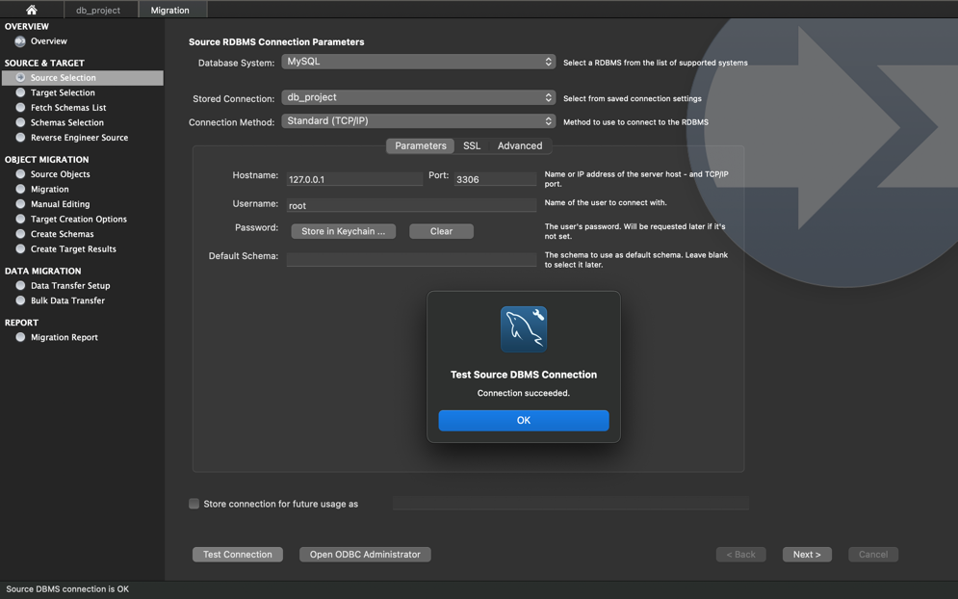

## Target Selection:

## Fetch Schema List:

The names of available schemas will be retrieved from the source RDBMS. The account used for the connection will need to have appropriate privileges for listing and reading the schemas you want to migrate. larger RUBMS connection settings will also be checked for validity.

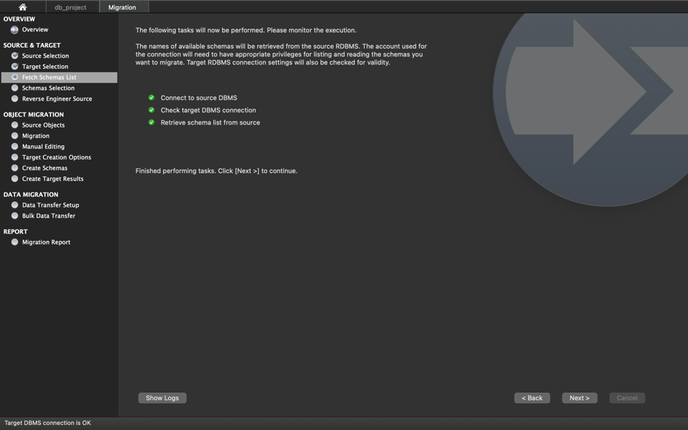

## Schemas Selection:

Here I am choosing only ‘HEALTHCARE’ schema for migration.

## Reverse Engineer Schema:

Selected schema metadata will now be fetched from the source RDBMS and reverse engineered so that its structure can be determined.

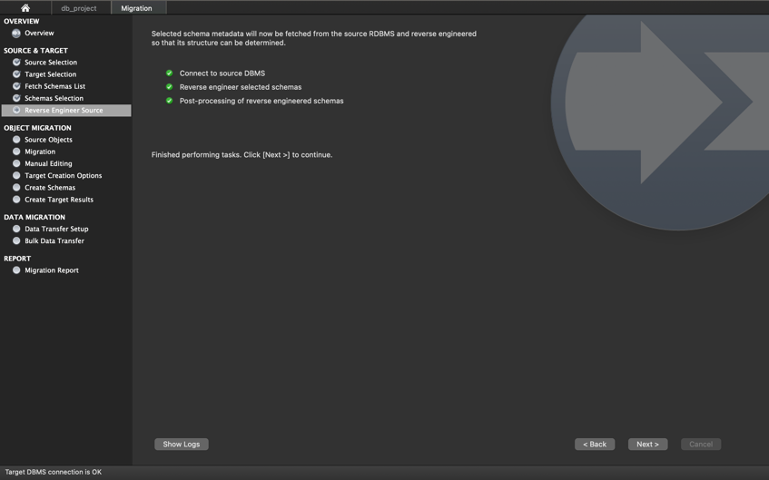

## Migration:

Reverse engineered objects from the source RDBMS will now be automatically converted into MySQL compatible objects. Default datatype and default column value mappings will be used. You will be able to review and edit generated objects and column definitions in the Manual Editing step.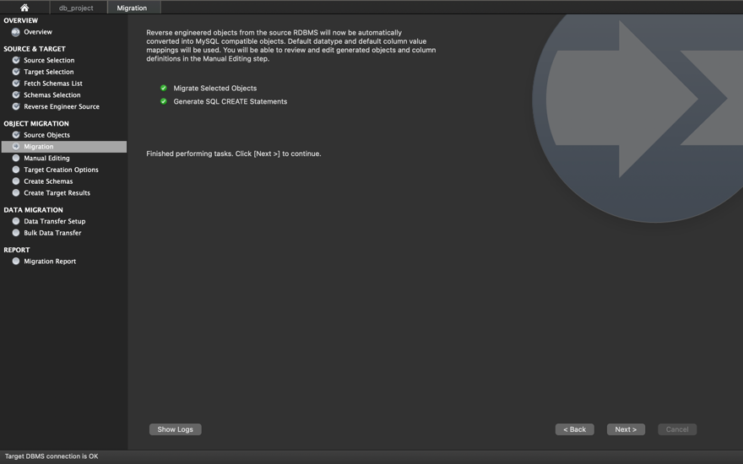

## Create Schemas:

The SQL scripts generated for the migrated schema objects will now be executed in the target database. You can monitor execution in the loas. If there are errors, you may correct them in the next step. able data will be migrated at a later step.

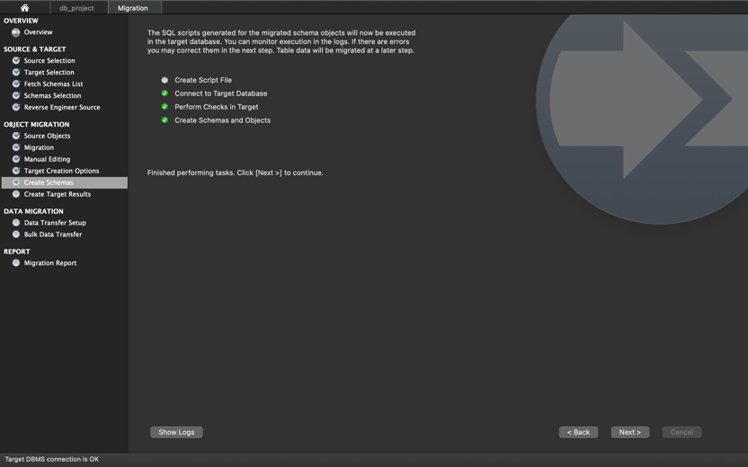

## Create Target Results:

Scripts to create the target schema were executed. No data has been migrated yet. Review the creation report below for errors or warnings. If there are any errors, you can manually fix the scripts and click [Recreate Objects] to retry the schema creation or return to the Manual Editing page to correct them there and retry the target creation.

## Data Transfer Setup:

## Bulk Data transfer:

## Migration Report:

# Results:

After Migration, all the tables are reflecting in the cloud database with data.

