PRADYOTH SINGENAHALLI PRABHU

02071847

[psingenahalliprabhu@umassd.edu](mailto:psingenahalliprabhu@umassd.edu)

CIS 552: Database Design – Homework 6

# Introduction:

In order to perform CRUD operations on MongoDB deployments, I am utilizing both the MongoDB Shell and MongoDB Compass. Specifically, I am using the 'mongosh' environment to interact with the database. This setup allows for efficient and effective management of data within the MongoDB environment.

## Pre-Requisites:

Connected using MongoDB Compass

Connected using MongoDB Shell:

# Creating a Database:

## Using MongoDB Compass:

The above image shows the step to create a database.

## Using MongoDB Shell:

In MongoDB Shell, inserting a data will create a collection if not exists.

# Inserting Document:

## Using MongoDB Compass:

## Using MongoDB Shell:

### Acknowledgement:

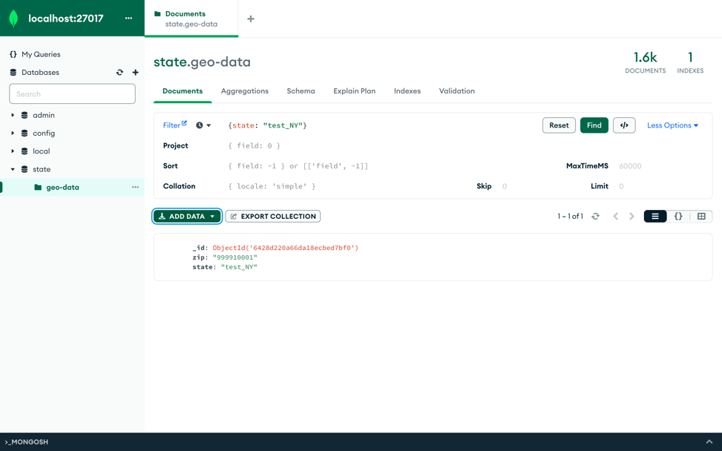

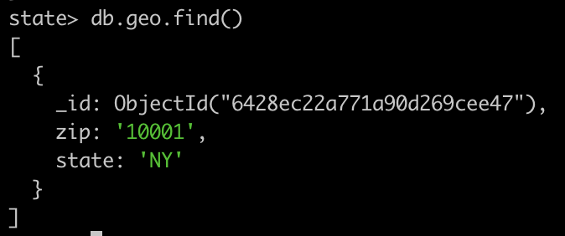

# Updating Document:

## Using MongoDB Compass:

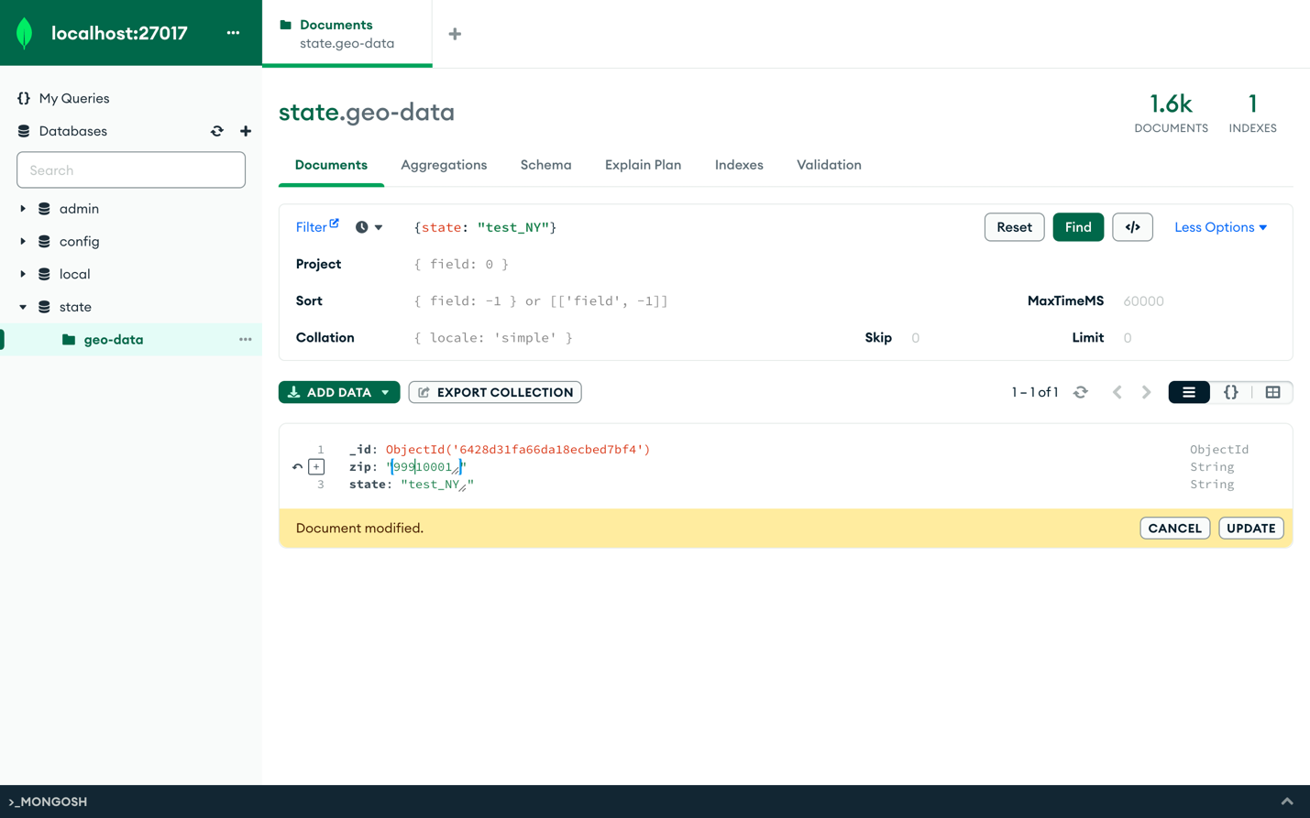

## Using MongoDB Shell:

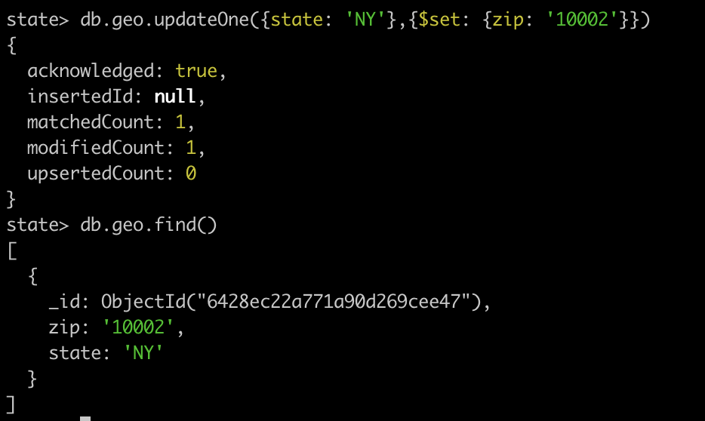

# Delete Documents:

## Using MongoDB Compass:

## Using MongoDB Shell:

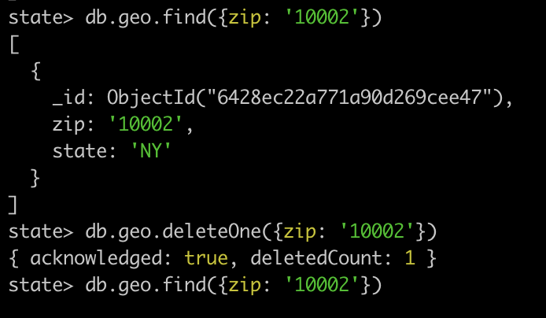

# Query Documents:

## Using MongoDB Compass:

## Using MongoDB Shell:

# Import Collection:

Imported Data:

# Exporting Collection:

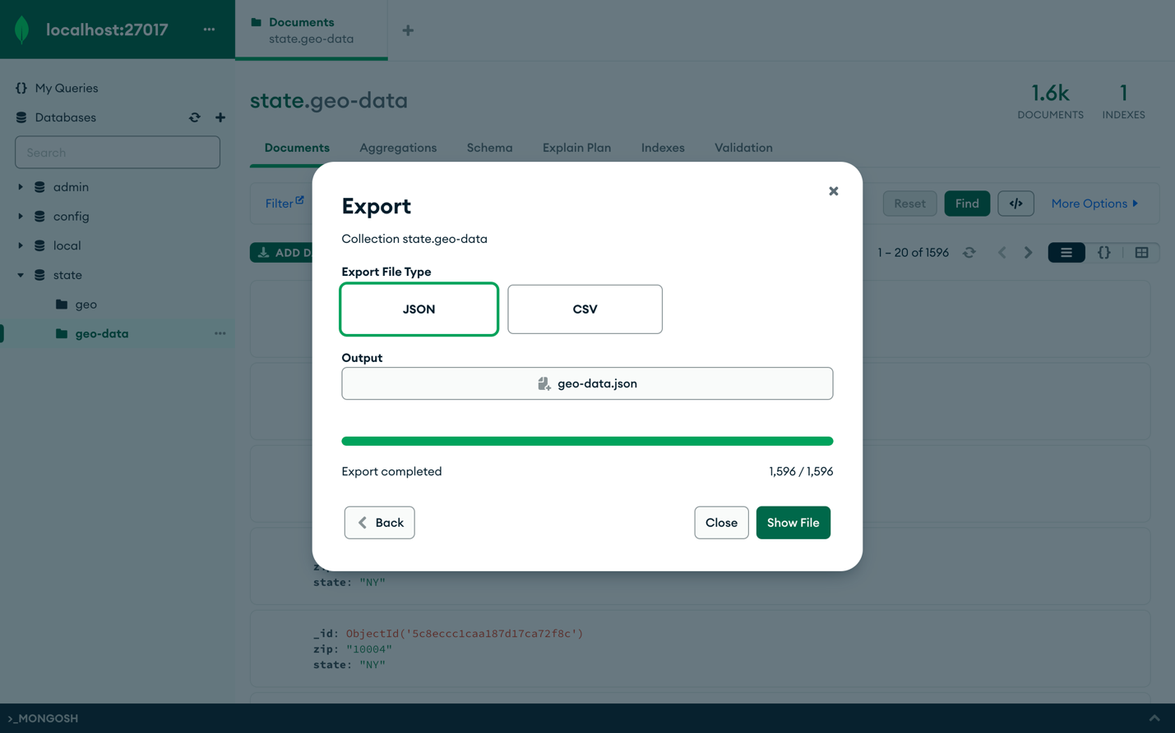

# Conclusion:

In conclusion, this assignment has provided hands-on experience with MongoDB, a popular NoSQL database system. Through the use of tools such as MongoDB Shell and MongoDB Compass, CRUD operations were performed, allowing for efficient management of data within MongoDB deployments. The 'mongosh' environment was particularly useful for interacting with the database. Additionally, MongoDB Compass was used to import and export collections, allowing for seamless data transfer between databases and backup of important data. This feature adds another layer of functionality to MongoDB Compass, making it a valuable tool in database management.