PRADYOTH SINGENAHALLI PRABHU

02071847

[psingenahalliprabhu@umassd.edu](mailto:psingenahalliprabhu@umassd.edu)

CIS 552: Database Design – Homework 7

# Introduction:

Neo4j is a highly scalable, native graph database that stores and manages large, interconnected datasets. It uses a property graph model to organize data into nodes and relationships for efficient querying. Neo4j is well-suited for social networking, recommendation engines, fraud detection, and identity and access management use cases. It offers a flexible data model, powerful query language, and indexing capabilities.

# Creating a Database:

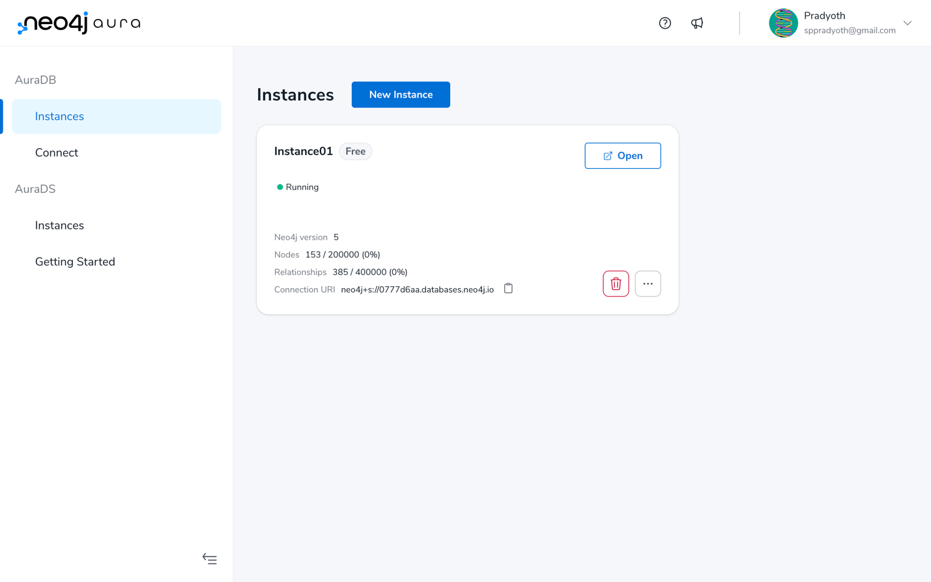

The above image shows the step to create a database.

After creating the database, I need to connect to the database via the neo4j website with the user and Password provided.

# Inserting Nodes and Edges:

After inserting the Nodes and Edges via the cypher code in the Ch14_FCC.txt. This is the result we get as shown below.

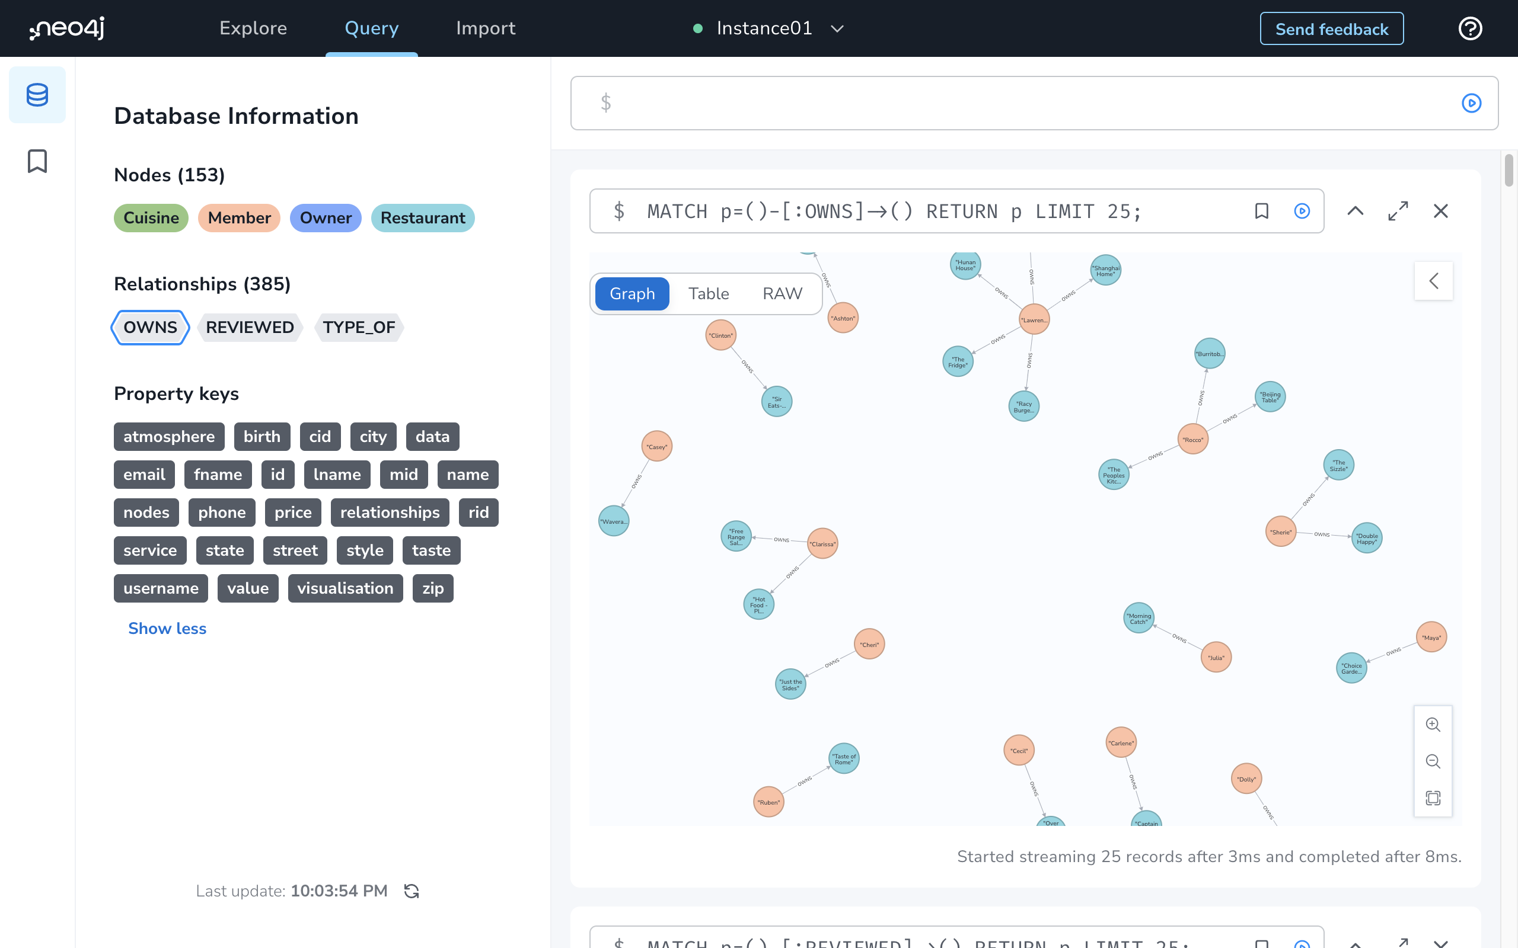

# Query Database using Cypher Query Language:

## Retrieve Restaurants and Cuisines Owned by Member Cecil Esparza:

## Retrieve Restaurant, Owner, and Cuisine Information for Restaurant with ID 4625:

## Retrieve Restaurant Review and Member Information for Member Cecil Esparza and Restaurant with ID 4657:

## Retrieve 25 Reviews with Their Associated Nodes:

# Conclusion:

In conclusion, Neo4j is a widely recognized and efficient graph database management solution that enables data storage and retrieval in a graph structure. It is particularly useful for complex use cases, such as social networks and fraud detection, due to its ability to represent and query intricate relationships. The Cypher query language used by Neo4j provides a flexible and expressive syntax for querying graph data, allowing developers to create and query complex relationships with ease. Neo4j's graph model and indexing capabilities make it a powerful tool for data analysis and insights. Overall, Neo4j is a valuable resource for developers, data scientists, and business analysts seeking to leverage graph database technology for their projects.