

PROJECT-

BLIND ASSISTANCE WRIST BAND

MADE BY
- AATIF (2023UEC2662)
- ATHANG (2023UEC2664)
- PRADYUMN (2023UEC2675)



SR no | Contents | Pg. no
1 | PROJECT DESCRIPTION AND OBJECTIVES | 3
2 | COMPONENTS REQUIRED | 3
3 | CIRCUIT DIAGRAMS | 5
4 | WIRING CONNECTIONS AND 3D LAYOUT | 6
5 | REAL LIFE WORKING MODEL AND ARDUINO CODE | 7
6 | WORKING PRINCIPLE AND ROLE OF COMPONENTS | 10
7 | METHODOLOGY AND FUTURE ENHANCEMENT | 11
8 | OBSERVATION AND RESULTS | 12
9 | CONCLUSION | 13
INDEX

Project Description
This project presents a wearable Blind Assistance Device designed to help visually impaired individuals navigate safely. It uses two ultrasonic sensors — one facing forward to detect obstacles ahead and another facing downward to sense changes in ground level like steps or slopes. The device provides real-time alerts through vibrations or sound, allowing the user to respond quickly and avoid accidents. It is compact, cost-effective, and suitable for both indoor and outdoor use.
Objectives
- To design and develop a low-cost, wearable electronic aid for visually impaired individuals.
- To implement ultrasonic sensors to detect obstacles in front of and below the user.
- To minimize the risk of accidents caused by unseen obstacles such as steps, potholes, or other hindrances.
- To ensure the system works reliably under various environmental conditions and surface types

Components Required
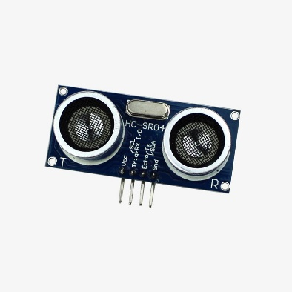
Ultrasonic Sensor Module - HC-SR04
The HC-SR04 is an ultrasonic distance sensor module commonly used in obstacle detection and range-finding applications. It integrates an ultrasonic transmitter and receiver to measure distances from 2 cm to 400 cm with high accuracy, making it ideal for robotics and assistive devices.
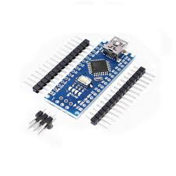
Nano R3 CH340 Chip Development Board
The Nano R3 CH340 is a compact microcontroller development board based on the ATmega328P, featuring the CH340 USB-to-Serial chip for communication. It offers similar functionality to the Arduino Uno but in a smaller form factor, making it ideal for space-constrained projects like wearable and embedded systems.

Zero PCB
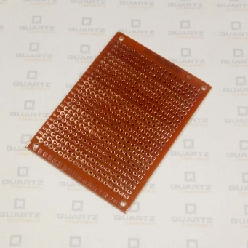
The Zero PCB (Printed Circuit Board) is a general-purpose board used for prototyping electronic circuits. It features a grid of pre-drilled holes with copper pads that allow easy mounting and soldering of components without needing a custom PCB layout.

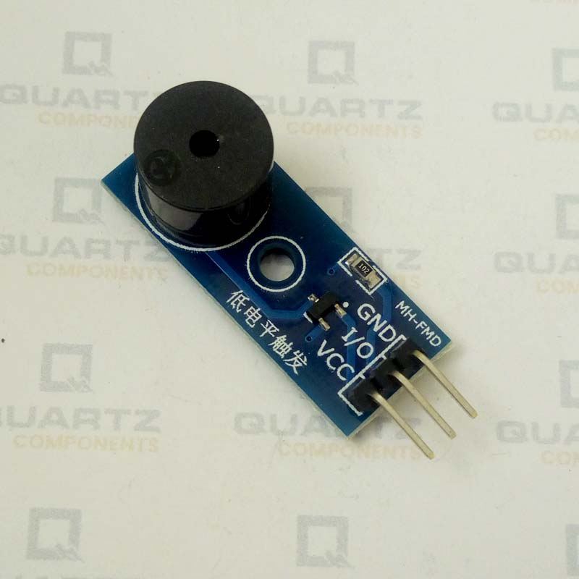
Passive Buzzer Module with PCB:
The Passive Buzzer Module with PCB generates sound when it receives a signal from a microcontroller like Arduino. It is used to provide audio alerts in response to detected obstacles or drops.

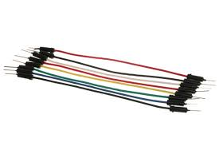
Wires
Wires play a crucial role in electrical circuits by providing a conductive path for current to flow between components, ensuring proper connectivity and signal transmission.

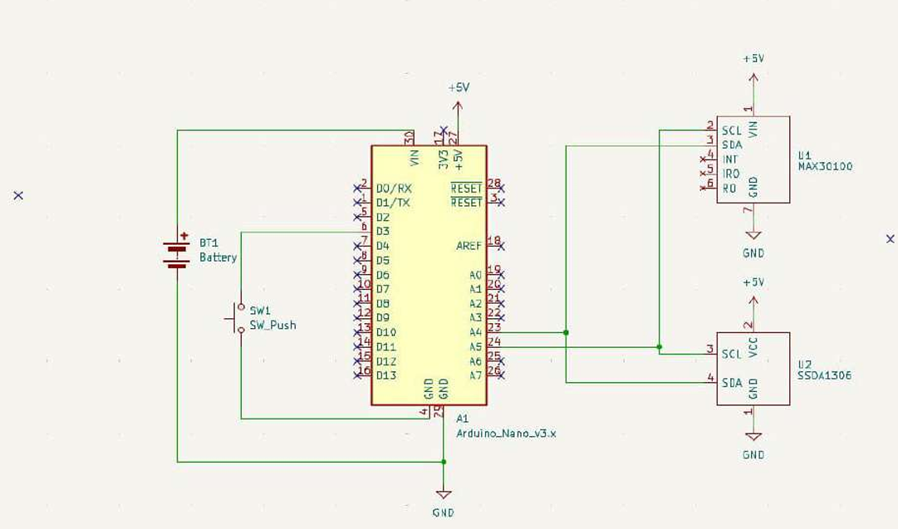
Circuit Diagram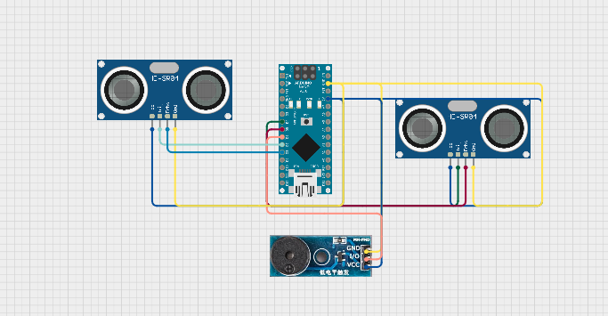

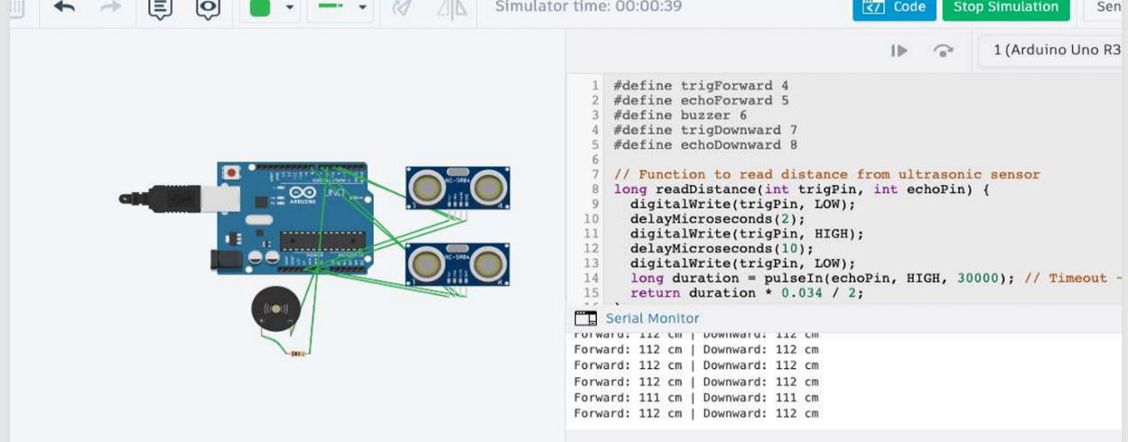

Wiring Connections: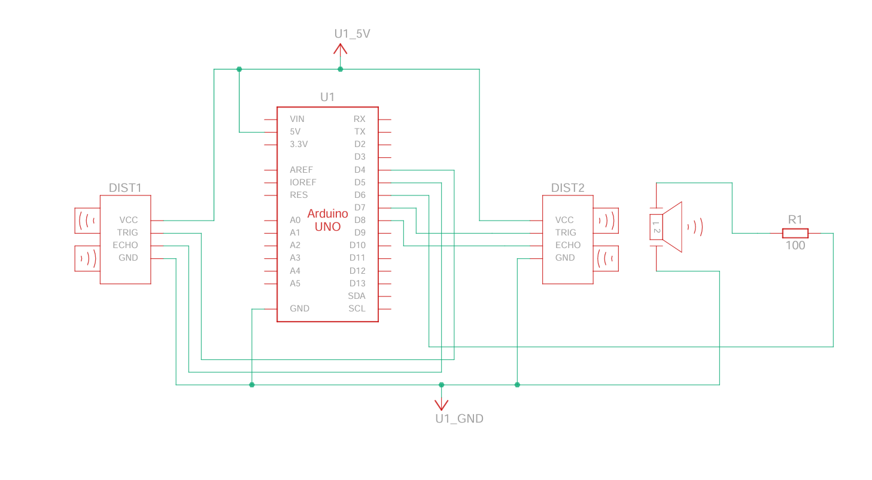
Passive buzzer module
I/OD6(Arduino Nano)
VCC 5V(Arduino Nano)
GNDGND(Arduino Nano)
DOWNWARD FACING SENSOR
VCC5V
GND GND
TRIGG D7
ECHOD8
FORWARD FACING SENSOR
VCC5V
GND GND
TRIGG D4
ECHOD5
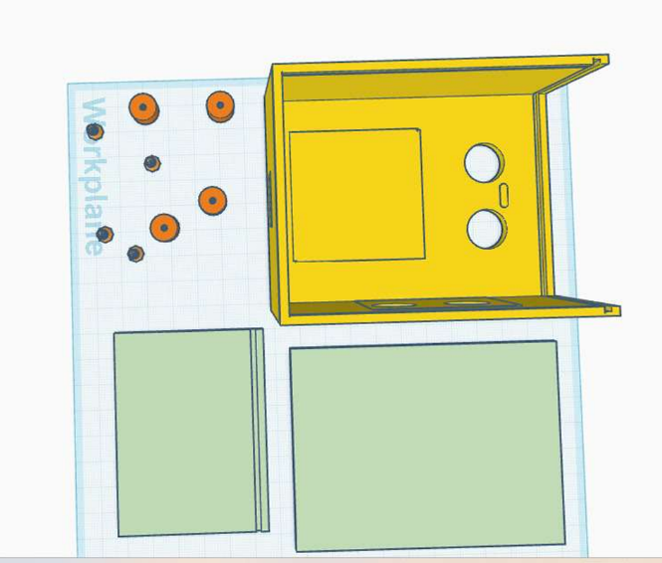
3D LAYOUT
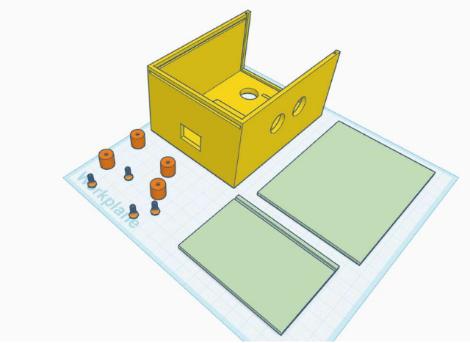

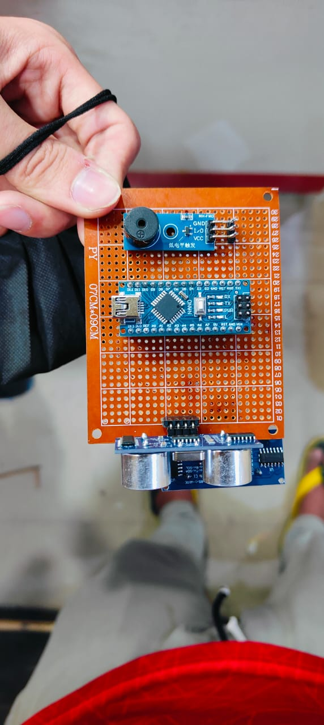
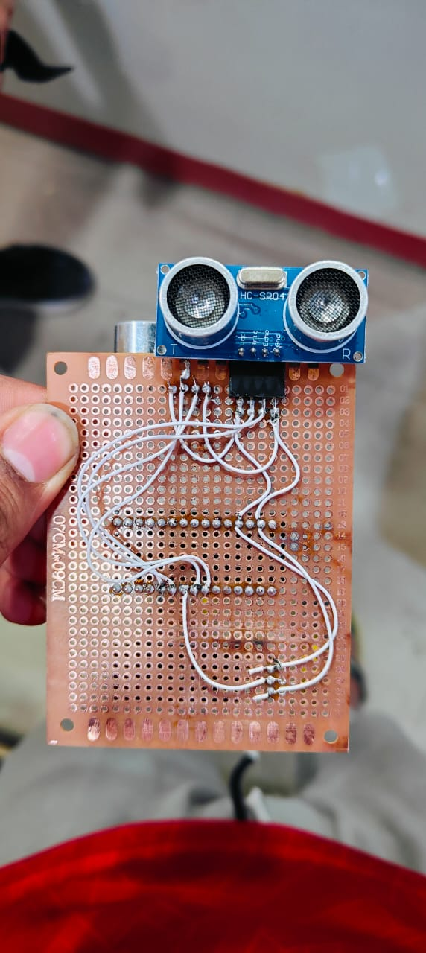
REAL LIFE WORKING MODEL

ARDUINO CODE
#define trigForward 4
#define echoForward 5
#define buzzer 6
#define trigDownward 7
#define echoDownward 8
// Function to read distance from ultrasonic sensor
long readDistance(int trigPin, int echoPin) {
digitalWrite(trigPin, LOW);
delayMicroseconds(2);
digitalWrite(trigPin, HIGH);
delayMicroseconds(10);
digitalWrite(trigPin, LOW);
long duration = pulseIn(echoPin, HIGH, 30000); // Timeout ~30ms = ~500cm
return duration * 0.034 / 2;
}
void setup() {
Serial.begin(9600);
pinMode(trigForward, OUTPUT);
pinMode(echoForward, INPUT);
pinMode(trigDownward, OUTPUT);
pinMode(echoDownward, INPUT);
pinMode(buzzer, OUTPUT);
digitalWrite(buzzer, LOW);
}
void loop() {
long forwardDist = readDistance(trigForward, echoForward);
long downwardDist = readDistance(trigDownward, echoDownward);

bool forwardTrig = (forwardDist > 0 && forwardDist <= 80); // Close or normal
bool downwardTrig = (downwardDist <= 50 || downwardDist > 110); // Raised or deep below
Serial.print("Forward: ");
Serial.print(forwardDist);
Serial.print(" cm | Downward: ");
Serial.print(downwardDist);
Serial.println(" cm");
// 1. Both forward and downward conditions triggered
if (forwardTrig && downwardTrig) {
tone(buzzer, 2000); // Combo alert tone
delay(200);
noTone(buzzer);
delay(200);
}
// 2. Forward-only alerts
else if (forwardDist > 0 && forwardDist <= 20) {
tone(buzzer, 1000); // Very close object ahead
delay(1000);
noTone(buzzer);
delay(100);
}
else if (forwardDist > 20 && forwardDist <= 80) {
tone(buzzer, 1200); // Object in normal forward range
delay(300);
noTone(buzzer);
delay(300);
}
// 3. Downward-only alerts
else if (downwardDist > 110) {
tone(buzzer, 1500); // Deep drop below
delay(200);
noTone(buzzer);
delay(800);
}
else if (downwardDist > 0 && downwardDist <= 50) {
tone(buzzer, 1700); // Raised object below
delay(100);
noTone(buzzer);
delay(100);
}
delay(100); // Stability delay
}

Working Principles:
The device uses two ultrasonic sensors to detect obstacles — one facing forward to sense objects in front, and one facing downward to detect steps or drops. These sensors measure distance by emitting ultrasonic waves and calculating the time taken for the echo to return. The Arduino Nano processes this data and activates a vibration motor or buzzer to alert the user in real-time.
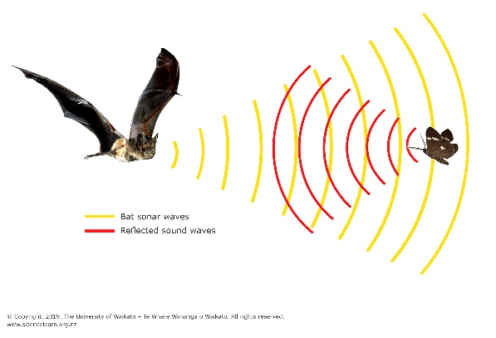
The ultrasonic sensors use the concept of echolocation, which is the process of emitting sound waves and measuring the time it takes for the echoes to return after bouncing off an object, allowing the device to calculate the distance to that object.

Role of Components:
1. Arduino Nano (CH340):
Acts as the brain of the device. It reads distance data from the ultrasonic sensors, processes the information, and controls the output components (buzzer/vibrator) to alert the user based on obstacle detection.
2. Ultrasonic Sensor (HC-SR04):
Measures the distance to nearby objects using ultrasonic waves. The front sensor detects obstacles ahead, while the downward sensor detects changes in ground level like steps or slopes.
3. Passive Buzzer Module with PCB:
Provides auditory feedback to the user when an obstacle or step is detected. It is activated by the Arduino Nano to alert the user in real-time.
Methodology
The project began with selecting suitable components like the Arduino Nano, ultrasonic sensors, and a passive buzzer. Two HC-SR04 sensors were mounted—one facing forward to detect obstacles and another facing downward to detect steps or drops. The Arduino Nano was programmed to read sensor data, calculate distances, and trigger alerts through the buzzer or vibration motor when obstacles were detected within a set range. The entire circuit was assembled on a Zero PCB for testing. The device was then powered using a battery and tested in different environments to ensure reliable performance.
Future Enhancement:
- GPS and Navigation Support:
Integrating GPS can help guide visually impaired users to their destination. It can also suggest safe routes and alert to turns or crossings.
- Voice Assistance:
Adding a speaker module can provide spoken alerts, making the feedback more understandable and user-friendly.
- Object Identification using AI:
With a camera and AI model, the device could recognize and differentiate objects like stairs, people, or vehicles for smarter navigation.
- Smartphone Integration:
Bluetooth or Wi-Fi connectivity can allow the device to sync with a mobile app for real-time tracking and emergency communication.
- Rechargeable Battery with Solar Charging:
Adding a rechargeable battery and a small solar panel can make the device more sustainable and reduce the need for frequent charging.

Observations:
- Obstacle Detection: The front ultrasonic sensor accurately detects obstacles within a range of 2 cm to 400 cm. When an object is detected within the set range (e.g., 100 cm), the device provides real-time feedback through vibration or sound.
- Ground Level Detection: The downward-facing ultrasonic sensor successfully detects changes in ground level, such as stairs or sudden drops. Alerts were triggered when the sensor measured a significant drop in distance, indicating potential hazards like steps.
- Power Consumption: The device operates continuously for several hours on a fully charged battery, with power consumption being relatively low due to the efficient design of the sensors and the processing unit.
Results:
- Effectiveness in Obstacle Avoidance: In controlled tests, the device successfully alerted users to obstacles like walls, poles, and furniture, preventing collisions and improving safety during navigation.
- Step Detection: The downward sensor reliably detected steps and sudden drops, providing timely alerts to help users navigate stairways and uneven ground safely.
- User Feedback: Initial user testing indicated that the vibration feedback was sufficient for immediate awareness, and some users preferred the audio feedback option for more clarity.
Advantages:
- Enhanced Safety: Helps visually impaired individuals detect obstacles and sudden drops, reducing the risk of accidents.
- Low Cost & Portable: Uses affordable components and has a compact design, making it accessible and easy to carry.
- Real-Time Feedback: Provides instant alerts through vibration or sound, allowing users to react immediately to their surroundings.
Limitations:
- Limited Range: Ultrasonic sensors have a limited detection range and may not perform well in very noisy or reflective environments.
- No Object Identification: The system detects obstacles but cannot classify or identify them (e.g., stairs vs. pothole).
- Power Dependency: Continuous operation depends on a stable power source or battery, which may require frequent recharging.
Conclusion:
The Blind Assistance Device successfully demonstrates the use of ultrasonic sensors to enhance the mobility and safety of visually impaired individuals. By providing real-time alerts for obstacles and changes in ground level, it can significantly reduce the risk of accidents. With its compact and cost-effective design, this device holds potential for widespread use in various environments, aiding users in navigating more independently.

