**Computational Fluid Dynamics**

**Assignment – 1**

***Submitted by:***

**Pradyumna D Thayur : ENG19ME0025**

**VIIth Semester, B.Tech, Mechanical Engineering**

**DSU.**

**Date: 12-10-2022**

**Objective:**

Solving the Poisson’s Equation in 2-D for Steady State Conduction subject to Convective Boundary Conditions using FDM and Gauss-Seidel Algorithm with relaxation.

**Problem Statement:**

A rectangular plate (2L x 2W) of material with thermal conductivity ‘k’ with uniform heat generation of q’’’ is exposed to a convective medium at T= T∞ and convective heat transfer coefficient ‘h’. The heat transfer is taking place at steady state in both the x and y directions. Due to symmetry, the domain can be divided into 4 equal sections and the solution can be calculated for only one section as the temperature field will be symmetric for all the sections.

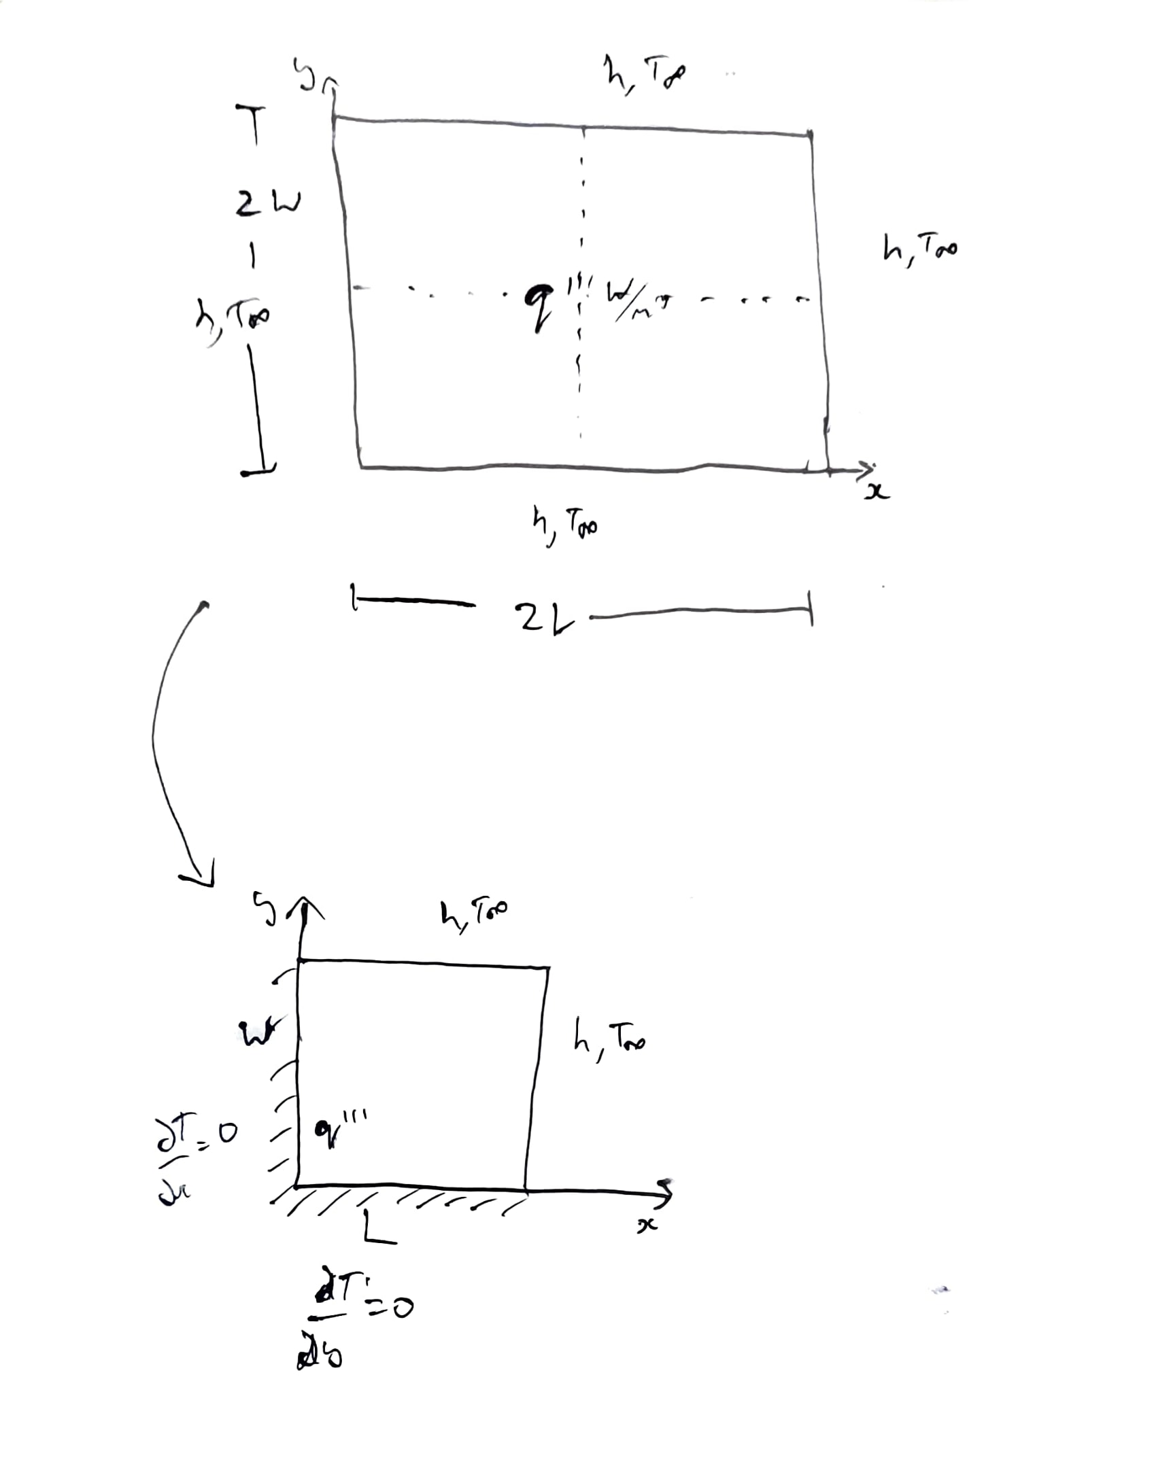

**Formulation**

The Governing Differential Equation is:

$$\frac{δ^{2}T}{δx^{2}}+\frac{δ^{2}T}{δy^{2}}+\frac{q'''}{k} = 0$$

Non-Dimensional form:

$$\frac{δ^{2}θ}{δX^{2}}+A^{2}\frac{δ^{2}θ}{δY^{2}}=-1$$

Where,

$$θ=\frac{Θ}{q^{'''}\frac{L^{2}}{k}}$$

$$Θ=T\left(x,y\right)-T_{∞}$$

$$A=\frac{L}{W}$$

$$X=\frac{x}{L} , Y=\frac{y}{W}$$

$$∴x=LX , y=WY$$

Boundary Conditions,

Left Edge,

$$\frac{δθ}{δX}|_{X=0,Y}=0$$

Bottom Edge,

$$\frac{δθ}{δY}|_{X,Y=0}=0$$

Right Edge,

$$\frac{δθ}{δX}|_{X=1,Y}=-Biθ_{L}$$

Top Edge,

$$\frac{δθ}{δY}|_{X,Y=1}=-\frac{Bi}{A}θ_{W}$$

**Discretization**

Dividing the domain into m and n nodes respectively along L and W and using 2nd Order Central Difference method for the differential equation, we get the following expression for $θ_{i,j}$,

$$\backslash Delta X = \backslash frac\{1\}\{m\} \& \backslash Delta Y = \backslash frac\{1\}\{n\}$$

$$θ_{i,j}=\frac{ΔY^{2}\left[θ_{i-1,j}+θ_{i+1,j}\right]+A^{2}ΔX^{2}\left[θ_{i,j-1}+θ_{i,j+1}\right]+ΔX^{2}ΔY^{2}}{2\left(ΔY^{2}+A^{2}ΔX^{2}\right)} for 2≤i≤m \& 2≤j≤n$$

At the right edge,

$$θ_{i,j}=\frac{2ΔY^{2}\left[θ_{i-1,j}\right]+A^{2}ΔX^{2}\left[θ_{i,j-1}+θ_{i,j+1}\right]+ΔX^{2}ΔY^{2}}{2\left(ΔY^{2}+A^{2}ΔX^{2}+BiΔXΔY^{2}\right)} for i=m+1 \& 2≤j≤n$$

At the top edge,

$$θ_{i,j}=\frac{ΔY^{2}\left[θ_{i-1,j}+θ_{i+1,j}\right]+2A^{2}ΔX^{2}\left[θ_{i,j-1}\right]+ΔX^{2}ΔY^{2}}{2\left(ΔY^{2}+A^{2}ΔX^{2}+BiAΔX^{2}ΔY\right)} for 2≤i≤m \& j=n+1$$

At the left edge,

$$θ_{i,j}=\frac{2ΔY^{2}\left[θ_{i+1,j}\right]+A^{2}ΔX^{2}\left[θ_{i,j-1}+θ_{i,j+1}\right]+ΔX^{2}ΔY^{2}}{2\left(ΔY^{2}+A^{2}ΔX^{2}\right)} for i=1 \& 2≤j≤n$$

At the bottom edge,

$$θ_{i,j}=\frac{ΔY^{2}\left[θ_{i-1,j}+θ_{i+1,j}\right]+2A^{2}ΔX^{2}\left[θ_{i,j+1}\right]+ΔX^{2}ΔY^{2}}{2\left(ΔY^{2}+A^{2}ΔX^{2}\right)} for 2≤i≤m \& j=1$$

At the top right corner,

$$θ_{i,j}=\frac{ΔY^{2}\left[θ_{i-1,j}+θ_{i+1,j}\right]+A^{2}ΔX^{2}\left[θ_{i,j-1}+θ_{i,j+1}\right]+ΔX^{2}ΔY^{2}}{2\left(ΔY^{2}+A^{2}ΔX^{2}+Bi\left(AΔX^{2}ΔY+ΔXΔY^{2}\right)\right)} for i=m+1 \& j=n+1$$

At the top left corner,

$$θ_{i,j}=\frac{2ΔY^{2}\left[θ_{i+1,j}\right]+2A^{2}ΔX^{2}\left[θ_{i,j-1}\right]+ΔX^{2}ΔY^{2}}{2\left(ΔY^{2}+A^{2}ΔX^{2}BiAΔX^{2}ΔY\right)} for i=1 \& j=n+1$$

At the bottom right corner,

$$θ_{i,j}=\frac{2ΔY^{2}\left[θ_{i-1,j}\right]+2A^{2}ΔX^{2}\left[θ_{i,j+1}\right]+ΔX^{2}ΔY^{2}}{2\left(ΔY^{2}+A^{2}ΔX^{2}BiΔXΔY^{2}\right)} for i=m+1 \& j=1$$

At the bottom left corner,

$$θ_{i,j}=\frac{2ΔY^{2}\left[θ_{i+1,j}\right]+2A^{2}ΔX^{2}\left[θ_{i,j+1}\right]+ΔX^{2}ΔY^{2}}{2\left(ΔY^{2}+A^{2}ΔX^{2}\right)} for i=1 \& j=1$$