Requirement Document

**VEHICLE DOCUMENTS AUTHENTICATION SYSTEM**

1. **Objective:**

* Eliminating usage of fake documents.
* To store information of the vehicle documents.
* Display the document information whenever the user requires.

1. **Scope:**

The vehicle documents authentication system considerably reduces the rate of corruption occurring in RTO department. The documents will be stored safely in the database and also reduces the burden of carrying hard copy of the documents.

1. **Application Functionality:**

The vehicle documents authentication system mainly reduces the burden of carrying all the vehicle documents while travelling but introduces a new method of document verification by accessing the document informations from the database at the time of document verification by the traffic police.In this system the documents will be stored safely in the database.Whenever an individual purchases a new vehicle the RTO admin will update all the document informations to the database and the user can view the information of the vehicle from the database by using his login credentials.Also the emission check centers and vehicle insurance companies can update the document informations regarding the pollution check and vehicle insurance.The user can check the documents whenever required.

* 1. User Login To View Documents

The user has to use the vehicle registration number as user id and also should set password inorder to successfully log in and view the vehicle documents but cannot update any document.

* 1. RTO Admin Login To Update Vehicle Documents

The RTO admin has to use the RTO user ID and password inorder to successfully log in and update the vehicle documents.

* 1. Insurance Company Admin Login To Update Insurance

The insurance company admin has to use the insurance company user ID and password to successfully log in and update the vehicle insurance.

* 1. Emission Test Center Admin Login To Update Pollution Report

The emission check center admin has to use the emission check center user ID and password to successfully log in and update the emission check report.

1. **Application User**

**User:**

The application user can be owner of the vehicle who can view all the documents related to vehicle and check for the expiry dates of any document which is going to expire in further upcoming days.

**RTO Admin:**

The RTO admin is the authority who updates the vehicle RC number,Vehicle registration number,vehicle name,vehicle model,fuel norms,vehicle owner name.

**Insurance Company Admin:**

The vehicle insurance company admin updates the vehicle insurance information.

**Emission Test Center Admin:**

The Emission test center admin will update the vehicle emission check reports.

**Back end: Oracle Database**

1. **ER Diagram:**
2. **Database Design:**

The database design mainly consists of vehicle details,RTO details,insurance company details,emission test center details .Along with these tables there are login tables for user,RTO admin,emission test center admin and insurance company admin.The vehicle details will stored in a separate table.The user has to use his login credentials to log in and view all the vehicle documents.The RTO admin can use the login credentials to log in and update certain vehicle documents.Also the emission test center admin and insurance company admin can use their login credentials to log in and update the emission test report and insurance document informations.

**7.Constraint:**

The primary key in the vehicle details table is the Vehiclereg_id which acts as foreign key in user login table,RTO details,insurance company details,emission test center details.The Vehiclereg_number which is the userid in user log in table is primary key in user login table.The RTOadmin_id is the primary key in RTO details table.The RTO user id is the primary key in RTO log in table.The insurance company admin id is the primary key in insurance company details table.The insurance company user id is the primary key in insurance company login table. The emission test center admin id is the primary key in emissiontestcenter details table.The emission test center user id is the primary key in emission test center login table.The Rc number in vehicle details table is unique.The vehicle registration number in user log in table is unique.

**Table Description**

|  |  |  |  |
| --- | --- | --- | --- |
| TABLE NAME | COLUMN NAME | CONSTRAINTS | DEFAULT VALUE |
| VEHICLE_DETAILS | Vehiclereg_id  Vehicle_owner  Vehicle_name  Vehicle_model  Fuel_norms  Rc_number  Emission_upto_date  Insurance_upto_date | PRIMARY KEY  NOT NULL  NOT NULL  NOT NULL  NOT NULL  UNIQUE KEY  NOT NULL  NOT NULL |  |

|  |  |  |  |
| --- | --- | --- | --- |
| TABLE NAME | COLUMN NAME | CONSTRAINTS | DEFAULT VALUE |
| USERLOGIN_DETAILS | Vehiclereg_id  Vehiclereg_number  User_password | FOREIGN KEY  PRIMARY KEY,NOT NULL  NOT NULL |  |

|  |  |  |  |
| --- | --- | --- | --- |
| TABLE NAME | COLUMN NAME | CONSTRAINTS | DEFAULT VALUE |
| RTO_DETAILS | Vehiclereg_id  RTOadmin_id  City | FOREIGN KEY  PRIMARY KEY  NOT NULL |  |

|  |  |  |  |
| --- | --- | --- | --- |
| TABLE NAME | COLUMN NAME | CONSTRAINTS | DEFAULT VALUE |
| RTOLOGIN_DETAILS | RTOadmin_id  RTOuser_id  RTO_password | FOREIGN KEY  PRIMARY KEY,NOT NULL  NOT NULL |  |

|  |  |  |  |
| --- | --- | --- | --- |
| TABLE NAME | COLUMN NAME | CONSTRAINTS | DEFAULT VALUE |
| INSURANCECOMPANY_DETAILS | Insurancecompanyadmin_id  Vehiclereg_id  Insurancevaliduptodate  Insurance_company | PRIMARY KEY  FOREIGN KEY  NOT NULL  NOT NULL |  |

|  |  |  |  |
| --- | --- | --- | --- |
| TABLE NAME | COLUMN NAME | CONSTRAINTS | DEFAULT VALUE |
| INSURANCECOMPANYLOGIN_DETAILS | Insurancecompanyadmin_id  Insurancecompanyuser_id  Insurancecompany_password | FOREIGN KEY  PRIMARY KEY,NOT NULL  NOT NULL |  |

|  |  |  |  |
| --- | --- | --- | --- |
| TABLE NAME | COLUMN NAME | CONSTRAINTS | DEFAULT VALUE |
| EMISSIONTESTCENTER_DETAILS | Emissiontestcenteradmin_id  Vehiclereg_id  Emissionreportvaliduptodate  Emissiontest_center | PRIMARY KEY  FOREIGN KEY  NOT NULL  NOT NULL |  |

|  |  |  |  |
| --- | --- | --- | --- |
| TABLE NAME | COLUMN NAME | CONSTRAINTS | DEFAULT VALUE |
| EMISSIONCENTERLOGIN_DETAILS | Emissiontestcenteradmin_id  Emissiontestcenteruser_id  Emissiontestcenter_password | FOREIGN KEY  PRIMARY KEY,NOT NULL  NOT NULL |  |

**PLSQL PACKAGE DESCRIPTION:**

|  |  |  |  |
| --- | --- | --- | --- |
| PACKAGE NAME | PROCEDURE/FUNCTION NAME | INPUT PARAMETERS | OUTPUT PARAMETES |
| VEHICLE_INFO_SEARCH | VEHICLE_SEARCH_BYVEHICLEREGID  USER_LOGIN_VALIDATION | P_VEHICLEREGID  V_Vehicleregid2  V_Vehicleregno  V_userpassword | REF_VEHI_RECORD  V_RESULT |
| 1.Displaying vehicle information based on vehicle registration id  i. Validating for BLANK/NULL for all the input fields.  2. validating the user login credentials and validating for BLANK/NULL values for input fields | | | |

|  |  |  |  |
| --- | --- | --- | --- |
| PACKAGE NAME | PROCEDURE/FUNCTION NAME | INPUT PARAMETERS | OUTPUT PARAMETES |
| VEHICLE_DETAILCLIENT_UTIL | VEHICLEINFO  USER_LOGIN_VALIDATION | V_Vehiclereg_id  V_Vehicleregid1  V_USERID4  V_PASSWORD4 | V_R_VEHICLE  V_RESULT |
| 1.Client code for displaying vehicle information based on vehicle registration id  i. Validating for BLANK/NULL for all the input fields.  2. validating the user login credentials and validating for BLANK/NULL values for input fields | | | |

|  |  |  |  |
| --- | --- | --- | --- |
| PACKAGE NAME | PROCEDURE/FUNCTION NAME | INPUT PARAMETERS | OUTPUT PARAMETES |
| VEHICLE_INFO_UPDATE | VEHICLEINFO_UPDATE_BYRTO  VEHICLEINFO_UPDATE_BYINSURCOMP  VEHICLEINFO_UPDATE_BYEMISCOMP  RTO_LOGIN_VALIDATION  INSURANCE_LOGIN_VALIDATION  EMISSION_LOGIN_VALIDATION | P_VEHICLEREGID2  P_Vehicle_owner  P_Vehicle_name  P_Vehicle_model  P_Fuel_norms  P_Rc_number  P_INSUREXPDATE  P_EMISSIONEXPDATE  P_VEHICLEREGID3  P_INSURANCECOMPANYADMINID  P_INSURANCEEXPIRY  P_VEHICLEREGID4  P_EMISSIONTESTCENTERADMINID  P_EMISSIONEXPDATE  V_RTOADMINID  V_RTOUSERID  V_RTOPASSWORD  V_INSURADMIN  V_INSURUSERID  V_INSURPASSWORD  V_EMISSADMIN  V_EMISUSERID  V_EMISPASSWORD | P_UPDATE_STATUS  P_UPDATE_STATUS2  P_UPDATE_STATUS3  V_RESULT10  V_RESULT11  V_RESULT12 |
| 1.Updating vehicle information based on vehicle registration id by RTO,Insurance company and emission test centers.  i. Validating for BLANK/NULL for all the input fields.  2. Validating the login credentials of RTO,insurance company admin,emission test center admin and validating for BLANK/NULL values for input fields | | | |

**DATAFLOW DIAGRAM PER MODULE:**

**1.VEHICLE DETAILS DISPLAY**

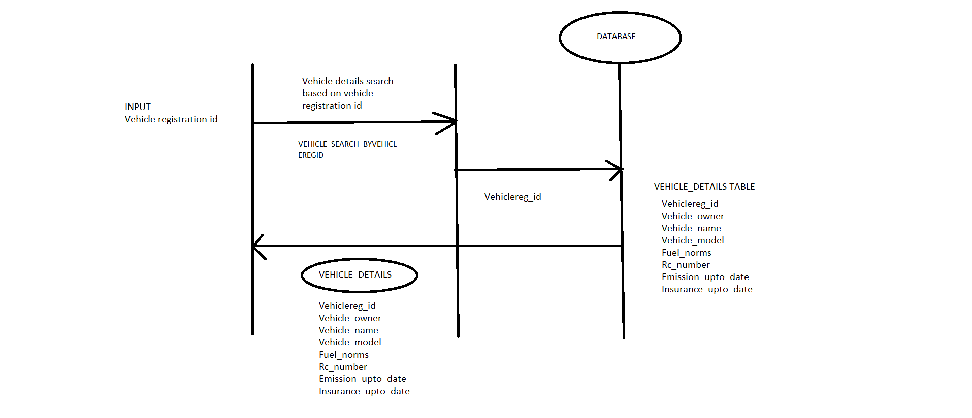

2.USER LOGIN VALIDATION

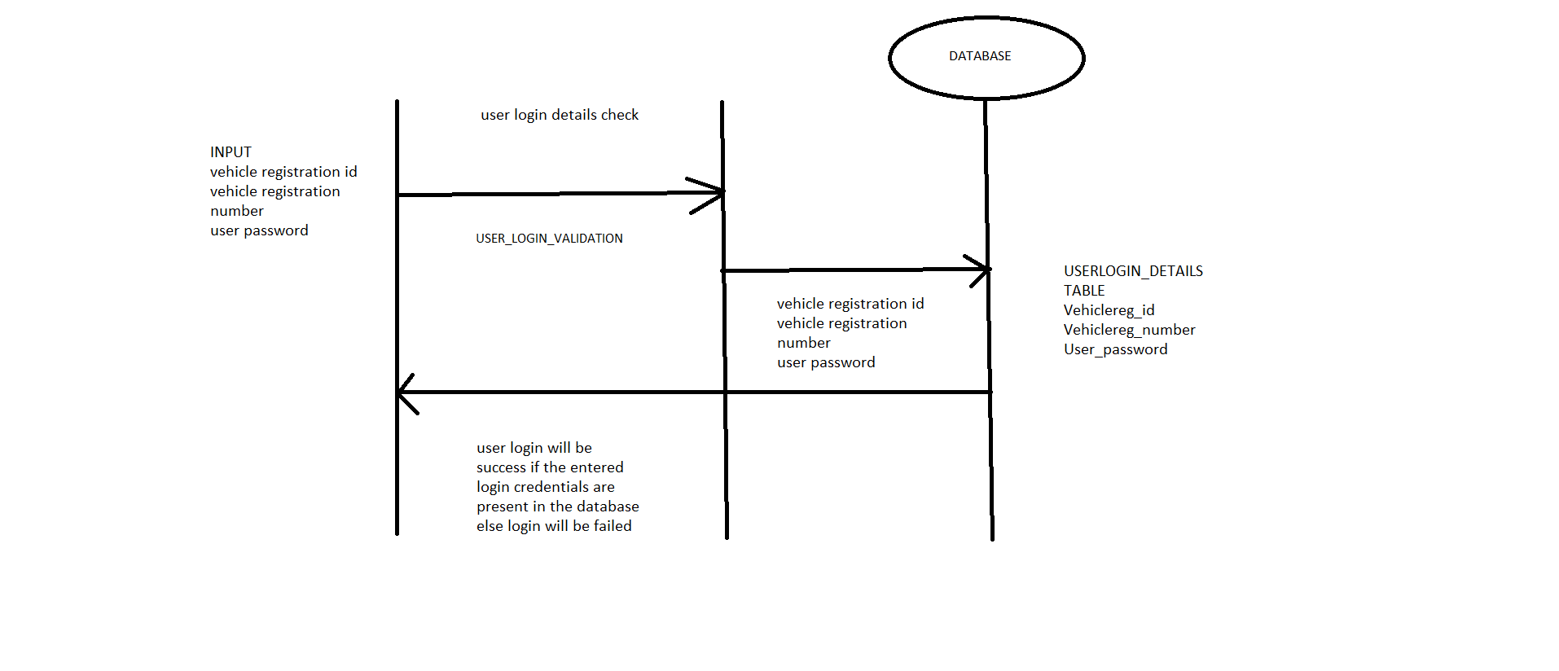

3.VEHICLE DETAILS UPDATION BY RTO ADMIN

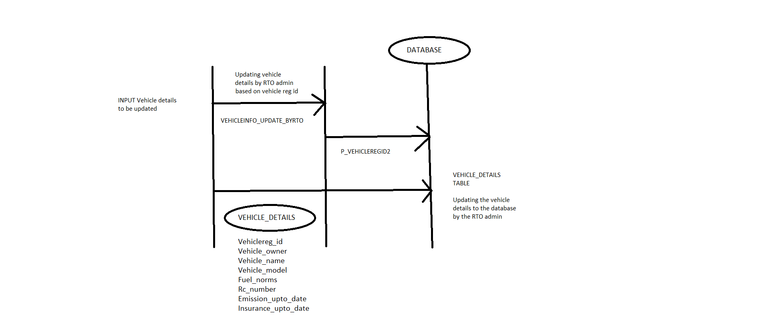

4.RTO ADMIN LOGIN VALIDATION

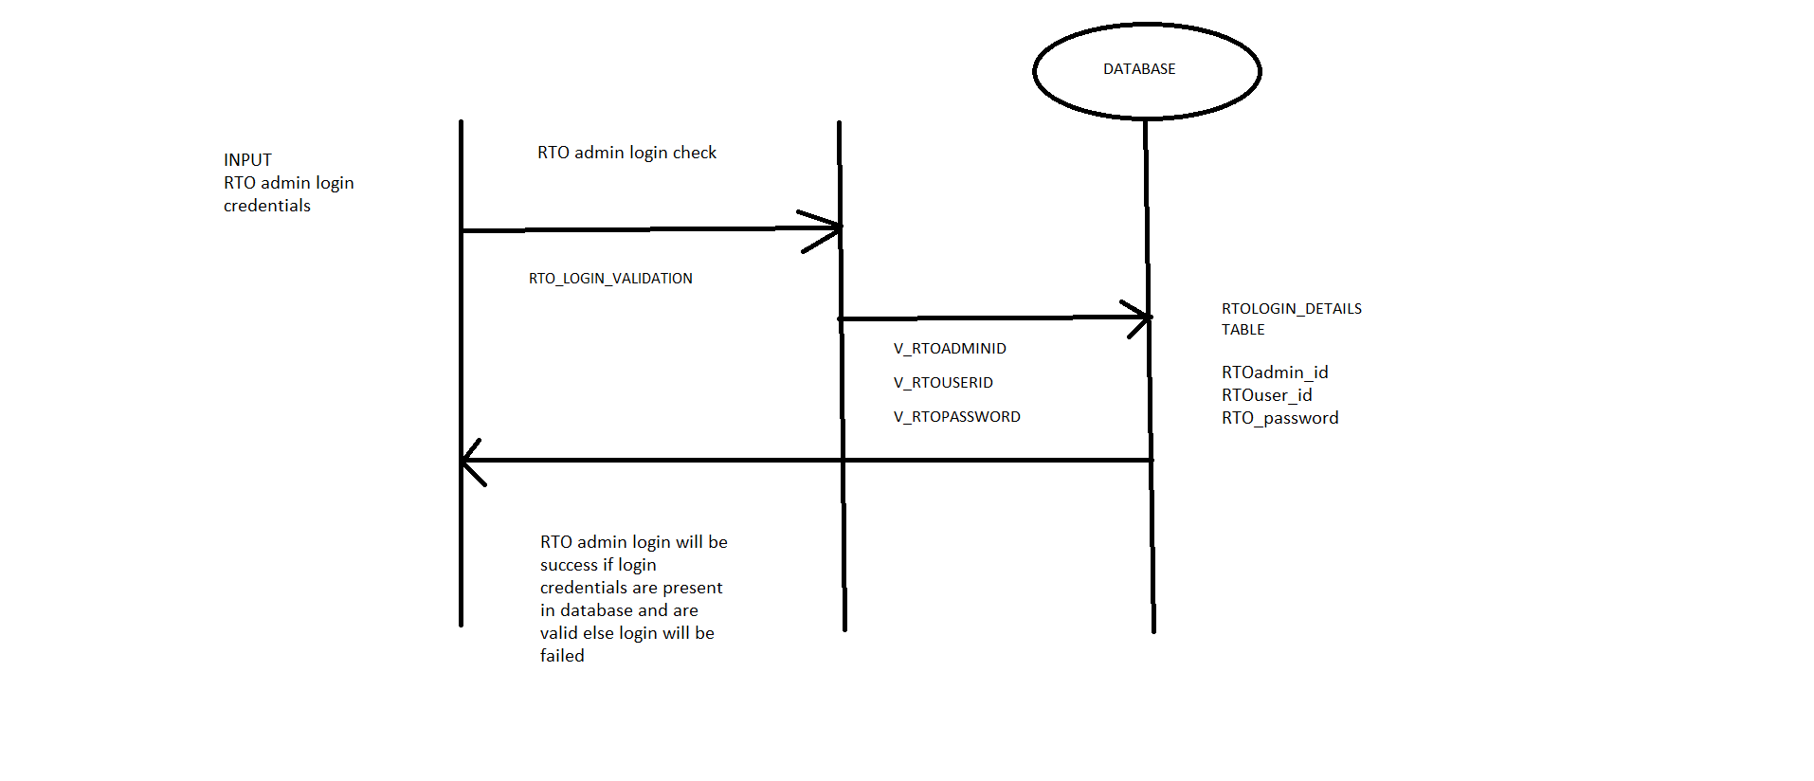

5.VEHICLE INSURANCE DETAILS UPDATION BY INSURANCE COMPANY

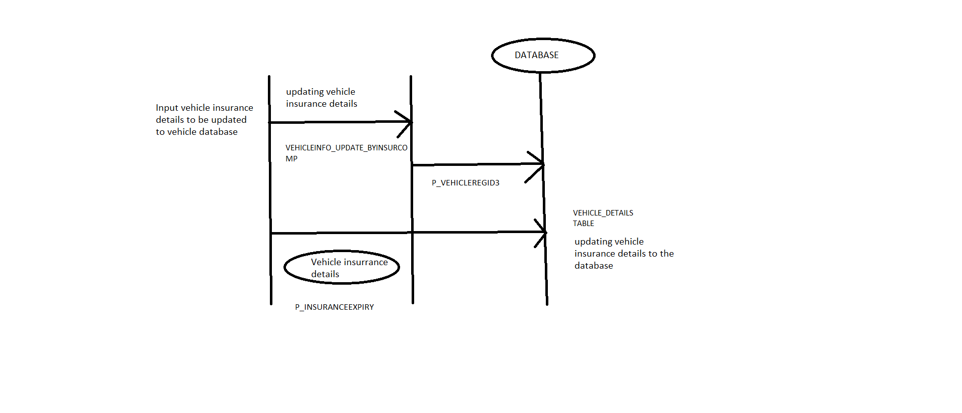

6.INSURANCE COMPANY LOGIN VALIDATION

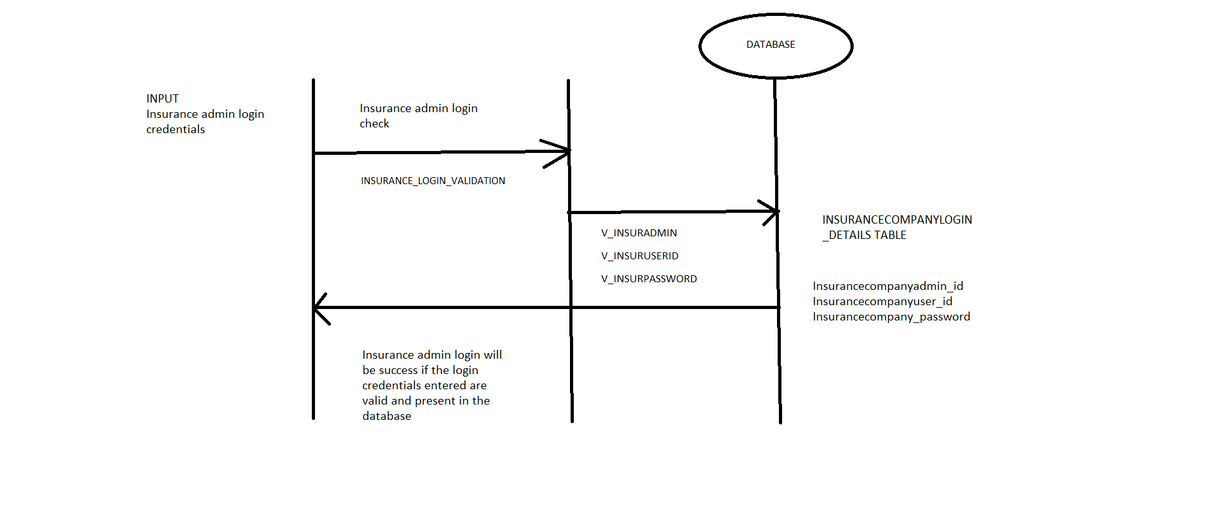

7.VEHICLE EMISSION DETAILS UPDATION BY EMISSION CHECK COMPANY

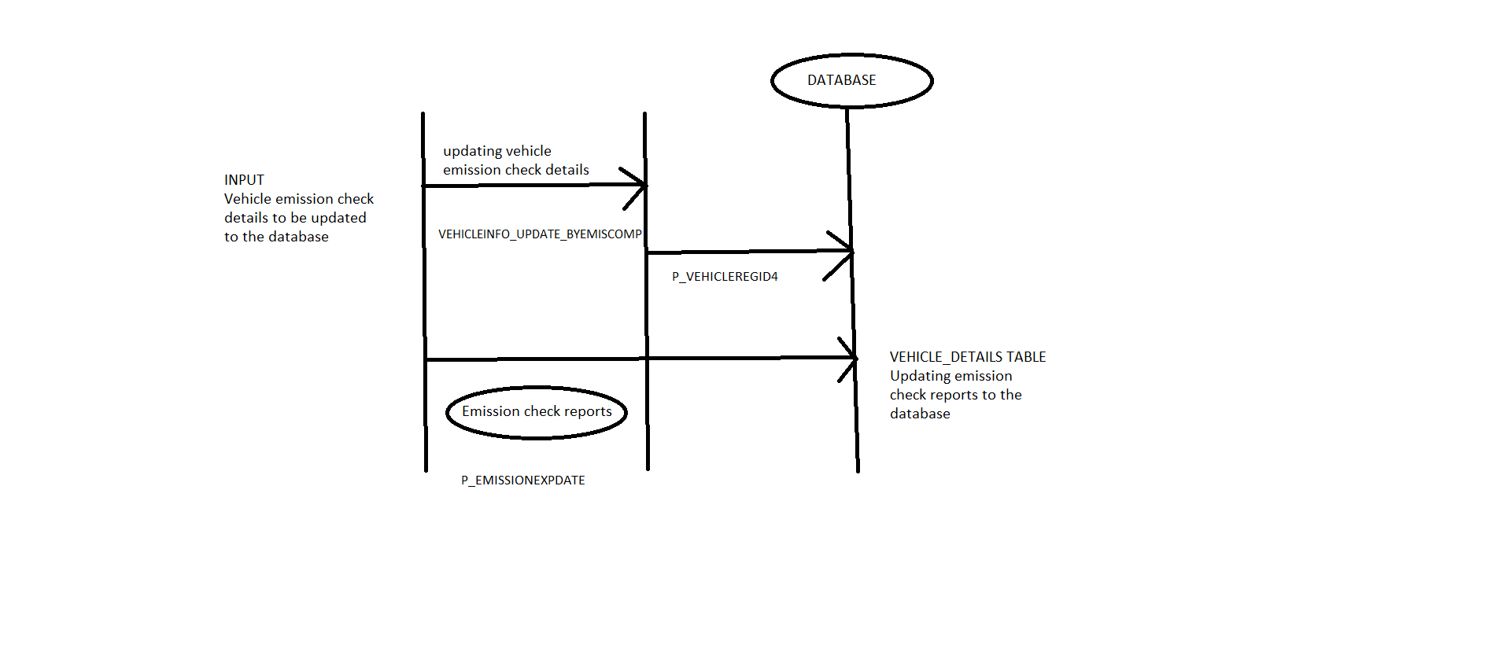

8.EMISSION CHECK ADMIN LOGIN VALIDATION

