**W07 - Grid Alignment Exercise  
Beau Travis**

Example 1

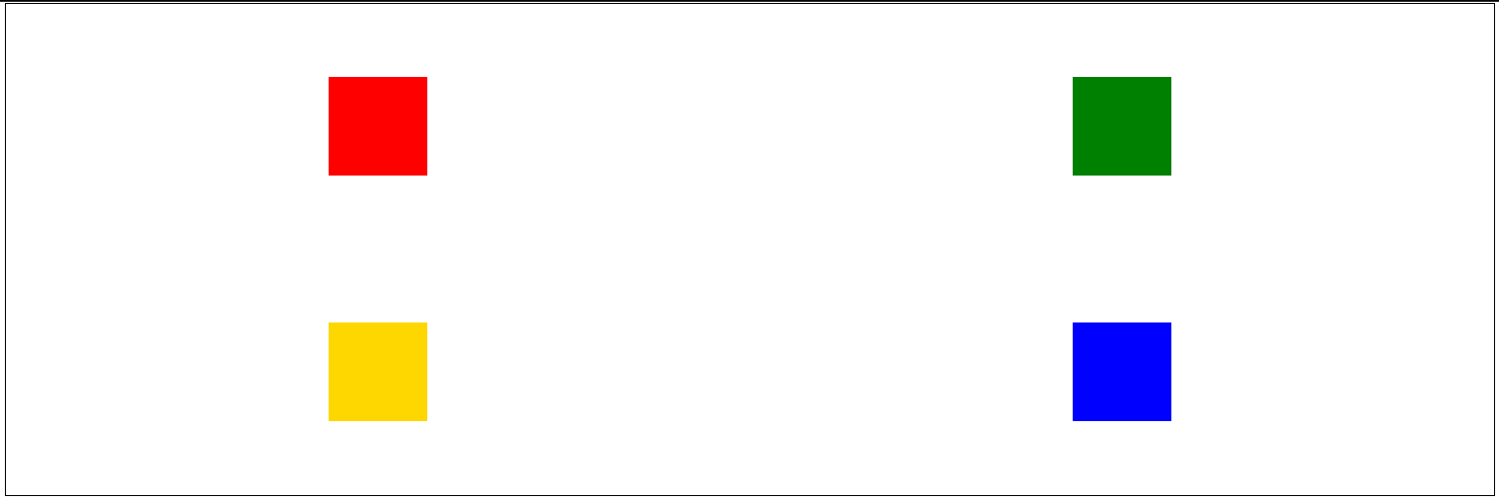

Example 2

Example 3

