Joshua Perez

February 26, 2023

**Reflection**

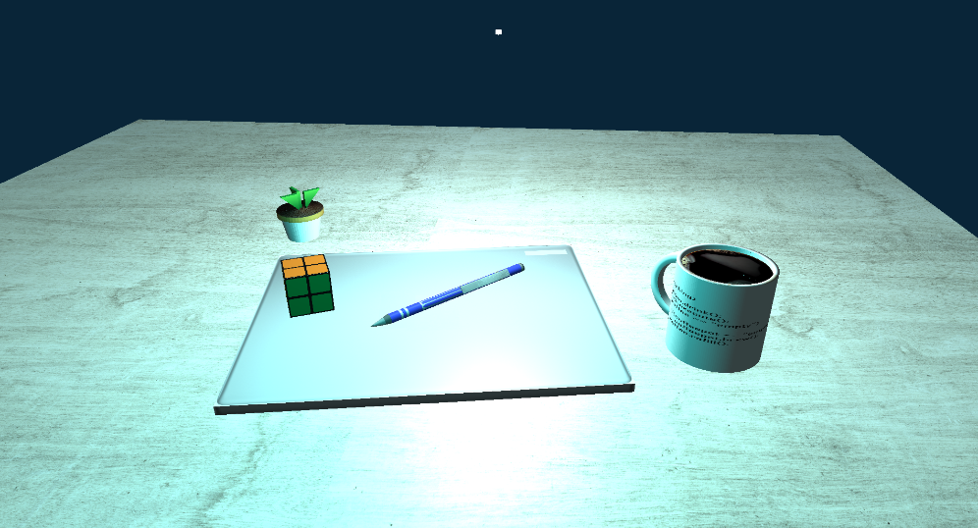In order to justify my choices in the development of my 3D scene I will first start with a picture comparison of the original scene and the recreation.

The ultimate justification for my choices was to get as close as possible to an accurate representation of the objects I chose to include in the picture. I selected these objects not only because they were around, but also because of the fact that I had somewhat figured out how to make these particular shapes work well and was able to mentally adapt to the task. I kept feeling like everything was breaking when I was attempting to program this, so figuring out this task was very difficult for me. The includes were the biggest breaking point for me as I would follow all the steps to get them working and then suddenly, they’d just stop functioning and give me lots of "external symbols are missing" errors. In terms of the shapes that went into the creation of the product above, I utilized cubes, cylinders, planes, cones, circles, and triangles/pyramids. In this process, I was forced to simplify quite a few of the objects as there was no way for me to really put in the amount of detail they actually contained. The toughest objects to get working were the coffee cup, pen, and planter as they all contained multiple shapes that needed to be correctly aligned and rotated in order to make sense. The Planter was made of 6 objects, the pen of 4 objects, and the cup of 3 objects.

As far as texturing goes, I quite enjoyed the process and even custom-made a few of the textures on my own. This is apparent in the coffee cup, which correctly matches my real-life cup and the Rubik’s cube coloring which correctly matches my real-life speed cube. For the lighting, I simply used lighting that I had already developed in previous modules and colored one a slightly green-blue since we were required to color one of the two light sources. I had a difficult time making more than one light source at first before I realized that I was doing it entirely wrong, and used the sample that was provided in week one for guidance. For the positioning of objects, I tried to get them as close as possible to the original picture, including the angle of the computer that the objects are resting on. For the movement, I implemented movement that we had utilized from previous modules as well as controls that allow for the control of lighting position, lighting color, lamp orbiting, perspective, and mouse movement. I used quite a few custom functions in my program to make it far more modular than it was, to begin with. Namely, this was done by offloading scene building, and shape building, both of which were essential to making this work. This also allowed for great deals of organization as I could separate everything based on function rather than some arbitrary listing. This was of great help as building the shapes was a far more rigorous process than could nicely be held within the main source file, something that I tried to do for a long time when working on this, before giving up and trying a new approach.

**References**

CS 330 Sourcing Textures Tutorial. (n.d.). Retrieved February 26, 2023, from <https://learn.snhu.edu/content/enforced/1236943-CS-330-T3338-OL-TRAD-UG.23EW3/course_documents/CS%20330%20Sourcing%20Textures%20Tutorial.pdf?_&d2lSessionVal=t8yS1oQIwieinypovpHaztsvo&ou=1236943>

CS 330 Visual Studio Export Tutorial. (n.d.). Retrieved February 26, 2023, from <https://learn.snhu.edu/content/enforced/1236943-CS-330-T3338-OL-TRAD-UG.23EW3/course_documents/CS%20330%20Visual%20Studio%20Export%20Tutorial.pdf?_&d2lSessionVal=t8yS1oQIwieinypovpHaztsvo&ou=1236943>

SNHU OpenGLSample ZIP. (n.d.). Retrieved February 24, 2023, from <https://learn.snhu.edu/content/enforced/1236943-CS-330-T3338-OL-TRAD-UG.23EW3/course_documents/OpenGLSample.zip?_&d2lSessionVal=h9NF7Ih2vKZfCc7rTSmNXGRfi&ou=1236943>