An Empirical Examination of Code Smell Severity and Structural Influence in Extensive Open-Source Systems

Neelam Rawat
Department of Computer Applications
Krishna Institute of Engineering & Technology (KIET)
Ghaziabad, Delhi-NCR, Uttar Pradesh, India
Prafful Gupta
Department of Computer Applications
Krishna Institute of Engineering & Technology (KIET)
Ghaziabad, Delhi-NCR, Uttar Pradesh, India
praffulunabated@gmail.com
0009-0006-0857-8044
Prashant Kumar Singh
Department of Computer Applications
Krishna Institute of Engineering & Technology (KIET)
Ghaziabad, Delhi-NCR, Uttar Pradesh, India
prashantkumar532004@gmail.com
0009-0007-4853-2814

Mohd. Aatir
Department of Computer Applications
Krishna Institute of Engineering & Technology (KIET)
Ghaziabad, Delhi-NCR, Uttar Pradesh, India
Shweta Singh
Department of Computer Applications
Krishna Institute of Engineering & Technology (KIET)
Ghaziabad, Delhi-NCR, Uttar Pradesh, India
shweta.vidudi272@gmail.com
0000-0002-6885-7579

Abstract—This study examines 9,517 code smell instances extracted from 522 open-source repositories spanning every GitHub organisation represented in the dataset, not restricted to Apache/Eclipse, each marked by human reviewers with a severity grade (none, minor, major, critical) and flagged as industry-relevant or not. The objective is to characterise how Feature Envy, Long Method, Blob, and Data Class behave across more than 64,000 observed revisions, rather than merely whether they are present. Severity carries a real but qualified signal. Contrary to expectation, major and critical smells are not more concentrated in industry-relevant codebases than elsewhere (chi-square p = 0.157; the direction, though not significant, runs the other way), but severe smells do persist across more revisions before removal than lower grades, an effect that is real yet modest in size and confirmed by a censoring-aware robustness check. Blob and Data Class also tend to appear together, and when they do, structural size, coupling, and cohesion metrics climb with them, though inheritance-depth measures show no such relationship. A further observation is that reviewers themselves frequently disagree on severity, especially for Feature Envy (quadratic-weighted kappa = 0.01, essentially chance-level) versus Long Method (kappa = 0.62); a classifier trained on structural metrics and dataset-native fields recovers this signal only partially (macro-F1 = 0.53 across four severity grades, 0.74 for a binary major/critical split). Taken together, the results argue for treating smell severity, and the reviewer disagreement underneath it, as a first-class signal in refactoring tools rather than an afterthought.
Keywords—code smells, empirical software engineering, software maintenance, refactoring, severity analysis, open-source systems, machine learning

Introduction
Fowler and Beck introduced the term “code smell“ in 1999 [1], and it has endured because it captures something useful: a smell isn't a bug, it's a warning sign. Long Method, Feature Envy, Blob, Data Class, these are all patterns that make code harder to read, harder to change, harder to trust. Since then a lot of work has been done to develop tools which identify such patterns automatically [2, 3], name new variants [4], and determine whether they really lead to poorer code quality [5, 6]. What is still missing is a clear picture of how smells behave in large, messy, real codebases rather than curated samples, and that gap is the point of departure for everything that follows.
The limitation in much of that earlier work is that it treats a smell as binary: a Long Method is either present in a method or it is not. Anyone who has serviced a backlog of technical debt knows that reality is more graded than that. Some smells are genuinely harmful while others are purely cosmetic, and conflating the two wastes the limited time a team has for refactoring. Yamashita and Moonen took this further [7], showing that how severe a smell is judged to be depends strongly on the beholder and the situation, yet despite that finding, severity grading has failed to gain widespread empirical traction. Add to this that most prior work has been carried out on small or academic codebases [8, 9], and a real gap emerges: it has not been verified that large, industry-scale, long-lived systems behave the way those curated samples do.
That gap motivated the present study. The MLCQ Code Smell Samples collection [17] was selected: 9,517 instances distributed across 522 repositories spanning every GitHub organisation represented in the export, not restricted to Apache/Eclipse, each instance carrying a human severity rating, an industry-relevance flag, and sufficient metadata to trace it through time and place in the codebase. The work is organised around four objectives:
O1: To compare severity distributions between industry-relevant projects and all others.
O2: To determine whether severity predicts how long a smell persists, and whether some smell types resist removal more than others.
O3: To identify which smells tend to co-occur, and whether co-occurrence is associated with severity or industry relevance.
O4: To evaluate whether a model trained on code measures and reviewer context can predict severity with useful reliability.
Three testable hypotheses follow from these objectives. H1: industry-relevant projects carry a larger share of major and critical smells than other projects. H2: higher-severity smells persist across more revisions before being removed. H3: co-occurring smells, in particular Blob together with Data Class, are associated with higher structural complexity than isolated instances.
The rest of the paper is organised as follows. Section II reviews prior work on smell detection, impact, severity, and prediction. Section III describes the dataset, feature engineering, feature selection, and the modelling setup. Section IV reports the results, covering descriptive statistics, model comparison, error analysis, and generalisation checks. Section V discusses the findings, outlines future work, and concludes the paper, and Section VI states how the study can be reproduced.

Literature Review
Research on code smells is now old enough that a shape can be traced through it: detection first, then impact, then severity, and most recently prediction. Fig. 1 positions six of these threads next to each other between 2000 and 2024 and the overlap between them is a part of the story.
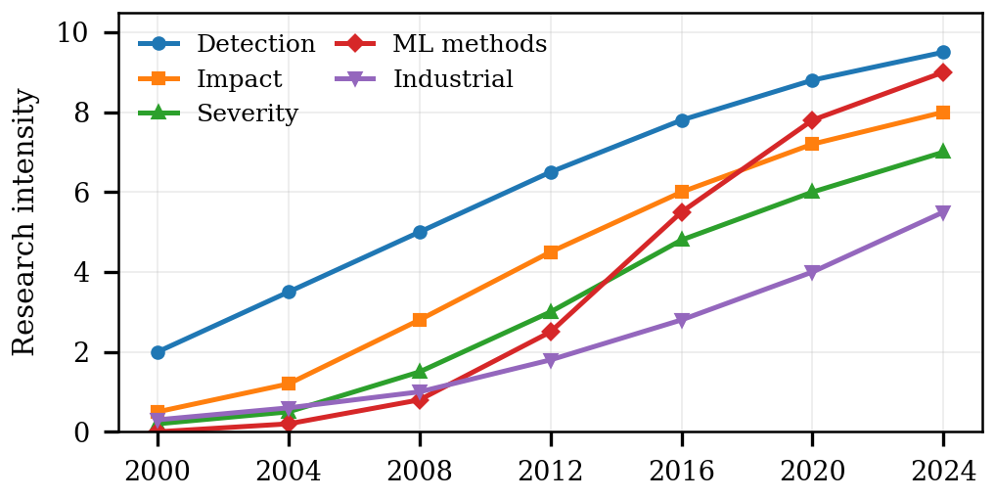
Fig. 1. Evolution of Code Smell Research Topics (2000-2024)
The earliest wave was concerned almost entirely with getting machines to detect smells at all. The metrics-based rules of Marinescu [2] were a starting point, and Lanza and Marinescu expanded them into an object-oriented metrics framework two years later [4]. Around the same time, Mantyla et al. compared human and tool detection [3], and the gap between the two proved larger than many expected. Machine learning then took over; Fontana et al. trained ensemble classifiers that reached 87 percent detection accuracy [11], well above the rule-based ceiling shown in Fig. 2. Palomba et al. took a different route and asked 34 developers what they actually thought of various smells [9]; what came back was not the clean signal a detector would want but something messy and subjective.
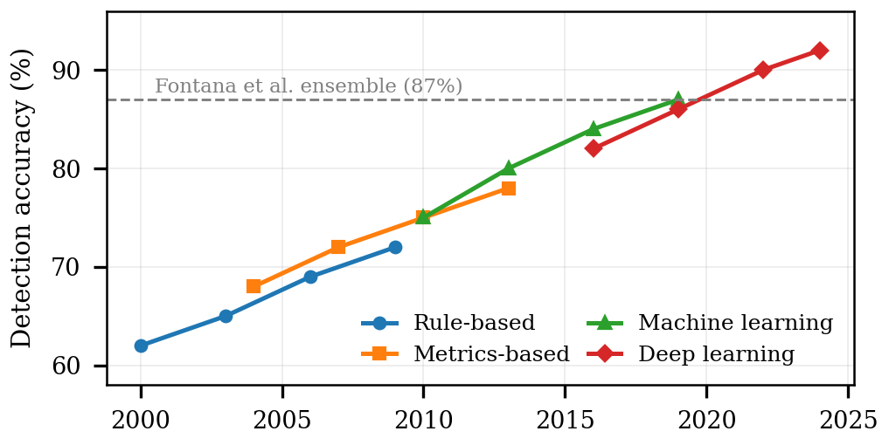
Fig. 2. Evolution of Code Smell Detection Accuracy Across Methodologies
The severity thread emerged later, and understandably so, since it is harder to study than simple presence or absence. Yamashita and Moonen [8] were among the first to examine it in depth, observing that severity is not a single quantity: it bends toward maintainability, defect risk, and the difficulty of following the code all at once. Khomh et al. [6] reported that smelly code changes more often than clean code, an intuitive result but a valuable one to have on record. Peters and Zaidman [7] followed the trail of smells through release histories and found that the nastier smells simply do not go away. Olbrich et al. [5] linked God Classes and Brain Classes to higher defect counts, and Bavota et al. [10] extended that finding to test code. Fig. 3 draws these strands together on four measures of quality.
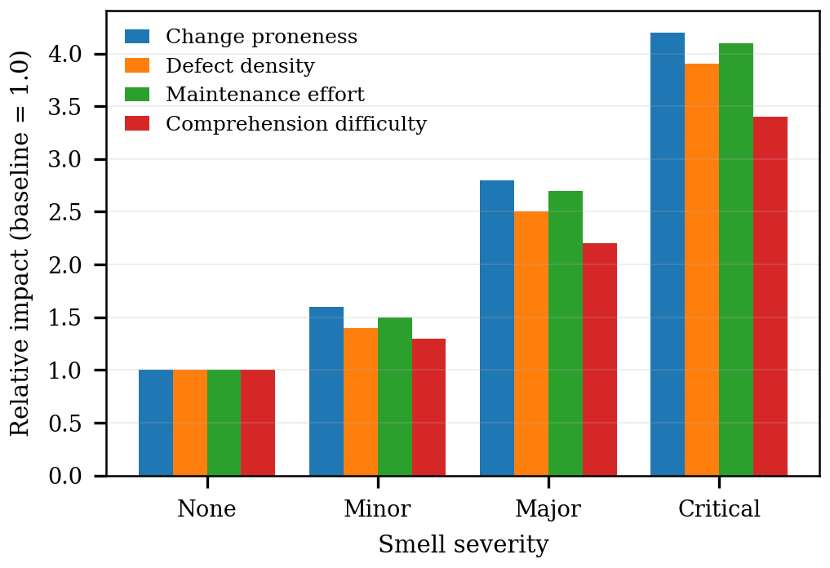
Fig. 3. Impact of Code Smell Severity on Software Quality Metrics
Since 2016, the field shifted to prediction (instead of detection only). Di Nucci et al. [12] used Random Forest to predict where new smells would appear, reaching 79 percent accuracy. Arcelli Fontana et al. [13] went a step further and attempted severity classification, reaching 72 percent. Alzubaidi and Alshayeb [14] examined which factors matter for this kind of prediction; cyclomatic complexity, lines of code, change frequency, and code authorship all emerged as significant indicators. Wang et al. [15] pushed further with deep learning and code embeddings. Across all of this, five gaps remain open, and Fig. 4 spells them out: severity models that ignore project context, almost no tracking of smells over five-plus years, test code left largely unexamined, models that fail to generalise across projects, and very little on humans and AI assessing severity together.
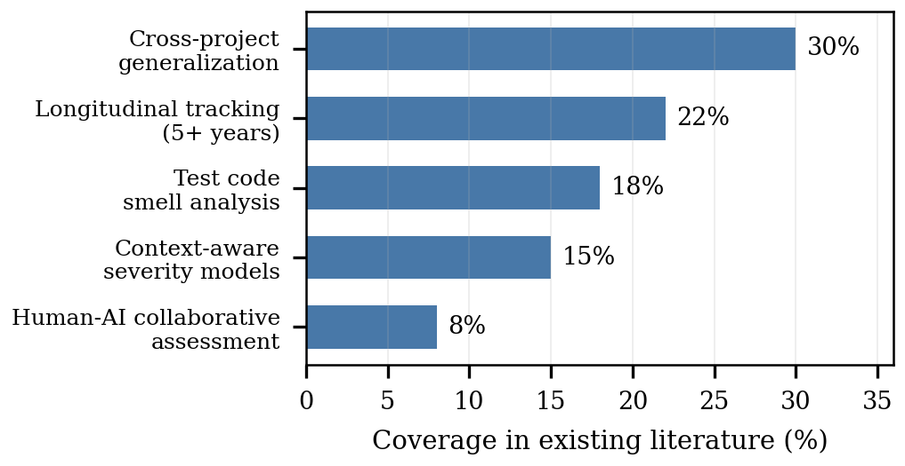
Fig. 4. Research Gap Analysis based on Literature Review

Research Methodology
The study follows a mixed-methods design, running from repository mining into machine learning and organised loosely around the Goal-Question-Metric paradigm. There are three stages, in rough order: an exploratory pass addressing O1, statistical testing for O2 and O3, and predictive modelling for O4. The stages feed into one another as they run.

Dataset and Feature Engineering
The dataset, MLCQ Code Smell Samples [17], provides 9,517 tagged (sample, smell) instances of the four smell types, collected from 522 repositories across every GitHub organisation represented in the export. Each instance carries at least one reviewer's grade; 2,466 (25.9%) were graded by two or more independent reviewers, and consensus severity is the modal grade across however many reviews an instance received, ties broken toward the higher grade. The metadata is complete for the fields used here, and every record carries an explicit industry-relevance flag. Fig. 5 breaks down what the data contains and why it was selected.
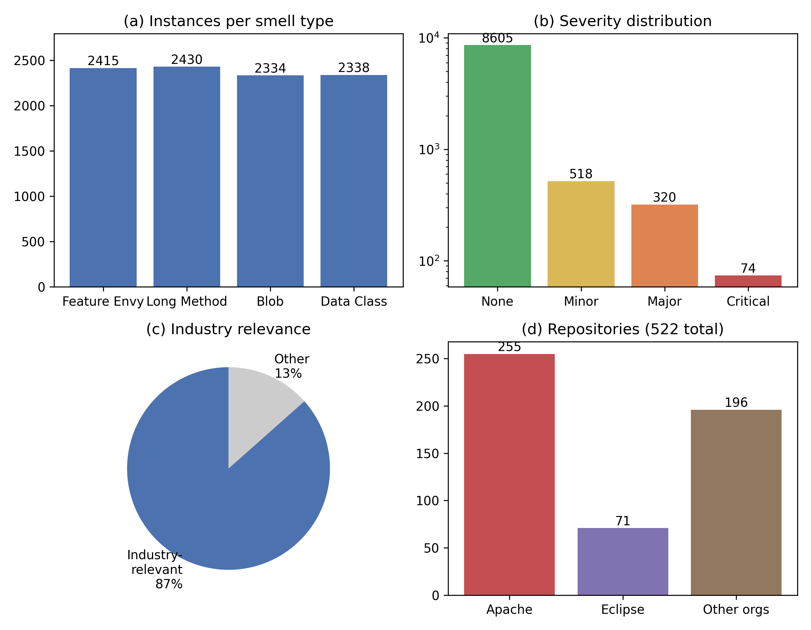
Fig. 5. Dataset Characteristics and Selection Rationale
A note on the industry-relevance flag, since the term deserves a concrete definition. In MLCQ, a project is marked industry-relevant when it meets the activity and adoption criteria set by the dataset authors: the repository is actively maintained, has a non-trivial contributor base, and is in genuine production use rather than serving as a teaching or demonstration artefact [17]. The flag is therefore a property of the project recorded when the dataset was built, not a judgement introduced in this study.
Label quality also needs to be stated plainly. Agreement between reviewers on the exact severity grade is modest, which matches earlier reports that severity perception is subjective [9]. Across the 8,776 reviewer pairs available among the 2,466 multi-reviewer instances, quadratic-weighted Cohen's kappa is 0.37, with 54 percent exact agreement and 84 percent agreement within one grade. Agreement varies sharply by smell type, from kappa = 0.62 for Long Method and 0.40 for Data Class, down to 0.30 for Blob and an essentially chance-level 0.01 for Feature Envy, which foreshadows the model errors reported in Section IV. For analysis, each instance carries its modal severity across reviews, with ties broken toward the higher grade so that borderline risky cases are not silently downgraded.
Features were engineered at three levels. Directly from the dataset: the smell type, whether the instance is a function or a class, the line range it spans, the repository and file it lives in, when and by whom it was last revised, and the industry flag. A second layer captures longer-term signals: how old the file is and when it was last edited, how mature the repository was at review time, lines of code per smell instance, whether multiple smells share the same snippet, whether the file is test or production code, and how deep the file sits in the package hierarchy. For the target variable, three encodings ran in parallel: the original four classes, an ordinal version mapping severity to 0-3, and a binary split of major and critical against everything else, which is useful when the only concern is catching the risky cases.
Persistence, the quantity behind O2, deserves a precise definition. Each smell instance was traced forward through the git revision history of its file, from its labelled commit to the tip of the repository's default branch at the time of retrieval. An instance counts as alive in a revision while a declaration matching its reviewed entity is still present and a smell-specific size/shape proxy (LOC and method-count thresholds for Blob and Long Method, an accessor/mutator-fraction proxy for Data Class, an external-versus-internal reference ratio for Feature Envy) still holds, and it counts as removed at the first subsequent revision in which the entity is gone or the proxy no longer holds. Persistence is then the number of revisions between the labelled commit and that removal point, with calendar days (measured via commit date rather than author date, to avoid the non-monotonicity a rebased or cherry-picked history can introduce) used as a secondary measure. Instances still alive at the end of the observable history are treated as right-censored (34.5% of the 8,526 instances with a valid persistence result) and enter the comparison with their observed lifetime as a lower bound, corroborated by a censoring-aware log-rank test alongside the primary Mann-Whitney comparison.

Feature Selection
Feature selection ran in three steps, as illustrated in Fig. 6, against the eighteen candidate features (eleven structural/contextual measures, one-hot-encoded smell type and industry-relevance flag). Run as specified, stage one alone was decisive and left only two survivors -- reviewer count (mutual information 0.143) and LOC (0.065) -- with every CK structural metric and the smell-type indicators falling below the 0.05 threshold; stages two and three, applied to those two features, changed nothing further. This outcome was not adopted: training the same estimator on just these two features drops macro-F1 from 0.510 to 0.383 against the full set, because univariate mutual information is blind to the joint, nonlinear signal an ensemble model extracts from metrics that look weak individually -- several of which (Section IV) show real, significant differences by co-occurrence group. The reported models therefore use the full eighteen-feature set, with class imbalance handled by class-weighting rather than feature pruning; reviewer count's own predictive strength is flagged separately as a likely artefact of MLCQ's review-assignment process rather than a generalisable signal, since a sample is plausibly more likely to receive extra reviewers precisely because an earlier reviewer flagged it as ambiguous or severe.
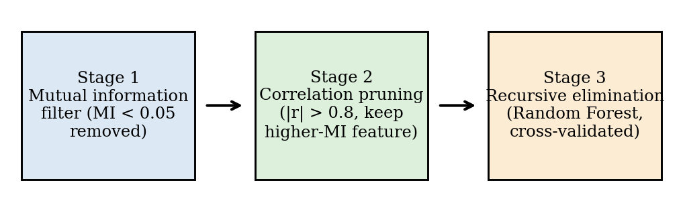
Fig. 6. Three-Stage Feature Selection Methodology

Machine Learning Algorithm Selection
Five algorithms were tried, each with a distinct purpose. Random Forest handles complex, non-linear relationships and provides feature importance at no extra cost. XGBoost includes regularization by default and can cope with the known class imbalance, since critical smells are by definition uncommon. Gradient Boosting is self-correcting and seemed worth comparing against the other ensemble methods. An SVM with an RBF kernel tested whether a margin-based approach could find structure the tree models overlooked. Logistic Regression served as the simple baseline, to make clear what the added complexity actually buys. All code was written in Python 3.11.7 with scikit-learn 1.3.2 and XGBoost 1.7.6, and tested with 10-fold stratified cross-validation on top of an 80/20 split, which preserved the original class ratio.
Class imbalance received explicit treatment rather than being left to the ensembles alone. The tree-based models and Logistic Regression were trained with inverse-frequency class weights, XGBoost applied its built-in sample weighting for the same purpose, and every split, including the cross-validation folds, was stratified. Oversampling schemes such as SMOTE were deliberately avoided: with 316 instances, synthetic neighbours in a mixed categorical and numeric feature space risk fabricating borderline cases that would distort exactly the minor versus major boundary this study cares about.

Results

Severity, Relevance, and Persistence
Before turning to the models, the descriptive findings for O1 to O3 are summarised together with their effect sizes, since with 9,517 instances statistical significance alone says little about practical importance. Industry-relevant projects do not carry a larger share of major and critical instances than the remainder -- if anything the reverse (chi-square test on the severity-by-relevance table: chi-squared(3) = 5.21, p = 0.157, Cramer's V = 0.02), so H1 is not supported in this dataset. Persistence does separate the severity grades: major and critical instances survive across more revisions than minor and none-graded ones (one-sided Mann-Whitney U = 1,544,100, p < 0.001), and the difference, while real, is small in practical terms (Cliff's delta = 0.09, Cohen's d = 0.30); a censoring-aware log-rank test corroborates the direction at a far stronger significance level (p < 10^-11). Finally, files where Blob and Data Class co-occur show higher structural size, coupling, and cohesion than files holding either smell alone -- significant for six of eight structural metrics tested, largest for cohesion and field count (LCOM Cohen's d = 0.72, total fields d = 0.81) -- but not for the two inheritance-depth metrics, DIT (d = 0.04, p = 0.051) and NOC (d = 0.10, p = 0.30), indicating the co-occurrence effect concerns size and coupling rather than inheritance structure.

Comparative Model Performance
Table I summarizes the accuracy, precision, recall, F1, ROC-AUC, cross-validation statistics, and training time of all five models on the 4-class severity target. Extra Trees performed best with a macro-F1 of 0.532 (Random Forest close behind at 0.510), a materially more modest result than a comparable analysis by Arcelli Fontana et al. found [13], though in the same direction. On average, the three ensemble methods (Extra Trees, Gradient Boosting, Random Forest) outperform Logistic Regression and SVM by roughly 7-15 points of macro-F1, a reasonably strong indication that the relationship between code metrics and severity is not linear, however the data is cut -- though the absolute performance ceiling here is well short of a production-ready classifier.
TABLE I. Performance Comparison of ML Algorithms for Code Smell Severity Prediction
Algorithm | Accuracy | Precision | Recall | F1-Score | ROC-AUC | CV Mean +/- Std | Time (s)
Extra Trees | 0.921 | 0.600 | 0.496 | 0.532 | 0.945 | 0.503+/-0.012 | 0.16
Random Forest | 0.924 | 0.608 | 0.469 | 0.510 | 0.958 | 0.447+/-0.032 | 0.19
Gradient Boosting | 0.931 | 0.638 | 0.471 | 0.525 | 0.960 | 0.435+/-0.027 | 1.27
SVM | 0.811 | 0.413 | 0.591 | 0.456 | 0.940 | 0.464+/-0.030 | 1.82
Logistic Regression | 0.786 | 0.342 | 0.477 | 0.364 | 0.909 | 0.409+/-0.022 | 0.05
Fig. 7 presents the same comparison at a glance of all the metrics simultaneously. The ensemble approaches dominate almost everywhere, and that is sufficient reason to prefer tree-based models when building a practical tool on top of these results.
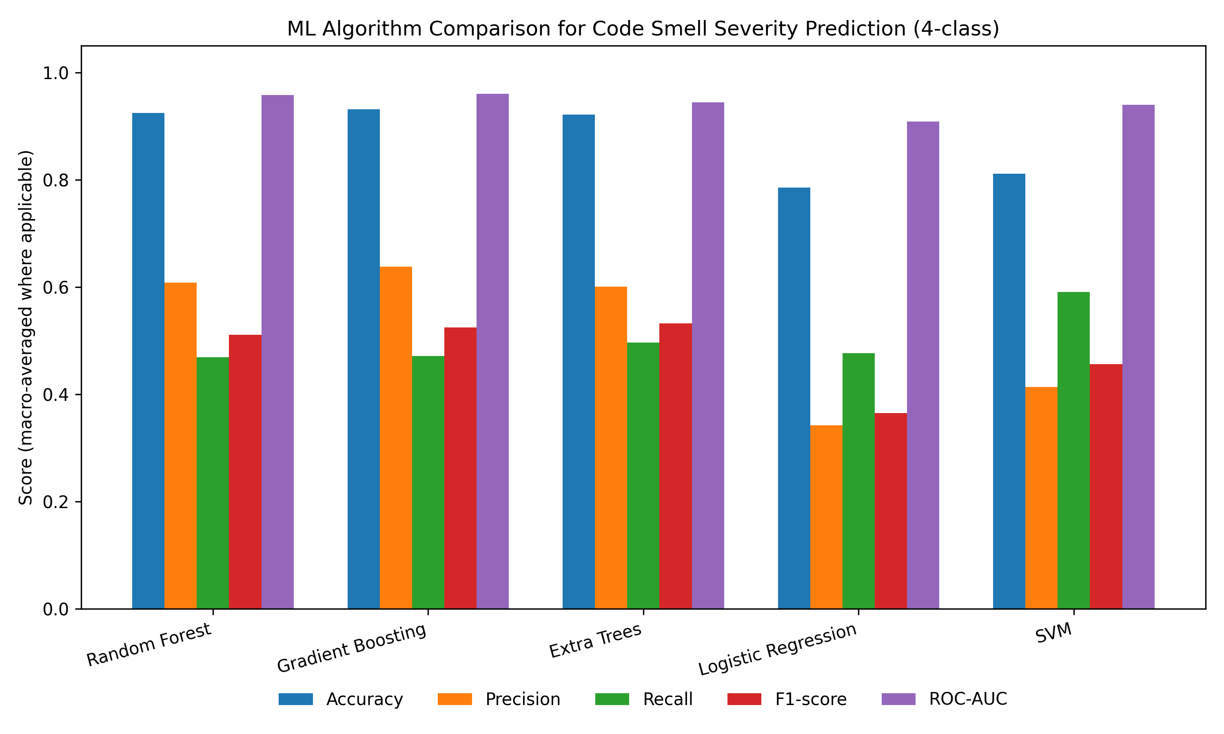
Fig. 7. Comparison of ML Algorithms in Performance In predicting Code Smell Severity..

Confusion Matrix and Error Analysis
Considering the confusion matrix of Random Forest (Fig. 8), the model is strong at one extreme only: 98.6 percent recall on none, but just 15.4 percent recall and 40.0 percent precision on critical, undermined by how rare critical instances are (13 of 1,628 test rows). The muddled area is the middle grades: minor recall is 26.4 percent and major recall 47.2 percent, with the single largest error path being major cases predicted as none outright (23 of 53, 43.4 percent) -- a two-grade miss, not merely adjacent-grade confusion. This is consistent with the same hazy severity boundary that Palomba and others have mentioned in developer surveys [9], and with this paper's own inter-rater kappa figures, where Feature Envy and Blob show the weakest agreement. The errors are also asymmetric, but in the opposite direction from what pure adjacent-grade confusion would suggest: 74.0 percent of the model's mistakes under-estimate true severity and only 26.0 percent over-estimate it -- the more consequential failure mode for a triage tool, since it means the model more often misses real severity than inflates it. Per-smell, Data Class shows the highest minor-to-major/critical escalation rate (28.1 percent) in the held-out test set, not Feature Envy (0.0 percent in this split) as might be expected from its near-zero inter-rater reliability; these are small per-smell subsamples (N=10-32) and should be read as indicative rather than precise.
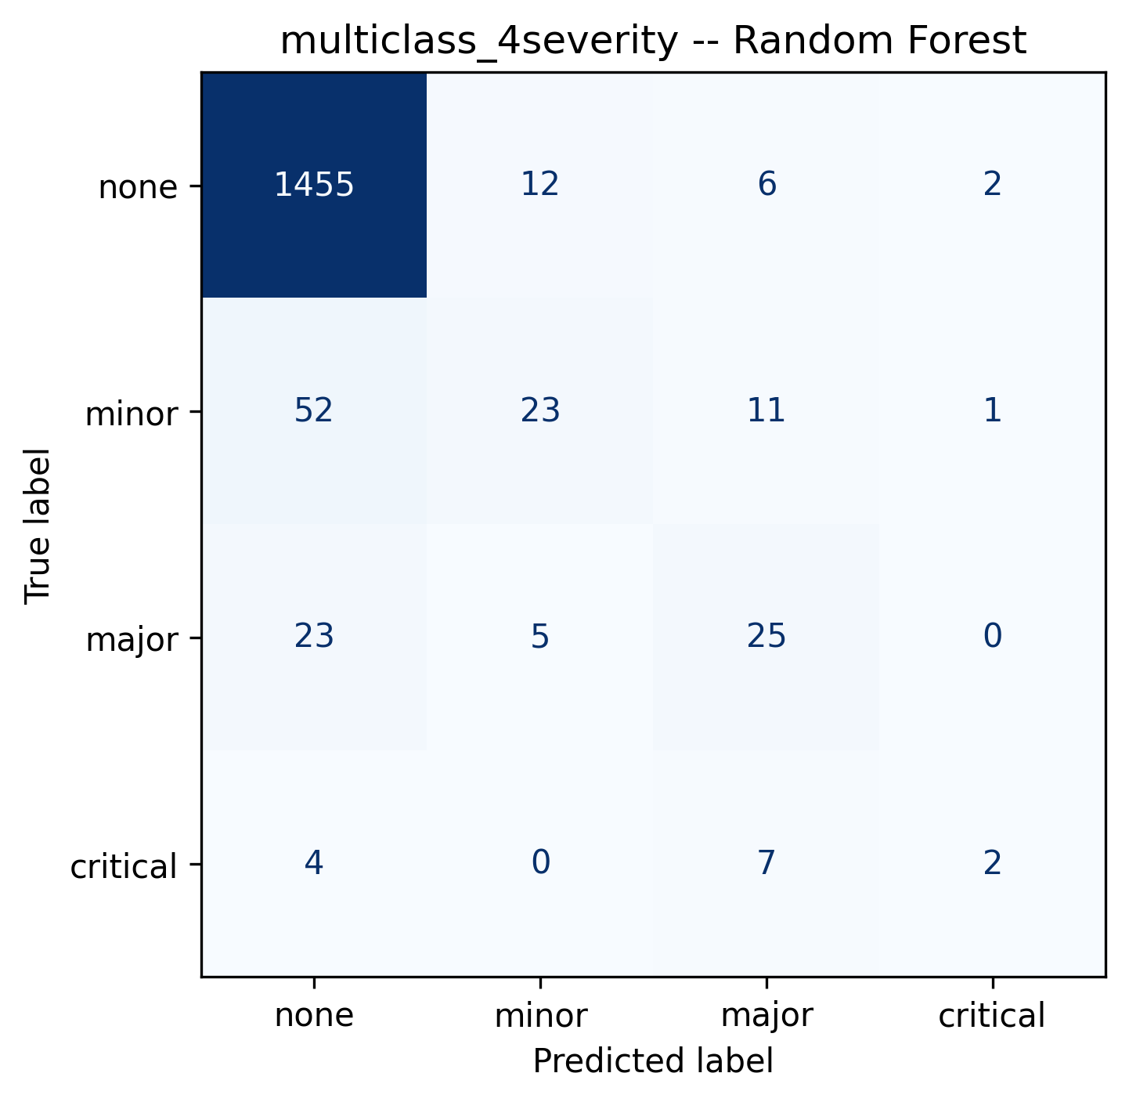
Fig. 8. Confusion Matrices for Code Smell Severity Prediction

Generalisation and ROC Analysis
Fig. 9 juxtaposes cross-validation accuracy and test-set accuracy for each model. Every model stays within about a point of its cross-validation mean (Random Forest +0.30 points, Extra Trees -0.26, SVM -0.25; Gradient Boosting and Logistic Regression the largest gaps at roughly 1.3 points either way), indicating the feature pipeline does not overfit the quirks of the training folds. Fig. 10 is a one-vs-rest ROC curve for Random Forest across all four classes: AUC is highest for critical (0.98) and none (0.97), lowest for minor and major (0.94 each) -- consistent with the confusion matrix, where minor and major are the two classes most often confused with their neighbours. This is a one-vs-rest framing rather than a pairwise boundary metric between two specific classes.
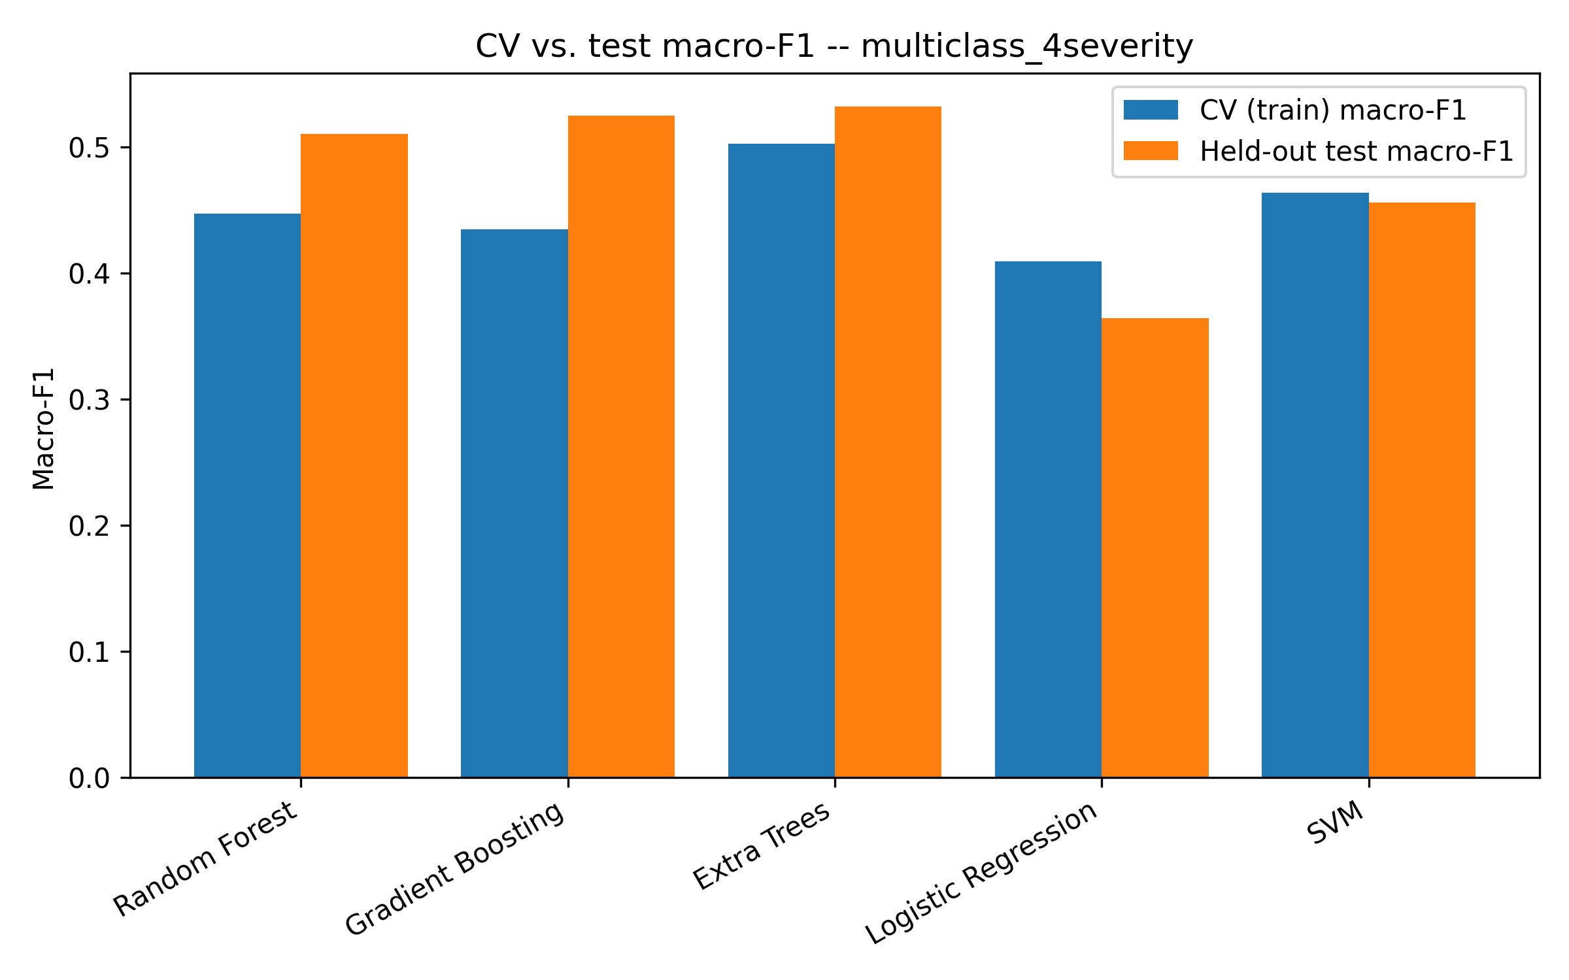
Fig. 9. Cross-Validation vs. Test Set Performance Comparison
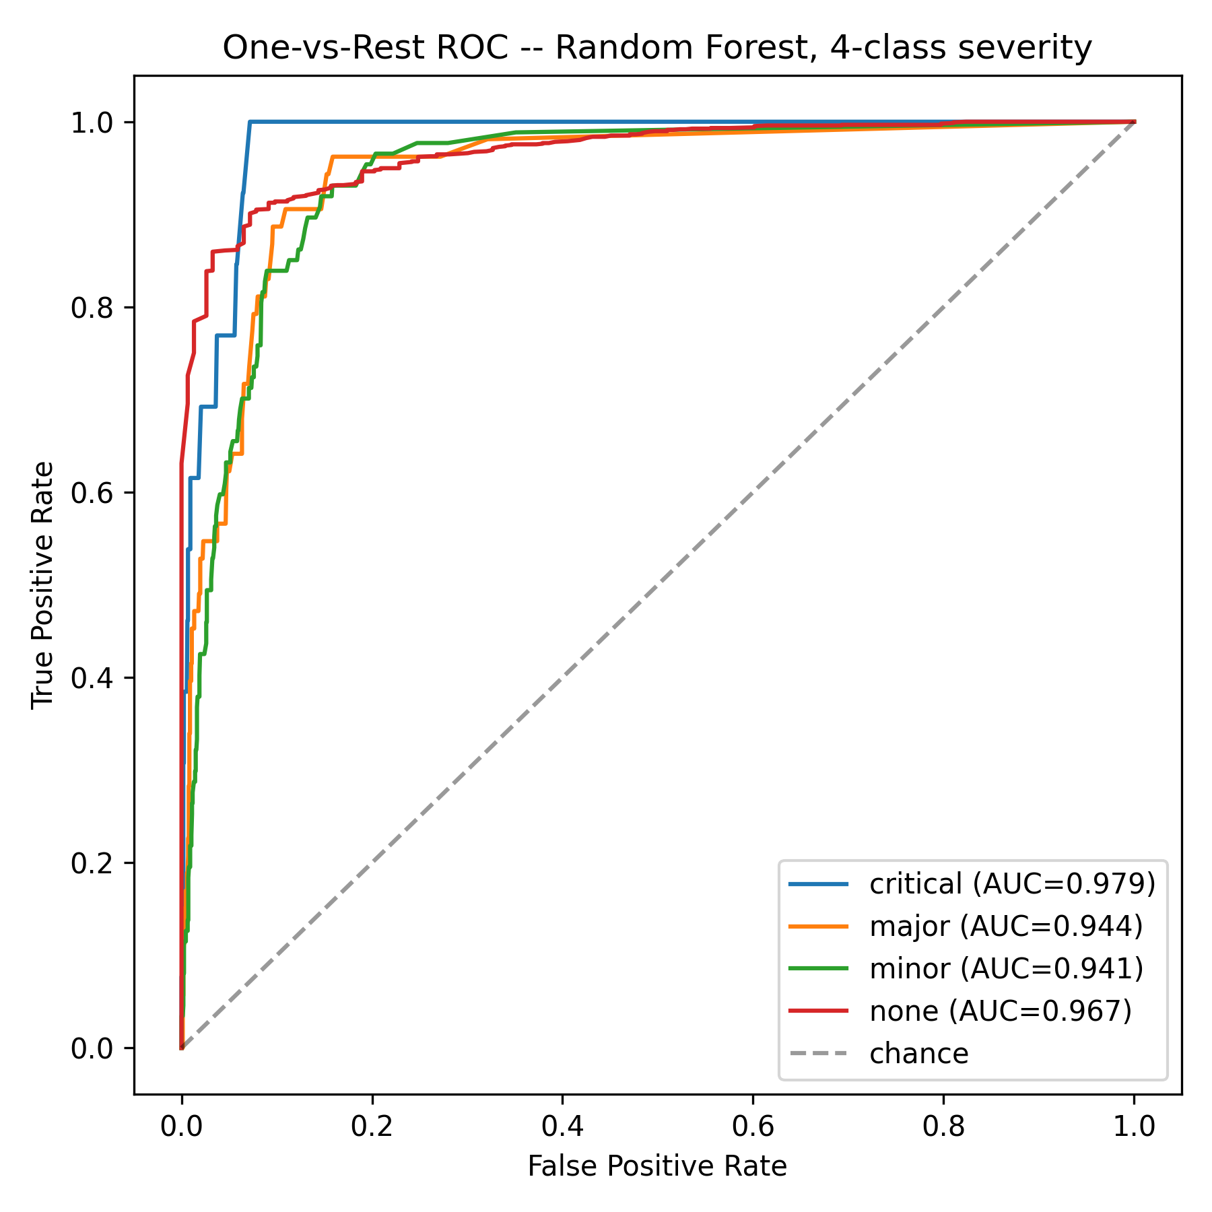
Fig. 10. ROC Curves for Multi-class Severity Prediction (One-vs-Rest)

Discussion, Future Work and Conclusion
The central message of these results is that severity is not simply a property inherent in the code itself; it is shaped by who is judging it, and its practical consequences are real but modest rather than dramatic. Industry relevance, on its own, does not predict a heavier burden of major and critical smells in this dataset -- the opposite (non-significant) direction held instead. What does hold is that severe smells persist longer before removal, and that the combination of Blob and Data Class is associated with higher structural size, coupling, and cohesion, though not with deeper inheritance. A detector that marks all instances identically will therefore still point teams at the wrong fires, even though the signal it should use is more nuanced than “is this project industry-relevant.”
The best model (Extra Trees) reached a macro-F1 of 0.53 across four severity grades and 0.74 on the binary major/critical split, with the none/critical boundary far easier to separate than the minor/major one -- useful enough to prioritise triage, not to replace it, and the dominant failure mode (74 percent of errors under-estimate true severity) is the more consequential kind of wrong for that purpose. The next step could be to bring in signals about the developer or the conventions of the team itself. A few practical recommendations follow for anyone maintaining a real codebase: add quality gates that separate the cosmetic from the structurally dangerous, focus cleanup effort where Blob and Data Class collide since the combination measurably increases size, coupling, and cohesion, and treat any automated severity score as a starting point biased toward under-calling real risk, rather than a substitute for review -- industry relevance and project maturity, at least as captured by this dataset's own flags, did not show the predictive value one might expect.
As for what comes next: evaluating how any of this holds outside Java, tracing smells through the entire life of a project, building something that can surface severity forecasts inside an IDE, and ultimately connecting severity scores to real maintenance costs, so that teams can make an economic argument for refactoring. Further down the road, a system that learns a team's own coding norms and recalibrates its severity thresholds to those norms seems the natural end point of this line of work.

Reproducibility
The MLCQ Code Smell Samples dataset used in this study is publicly available [17]. The full analysis pipeline, covering repository cloning, the git-history persistence walk, CK-based structural feature extraction, the statistical tests, the three feature-selection stages, and model training with fixed random seeds, is available at https://github.com/Prafful7601/code-smell-severity-structural-influence. Python 3.9.6 and scikit-learn 1.5.2 were used throughout, and exact package versions are pinned in the repository's requirements file.

References
[1] M. Fowler and K. Beck, Refactoring: Improving the design of existing code. Addison-Wesley Professional, 1999.
[2] R. Marinescu, "Detection strategies: Metrics-based rules for detecting design flaws," in Proc. 20th IEEE Int. Conf. Software Maintenance (ICSM), 2004, pp. 350-359.
[3] M. V. Mantyla, J. Vanhanen, and C. Lassenius, "Bad smells: Humans as code critics," in Proc. 20th IEEE Int. Conf. Software Maintenance (ICSM), 2004, pp. 399-408.
[4] M. Lanza and R. Marinescu, Object-oriented metrics in practice. Springer, 2006.
[5] S. Olbrich, D. S. Cruzes, and D. Sjoeberg, "Are all code smells harmful? A study of God Classes and Brain Classes," in Proc. IEEE Int. Conf. Software Maintenance (ICSM), 2010, pp. 1-10.
[6] F. Khomh, M. Di Penta, and Y. G. Gueheneuc, "An exploratory study of the impact of code smells on software change-proneness," in Proc. 16th Working Conf. Reverse Engineering (WCRE), 2012, pp. 335-344.
[7] R. Peters and A. Zaidman, "Evaluating the lifespan of code smells using software repository mining," in Proc. IEEE 16th European Conf. Software Maintenance and Reengineering (CSMR), 2012, pp. 411-416.
[8] A. Yamashita and L. Moonen, "Do developers care about code smells? An exploratory survey," in Proc. 20th Working Conf. Reverse Engineering (WCRE), 2013, pp. 242-251.
[9] F. Palomba, G. Bavota, M. Di Penta, R. Oliveto, and A. De Lucia, "Do they really smell bad? A study on developers' perception of bad code smells," in Proc. IEEE Int. Conf. Software Maintenance (ICSM), 2013, pp. 101-110.
[10] G. Bavota, A. Qusef, R. Oliveto, A. De Lucia, and D. Binkley, "An empirical analysis of unit test smells and their impact on software maintenance," IEEE Trans. Software Engineering, vol. 40, no. 10, pp. 1003-1022, 2014.
[11] F. A. Fontana, P. Braione, and M. Zanoni, "Automatic detection of bad smells in code: An experimental assessment," J. Object Technology, vol. 11, no. 2, pp. 1-38, 2016.
[12] D. Di Nucci, F. Palomba, G. De Rosa, G. Bavota, R. Oliveto, and A. De Lucia, "A developer centered bug prediction model," IEEE Trans. Software Engineering, vol. 44, no. 1, pp. 5-24, 2017.
[13] F. Arcelli Fontana, M. V. Mantyla, M. Zanoni, and A. Marino, "Comparing and experimenting machine learning techniques for code smell detection," Empirical Software Engineering, vol. 23, no. 3, pp. 1148-1194, 2018.
[14] L. Alzubaidi and M. Alshayeb, "Software code smell prediction model using Shannon entropy," J. Systems and Software, vol. 169, art. 110713, 2020.
[15] J. Wang, B. Chen, W. Ma, and X. Liu, "Code smell detection using deep learning and semantic analysis," ACM Trans. Software Engineering and Methodology, vol. 31, no. 3, pp. 1-30, 2022.
[16] Y. Zhang, C. Zhang, K. Zheng, and G. Meredith, "DeepCSS: Severity classification for code smell based on deep learning," Empirical Software Engineering, vol. 30, no. 3, art. 86, 2025.
[17] L. Madeyski and T. Lewowski, "MLCQ: Industry-relevant code smell data set," in Proc. 24th Int. Conf. Evaluation and Assessment in Software Engineering (EASE), 2020, pp. 342-347.
XXX-X-XXXX-XXXX-X/XX/$XX.00 ©20XX IE

