**Screenshot - 10.2**

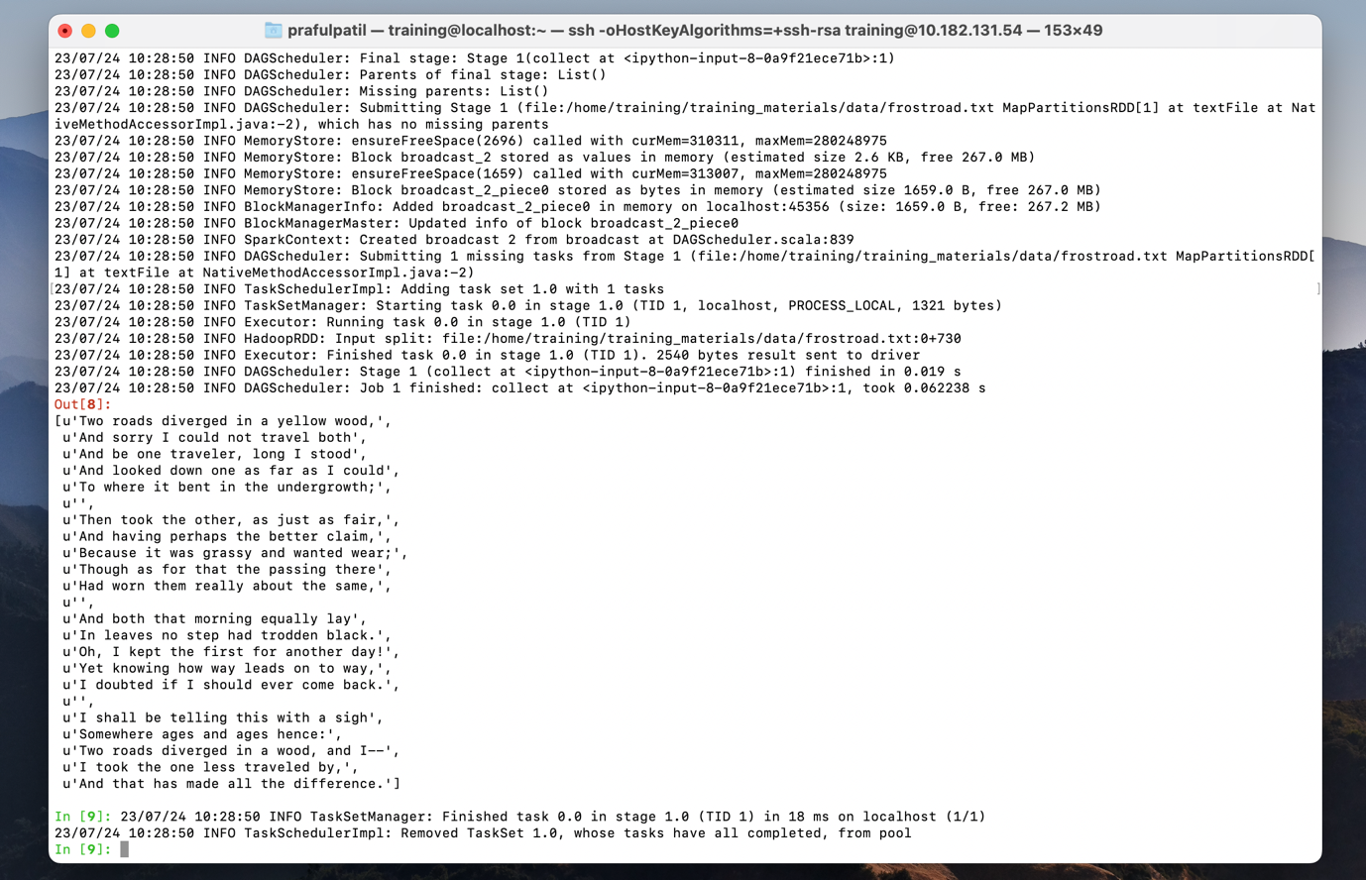

**Screenshot 10.3.5**

**Screenshot 10.3.6**

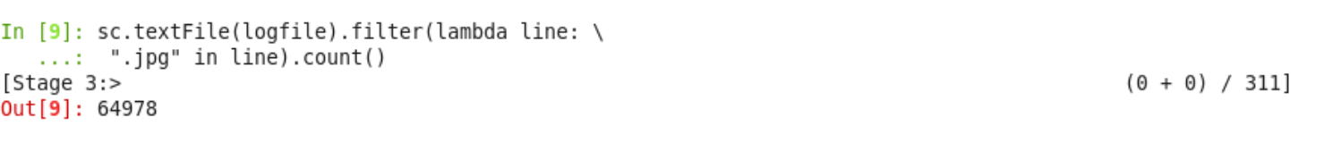

**Screenshot 10.3.11**

