**Pacman Gaming System**

**Report**

* **Overview**

In this project, the snake game resembles to some extent in such a way that Pacman in the game will be driven where it moves along with the predefined path. While moving on the predefined blue path the path is eaten or erased by the Pacman.

More you eat the path the more your score increases. This game application is very easy to play which gives a realistic feel of playing the original game.

* **Components Used**

This project is a console-based application designed for entertainment purposes. This project is designed in the C language using code:: Blocks with the help of GCC compiler.

In this project, the user-defined header file is created in the source code. The external C files are to control the behavior and moving direction of the Pacman.

* **Architecture**
* Use Case Diagram:

Use-case diagrams **describe the high-level functions and scope of a system**. These diagrams also identify the interactions between the system and its actors. The use cases and actors in use-case diagrams describe what the system does and how the actors use it, but not how the system operates internally.

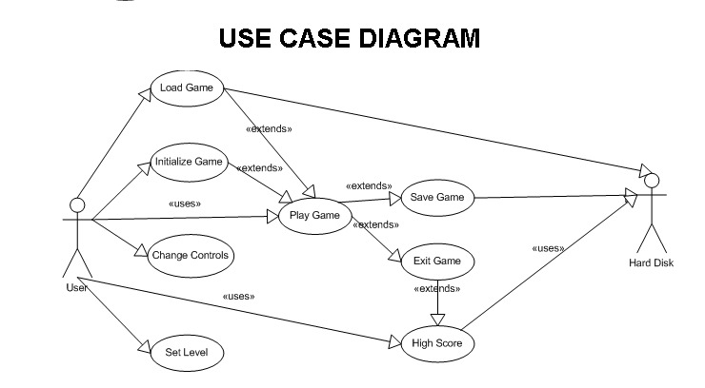

* Sequence Diagram:

A sequence diagram is structured in such a way that **it represents a timeline which begins at the top and descends gradually to mark the sequence of interactions**. Each object has a column and the messages exchanged between them are represented.

