**Assignment 3: Perform Parsing of Family Tree Using Knowledge Base**

**Problem Statement**

The goal of this assignment is to parse a family tree using a knowledge base and infer relationships such as parent, sibling, or cousin. By applying logical reasoning, you will deduce various familial connections.

**Objectives:**

* Understand how knowledge representation and reasoning are used in artificial intelligence.
* Apply inference rules to parse and deduce relationships within a family tree.

**Theory**

**Knowledge Representation:**  
In AI, knowledge representation involves defining entities (such as family members) and their relationships in a way that allows a computer to perform logical reasoning on this information.

**Inference:**  
Inference is the process of deriving new facts or relationships from existing information using established rules. In the case of a family tree, inference involves applying logical rules to deduce relationships such as parent, sibling, or cousin.

**Methodology**

1. **Represent Family Members and Relationships:**
   * Use facts to represent family members and their direct relationships. For example:
     + parent(John, Mary). (John is Mary’s parent)
     + parent(John, David). (John is David’s parent)
     + parent(Mary, Sara). (Mary is Sara’s parent)
2. **Define Rules for Inferring Relationships:**
   * Create rules to infer new relationships from existing facts. For instance:
     + sibling(X, Y) :- parent(Z, X), parent(Z, Y), X \= Y. (X and Y are siblings if they share at least one parent and are different individuals)
     + cousin(X, Y) :- parent(A, X), parent(B, Y), sibling(A, B). (X and Y are cousins if their parents are siblings)
3. **Apply Rules to Infer New Relationships:**
   * Implement a reasoning engine that uses the rules to deduce relationships from the facts in the knowledge base. This can be done using logic programming languages like Prolog or custom implementations in Python.

**Working Principle / Algorithm**

The steps to parse and infer relationships in a family tree are as follows:

1. **Input the Family Data:**
   * Populate the knowledge base with facts about family members and their direct relationships.
2. **Define Inference Rules:**
   * Write rules for inferring relationships such as sibling, cousin, etc.
3. **Query the Knowledge Base:**
   * Use queries to extract information about relationships, such as asking for all siblings of a particular individual or identifying cousins.
4. **Output Inferred Relationships:**
   * Display the inferred relationships based on the knowledge base.

**Advantages:**

* **Complex Reasoning:** This approach enables complex reasoning, allowing for the deduction of intricate relationships that are not immediately obvious.
* **Flexibility:** The knowledge base can be easily updated or expanded with additional facts or rules.

**Disadvantages / Limitations:**

* **Complexity:** As the family tree becomes larger and more complex, managing and querying the knowledge base can become increasingly difficult.
* **Performance:** Inference over a large set of facts and rules can lead to performance challenges, particularly if the rules are not optimized.

**Diagram:**

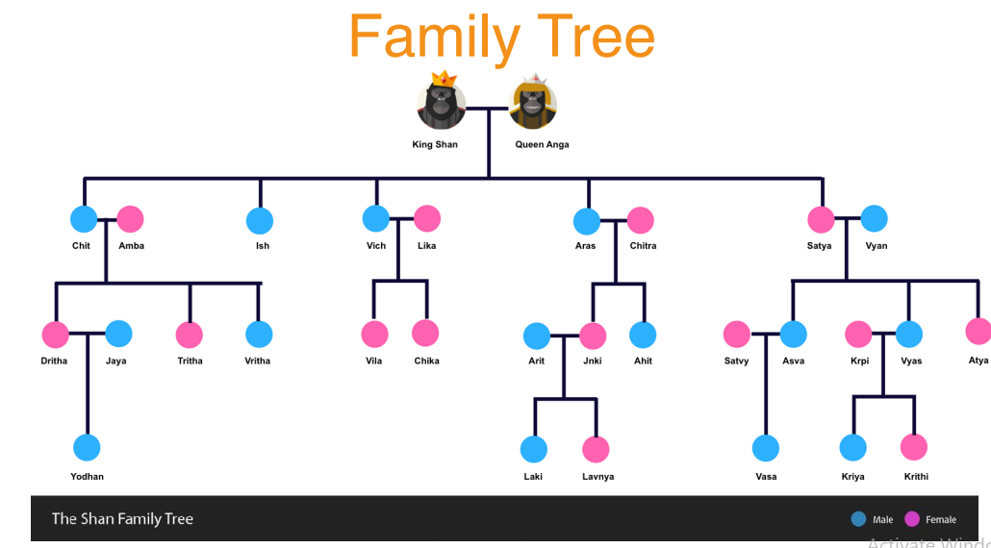

**Conclusion:**  
Using a knowledge base with inference rules provides a systematic approach to parse and deduce relationships in a family tree. This technique enhances the ability to reason about complex familial connections, making it a valuable tool for understanding family structures.