**Assignment 4: Implement A* Algorithm for an Application**

**Problem Statement**

The objective of this assignment is to implement the A* search algorithm for a pathfinding application. This involves developing a method to find the most efficient path from a starting point to a goal while considering various obstacles and costs associated with movement.

**Objectives:**

* Understand the principles of heuristic search.
* Implement the A* algorithm to find the optimal path in a grid or graph-based environment.

**Theory**

*What is the A Algorithm?*\*  
A* is a heuristic search algorithm that combines elements of Dijkstra’s algorithm and Greedy Best-First Search. It finds the least-cost path from a start node to a goal node by considering both the actual cost to reach a node and an estimated cost to reach the goal.

**Methodology**

1. **Define a Heuristic Function:**
   * The heuristic function h(n) estimates the cost from the current node n to the goal node. Two common heuristics used in grid-based pathfinding are:
     + **Manhattan Distance:** Suitable for grid movements where diagonal moves are not allowed:
       - h(n)=∣x1−x2∣+∣y1−y2∣h(n) = |x_1 - x_2| + |y_1 - y_2|h(n)=∣x1​−x2​∣+∣y1​−y2​∣
     + **Euclidean Distance:** Suitable for grid movements allowing diagonal moves:
       - h(n)=(x1−x2)2+(y1−y2)2h(n) = \sqrt{(x_1 - x_2)^2 + (y_1 - y_2)^2}h(n)=(x1​−x2​)2+(y1​−y2​)2​
2. **Explore Nodes Based on Cost:**
   * Each node maintains two costs:
     + g(n)g(n)g(n): The cost to reach the node from the start.
     + f(n)=g(n)+h(n)f(n) = g(n) + h(n)f(n)=g(n)+h(n): The total estimated cost of the cheapest solution through node n.
3. **Continue Until the Goal is Reached:**
   * Initialize the open list (nodes to be evaluated) with the start node, and the closed list (evaluated nodes) as empty.
   * While there are nodes to explore:
     + Extract the node with the lowest f(n) from the open list.
     + If this node is the goal, backtrack to construct the path.
     + Otherwise, generate the node’s successors, calculate their costs, and update the lists.
     + Move the current node to the closed list to avoid revisiting it.

**Working Principle / Algorithm**

A basic outline of the A* algorithm is as follows:

1. **Initialize the Open and Closed Lists:**
   * Add the starting node to the open list.
2. **While the Open List is Not Empty:**
   * Choose the node with the lowest f(n) from the open list.
   * If this node is the goal, reconstruct the path and terminate the search.
   * Generate neighboring nodes:
     + Calculate g(n) for each neighbor.
     + If the neighbor is in the closed list and the new path is better, update its cost.
     + If the neighbor is not in the open or closed list, add it to the open list.
3. **Path Reconstruction:**
   * Once the goal node is reached, trace back from the goal to the start using parent pointers or a recorded path list.

**Advantages:**

* **Optimality:** A* guarantees the shortest path if the heuristic used is admissible (i.e., it never overestimates the cost to reach the goal).
* **Flexibility:** Different heuristics can be used depending on the nature of the problem.

**Disadvantages / Limitations:**

* **Memory Usage:** A* can be memory-intensive since it stores all generated nodes in the open list.
* **Performance:** The algorithm’s performance can decline in large search spaces or if the heuristic is poorly designed.

**Diagram:**

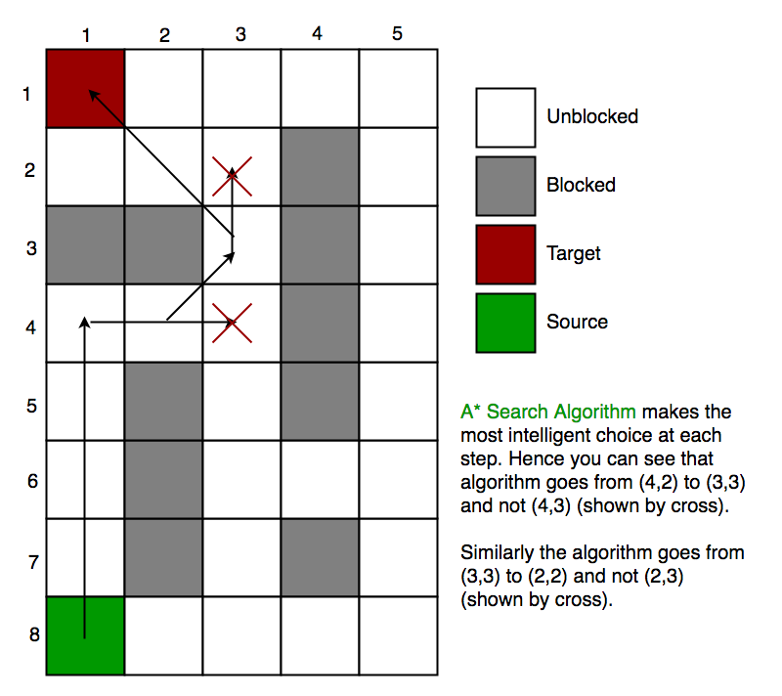

**Conclusion**  
The A* algorithm is a highly effective search method that balances exploration with heuristic guidance to find the optimal path. Its flexibility and ability to guarantee optimal paths make it an essential algorithm in fields like robotics, game development, and navigation systems