**Assignment 7: Implement Forward Chaining Algorithm**

**Problem Statement**

The goal of this assignment is to implement the Forward Chaining algorithm, which is used to infer new facts from a given set of known facts within a knowledge base. This technique is essential for rule-based systems where knowledge needs to be derived dynamically.

**Objectives**

* Understand the principles of rule-based reasoning.
* Implement the Forward Chaining algorithm to infer new knowledge dynamically.

**Theory**

**What is Forward Chaining?**  
Forward Chaining is a reasoning method where inference rules are applied to a set of known facts to derive new facts. It follows a data-driven approach, working from known facts and applying rules iteratively until no new facts can be inferred.

**Methodology**

1. **Start with an Initial Set of Known Facts:**
   * Begin with a knowledge base containing a set of known facts, which will be used as the starting point for inference.
2. **Apply Rules to Infer New Facts:**
   * Each rule in the knowledge base consists of a premise (condition) and a conclusion (fact). If the premise is satisfied by known facts, the conclusion is inferred and added to the knowledge base.
3. **Repeat Until No More Facts Can Be Inferred:**
   * Continue applying rules iteratively until no further conclusions can be drawn.

**Working Principle / Algorithm**

Below is a simplified outline of the Forward Chaining algorithm:

1. **Initialize the Knowledge Base:**
   * Represent known facts and rules as sets. For example:
     + **Facts:** {F1, F2, …, Fn}
     + **Rules:**
       - Rule 1: If A and B, then C.
       - Rule 2: If C, then D.
2. **Create a Loop for Inference:**
   * **While** new facts can be inferred:
     + For each rule:
       - Check if the premises of the rule are satisfied by the known facts.
       - If satisfied, infer the conclusion and add it to the set of known facts.
3. **Output the Inferred Facts:**
   * When no more facts can be inferred, output the final set of known facts.

**Advantages**

* **Dynamic Inference:**  
  Forward Chaining is suitable for environments where facts are added dynamically, allowing the system to keep generating new conclusions.
* **Simplicity:**  
  It is a straightforward and easy-to-understand algorithm, ideal for rule-based reasoning.

**Disadvantages / Limitations**

* **Unnecessary Inferences:**  
  Without proper control, the algorithm may infer irrelevant facts that do not contribute to the solution.
* **Computational Complexity:**  
  In large knowledge bases, the constant application of rules can become computationally expensive and time-consuming.

**Example**

Consider the following knowledge base:

* **Facts:**
  + F1: The sky is cloudy.
  + F2: It is cold outside.
* **Rules:**
  + **R1:** If the sky is cloudy (F1) and it is cold outside (F2), then it might rain (F3).
  + **R2:** If it might rain (F3), then carry an umbrella (F4).

Using forward chaining, we can infer the following:

* Start with F1 and F2.
* Apply **R1**: Since both F1 and F2 are true, infer F3 (it might rain).
* Apply **R2**: Since F3 is now true, infer F4 (carry an umbrella).
* Final facts: {F1, F2, F3, F4}.

**Diagram**

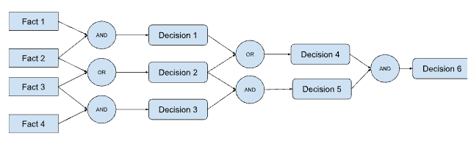

**Conclusion**

Forward Chaining is a powerful reasoning algorithm for rule-based systems, particularly in dynamic environments where new facts need to be inferred continuously. Although simple, it can become computationally intensive with large knowledge bases, but it remains an effective strategy for knowledge inference in artificial intelligence and expert systems.