**Assignment 8: Implement Backward Chaining Algorithm**

**Problem Statement**

The objective of this assignment is to implement the Backward Chaining algorithm, which is used to answer specific queries from a knowledge base. This technique is essential for goal-driven reasoning, allowing systems to infer information based on established facts and rules.

**Objectives**

* Understand the principles of goal-driven reasoning.
* Implement the Backward Chaining algorithm for knowledge inference.

**Theory**

**What is Backward Chaining?**  
Backward Chaining is a reasoning method that starts with a specific goal or query and works backward to determine what facts and rules support or prove that goal. This approach is particularly useful for answering specific queries from a knowledge base, rather than inferring all possible facts like forward chaining.

**Methodology**

1. **Start with a Goal Query:**
   * Define the goal or query that you want to prove based on the knowledge base.
2. **Identify Rules that Can Satisfy the Goal:**
   * Search through the knowledge base to find rules whose conclusions match the goal. A typical rule might be structured as "If A and B, then C."
3. **Work Backward to Find Supporting Facts for the Rules:**
   * For each rule identified, verify whether the premises of the rule (conditions) can be satisfied by known facts or other rules.
4. **Continue Until the Goal is Proven or No More Rules Can Be Applied:**
   * If the premises can be satisfied, the goal is proven true. If no applicable rules can satisfy the goal, or if the premises cannot be satisfied, the goal cannot be proven.

**Working Principle / Algorithm**

The Backward Chaining algorithm works as follows:

1. **Initialize the Knowledge Base:**
   * Represent known facts and inference rules. For example:
     + **Facts:** {F1, F2, …, Fn}
     + **Rules:**
       - Rule 1: If A then B.
       - Rule 2: If C then D.
2. **Define the Goal Query:**
   * Specify the goal you want to prove, e.g., G.
3. **Check for Known Facts:**
   * If the goal is already a known fact, return True.
4. **Search for Relevant Rules:**
   * For each rule, check if the goal matches the conclusion of any rule.
   * If a rule is found, apply the algorithm recursively to check whether its premises can be proven.
5. **Return the Result:**
   * If all premises of the rules supporting the goal are satisfied, return True (goal is proven). If any premise cannot be proven, return False and backtrack to try other rules.

**Advantages**

* **Efficiency:**  
  Backward Chaining is efficient for goal-driven reasoning because it focuses only on information needed to prove the goal, avoiding unnecessary inferences.
* **Dynamic Queries:**  
  The algorithm is flexible, enabling dynamic queries to be made based on the current state of the knowledge base.

**Disadvantages / Limitations**

* **Handling Dynamic Knowledge:**  
  Backward chaining does not handle dynamically changing knowledge well since it relies on existing facts and rules.
* **Complexity in Large Knowledge Bases:**  
  In large knowledge bases with many facts and rules, determining which rules apply to the goal can become computationally expensive.

**Example**

Consider the following knowledge base:

* **Facts:**
  + F1: The sky is cloudy.
  + F2: It is cold outside.
* **Rules:**
  + **R1:** If the sky is cloudy (F1), then it might rain (G1).
  + **R2:** If it might rain (G1), then carry an umbrella (G2).

If we want to prove the goal G2: carry an umbrella, the backward chaining algorithm works as follows:

1. Start with the goal G2.
2. Search for a rule where G2 is the conclusion:
   * Apply **R2**: If G1 (it might rain), then G2.
3. Now, set G1 as the new goal.
4. Search for a rule where G1 is the conclusion:
   * Apply **R1**: If F1 (the sky is cloudy), then G1.
5. Check if F1 (the sky is cloudy) is a known fact. Since it is true, the goal G1 is proven.
6. As a result, the goal G2 is also proven.

Thus, backward chaining successfully proves that you should carry an umbrella.

**Diagram**

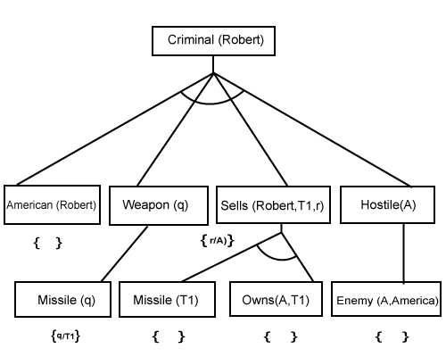

**Conclusion**

Backward Chaining is a powerful algorithm for goal-driven reasoning, particularly when specific answers are sought from a knowledge base. It focuses on satisfying specific queries by searching backward through applicable rules and known facts, making it a key tool for expert systems and AI applications. However, its complexity may increase in larger knowledge bases, requiring more computational resources.