**Assignment 9: Create a Chatbot Application for Any Real-World Scenario**

**Problem Statement**

The objective of this assignment is to develop a chatbot application tailored for a specific real-world scenario, such as customer service or health advisory. The chatbot will utilize natural language processing (NLP) to understand user queries and provide relevant responses.

**Objectives**

* Understand the structure and implementation of chatbots.
* Create a chatbot that can effectively handle a specific real-world scenario.

**Theory**

**What is a Chatbot?**  
A chatbot is an AI-based software designed to simulate conversations with users, either through text or voice. It uses natural language processing (NLP) to understand user inputs and respond appropriately. Chatbots are used in a wide range of applications, such as customer support, virtual assistants, and even entertainment.

**Methodology**

1. **Define User Intents and Corresponding Responses:**
   * Identify the intents or topics the chatbot will handle based on the chosen scenario. For example, if the chatbot is designed for a health advisory system, intents might include "Symptoms Check," "Appointment Booking," "Health Tips," etc.
   * For each intent, create predefined responses or define actions (e.g., fetching information from a database, making appointments).
2. **Use NLP Libraries or APIs to Process User Queries:**
   * Implement NLP techniques to analyze user input. Popular libraries like **spaCy**, **NLTK**, or frameworks like **Dialogflow**, **Microsoft Bot Framework**, or **Rasa** can be used to process queries.
3. **Implement Logic to Map User Queries to Intents:**
   * Build a system to match the user’s query to the most appropriate intent and respond accordingly. This might involve machine learning models, keyword matching, or rule-based approaches.

**Working Principle / Algorithm**

1. **Initialize the Chatbot:**
   * Set up the development environment and load necessary libraries like NLP tools (e.g., spaCy, NLTK, or a chatbot API such as Rasa).
2. **Define Intents and Responses:**
   * Create a data structure (e.g., a dictionary) to map various intents to predefined responses.  
     For example:

intents = {

"greeting": "Hello! How can I assist you today?",

"order_status": "Please provide your order ID to check the status.",

"health_tips": "Make sure to stay hydrated and exercise regularly!"

}

1. **Process User Input:**
   * Capture the user's input (for example, through a chat interface on a web page or mobile app).
   * Preprocess the input using NLP techniques, such as tokenization, stemming, and removing stopwords, to extract key information from the query.
2. **Identify the Intent:**
   * Use NLP or machine learning methods to match the user's input with predefined intents. For example, using cosine similarity to find the closest match, or a rule-based approach like matching keywords.
3. **Provide Response:**
   * Based on the identified intent, fetch the relevant response and display it to the user. If no intent is found, provide a fallback response (e.g., "I'm sorry, I didn't understand that.").
4. **Loop for Continuous Interaction:**
   * After responding, continue to accept user input for follow-up queries or to change the topic.

**Advantages**

* **Automated Assistance:**  
  Chatbots can provide real-time assistance without the need for human intervention, improving operational efficiency and customer satisfaction.
* **24/7 Availability:**  
  Since chatbots can operate continuously, they are ideal for services requiring round-the-clock availability, such as customer support or health advisory.

**Disadvantages / Limitations**

* **Limited Understanding:**  
  Chatbots might not handle complex or ambiguous queries well, especially if the query falls outside the predefined intents or the NLP model’s training.
* **Dependence on Data Quality:**  
  The chatbot's performance depends on the quality of data used to train it and the comprehensiveness of the defined intents. Poor data leads to suboptimal responses.

**Example Scenario: Health Advisory Chatbot**

**Step 1: Define Intents and Responses**

* **Intents:**
  1. **Greeting**: "Hi," "Hello."
  2. **Symptoms Check**: "I have a headache," "I feel dizzy."
  3. **Health Tips**: "Can you give me some health tips?"
  4. **Appointment Booking**: "I want to book an appointment."
* **Responses:**
  1. **Greeting**: "Hello! How can I help you today?"
  2. **Symptoms Check**: "I'm sorry to hear that. How long have you been feeling this way?"
  3. **Health Tips**: "Drink plenty of water, get enough sleep, and exercise regularly."
  4. **Appointment Booking**: "Please provide a date and time for the appointment."

**Step 2: User Input and Processing**

* **User Query**: "I have a headache."
* **NLP Process**: Tokenize and analyze the input to identify keywords like "headache."
* **Identify Intent**: Match the keywords to the "Symptoms Check" intent.

**Step 3: Response**

* **Response**: "I'm sorry to hear that. How long have you been feeling this way?"

**Step 4: Continuous Interaction**

* After responding, the chatbot continues to engage with follow-up questions or new queries.

**Diagram**

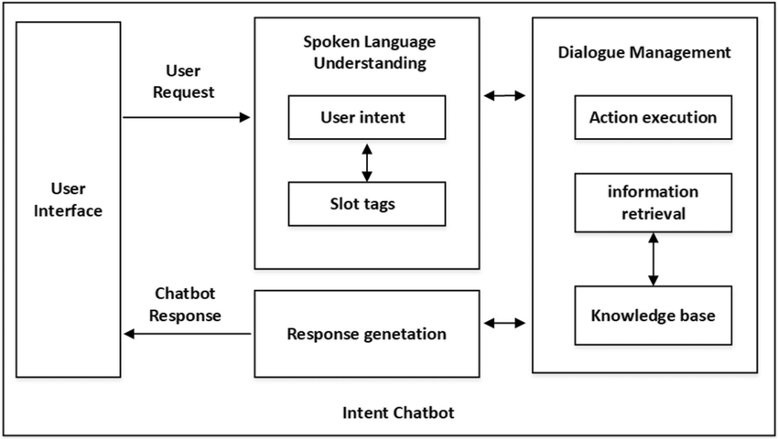

**Conclusion**

Chatbots are a practical application of AI and NLP, automating real-world tasks by providing interactive assistance. With proper design and intent management, chatbots can significantly enhance user experiences in various domains like customer service, health advisory, or even retail. However, limitations such as handling complex queries and the reliance on well-defined intents and high-quality data must be addressed for optimal performance.