**Assignment No: - 2**

**Facial Recognition using OpenCV**

**Problem Statement:**

Facial Recognition Using OpenCV and Deep Learning for Binary Classification.

**Objective:**

1. Understand the fundamentals of face detection and recognition.
2. Preprocess face data and extract facial embeddings.
3. Implement a deep learning-based model for binary face classification.
4. Evaluate the model's performance.
5. Visualize the training process and metrics.

**Software and Hardware Requirements:**

* **Operating System:** Windows/Linux/MacOS
* **Kernel:** Python 3.x
* **Tools:** Jupyter Notebook, Anaconda, or Google Colab
* **Hardware:** CPU with 4GB RAM minimum, GPU recommended for faster processing

**Libraries and Packages:**

* TensorFlow/Keras (for deep learning)
* OpenCV (for face detection)
* Dlib (for facial landmark extraction)
* face_recognition (for face embeddings)
* NumPy (for numerical operations)
* Pandas (for data manipulation)
* Matplotlib (for visualization)
* Scikit-Learn (for model evaluation and metrics)

**Theory Overview:**

**Facial Recognition:** Facial recognition technology identifies or verifies a person by comparing facial features from an image or video frame to a stored database. In this context, binary classification refers to identifying whether a given input is a "face" or "no face."

**System Components:**

1. **Face Detection Module:** Detects faces using algorithms like Haar Cascades or deep learning-based detectors (e.g., YOLO, SSD).
2. **Feature Extraction Module:** Uses Convolutional Neural Networks (CNNs) to extract unique facial features.
3. **Classification Module:** A binary classifier like CNN or SVM identifies if the detected region contains a face.

**Methodology:**

**Step 1: Data Collection**

* Gather a dataset of face and non-face images from a publicly available dataset or custom images.

**Step 2: Preprocessing**

* **Face Detection:** Use OpenCV's pre-trained Haar Cascade or deep learning-based methods for detecting faces in images.
* **Resizing and Normalizing:** Resize all images to a uniform shape (e.g., 128x128 pixels) and normalize the pixel values.

**Step 3: Model Architecture**

* Build a CNN using TensorFlow/Keras for binary classification (face/no face). Suggested architecture:
  + Three convolutional layers with increasing filter sizes (32, 64, 128) and ReLU activation.
  + Max-pooling layers after each convolution to downsample feature maps.
  + Fully connected layers followed by a dropout layer to prevent overfitting.
  + The final layer uses the Sigmoid activation for binary classification.

**Step 4: Model Compilation**

* Compile the model using Adam optimizer, binary cross-entropy loss, and accuracy as the evaluation metric.

**Step 5: Model Training**

* Train the model using the preprocessed dataset. Divide the dataset into training (80%) and testing (20%) splits, with 15-20 epochs of training.

**Step 6: Model Evaluation**

* Evaluate the trained model on the test data. Calculate accuracy, precision, recall, and other relevant metrics using Scikit-Learn.

**Step 7: Prediction and Real-time Face Detection**

* Use the trained model to classify new images. Use OpenCV for live face detection via webcam and make real-time predictions on the detected faces.

**Step 8: Save and Load the Model**

* Save the trained model for future use. Load the model to make predictions on unseen data.

**Step 9: Visualization**

* Visualize the training process (loss and accuracy) using Matplotlib. Display the confusion matrix for test data predictions.

**Advantages:**

* **High Accuracy:** CNNs provide high precision in face detection and classification.
* **Real-Time Processing:** OpenCV allows real-time detection, making it practical for applications like surveillance.
* **Automation:** Automates tasks like facial authentication and access control.

**Limitations:**

* **Data Quality:** High-quality and diverse datasets are essential for reliable face recognition.
* **Lighting/Poses:** Variations in illumination, poses, and occlusions affect model performance.
* **Privacy Concerns:** Unauthorized use of facial recognition can lead to privacy issues.

**Applications:**

1. **Security and Surveillance:** Identify individuals in real-time for access control and monitoring.
2. **Biometric Authentication:** Used in devices like smartphones for face unlock.
3. **Healthcare:** Monitor patient conditions through facial analysis.
4. **Retail and Marketing:** Personalized customer services based on facial recognition.

**Working Algorithm:**

1. **Install Libraries:**
   * Install OpenCV, TensorFlow, Keras, and other required packages.
2. **Face Detection (OpenCV + Haar Cascade):**
   * Use a pre-trained Haar Cascade classifier to detect faces from webcam input.
   * Convert images to grayscale for better face detection accuracy.
3. **Preprocess Dataset:**
   * Load images, resize them to a uniform size, normalize pixel values, and handle labels for classification.
4. **CNN Model:**
   * Design a CNN for binary classification. Use three convolutional layers followed by max-pooling, a fully connected layer, and a binary output layer with Sigmoid activation.
5. **Train and Evaluate:**
   * Train the model on the preprocessed dataset, validate on test data, and evaluate accuracy.
6. **Save and Predict:**
   * Save the trained model. Use it to predict face presence in real-time webcam input or unseen images.

**Diagram:**

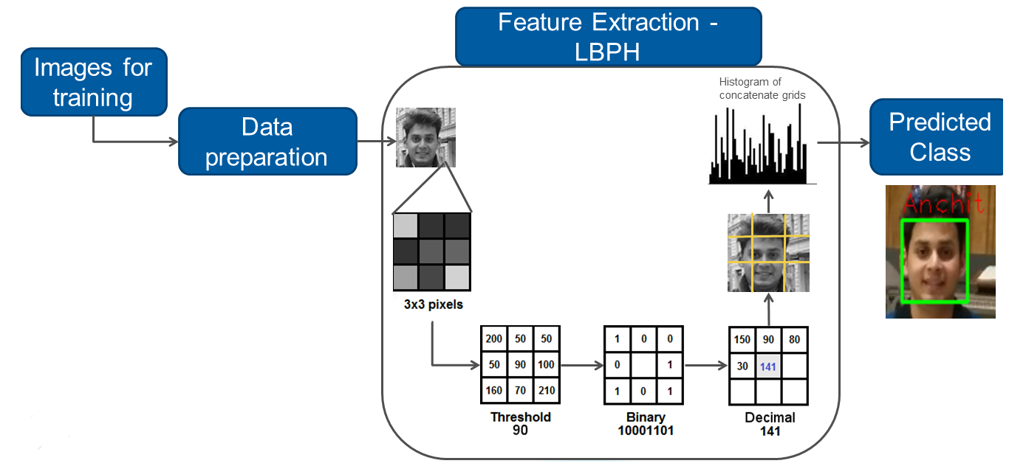

**Conclusion:**

Facial recognition using OpenCV and deep learning can achieve high accuracy and be implemented in real-time applications. By leveraging CNNs, facial features are efficiently extracted and classified, providing robust solutions for security, authentication, and other facial recognition applications. However, challenges like varying lighting, occlusions, and privacy concerns must be addressed.