**A PRELIMENERY REPORT ON**

**OFFLINE PAYMENT SYSTEM**

SUBMITTED TO THE VISHWAKARMA INSTITUTE OF INFORMATION TECHNOLOGY, PUNE

IN THE PARTIAL FULFILLMENT OF THE REQUIREMENTS

FOR THE AWARD OF THE DEGREE

OF

**BACHELOR OF TECHNOLOGY (COMPUTER ENGINEERING)**

##### **SUBMITTED BY**

**PRAFULL BHOIRKAR** Exam Seat No. : **22210189**

**VAIBHAV GOLHAR** Exam Seat No. : **22210180**

**DIVYANSH MOHTA**  Exam Seat No. : **22210998**

**NISHANT DESALE**  Exam Seat No. : **22210322**

## **DEPARTMENT OF COMPUTER ENGINEERING**

**BRACT’S**

**VISHWAKARMA INSTITUTE OF INFORMATION TECHNOLOGY**

SURVEY NO. 3/4, KONDHWA (BUDRUK), PUNE – 411048, MAHARASHTRA (INDIA).

| **Sr. No.** | | | | **Title of Chapter** | | **Page No.** |
| --- | --- | --- | --- | --- | --- | --- |
| **01** | | | | **Introduction** | | 3 |
|  | 1.1 | | | Overview | | 3 |
|  | 1.2 | | | Motivation | | 3 |
|  | 1.3 | | | Problem Definition and Objectives | | 3 |
|  | 1.4 | | | Project Scope & Limitations | | 4 |
|  | 1.5 | | | Methodologies of Problem solving | | 4 |
| **02** | | | | **Literature Survey** | | 5 |
| **03** | | | | **System Design** | | 7 |
|  | | 3.1 | | System Architecture | | 7 |
| **04** | | | | **Project Implementation** | | 9 |
|  | | | 4.1 | Overview of Project Modules | | 9 |
|  | | | 4.2 | Tools and Technologies Used | | 9 |
|  | | | 4.3 | Algorithm Details | | 10 |
|  | | |  | 4.3.1 | Algorithm 1 | 10 |
|  | | |  | 4.3.2 | Algorithm 2 | 10 |
|  | | |  | 4.3.3 | Algorithm 3 | 10 |
|  | | |  | 4.3.4 | Algorithm 4 | 11 |
| **05** | | | | **Results** | | 11 |
|  | | | 5.1 | Outcomes | | 11 |
|  | | | 5.2 | Screen Shots | | 12 |
| **06** | | | | **Conclusions** | | 13 |
|  | | 9.1 | | Conclusions | | 13 |
|  | | 9.2 | | Future Work | | 13 |
|  | | 9.3 | | Applications | | 13 |
|  | | | | **Appendix A**: Problem statement feasibility assessment using, satisfiability analysis and NP Hard, NP-Complete or P type using modern algebra and relevant mathematical models.  **Appendix B**: Details of paper publication: name of the conference/journal, comments of reviewers, certificate, paper.  **Appendix C**: Plagiarism Report of project report. | | 14 |
|  | | | | **References**  Thomas Noltey, Hans Hanssony, Lucia Lo Belloz,”Communication Buses for Automotive Applications” In *Proceedings of the* 3rd *Information Survivability Workshop (ISW-2007)*, Boston, Massachusetts, USA, October 2007. IEEE Computer Society. | |  |
|  | | | |  | |  |

**1. Introduction**

**1.1 Overview**

In today’s increasingly digital world, online payment mechanisms are now something every person interacts with in his or her everyday life. Nevertheless, these systems are highly dependent on reliable internet connectivity to be made available in relatively inaccessible areas, such as the remote or disaster-affected areas. The Offline Payment System thereby seeks to bring a solution to this: a Bluetooth and QR code-based payment method that does not require an internet connection at all. It enables the user to send and receive money without any hindrance through local communication protocols, perfect for areas with rugged networking infrastructure. The key concept is to use Bluetooth Low Energy (BLE) for communication between devices with QR codes used as a secure form of initiating a connection. A fixed value of the wallet is maintained on each user's device to allow real-time transfers with actual feedback and receipt generation. The system is built using React Native to allow cross-platform compatibility, with primary focus on Android in the very first phase.

**1.2 Motivation**

Motivation behind this project is the hardship faced by users in areas with little or no connectivity during digital transactions. People are obliged to use cash due to their inability to access the internet for digital payments in many parts of the world. The inability to transact critical transactions may be a matter of life and death in areas prone to disasters where communication infrastructure fails.

Key motivating factors include:

1. Inclusion: To bring digital payments to people living in remote areas.
2. Resilience: System-based functioning even in the persona of network outages.
3. Affordability: Using already existing smartphone features without requiring extra hardware.
4. Security: Processing transactions without actually being connected, but having verifiable digital records.

This system brings digital payments to the previously disinclined using them because of the barriers of technology.

**1.3 Problem Statement and Objectives**

Problem Statement - Digital wallets and services for online payments have been embraced to various degrees, yet they do share commonalities in that all require the internet. Therein lies a major problem in some regions where connectivity is poor, in emergencies, or for persons with data access limits. To put it bluntly, the inaccessibility of digital payments without the activation of the internet.

Objectives -

* To develop a payment system fully functional in offline mode.
* To enable peer-to-peer transfers of money using Bluetooth technology initiated through QR code scanning.
* To provide validation for safety using device identity and transaction identification.
* To keep and administer a fixed wallet balance in a secure manner on the mobile.
* To provide a reference of transaction that both sender and receiver can refer to.
* To have an intuitive feel and easy interaction, making it simple for all user demographics.

**1.4 Project Scope & Limitations**

**Scope -**

The scope of the project includes:

* Offline transfer of funds between two Android smartphones using BLE and QR codes.
* Secure transaction logic with acknowledgements and transaction logging.
* An intuitive mobile app UI for wallet management and receipts.
* Implementation on the React Native framework to simplify development and testing.
* Use of device-specific identifiers to maintain account uniqueness.

**Limitations -**

* Despite its potential, the system has a few limitations in its current form:
* It works only on Android devices (iOS not yet supported).
* Limited to Bluetooth range (~10 meters), restricting usability in certain environments.
* No real-time fraud detection or online verification.
* Requires manual synchronization for central records if needed.
* Offline balance means trust is placed in local device integrity (vulnerable if the device is rooted or tampered with).

**1.5 Methodologies of Problem Solving**

To address the challenges mentioned, the following methodologies are used:

* **The Bluetooth Connection is Initialized by a QR Code:** Each device shows a QR code that depicts its Bluetooth UUID or a custom identifier. The sender scans this QR to start the transaction.
* **Data Transfer Goes over BLE-Bluetooth Low Energy:** BLE is low-power, secure, and efficient communication between devices. Once paired, the devices transfer transaction-related information (amount, ID, and timestamp).
* **Transaction Verification and Acknowledgment:** The receiver verifies the transaction details, acknowledges those, thus preventing tampering, and enables the transaction to be regarded as having been accepted.
* **Local Wallet Management:** A wallet module tracks the user balance. After a successful transaction and acknowledgment, both the sender and receiver update their local balance in consideration of the transaction.
* **Transaction Logging and Receipts:** Each device maintains its own log file of transactions viewable as digital receipts stored in JSONlocally.
* **Error Handling and Timeout Management:** The system aborts the transaction gracefully and provides feedback to the user in case of failed connections, rejection of transactions, or timeouts.

**2. Literature Survey**

The Offline Payment System leverages technologies like Bluetooth Low Energy (BLE), QR code scanning, and local data storage. To design and implement such a system effectively, it's important to explore existing research and real-world implementations related to digital payments, offline transaction mechanisms, Bluetooth-based communication, and secure device pairing.

**2.1 Existing Digital Payment Solutions**

Digital wallets like Google Pay, PayTM, PhonePe, and Apple Pay dominate the current mobile payment landscape. These platforms rely heavily on cloud-based infrastructure and constant internet access to authenticate transactions, sync balances, and provide real-time updates. Although they are secure and fast, their dependence on connectivity renders them ineffective in offline environments.

Key Takeaway:

Current mainstream solutions are internet-dependent and cannot function in offline conditions, highlighting the need for alternative models.

**2.2 Offline Payment Research and Solutions**

Several research initiatives and pilot systems have tried to address the offline payment problem:

* **M-Pesa (Kenya):** Initially operated over SMS and USSD, M-Pesa was an early attempt at enabling payments in regions with limited internet access. However, it still relied on cellular networks.
* **NFC-Based Offline Payments:** NFC has been explored for offline transfers, particularly in public transit systems (e.g., metro cards), but it often requires specialized hardware.
* **MIT’s "Cashtag" Project:** A conceptual system using sound waves for offline transfers.
* **UPI-Lite (India):** Recently introduced by the National Payments Corporation of India to enable small-value transactions in offline mode through stored value on the device. However, it requires initial loading with internet.

Key Takeaway:

Offline payments are viable with certain constraints. Existing systems either use cellular/SIM infrastructure or proprietary hardware. There is a lack of smartphone-only offline systems using Bluetooth and QR.

**2.3 Bluetooth Low Energy (BLE) Communication**

BLE has emerged as a lightweight and efficient protocol for short-range communication between smart devices. Its key advantages include:

* **Low Power Consumption:** Ideal for mobile applications.
* **Fast Connection Times:** Suitable for quick transactions.
* **Security:** BLE supports encrypted data transfer with secure pairing modes.

BLE is commonly used in healthcare, IoT, and file-sharing apps, but its application in payment systems is still underexplored due to security concerns and regulatory challenges.

Key Takeaway:

BLE is a technically sound method for device-to-device communication in offline contexts, especially when paired with secure identifiers and encrypted messaging.

**2.4 QR Code-Based Communication**

QR codes are widely used for data sharing, payments, and authentication. In payment systems, they are typically used to represent:

1. Account details
2. Merchant UPI addresses
3. Transaction metadata

When combined with offline communication protocols like BLE, QR codes can serve as a secure handshake mechanism—helping devices identify each other and initiate secure connections.

Key Takeaway:

QR codes are reliable, easy to use, and already familiar to users in payment contexts. They are an ideal choice for device discovery and initiation in this system.

**2.5 Local Data Integrity & Wallet Systems**

Maintaining a consistent and tamper-proof balance on a user’s device is a challenge without online synchronization. Techniques to ensure wallet integrity include:

1. Secure storage (JSON files)
2. Device-specific identifiers to bind wallets
3. Transaction receipts and logs for verification

Research in distributed systems and blockchain touches on similar concepts, but lightweight implementations are needed for mobile offline environments.

Key Takeaway:

Offline wallet storage must prioritize tamper resistance and reliable transaction records, even without server-side validation.

**2.6 Gaps in Existing Systems:**

| **Features** | **Online Wallets** | **M-Pesa** | **NFC** | **UPI-Lite** | **Proposed System** |
| --- | --- | --- | --- | --- | --- |
| Internet-Free | No | No | Yes | Yes | Yes |
| Uses QR code | Yes | No | No | Yes | Yes |
| Uses BLE | No | No | No | No | Yes |
| Local Wallet | No | Yes | Yes | Yes | Yes |
| Smartphone-Only | Yes | No | No | Yes | Yes |

**3. System Design**

**3.1 System Architecture**

**3.1.1 Component of System:**

| **Component** | **Description** |
| --- | --- |
| User Wallet | Local storage of the user's balance on the device. |
| QR Code Generator | Generates a unique QR code representing the device and user ID. |
| QR Code Scanner | Scans another device's QR code to get connection information. |
| Bluetooth Connection Manager | Handles BLE connection establishment between two devices. |
| Transaction Manager | Manages the sending, receiving, and verification of payment data. |
| Transaction Manager | Maintains a record of successful transactions for both parties. |

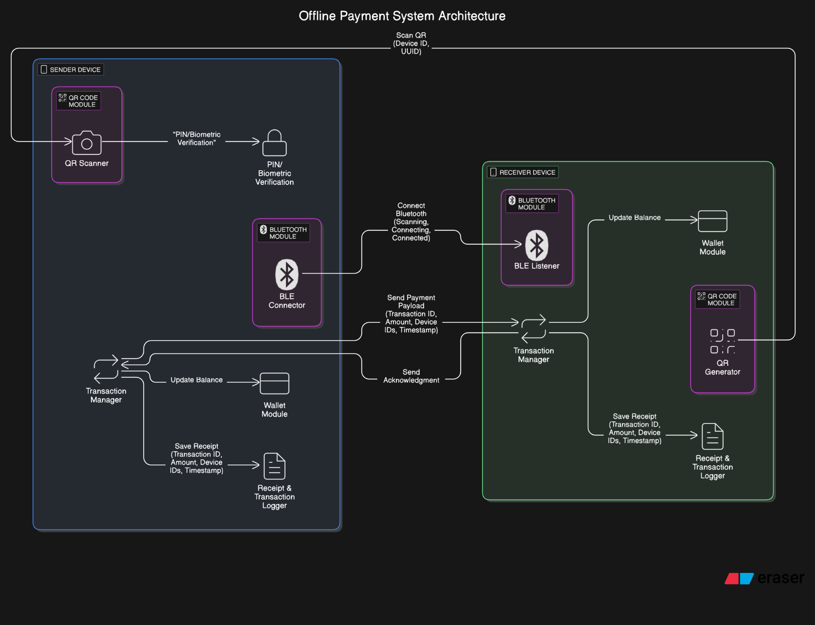

**Fig. 1 System Design**

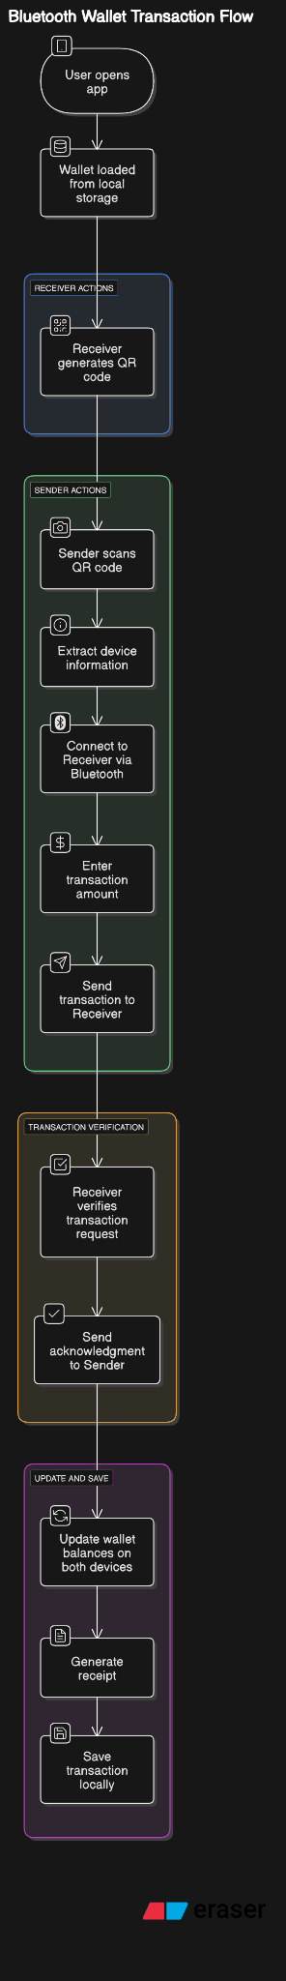

**Fig. 2 Flow of Proposed System**

**3.1.2 Key Design Principle:**

| **Principle** | **How It's Applied** |
| --- | --- |
| Offline First | No dependency on cellular data or WiFi. Fully offline using BLE and QR. |
| Security | Device IDs and transactions are uniquely identified using UUIDs and timestamps. BLE encryption used if available. |
| Reliability | Transaction confirmation only after both sender and receiver acknowledge receipt. |
| Local Persistence | All important data (wallet, transaction history) stored securely on the device. |
| Scalability | Easily extendable to multiple offline transactions without internet sync. |

**3.1.3 Challenges Addressed in Design:**

* **Ensuring Wallet Consistency:** Preventing duplication, loss, or double-spending of balance during offline transactions.
* **Secure Device Pairing:** Avoiding unauthorized Bluetooth connections through QR code-based discovery.
* **Transaction Verification:** Using unique transaction IDs to verify transaction authenticity and prevent replay attacks.
* **Low Power Usage:** BLE chosen for minimal battery drain during transfers.

**4. Project Implementation**

**4.1 Overview of Project Modules**

The Offline Payment System is divided into several core modules, each responsible for a specific part of the functionality:

**1. Wallet Module:**

* Manages the local wallet balance.
* Handles debit/credit operations after transaction confirmation.
* Ensures data persistence using SQLite or local JSON storage.

**2. QR Code Generation & Scanner Module:**

* Generates a unique QR code for the user based on a device-specific ID or Bluetooth UUID.
* Scans the recipient’s QR code to initiate a transaction.
* QR payload includes: device ID, user name, and Bluetooth service UUID.

**3. Bluetooth Communication Module:**

* Uses BLE (via react-native-blx) to establish peer-to-peer connection.
* Handles secure data transfer between sender and receiver.
* Transfers transaction payloads and acknowledgments.

**4. Transaction Module:**

* Manages the creation, validation, and acknowledgment of transactions.
* Ensures both parties update wallet balances only after successful exchange.
* Generates a unique Transaction ID for each exchange.

**5. Receipt and History Module:**

* Stores transaction logs locally for both sender and receiver.
* Displays transaction history with timestamps, parties involved, amount, and transaction ID.

**4.2 Tools and Technologies Used**

| **Tool/Technology** | **Purpose** |
| --- | --- |
| React Native | Cross-platform mobile app development (focus on Android). |
| Bluetooth BLE Library (react-native-blx) | For Bluetooth communication between devices. |
| QR Code Library (react-native-qrcode-svg) | To generate and scan QR codes. |
| JSON | For storing wallet balance and transaction history locally. |
| TypeScript | For safer and cleaner code structure. |
| Expo React Native CLI | For app development and debugging. |

**4.3 Algorithm Details**

**4.3.1 Algorithm 1: Wallet Initialization**

Input: First-time app launch

Output: Initialized wallet with fixed balance

1. Check if local wallet exists

2. If not:

a. Generate unique device ID

b. Assign fixed wallet balance (e.g., Rs. 5000)

c. Save wallet data to local storage

3. Else:

Load existing wallet data

**4.3.2 Algorithm 2: QR Scan and Connection Initiation**

Input: Receiver’s QR Code

Output: Bluetooth connection established

1. Scan QR code and extract device ID and UUID

2. Search for Bluetooth device matching UUID

3. Establish BLE connection with receiver

4. Proceed to transaction initiation if connection is successful

**4.3.3 Algorithm 3: Offline Transaction Flow**

Input: Sender selects amount and initiates payment

Output: Amount transferred and receipt generated

1. Sender inputs amount and initiates transfer

2. Sender sends transaction payload:

- Transaction ID (UUID + timestamp)

- Amount

- Sender ID

3. Receiver validates amount and responds with:

- QR code with Acknowledgment + Timestamp

4. On success:

a. Sender deducts amount from wallet

b. Receiver adds amount to wallet

c. Both store transaction in local history

5. On failure:

- Abort transaction and notify sender

**4.3.4 Algorithm 4: Receipt Generation**

Input: Successful transaction

Output: Receipt stored locally

1. Create receipt with:

- Transaction ID

- Date & Time

- Amount

- Sender and Receiver IDs

2. Store receipt in local database

3. Update transaction history view

**5. Results**

**5.1 Outcomes**

The Offline Payment System project successfully meets its defined objectives and delivers the following key outcomes:

**1. Offline Peer-to-Peer Money Transfers:**

* Successfully enabled money transfer between two Android devices without the need for any internet connection.
* Utilized Bluetooth Low Energy (BLE) and QR codes to establish secure, efficient communication.
* Enabled users to initiate transactions seamlessly by scanning the recipient’s QR code and transferring funds over BLE.

**2. Secure and Reliable Local Wallet Management:**

* Each user’s wallet is initialized with a fixed balance (e.g., ₹5000) at first app launch.
* Transactions (debit and credit) are securely handled and reflected immediately in the local wallet.
* Wallet information is safely stored using SQLite or local encrypted storage to ensure persistence and prevent tampering.

**3. Transaction Verification and Acknowledgment:**

Every transaction undergoes a two-way verification:

* → Sender initiates transaction → Receiver validates and acknowledges before wallet updates happen.
* Prevents fraud or accidental transfers through confirmation dialogues and dual-side validation.

**4. Receipt Generation and History Maintenance:**

For every successful transaction:

* A digital receipt is generated.
* Details like Transaction ID, Amount, Sender ID, Receiver ID, Date & Time are recorded.
* Users can view their transaction history through an intuitive interface inside the app.
* Transaction records are maintained even in the case of app restarts or device reboot.

**5. User-Friendly Interface and Experience:**

* Designed with simple and intuitive UI/UX so that users of any demographic (including less tech-savvy) can easily use it.
* Features like “Send Money,” “Scan to Pay,” “Wallet Balance,” and “Transaction History” are cleanly laid out.

**6. Device-Specific Security:**

* Unique device identifiers (UUIDs) are used to bind wallets to specific smartphones, ensuring uniqueness and traceability.
* Even without internet, transactions can be verified later manually using stored receipts.

**7. Lightweight and Efficient System:**

* BLE ensures low battery consumption during money transfers.
* The application remains lightweight (~50–60 MB size), allowing it to work on low-end smartphones too.

**5.2 Screenshots**

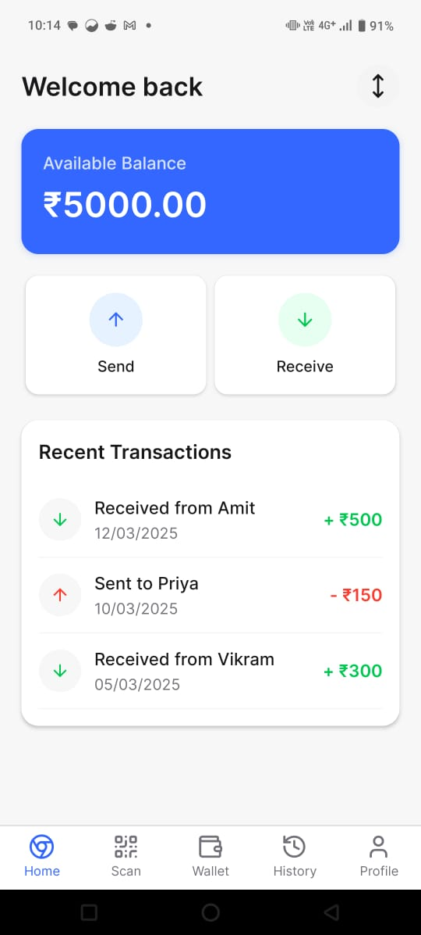 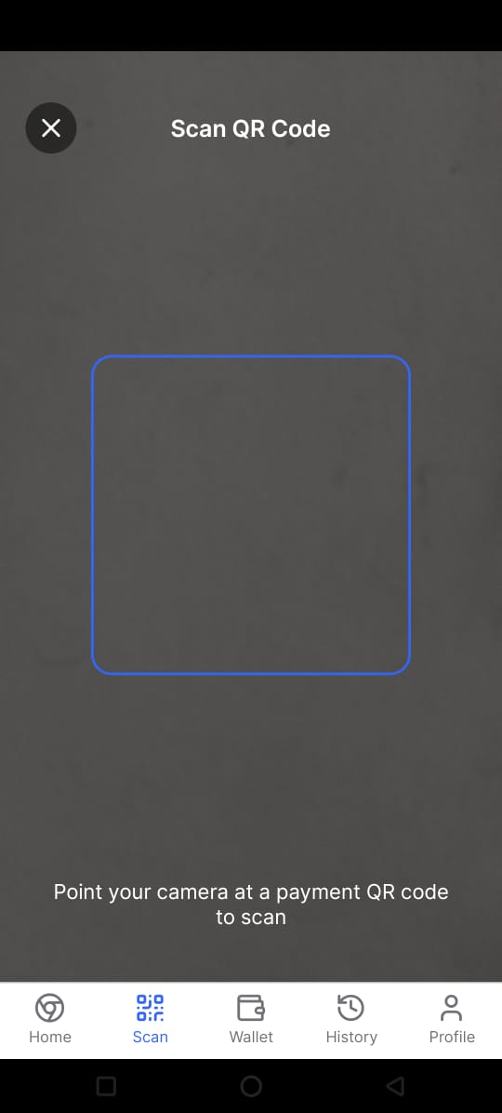 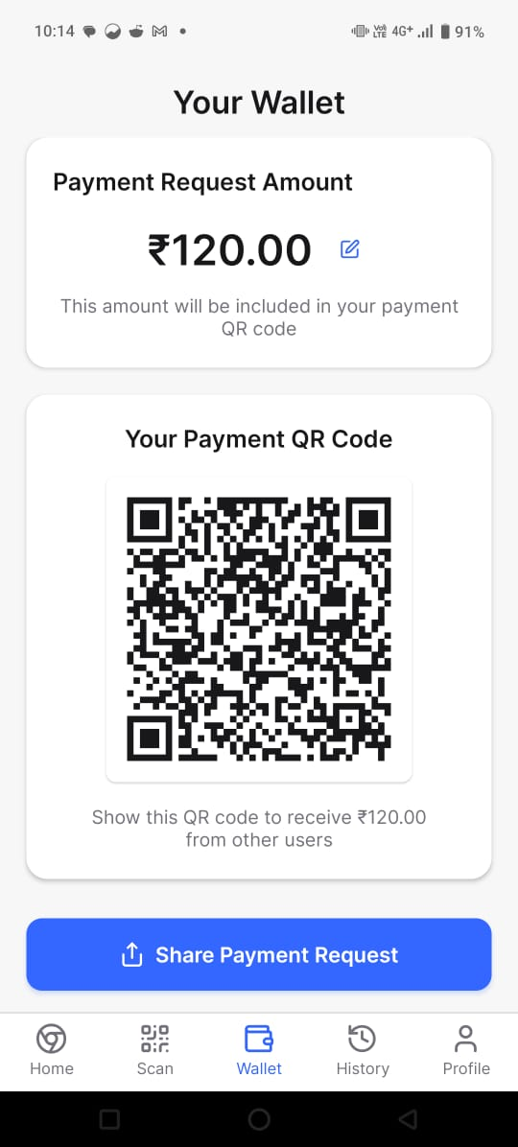

**Fig. 3 UI of Proposed System**

**6. Conclusions**

**6.1 Conclusions**

The Offline Payment System project successfully addresses the critical need for enabling digital transactions in areas without internet connectivity. By leveraging Bluetooth Low Energy (BLE) and QR code-based pairing, it creates a secure, efficient, and easy-to-use mechanism for offline peer-to-peer money transfers. The system ensures the local management of wallet balances with high integrity, generates verifiable receipts, and maintains transaction logs for user verification. It achieves its objective of offering a resilient, affordable, and user-friendly solution for environments with limited network infrastructure. The project demonstrates that Bluetooth and QR technologies, when combined thoughtfully, can offer a viable offline digital payment system without relying on cellular or internet networks. This solution can potentially bridge the gap for millions of users still excluded from digital payment ecosystems due to connectivity barriers.

**6.2 Future Works**

While the current system meets its primary objectives, there are multiple areas where enhancements can be considered for future iterations:

1. **iOS Support:** Extend the app to support iOS devices, ensuring complete cross-platform functionality.
2. **Real-Time Fraud Detection:** Integrate lightweight fraud detection mechanisms locally to identify anomalies in transaction behavior.
3. **Multi-Device Synchronization:** Enable synchronization of transaction records across devices once an internet connection is available, providing centralized auditing.
4. **NFC Integration:** Explore the addition of NFC-based tap-and-pay support as an optional alternative to QR code scanning.
5. **Offline Transaction Limit Regulation:** Implement dynamic transaction limit controls to reduce potential misuse if a device is lost or tampered with.
6. **Enhanced Security Protocols:** Introduce device attestation and secure enclave usage for stronger protection against rooted or compromised devices.
7. **Blockchain-Based Receipt Storage:** Investigate decentralized options like lightweight blockchain systems for tamper-proof receipt verification.
8. **User Reward Programs:** Implement loyalty or incentive programs to promote adoption in rural or semi-urban areas.

**6.3 Applications**

The Offline Payment System has a wide range of real-world applications:

1. **Remote Villages and Rural Areas:** Enable digital financial inclusion where internet services are weak or unavailable.
2. **Disaster Relief Zones:** Facilitate monetary aid distribution in areas affected by natural disasters where communication infrastructure is destroyed.
3. **Military and Defense Camps:** Provide a secure and isolated transaction method for internal use without external connectivity.
4. **Events and Temporary Gatherings:** Allow quick payments during fairs, exhibitions, and temporary camps where internet infrastructure cannot be set up.
5. **Public Transportation:** Enable ticket payments or micro-transactions in buses, trains, and metros operating in remote regions.
6. **Developing Nations:** Help economies where smartphone penetration is growing but reliable internet access remains a challenge.
7. **Backup Payment Method:** Act as a secondary transaction system when mainstream payment methods fail due to internet outages or cyber-attacks.

**Appendix A: Problem Statement Feasibility Assessment**

**Feasibility using Satisfiability Analysis:**

The core requirement of the Offline Payment System is to successfully complete a payment transaction without internet access, relying only on QR scanning and Bluetooth communication.

The problem can be broken down into the following satisfiability conditions:

* QR code must successfully encode necessary device data.
* QR code must be scannable by another device.
* Devices must find each other over Bluetooth.
* Bluetooth connection must be securely established.
* Data transmission (amount, transaction ID) must be correct and acknowledged.
* Wallet balances must be updated atomically only after acknowledgment.

**Satisfiability Conclusion:**

Given the maturity of BLE protocols and QR technology, all individual components are satisfiable under normal hardware constraints (modern smartphones). Hence, the overall system is satisfiable in real-world conditions.

**Problem Classification: P, NP-Complete, or NP-Hard**

Analyzing the core computational aspects:

* **QR Code Scanning:** O(1) after image capture.
* **Bluetooth Device Discovery:** Time complexity depends linearly on number of nearby devices (O(n)).
* **Transaction Verification:** Simple UUID validation and checksum (O(1)).
* **Wallet Update and Local Storage:** O(1) per transaction.

There are no combinatorial explosion problems (no exponential increase in possibilities like traveling salesman problem or satisfiability SAT problems).

Thus, all operations are solvable in polynomial time.

**Classification:**

The Offline Payment System problem lies in the P-Class (problems solvable in polynomial time).

**Modern Algebra & Mathematical Model Used:**

Mathematically, the transaction system can be modeled using Group Theory:

Set of all wallet balances under the operation of transactions (addition/subtraction) forms an Abelian Group:

* Closure: After a transaction, wallet balances still exist within valid monetary values.
* Associativity: Transactions are associative.
* Identity: A transaction with amount 0 leaves wallet unchanged.
* Inverse: A refund is the inverse transaction.
* Commutativity: In simple transactions between two parties, the operations are commutative.

Thus, wallet operations (transfer and receipt) under addition behave like an Abelian group in modern algebra.