**ASSIGNMENT 13.1**

Problem Statement

Perform below operations in Hbase shell

● Create the table customer with two column families - Personal details and order details as column families.

● Create a unique number as row key (ssn/Adhar no.,etc) Insert at least 10 records to each column Insert following values for personal details column family - Name, age, city, state

. ● Insert following values for order details column family

● Order no, order quantity, and order amount

● Use put command to insert the values for each record. ● Use get command, to retrieve all the records of single customer.

**Creation of Hbase table and inserting records :**

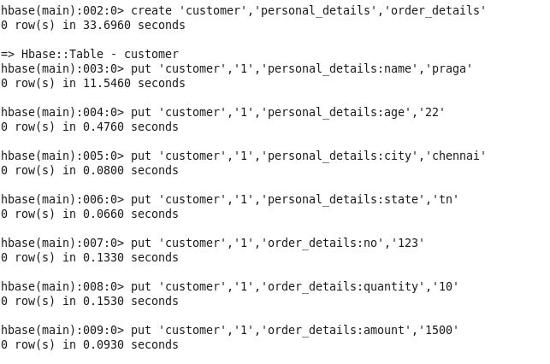

**Inserting atleast 10 records using put:**

put 'customer','1','personal_details:name','praga'  
put 'customer','1','personal_details:age','22'  
put 'customer','1','personal_details:city','chennai'  
put 'customer','1','personal_details:state','tn'  
put 'customer','1','order_details:no','123'  
put 'customer','1','order_details:quantity','10'  
put 'customer','1','order_details:amount','1500'  
  
put 'customer','2','personal_details:name','pragadeesh'  
put 'customer','2','personal_details:age','22'  
put 'customer','2','personal_details:city','bangalore'  
put 'customer','2','personal_details:state','karnataka'  
put 'customer','2','order_details:no','111'  
put 'customer','2','order_details:quantity','12'  
put 'customer','2','order_details:amount','1700'  
  
put 'customer','3','personal_details:name','aaa'  
put 'customer','3','personal_details:age','23'  
put 'customer','3','personal_details:city','chennai'  
put 'customer','3','personal_details:state','tn'  
put 'customer','3','order_details:no','110'  
put 'customer','3','order_details:quantity','14'  
put 'customer','3','order_details:amount','2000'  
  
put 'customer','4','personal_details:name','bbb'  
put 'customer','4','personal_details:age','30'  
put 'customer','4','personal_details:city','hyderabad'  
put 'customer','4','personal_details:state','andhra'  
put 'customer','4','order_details:no','98'  
put 'customer','4','order_details:quantity','20'  
put 'customer','4','order_details:amount','2500'  
  
put 'customer','5','personal_details:name','ccc'  
put 'customer','5','personal_details:age','35'  
put 'customer','5','personal_details:city','bangalore'  
put 'customer','5','personal_details:state','karnataka'  
put 'customer','5','order_details:no','89'  
put 'customer','5','order_details:quantity','25'  
put 'customer','5','order_details:amount','4000'  
  
  
put 'customer','6','personal_details:name','ddd'  
put 'customer','6','personal_details:age','20'  
put 'customer','6','personal_details:city','mumbai'  
put 'customer','6','personal_details:state','maharashtra'  
put 'customer','6','order_details:no','57'  
put 'customer','6','order_details:quantity','50'  
put 'customer','6','order_details:amount','7000'  
  
put 'customer','7','personal_details:name','eee'  
put 'customer','7','personal_details:age','40'  
put 'customer','7','personal_details:city','bangalore'  
put 'customer','7','personal_details:state','karnataka'  
put 'customer','7','order_details:no','171'  
put 'customer','7','order_details:quantity','15'  
put 'customer','7','order_details:amount','1400'  
  
put 'customer','8','personal_details:name','fff'  
put 'customer','8','personal_details:age','34'  
put 'customer','8','personal_details:city','chennai'  
put 'customer','8','personal_details:state','tn'  
put 'customer','8','order_details:no','148'  
put 'customer','8','order_details:quantity','12'  
put 'customer','8','order_details:amount','1700'  
  
put 'customer','9','personal_details:name','ggg'  
put 'customer','9','personal_details:age','24'  
put 'customer','9','personal_details:city','delhi'  
put 'customer','9','personal_details:state','delhi'  
put 'customer','9','order_details:no','150'  
put 'customer','9','order_details:quantity','14'  
put 'customer','9','order_details:amount','1900'  
  
put 'customer','10','personal_details:name','hhh'  
put 'customer','10','personal_details:age','30'  
put 'customer','10','personal_details:city','chennai'  
put 'customer','10','personal_details:state','tn'  
put 'customer','10','order_details:no','135'  
put 'customer','10','order_details:quantity','55'  
put 'customer','10','order_details:amount','8000'

**Retrieving using get:**

