**ASSIGNMENT 14.1**

Problem Statement

Load a table contents from Hive to Hbase table. Explain the steps performed with the screenshot of the code used and final output.

**Creating a Table in HBase:**

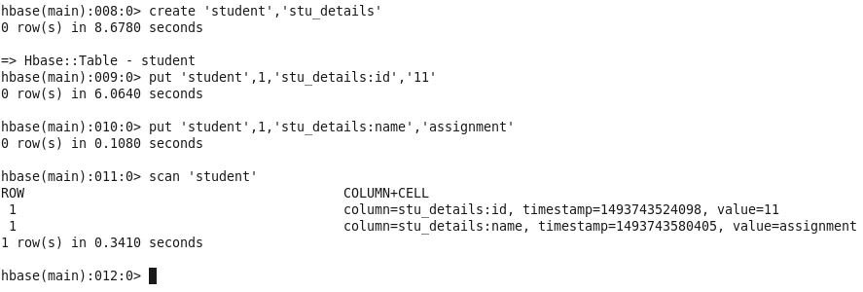

**Creating an External Table in Hive:**

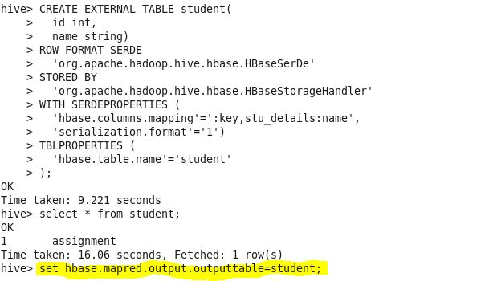

For inserting data into the HBase table through Hive, we need to specify the HBase table name in the hive shell by using the below property before inserting.

|  |
| --- |
| **set hbase.mapred.output.outputtable=student;**  Creating A Staging Table:  **a3.JPG**  **Inserting data from staging table to hive table:**  **a4.JPG** |
|  |
| **Hbase output:**  **a5.JPG** |