**ASSIGNMENT 15.4**

1. Give a hands on demo on the below sqoop techniques

-- Protect your mysql password by saving in a file

-- Protect your mysql password by reading it from a standard input

Note: You can import any of the table present in your mysql for performing this sqoop operation

Giving your password directly in the command line while executing an Apache Sqoop command is highly insecure. For that reason, Sqoop provides two options to protect your password. Let us explore how to secure password while transferring data.

**Reading Password From a Standard Input**

We have the following data in our MySQL database. It contains database **Assignment** which has an **STUDENT**table.

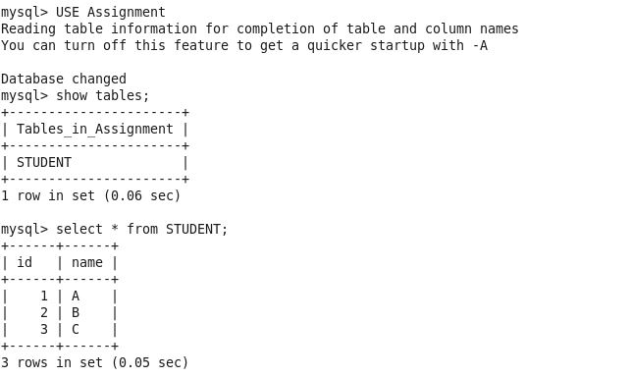

Now we will export this data from MySQL to HDFS using Sqoop.

|  |
| --- |
| **sqoop import --connect jdbc:mysql://localhost:3306/Assignment --username root --table STUDENT -P** |

Users can use the above command to transfer data from MySQL to HDFS mentioning **-P**at the last to enter their password through a standard input.

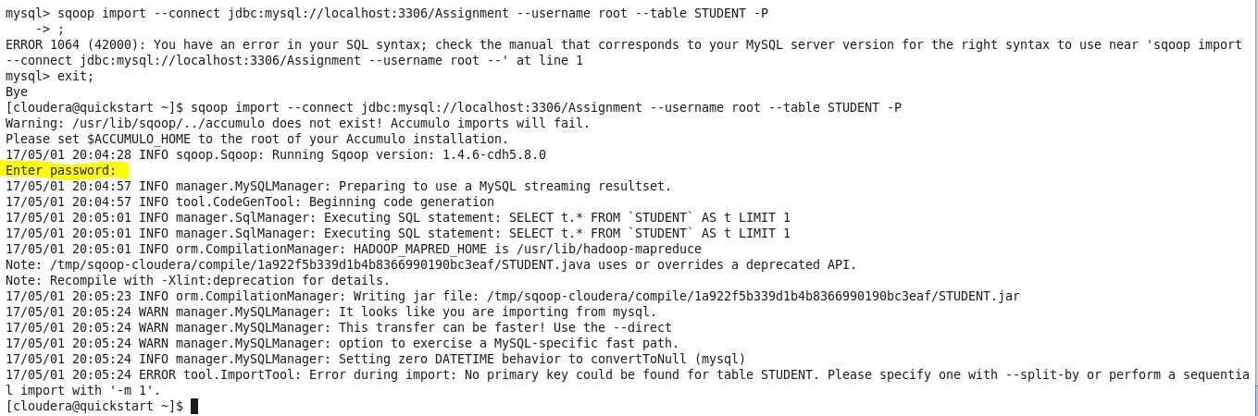

In the above screenshot, you can see that Sqoop has prompted to enter a password so that no one can see what the user is typing. This is one way of securing the password.

### Reading a Password from the File:

Here is how to write your password to a file

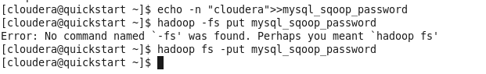

Sqoop will read your password from a file that is stored in HDFS cluster. You can also set the permission of file to 400 so that no other user can access that file.

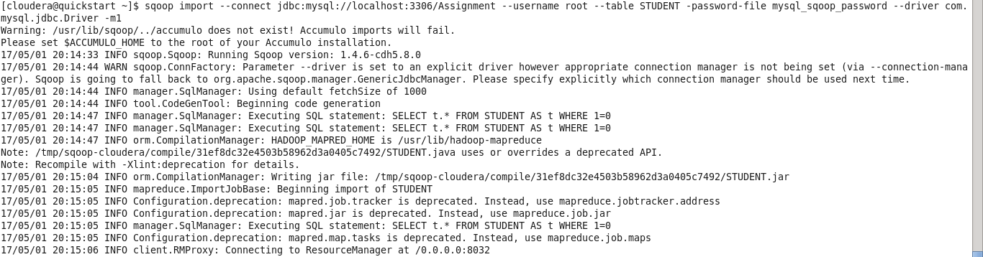

2. Explain waht is Speed Transfer and give a handson demo on speed transfer using sqoop

Sqoop can handle bulk transfers very well. You can speed up the transfers by using the –**direct**parameter. Normally Sqoop uses JDBC as an interface for transferring data. Alternatively, direct mode transfers the data using the native utilities of the database provider. In MySQL, mysqldump and mysqlimport are used for data transfers between MySQL. Sqoop will use pg_dump utility to import the data.

