**ASSIGNMENT 15.6**

1. Import a table in Mysql as an avro file into HDFS

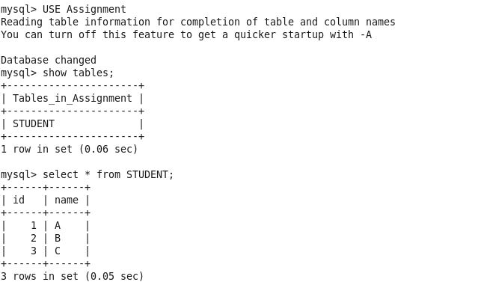

SQOOP IMPORT AS AVROFILE:

sqoop import --connect jdbc:mysql://localhost:3306/Assignment --username root --password cloudera --table STUDENT -m1 --target-dir /sqoop_data/avro/ --as-avrodatafile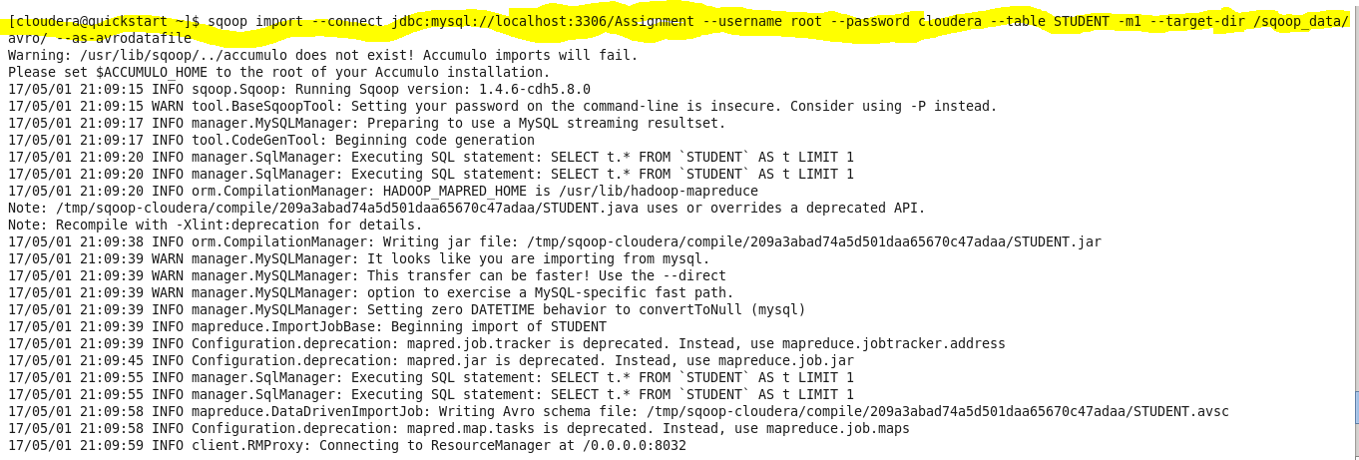

HDFS:

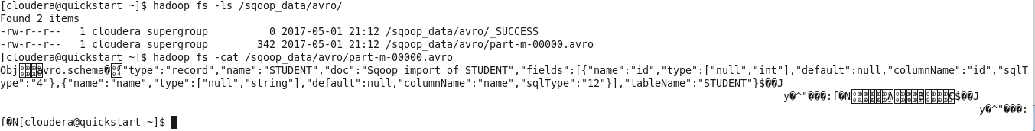

1. Import a table in Mysql as a sequence file into HDFS

SQOOP IMPORT:

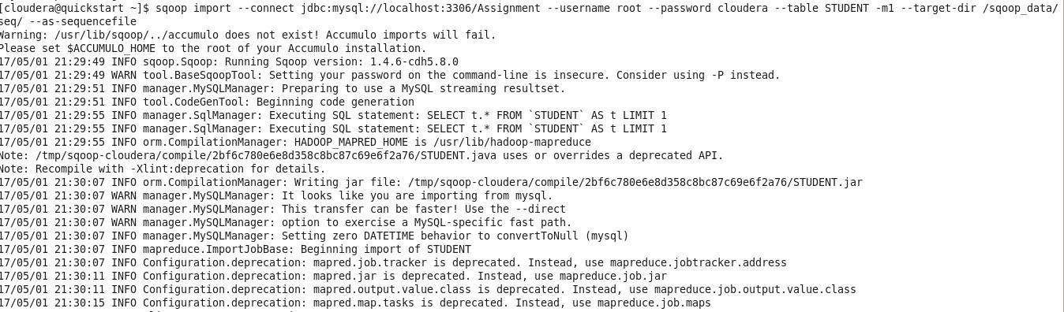

HDFS:

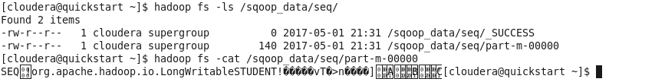

1. Export a file data in HDFS into a Mysql table

CREATING TABLE:

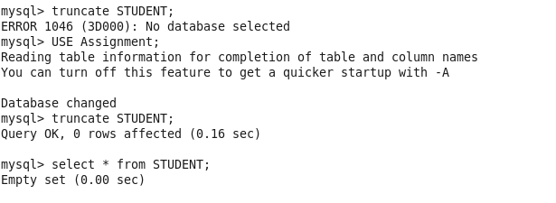

EXPORT:

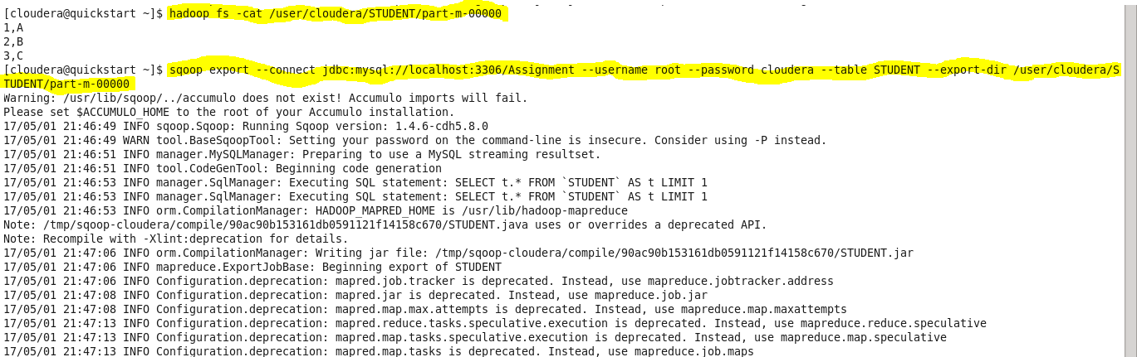

EXPORTED TABLE:

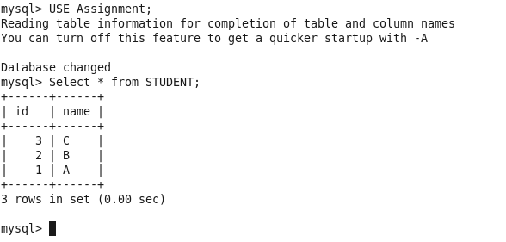

1. How can you control parallelism in running sqoop jobs. Control the number of mappers to run parallely to 5 while transfering data from Mysql to HDFS using sqoop.

By default, Sqoop uses 4 mappers running in parallel to transfer data to HDFS. We can also control the parallelism by using the option –**num-mappers mappers_count.**

