**ASSIGNMENT 8.3**

Problem Statement:

Write a Pig UDF to find the tweets posted by @realDonaldTrump from the given dataset.

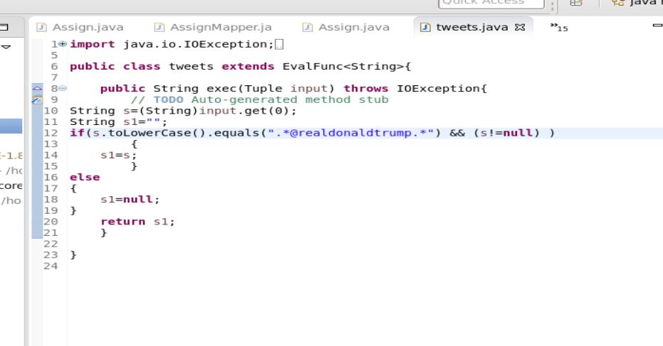

**PIG EXECUTION:**

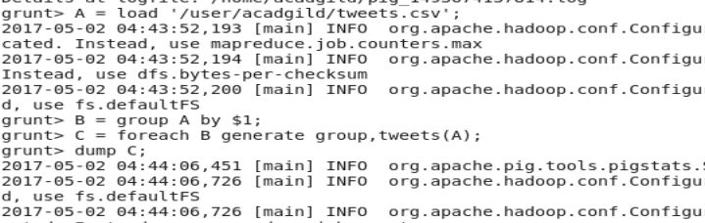

**No of tweets posted by @realDonaldTrump :**

**3218**