**ASSIGNMENT 9.2**

Problem Statement:

Create a flume agent that streams data from Twitter and stores it in the HDFS cluster.

CREATING APP:

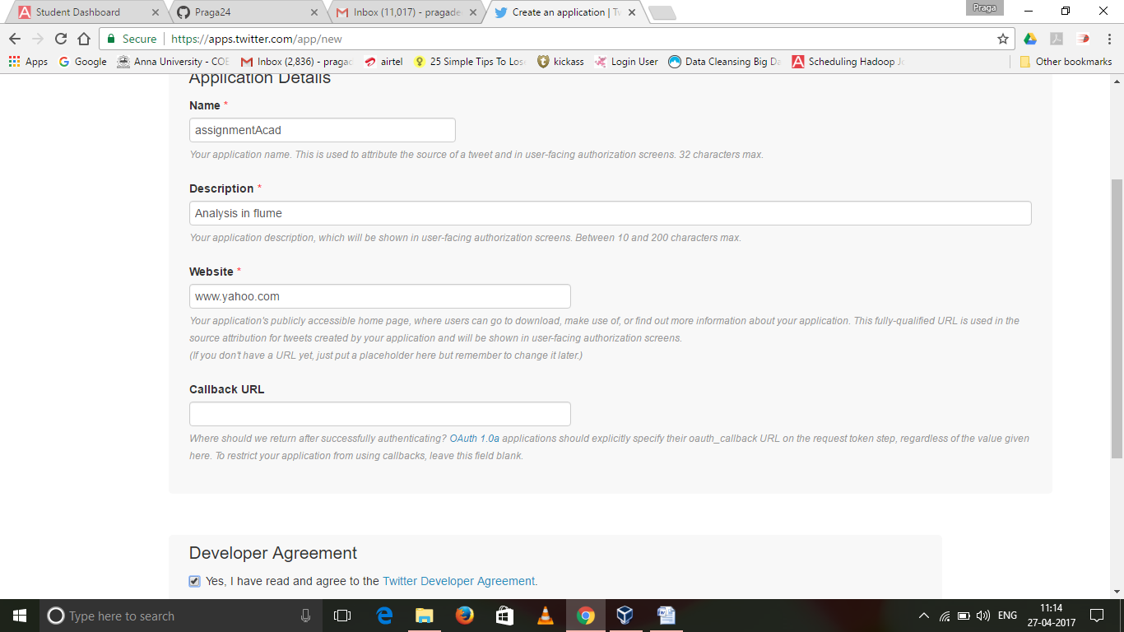

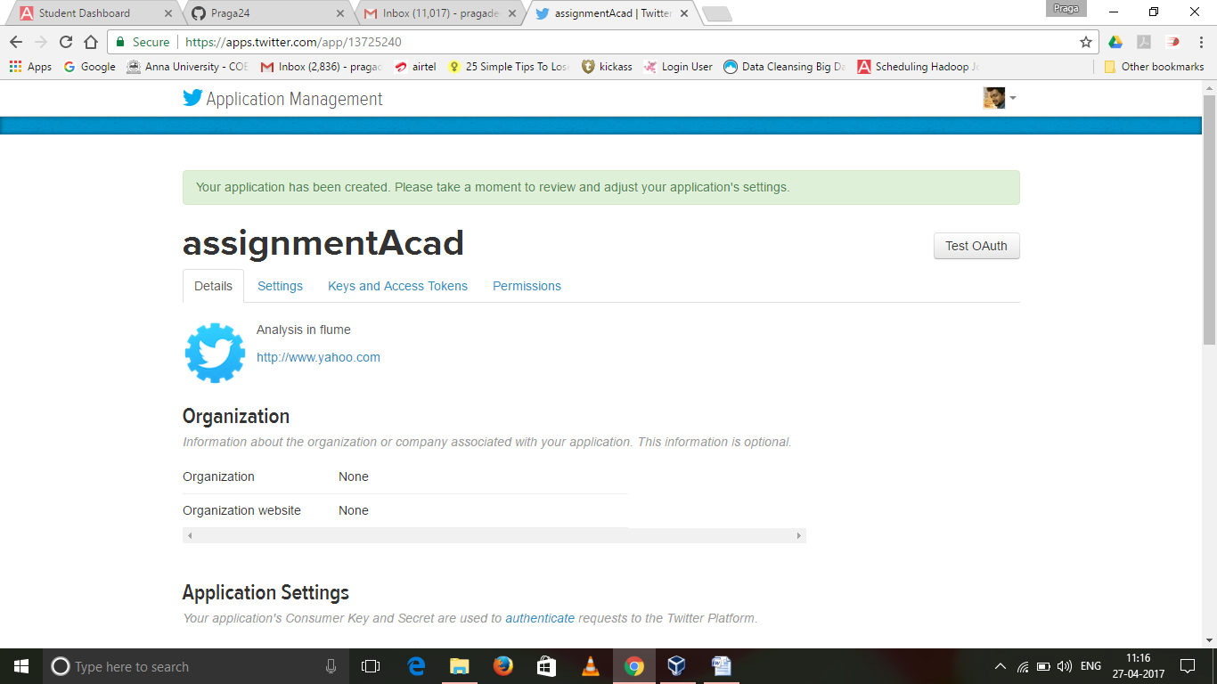

GENERATING ACCESS TOKEN:

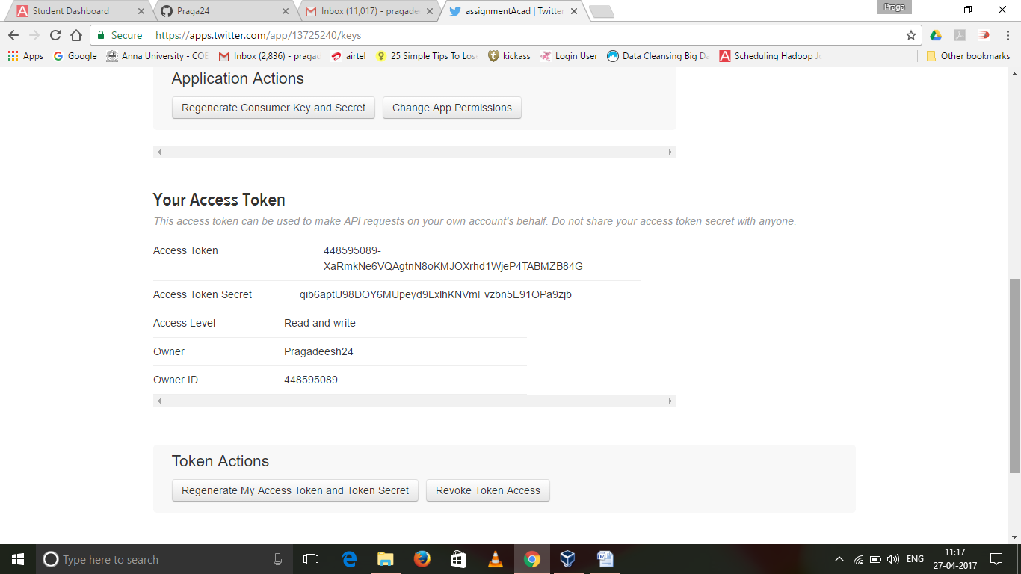

Changing the twitter api keys with the keys generated in flume.conf :

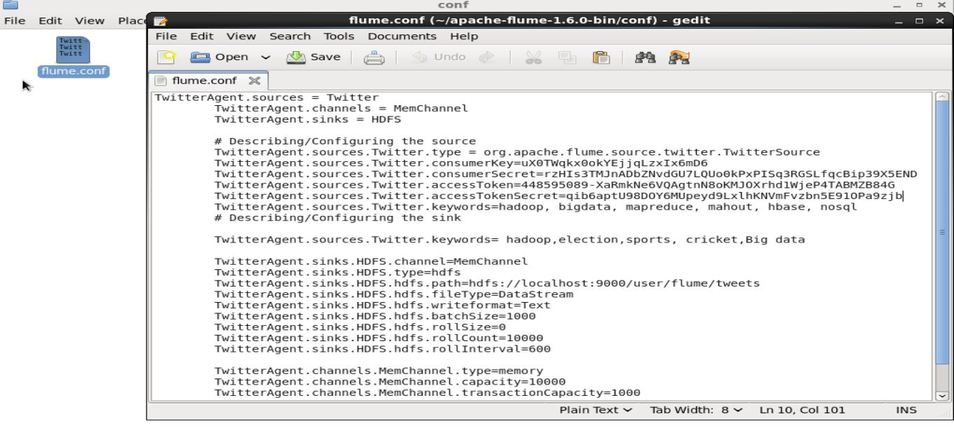

Create a new directory inside HDFS path, where the Twitter tweet data should be stored

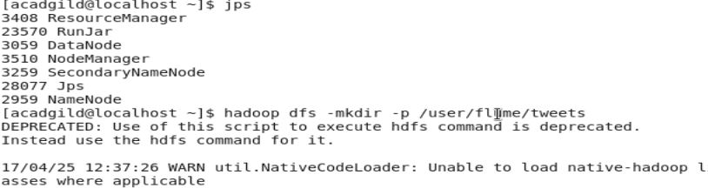

Fetching the twitter tweet data into the HDFS cluster path:

flume_agent.JPG

Checking the contents of the tweet data:

