**ASSIGNMENT 9.4**

PROBLEM STATEMENT:

Transfer streaming data from your local file system to HDFS using flume spool directory.

**Step-by-step Demonstration : Data Streaming from Local File System to HDFS:**

**Moving the AcadgildLocal.conf file inside flume/conf directory:**

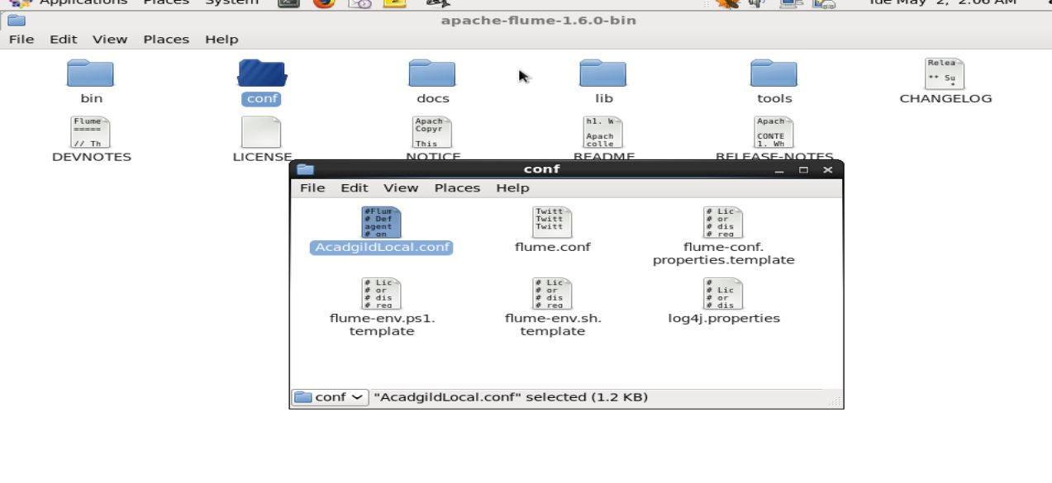

1)agent1.sources.source1_1.spoolDir is set with input path as in local file system path.  
2)agent1.sinks.hdfs-sink1_1.hdfs.path is set with output path as in HDFS path.

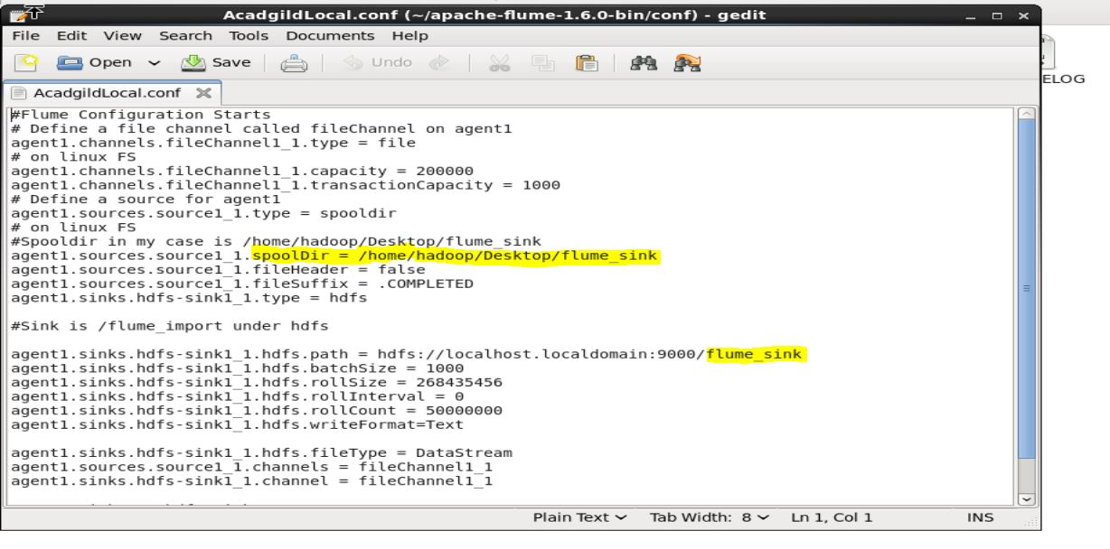

**Creating the folder as specified in AcadgildLocal.conf file will make our ”spooling “directory.**

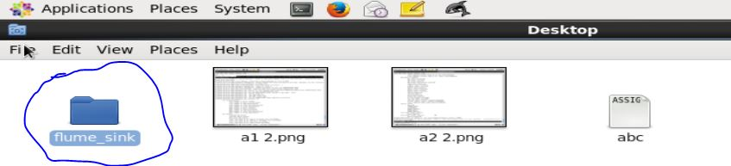

**Making destination directory inside HDFS as mentioned in AcadgildLocal.conf.**



**Starting flume agent:**



For our dummies dataset we will be creating 3 different test file which will act as 3 log files created at different times from same web server.

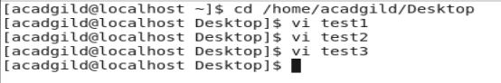

**The sample data inside the files contains list of webpage , sessionID, sessionIN, sessionOUT.**

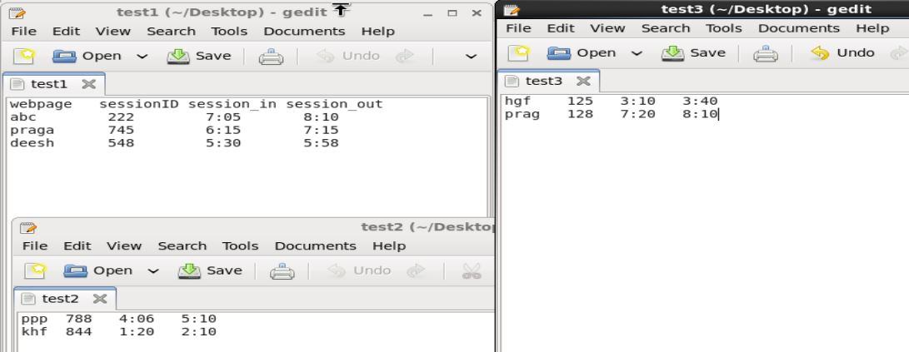

One by one we will place all the test file inside flume_sink directory. Wait for a moment and you can see the filename change to  **“filename. COMPLETED”**

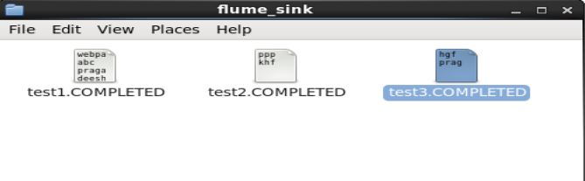

We can now check the resultant temporary file inside HDFS at destination path generated by Flume.

